1. In the Azure Databricks Workspace, under Common Tasks, click “Import Library”

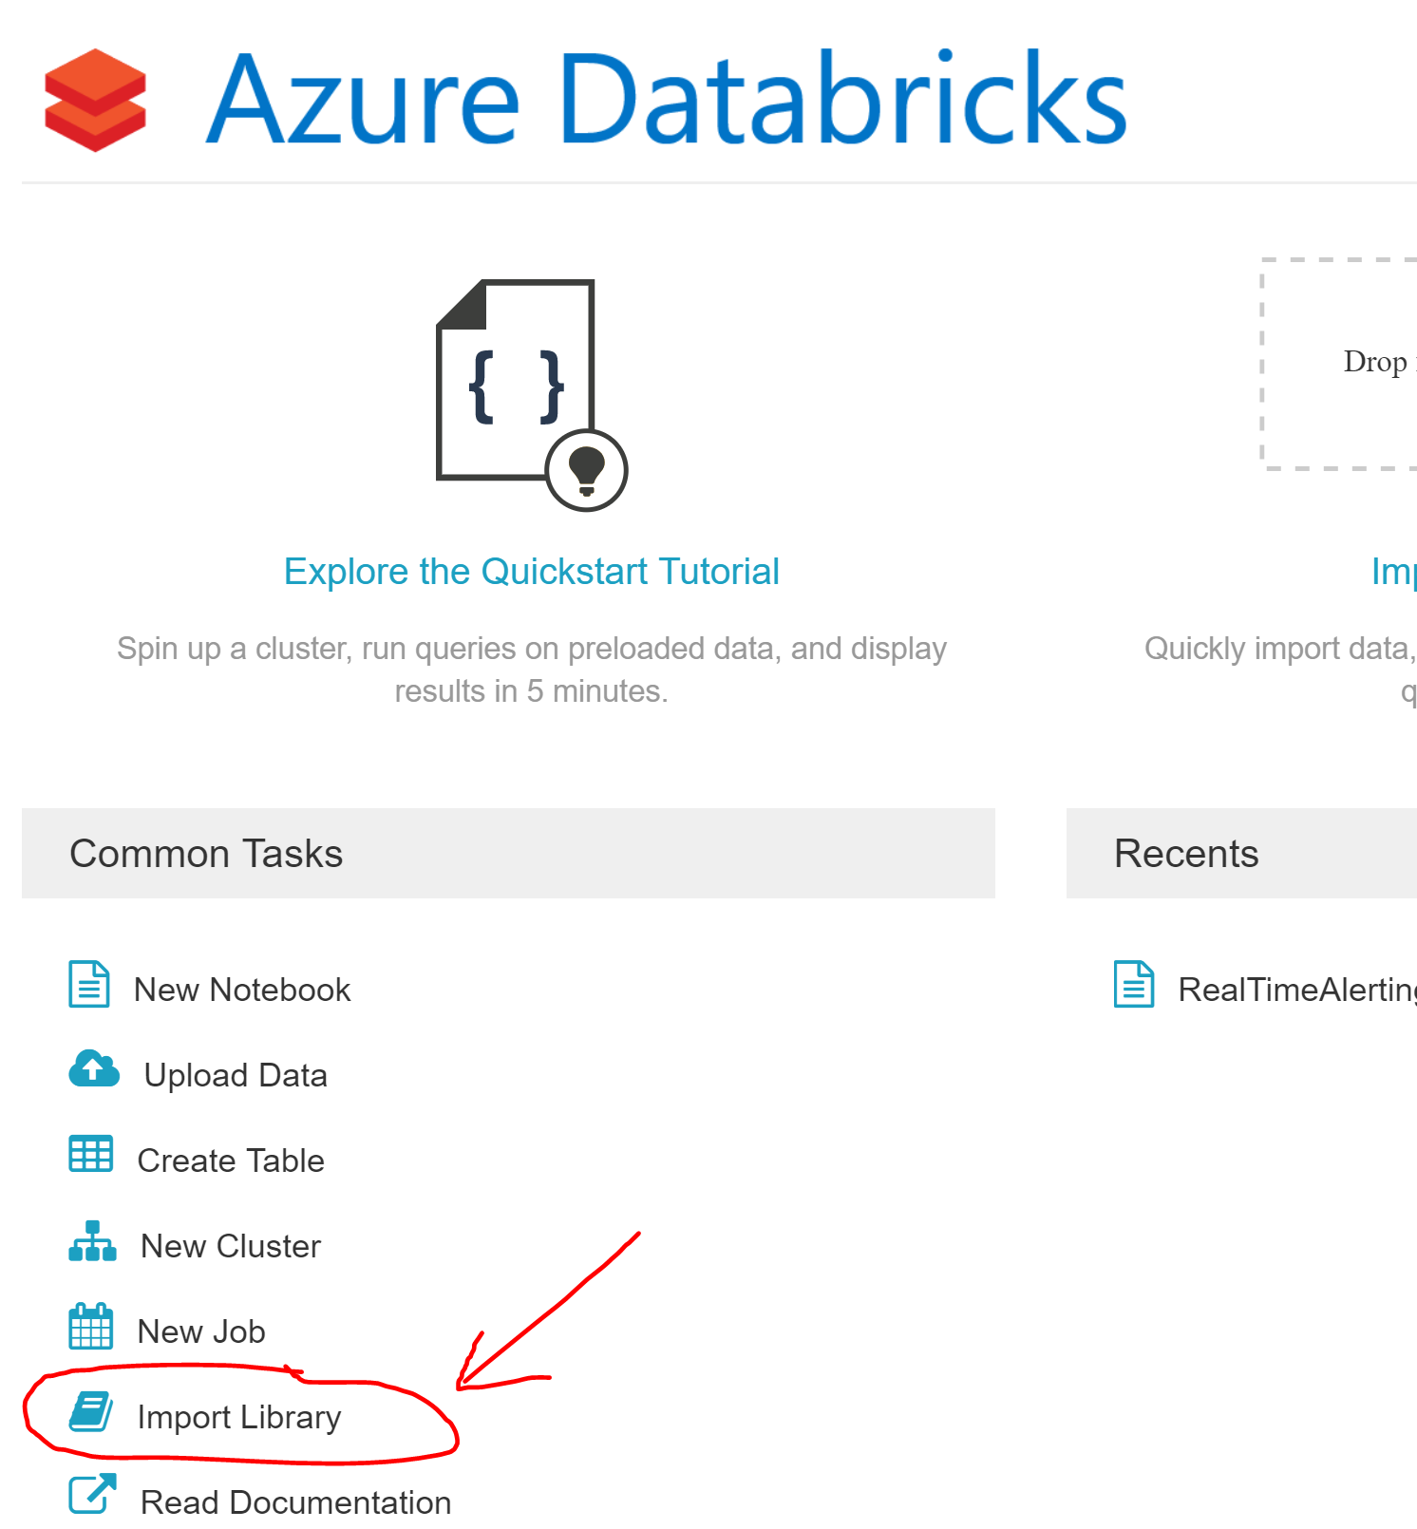

1. For Library Source choose “Search Packages”

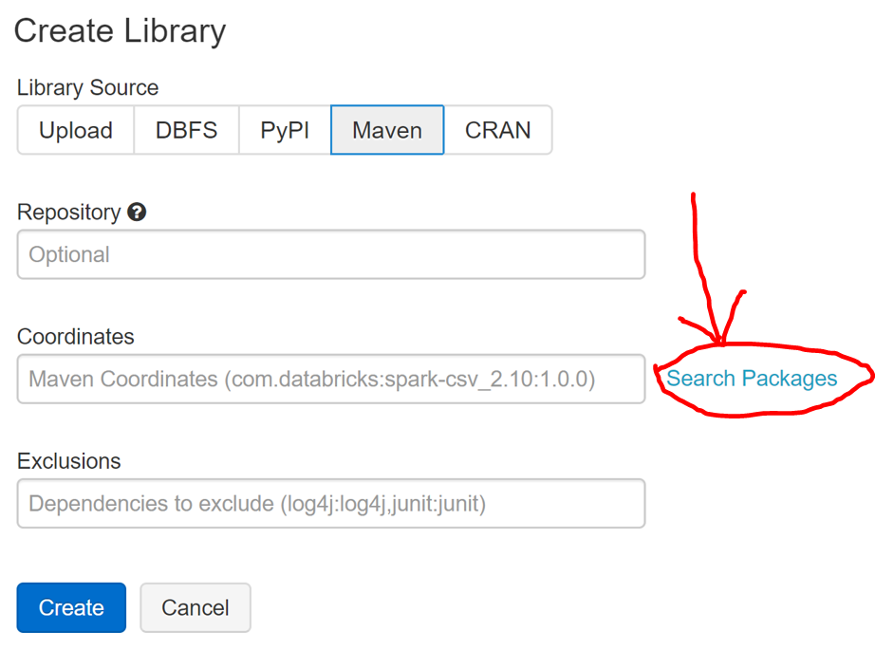

1. Choose “Maven Central” and type “eventhubs-spark” into the search bar. Then select the package associated with “com.microsoft.azure”

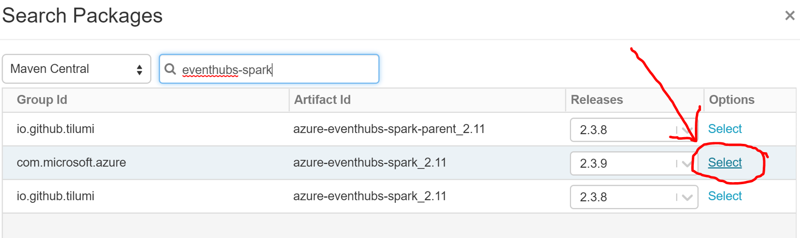

1. Now click “Create”

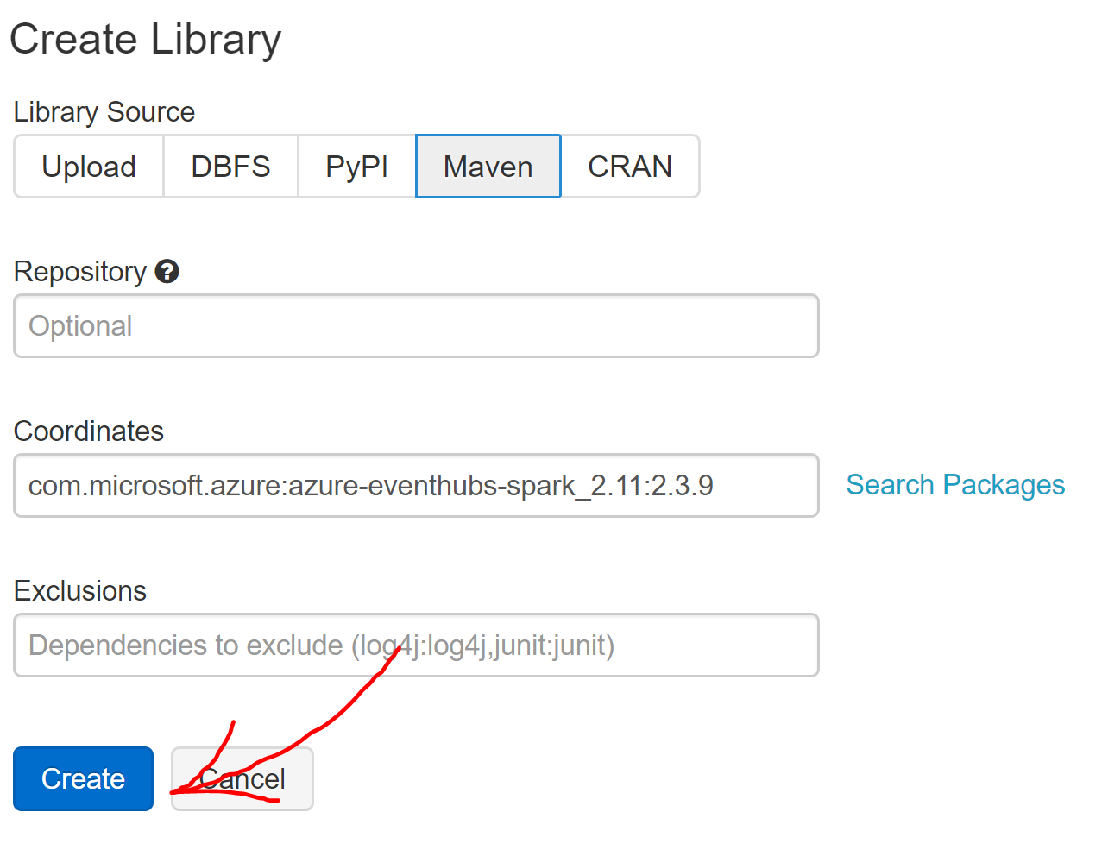

1. First, click the checkmark at the top of the table of clusters and then click “Install”

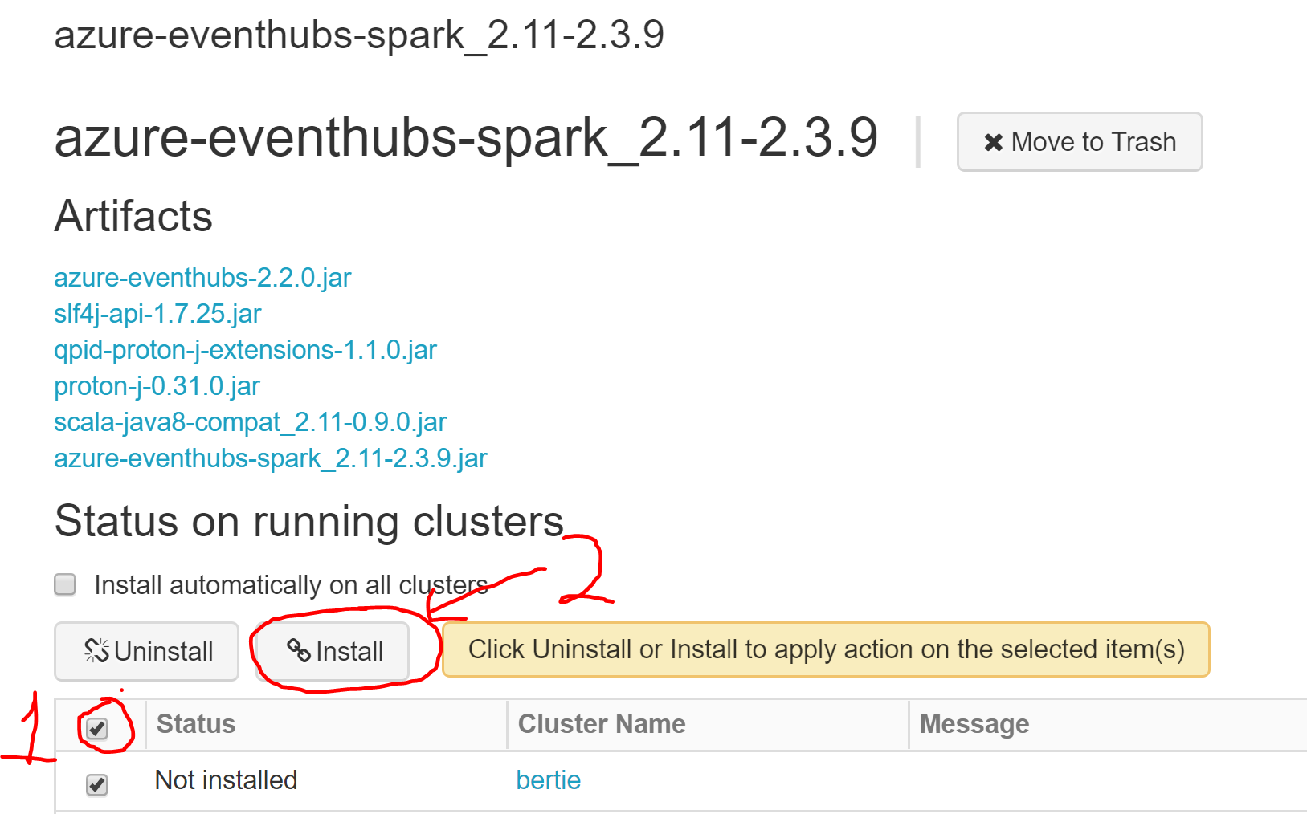

1. Once it says “Installed” you are ready to go!

