How to Set Up the Logic App

1. Go to the Azure Portal
2. Click “Create a resource”
3. Choose Logic App / Search for and choose Logic App
4. Search for the Event Hub Connector in the Logic App Designer

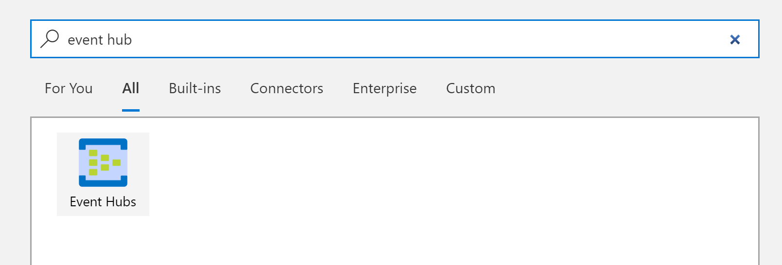

1. Choose the “When events are available in Event Hub” Trigger

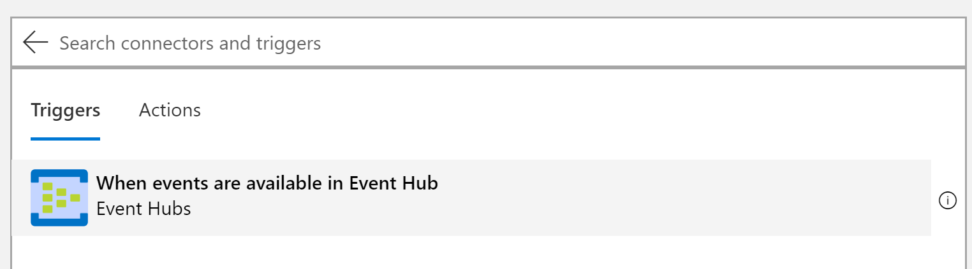

1. Choose the Event Hub Namespace that you deployed for this solution and the Key that you have chosen to use in the Structured Streaming Script

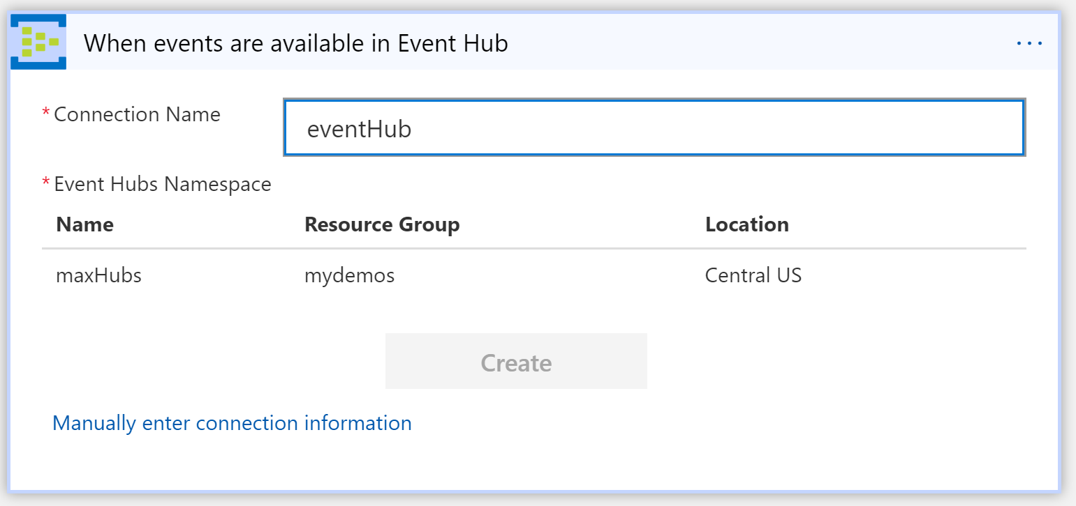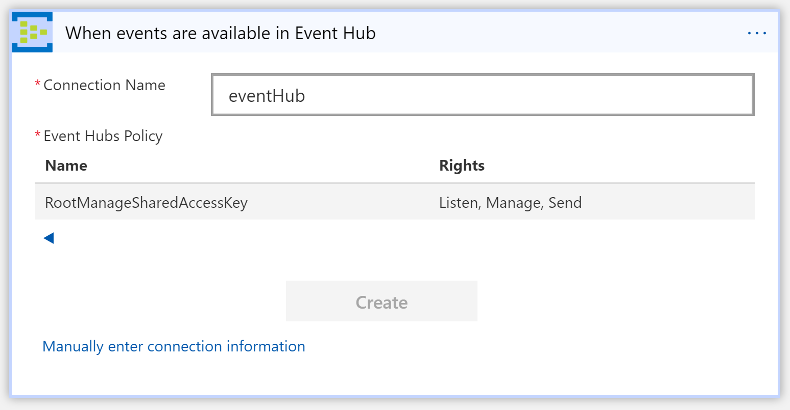

1. Choose the “alerting” Event Hub

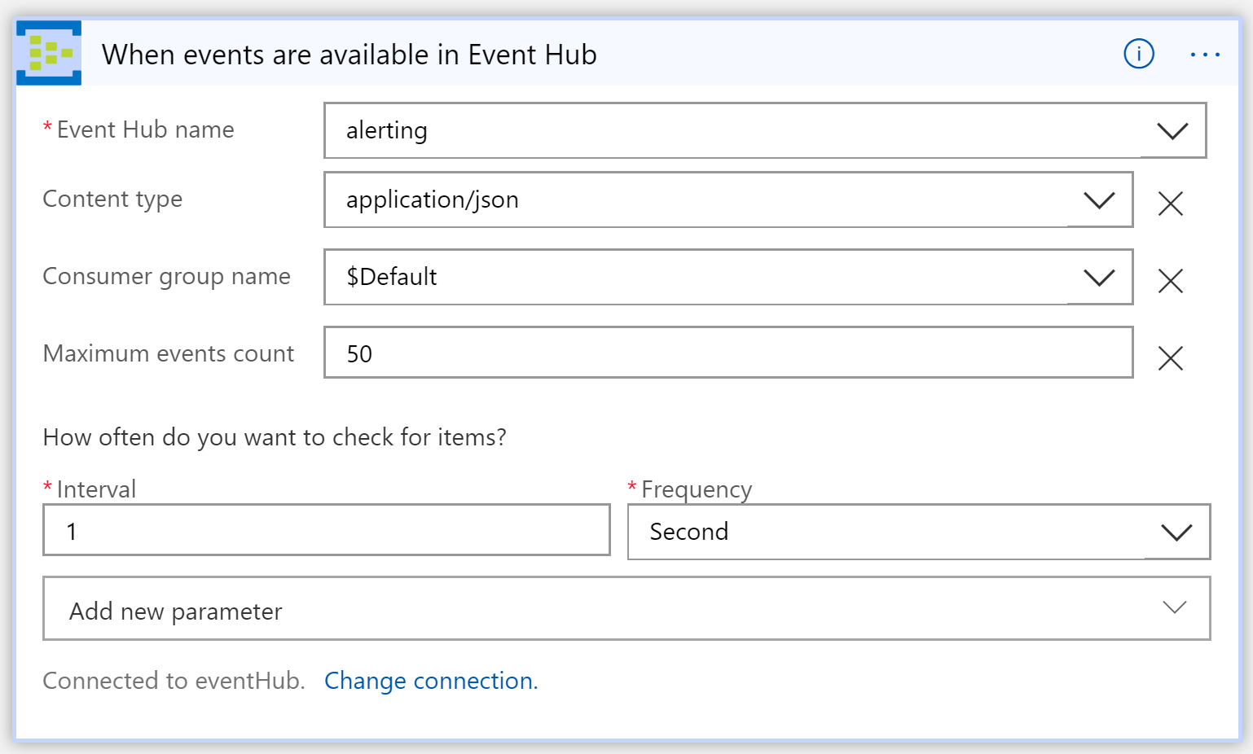

1. Search for “Gmail” or your favorite Email provider (i.e. Outlook) and choose the connector

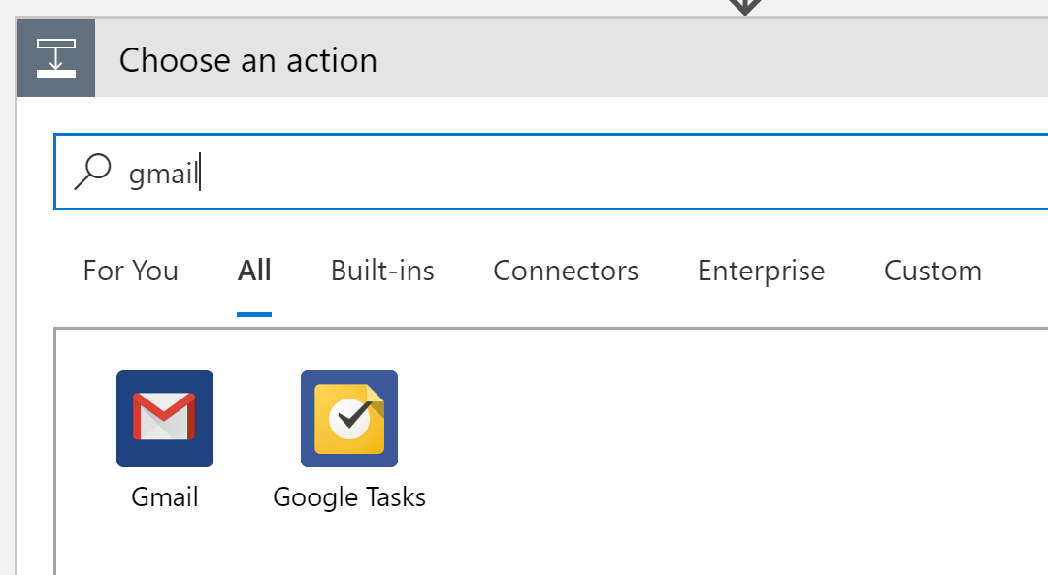

1. Choose “Reply to email”

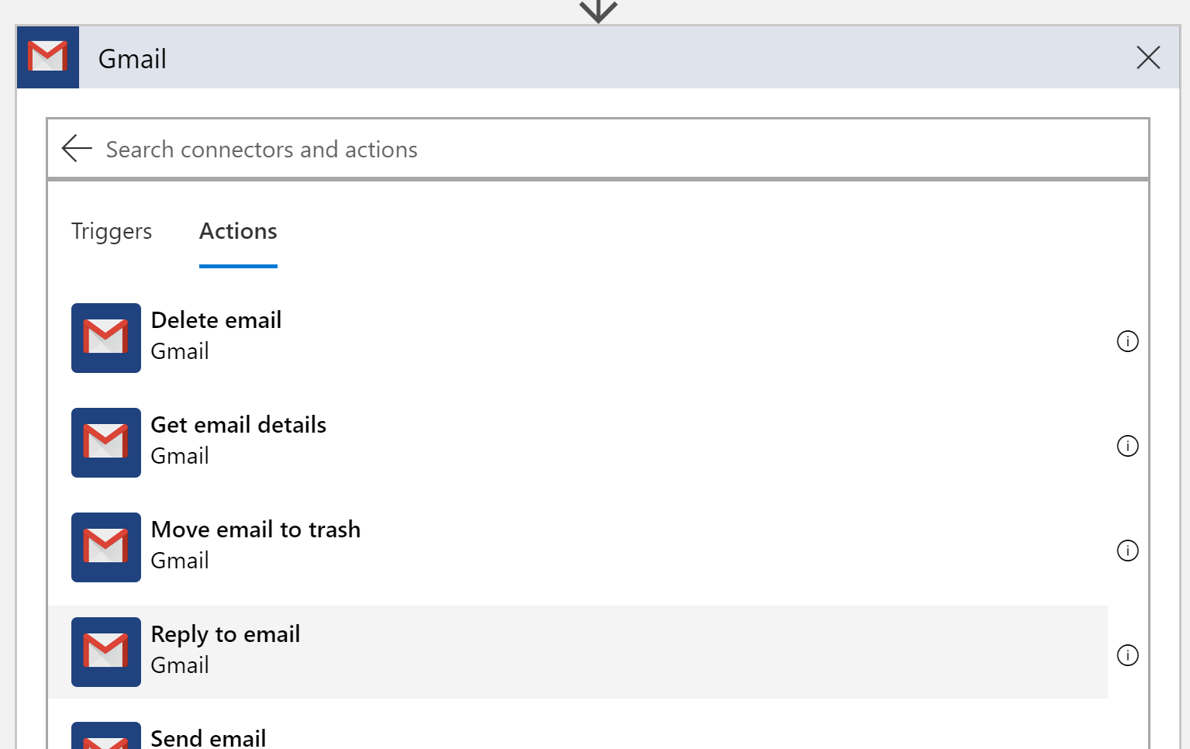

1. Specify the email address you want to use (**HINT**: set up an email rule to filter on the subject of the email), the subject line, and then add “Content” to the Body of the message

