*****BEFORE YOU DO ANYTHING, PULL THE NEWEST FROM THE REPO*****

How to connect to ‘DugsCodingDB’:

1. Go to your WAMP / XAMP / MAMP (whichever you are using) and open the menu and select phpMyAdmin. This will open the phpMyAdmin in your browser.

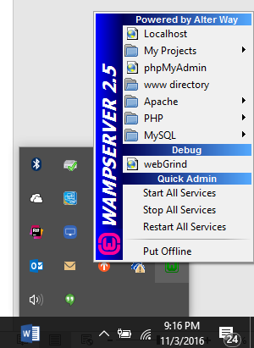

1. Once you are in phpMyAdmin, go to Import on the top nav row

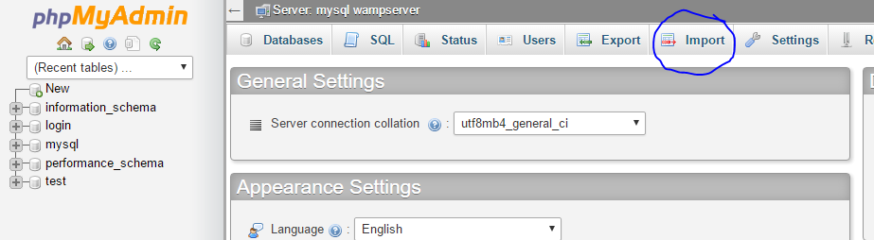

1. Click the “Choose File” button and navigate to the repo “db/dugscodingdb.sql” file and open. Next, click the “Go” button. **Boom database**.

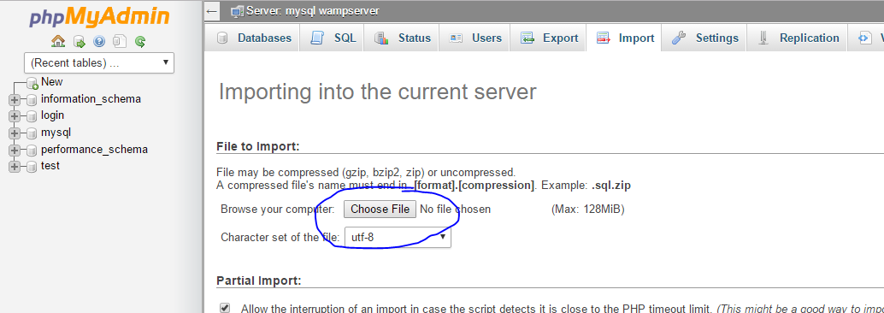

1. Go into the application now and test the Login using “testuser” and “testpassword” for the username/password combination. Then, try out the Sign Up. Go back into myPhpAdmin and check the table to see your newly inserted record.