Running Windows 10

<https://docs.rocket.chat/installation/community-supported-installation/windows-10-pro>

System Requirements:

• you have at least 4 GB of memory on your Windows 10 Pro machine

• you are running 64 bit edition of Windows 10 Pro

• you have the latest updates installed, and no updates pending

• you have enabled Hyper-V (requires a reboot, go to Control Panel -> Add Windows Components -> Hyper-V)

• you have at least 20 GB of disk space, preferably SSD

Installed Docker for Windows:

<https://docs.docker.com/docker-for-windows/>

Was prompted to install the WSL 2 Kernel update:

<https://docs.microsoft.com/en-us/windows/wsl/wsl2-kernel>

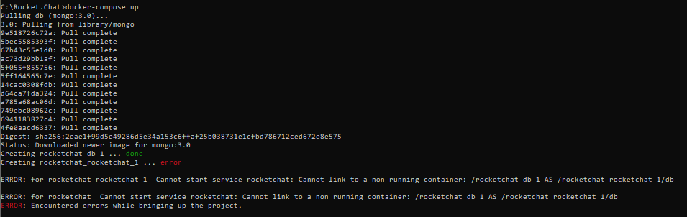ran into the following error after running docker-compose up (UNABLE TO RESOLVE)

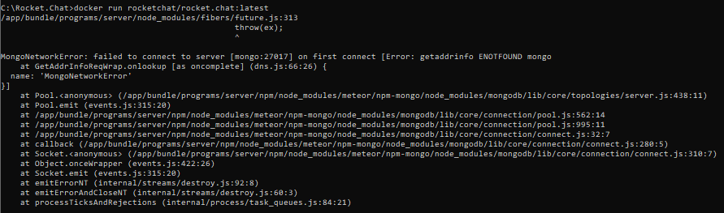

Reset Docker to factory settings

Decided to run sample yml file from <https://github.com/RocketChat/Rocket.Chat/blob/develop/docker-compose.yml>/<https://raw.githubusercontent.com/RocketChat/Rocket.Chat/develop/docker-compose.yml> instead, following:

<https://docs.rocket.chat/installation/docker-containers/docker-compose>

Was able to successfully access RC instance. Server Info:

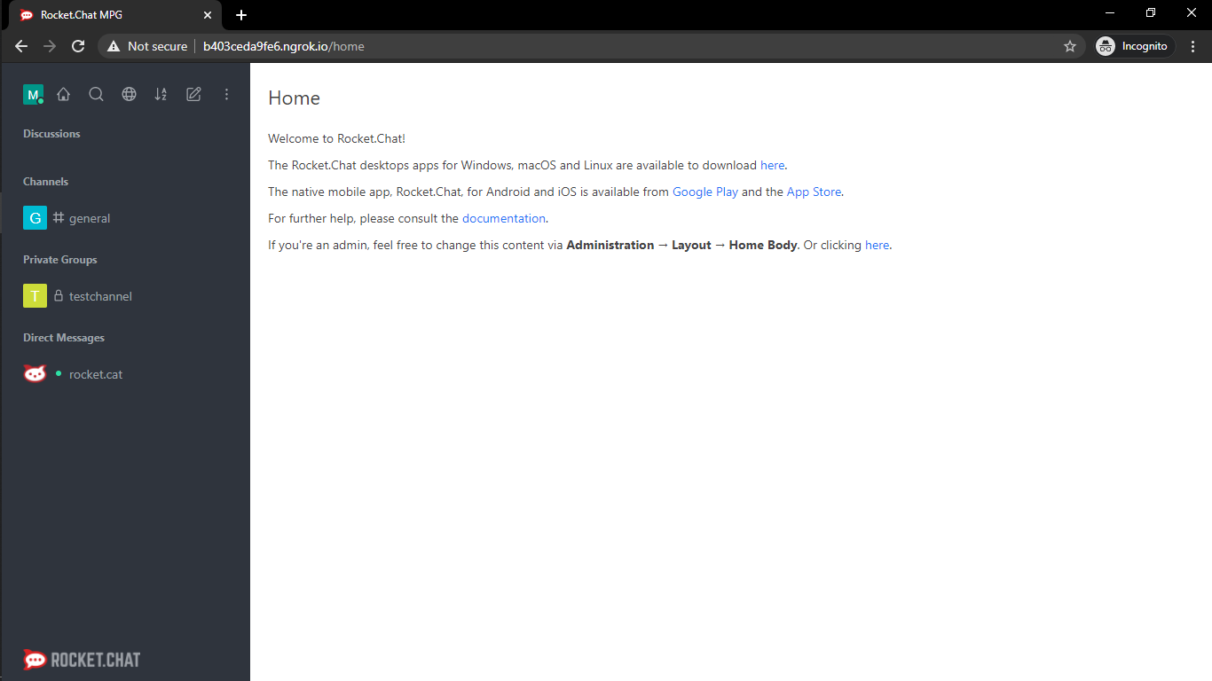Rocket.Chat MPG – <http://localhost:3000>

To enable accessibility outside of local:

Downloaded ngrok, followed documentation on <https://ngrok.com/docs> to enable forwarding (one-time deal, always expires within 07:59 hours)

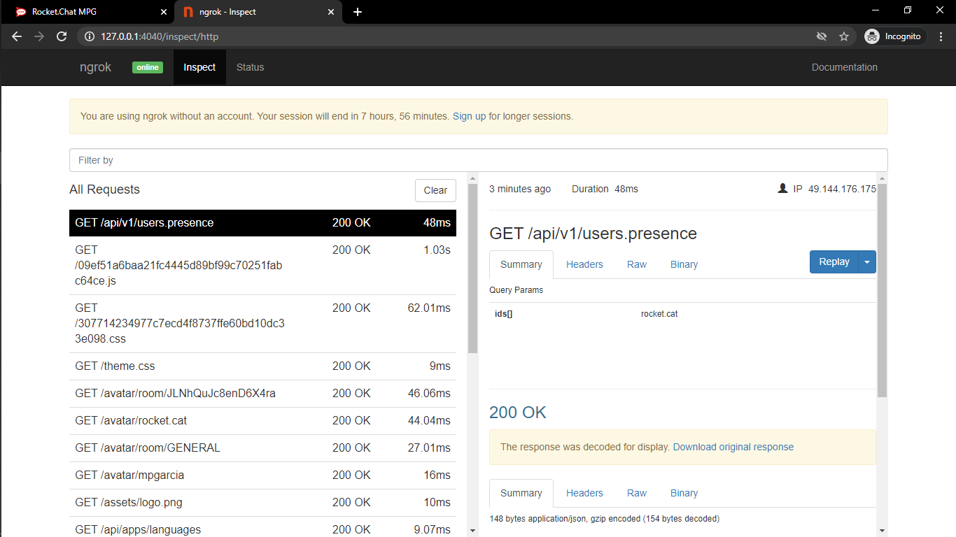

\*\*No more time to study how to execute item 1.b\*\*

API TASKS:

/api/v1/login?user=test1&password=12345

To get: x-auth token, x-auth ID

* Create a new user via an API endpoint - <https://docs.rocket.chat/api/rest-api/methods/users/create>

Unable to run using param keys, kept getting error:

{

"success": false,

"error": "Match error: Missing key 'email'"

}

Result: <https://drive.google.com/file/d/10mJUhjsWSd2iHeDfC0H3b4Xcp_yy8E6P/view?usp=sharing>

* Get the room information via an API endpoint - <https://docs.rocket.chat/api/rest-api/methods/rooms/info>

Get all rooms first to get: RoomName, RoomID

Result: <https://drive.google.com/file/d/1-FpE2dwIYJgTkq_aZXsbNInVmyIb9e3y/view?usp=sharing>

* Get a list of all user roles in the system via an API endpoint - <https://docs.rocket.chat/api/rest-api/methods/roles/list>

Result: <https://drive.google.com/file/d/1APtk_hFJ8REkRmjyvxHuJXih-37v78K1/view?usp=sharing>