

Formal Modeling of the ‘Via Verde’ system in VDM++

Diogo Vaz Nunes

Gabriel Cardoso Candal

Miguel Jorge Gonçalves Pereira

Mestrado Integrado em Engenharia Informática e Computação

Métodos Formais em Engenharia de Software

17/12/2014

Contents

1. Informal system description and list of requirements 3

1.1 Informal system description 3

1.2 List of requirements 3

2. Visual UML model 4

2.1 Use case model 4

2.3 Class model 4

3. Formal VDM++ model 5

3.1 Class ViaVerde 5

4. Model validation 5

4.1 Class MyTestCase 5

4.2 Class TestViaVerde 6

5. Model verification 6

5.1 Example of domain verification 6

5.2 Example of invariant verification 6

6. Conclusions 6

7. References 6

# 1. Informal system description and list of requirements

## 1.1 Informal system description

Via Verde facilitates the usage and payment of certain services through the attachment of a device to the front of a vehicle. Those services include highways, parking lots, gas stations and SCUT. For those vehicles not identified by a device, the system will record its usage anyway, so that the user can associate a device to that vehicle when he wishes.

## 1.2 List of requirements

|  |  |  |
| --- | --- | --- |
| **Id** | **Priority** | **Description** |
| R1 | Mandatory | Clients may register a Via Verde device for their vehicles. |
| R2 | Mandatory | Clients may unregister a Via Verde device from their previously registered vehicles. |
| R3 | Mandatory | Clients may change the credit card number associated to one of his Via Verde devices. |
| R4 | Mandatory | Clients may use the services provided by Via Verde, having a device or not. |
| R5 | Mandatory | Clients must be able to check the records for a given car. |
| R6 | Mandatory | The police must be able to retrieve a vehicle’s current location, if that vehicle is still in a park or in a highway. |

# 2. Visual UML model

## 2.1 Use case model

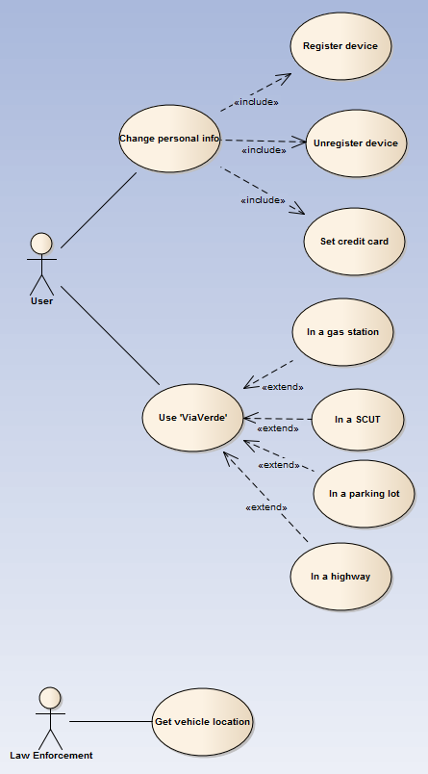

## 2.3 Class model

# 3. Formal VDM++ model

## 3.1 Class ViaVerde

# 4. Model validation

## 4.1 Class MyTestCase

**class** MyTestCase

/*

Superclass for test classes, simpler but more practical than VDMUnit`TestCase.

For proper use, you have to do: New -> Add VDM Library -> IO.

JPF, FEUP, MFES, 2014/15.

*/

**operations**

-- Simulates assertion checking by reducing it to pre-condition checking.

-- If 'arg' does not hold, a pre-condition violation will be signaled.

**protected** assertTrue: **bool** ==> ()

assertTrue(arg) ==

return

**pre** arg;

-- Simulates assertion checking by reducing it to post-condition checking.

-- If values are not equal, prints a message in the console and generates

-- a post-conditions violation.

**protected** assertEqual: ? * ? ==> ()

assertEqual(expected, actual) ==

if expected <> actual **then** (

IO`print("Actual value (");

IO`print(actual);

IO`print(") different from expected (");

IO`print(expected);

IO`println(")\n")

)

**post** expected = actual

**end** MyTestCase

## 4.2 Class TestViaVerde

# 5. Model verification

## 5.1 Domain verification

## 5.2 Invariant verification

# 6. Conclusions

# During the development of this project we have grown more familiar with formal methods for software development and in particular the VDM++ language, we are now capable of solving similar problems and learning similar languages/tools.

# About the project we can conclude that we have successfully fulfilled all of our specifications and we are overall satisfied with the results and the development process despite some problems caused by the lack of information about VDM++.

# In spite of this we believe that we could have broadened the scope of the project by making the modeling more in depth, and regarding the development process the group had some difficulties due to not doing the tests before the code. Regarding possible future extensions, modelling payment methods would be a possibility.

# 7. References

1. VDM-10 Language Manual, Peter Gorm Larsen et al, Overture Technical Report Series No. TR-001, March 2014
2. Formal Methods in Software Engineering course’s VDM++ handouts, Ana Paiva/João Pascoal Faria