Implied timescales vs. Number of clusters

Figure row – Implied timescale number
Figure column – Fixed lag time, 1 or 11

Black line – analytic solution from 32,000 state transition matrix from which trajectories were generated
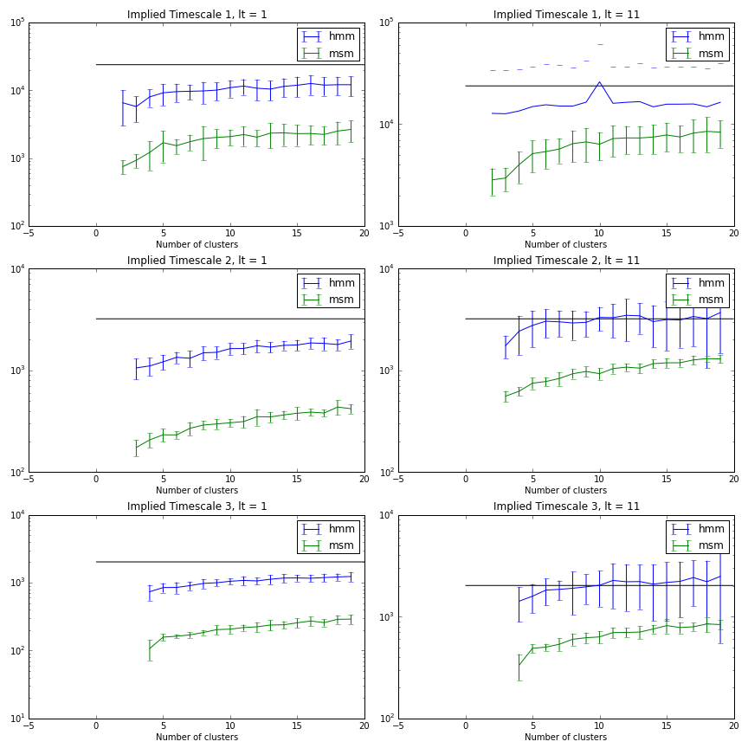

Implied timescales vs. Lag time

Figure row – Implied timescale number
Figure column – Fixed number of clusters, 5 or 11

Black line – analytic solution from 32,000 state transition matrix from which trajectories were generated
