Rooted in Anniston

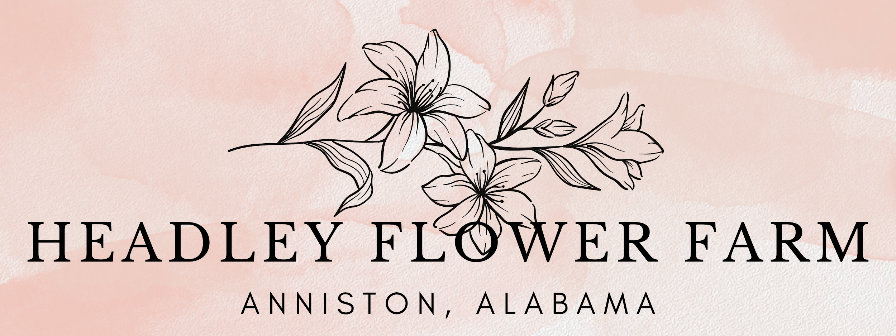
A Trailfront Partnership for Progress
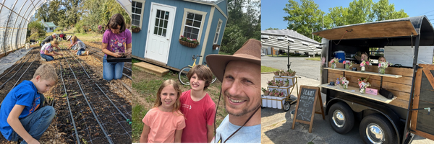 Rooted in Anniston. Growing for Good.

🌿 The Opportunity
Headley Flower Farm sits on over 500 feet of trail frontage along the Chief Ladiga Trail, behind Walmart and Tractor Supply.
What began as a small flower stand has become a community-driven hub—a place for beauty, safety, rest, and connection.
We now invite Mayor Ciara Smith into a shared effort to bring visibility, access, and vitality to this underutilized stretch of trail.
“We believe beauty belongs in every neighborhood—and that trails can be places where safety, small business, and hospitality come together.”

💛 Shared Goals
Mayor Smith's Priorities:
- ✅ Public safety and walkable visibility
- ✅ Equitable development that uplifts the underserved
- ✅ Economic activation without straining city budgets
- ✅ Smart, scalable housing innovation
Headley Farm’s Vision:
- 🌸 Hospitality for trail users at no public cost
- 🌱 Youth internships & restorative volunteer programming
- 🚲 Trailsider amenities: bike pump, rest station, signage
- 🏡 Tiny house pilot to support housing and trail goals

🛠️ What’s Already in Motion
- 🏕️ Trail Shop kiosk installed (launching May 2025)
- 🌼 Bloom Bar hospitality cart up and running
- 🌿 30+ ft of trail cleared; visibility improvements underway
- ⚡ Temporary generator power; Alabama Power service pending
- 🌉 Privately funded bridge planned to connect trail + Walmart side

📈 Strategic Trail Access Enhancements
Activating trail access from the Walmart side through a privately funded footbridge offers a timely, place-based opportunity to support the city’s growth—while solving multiple civic challenges at minimal cost.
🚀 Economic Momentum Is Already Underway:
- Starbucks at Summerall Subdivision: 40 new jobs, over $1M in projected sales
- Retail corridor expansion near Walmart and McClellan Blvd
- New housing and a 21-acre residential development at McClellan
- Cultural investment from Katt Williams’ film studio at the Starship buildings
North Anniston is one of the city’s most active zones—economically and culturally.
🧭 What’s Missing? People-First Connectivity
Our proposed bridge creates a direct, inviting link between this thriving district and the Chief Ladiga Trail. It opens a currently hidden stretch of the trail to walkers, cyclists, families and regional visitors.
And it activates it with beauty, rest, safety, and civic charm.
🪜 More Than a Footbridge—A Civic Gateway
This is more than infrastructure. It’s a gateway to Anniston’s next chapter:
- No city funding required
- Aligns with your economic narrative
- Demonstrates a model for public-private partnership
By linking Walmart, Starbucks, McClellan, and our trailfront, Anniston can offer a seamless experience from commerce to nature—powered by vision and shared investment.

⚖️ What We’re Asking For
- ✅ Alabama Power Access – help us secure permanent utility service
- ✅ City Guidance on Footbridge Logistics – so we build the right way
- ✅ Brush Clearing & Safety Support – to improve visibility and security
- ✅ Unified Trail Signage Alignment – Calhoun County is planning a regional signage strategy (per Audrey Maxwell)—we’d love to integrate

✨ The Bigger Picture
We envision the Trail Shop as an early model of trail-based revitalization—where agritourism, beauty, and local enterprise intersect.
With city and county alignment, it becomes a low-cost, high-trust prototype for community-led civic improvement.
Let’s solve each other’s problems.
Let’s lead with beauty and belonging.
Contact: Matt Headley
matt@headleyflowerfarm.com
@headleyflowerfarm | www.headleyflowerfarm.com


