Hi Toby,
Thanks again for your time and support. Following up on our conversation, I’d like to formally request assistance from the City of Anniston’s Public Works Department to help clear light brush, small undergrowth and any trees or branches along the section of the Chief Ladiga Trail adjacent to Headley Farm, to prepare for Alabama Power’s utility access and a future pedestrian connection to our property.
Here’s the scope of what we’re requesting:
  - Selective clearing only: We’re not asking for any large trees to be removed—only what is necessary for the power line to be safely installed. We’d like to retain as many existing trees as possible for ecological health and trail aesthetics.
  - Brush and privet removal: We do request the removal of invasive privet and low-lying brush along the trail-facing section of our farm, both to increase visibility and prepare for the next phase of infrastructure.
  - Pedestrian bridge access: We’d also like to request permission to construct a small pedestrian bridge from the Ladiga Trail onto our property to allow trail users to access our new Trail Shop, which will serve as a point of hospitality, local flowers, and trail-friendly commerce.
Location Overview:
This area runs along our western trail frontage, near the Walmart and Tractor Supply corridor. It falls within the former railroad right-of-way, now owned by the city, which includes a 50-foot buffer on either side of the trail.
To help clarify the exact location, I’ve included a survey drawing of our property and a photo of the location where right of way and brush removal is requested.
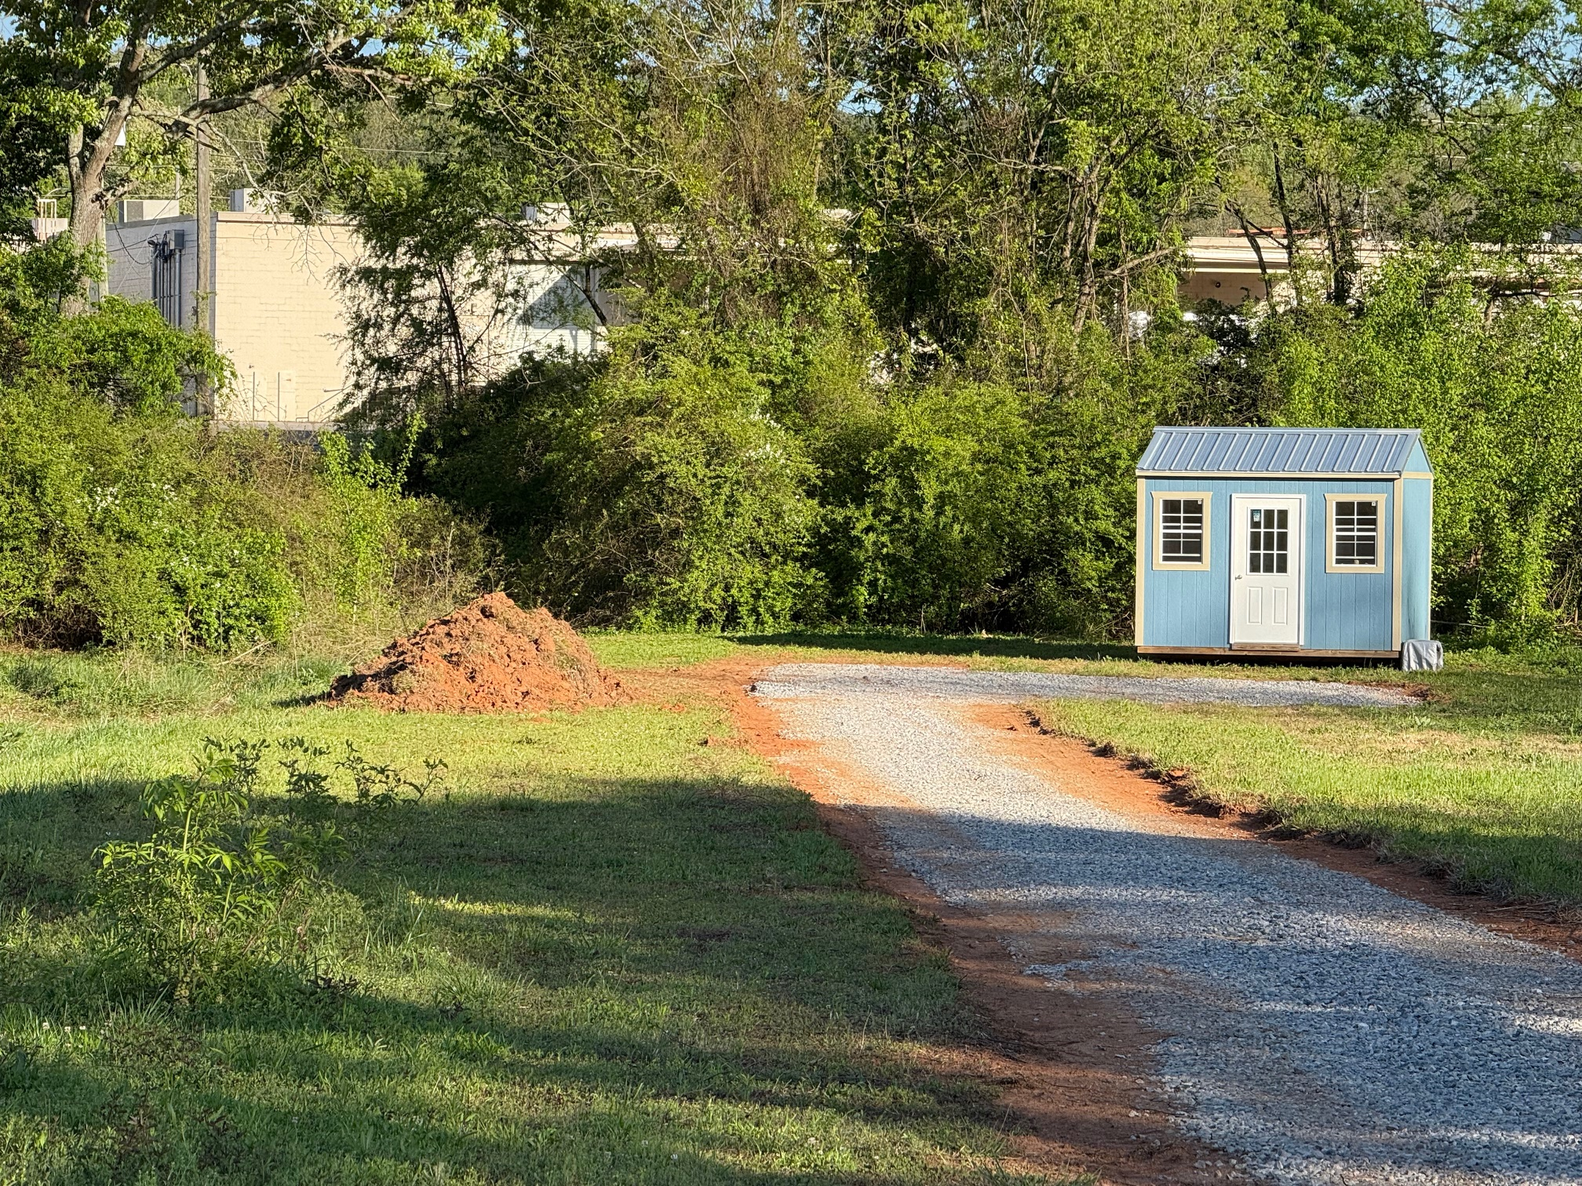

Survey of 5400 Ridgewood Ave:
https://drive.google.com/file/d/1053hR5H5FHyRAjEJ_Jqd7xGHqpUmVAnE/view?usp=drivesdk

Here is a Google map coordinate:
https://maps.app.goo.gl/FVM5ytaZ1nTFQPrL7?g_st=com.google.maps.preview.copy

Let me know if a site visit would be helpful, or if you need anything else to pass this on to Public Works. We’re eager to collaborate with the city on this as part of your broader Ladiga Trail goals—and grateful for your help as we build a community-rooted space at the intersection of nature, small business, and trail culture.
Thanks again for your time and partnership.
With gratitude,
Matt Headley
Headley Flower Farm
256-644-7334
www.headley.farm

