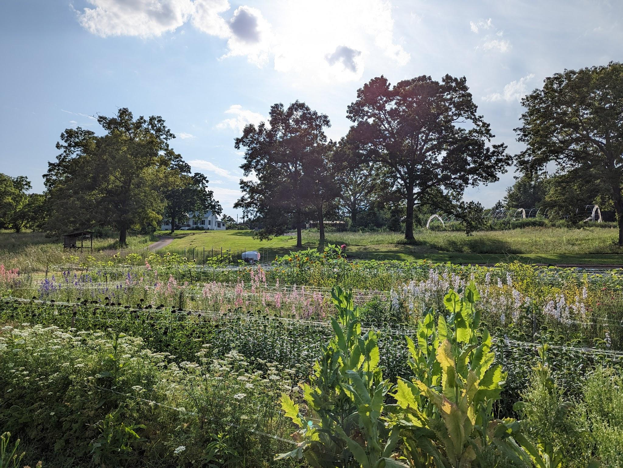
ReModel City & Wholehearted Roots: Fiscal Sponsorship Brief for Shannon Jenkins

Prepared for May 7 Coffee Conversation at Called Coffee

✨ Personal Note
Shannon, I want to begin by acknowledging our friendship and your support during my mental health journey this past year. As we near the one-year mark, I’m profoundly grateful for the role you played in helping me get here. This vision—and the health it grows from—wouldn’t exist without that season.

As I invite you to consider a professional partnership through United Way, I do so with reverence for the trust between us, and an awareness that this conversation bridges personal and public spheres. I’m open to your wisdom on how to navigate that well.

📚 Overview
Project: Wholehearted Roots at Headley Farm
Umbrella: ReModel City (emerging nonprofit framework)
Request: Fiscal sponsorship + potential seed funding partnership through United Way of East Central Alabama

📍 Location
5400 Ridgewood Ave, Anniston, AL – adjacent to Chief Ladiga Trail, Walmart, and Tractor Supply

🌿 What’s Emerging
- Public-facing Trail Shop offering flowers, rest, and connection
- Regular volunteer engagement (youth + adults)
- Nature-based healing, creative economy, and civic storytelling
- Vision for long-term public access, education, and hospitality

🏛️ Proposed Structure
Umbrella Nonprofit: ReModel City “ReModel City” is a play on Anniston’s historic identity as the “Model City.” This emerging nonprofit reimagines that vision—rooted in community healing, trail-connected development, and the revitalization of public spaces through story, service, and soil.

Flagship Program: Wholehearted Roots at Headley Farm Located on a working homestead and flower farm, Wholehearted Roots embodies the ethos of ReModel City: rooted beauty, restorative work, and relational infrastructure.

- Trail Shop
- Volunteer & Youth Engagement
- Healing Spaces
- Civic Partnerships

Emerging Initiatives:

- Boom Circle – core of sustaining supporters
- 3rd Saturday Market – monthly trail-side community day
- Trail Commons (future prayer/event space)
- Farm-acy Project (herbal + perennial wellness model)
- Youth Storytelling/Apprenticeship Cohort
- Community Workshops & Healing Hospitality – Seasonal experiences rooted in land, story, and sabbath rhythm, including grief support, flower-based ceremonies, permaculture trainings, and neighbor-to-neighbor care

🚀 Strategic Goals (2025–2027)
- Solidify trail-side operations
- Expand youth engagement pathways
- Formalize civic & community partnerships
- Develop event/prayer garden space adjacent to trail
- Pilot nature-based healing programming + local internship model

🛤️ Strategic Alignment: Rails-to-Trails Conservancy
ReModel City shares deep alignment with the mission of Rails-to-Trails Conservancy, particularly around:

- Reimagining trail-connected public spaces as centers of healing, culture, and belonging
- Building safe, beautiful environments for walking, biking, and being together outdoors
- Activating civic infrastructure near trails with youth programming, public art, and nature access

Wholehearted Roots at Headley Farm serves as a replicable pilot site that advances the Rails-to-Trails vision in rural Southern communities.

🚫 What We’re Not Asking For (Yet)
- Immediate funding commitment
- Formal nonprofit filing assistance
- High-touch administrative burden

✉️ What We Are Asking For
- Fiscal Sponsorship to accept tax-deductible donations + grants under United Way umbrella
- Seed Funding Possibility: modest support to launch public-facing programs (insurance, signage, volunteer stipends, ADA access)
- Strategic Input: guidance on growth, structure, and relationship-building with community partners

✂ Org Chart (Text Format)
ReModel City (Umbrella Nonprofit) └─ Wholehearted Roots at Headley Farm (Flagship Program) ├─ Trail Shop ├─ Volunteer & Youth Engagement ├─ Healing Spaces ├─ Civic Partnerships └─ Emerging Initiatives: │ ├─ Boom Circle │ ├─ 3rd Saturday Market │ ├─ Trail Commons (future) │ ├─ Farm-acy Project │ ├─ Youth Storytelling Cohort │ └─ Community Workshops & Healing Hospitality

🌈 How to Recreate the Org Chart (DIY)
Use Google Drawings or Canva:

- Create a central box: "ReModel City"
- Beneath, branch to "Wholehearted Roots"
- From there, add horizontal branches for each program
- Group emerging initiatives under a nested section
- Use lines/boxes with a consistent color scheme (greens, earth tones)
- Add icons for clarity (leaf, handshake, flower, book)

💬 Let’s Talk
I’m grateful for the chance to share this with you in person. I’m not looking for a transaction—I’m inviting a conversation. I trust you to speak with honesty and care.

With gratitude, Matt Headley [Phone] | [Email] | @headleyflowerfarm | headley.farm

