## Extracting the Project

Make sure the project is extracted into your **xampp/htdocs** folder. This allows you to access the project through your xampp program.

## Import the Database

There is a file in the root directory of the project named "dbmarkphilipp.sql". You can import this file into phpmyadmin.

To do this, open XAMPP and start apache and mySQL.

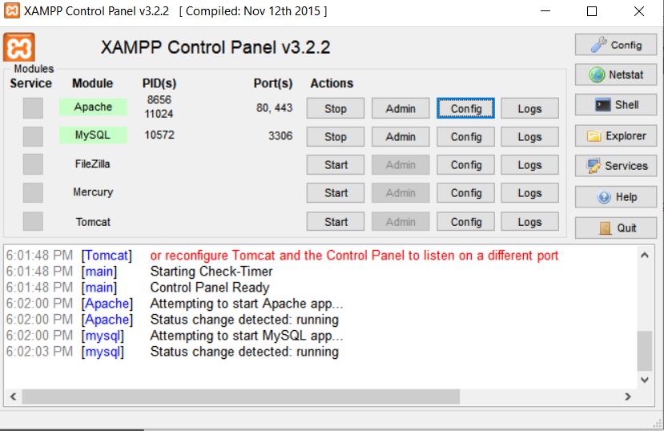

Then, in your browser, go to localhost. Once the page loads, click “phpMyAdmin” at the top-right

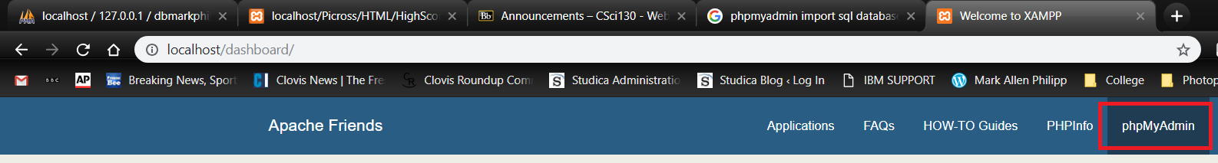

Once you’re in phpMyAdmin, you need to make a new database by clicking the “New” option on the left menu bar:

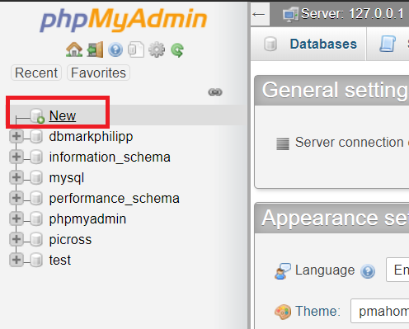

For the database name, put “dbmarkphilipp”. Leave the rest of the information default and click “Create”

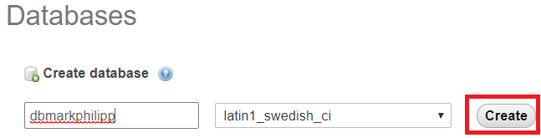

Once the DB is created, left-click on it in the left menu bar to make sure it’s selected. Once it’s selected, choose “Import” from the tabs across the top of the page:

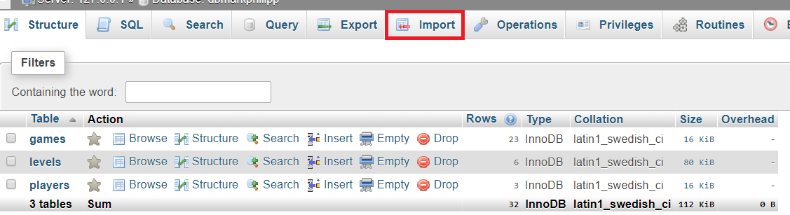

On the import page, click “Choose File” and select the “dbmarkphilipp.sql” file from the root directory of the project.

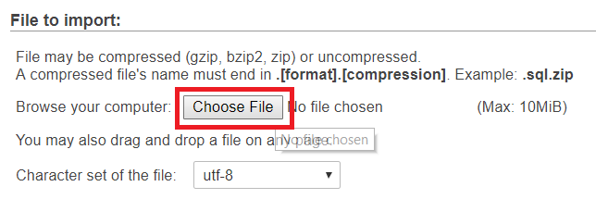

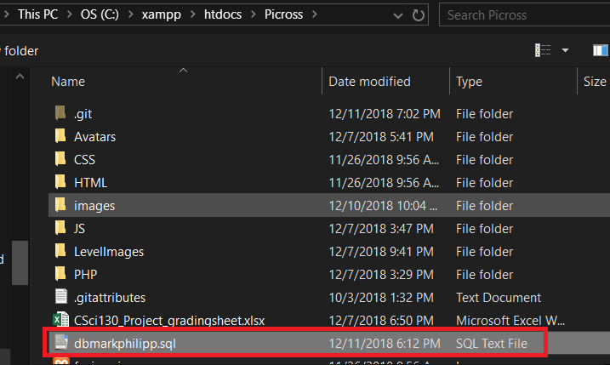

Leave all the other settings default and scroll down and click “Go”. This will run an SQL query that populates the dbmarkphilipp database.

## Setting up the User

I created all the code under the assumption the username is csci130 and password is 123456, as per your instructions. However, my code also assumes the user is associated with the server named “localhost”

If the user csci130 is not part of the server “localhost”, then you’ll need to create this user. To do this, make sure phpMyAdmin is open and left-click “dbmarkphilipp” from the left menu.

Once the database is selected, click the “privileges” tab at the top of the page.



On this page, scroll down and choose “Add user account”

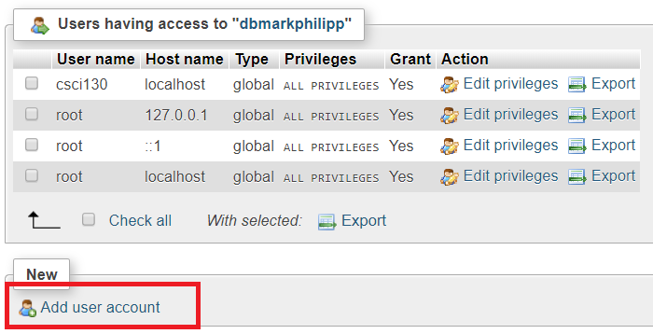

On the new user account page, use username **csci130** and password **123456**

For “Host Name”, put “localhost”

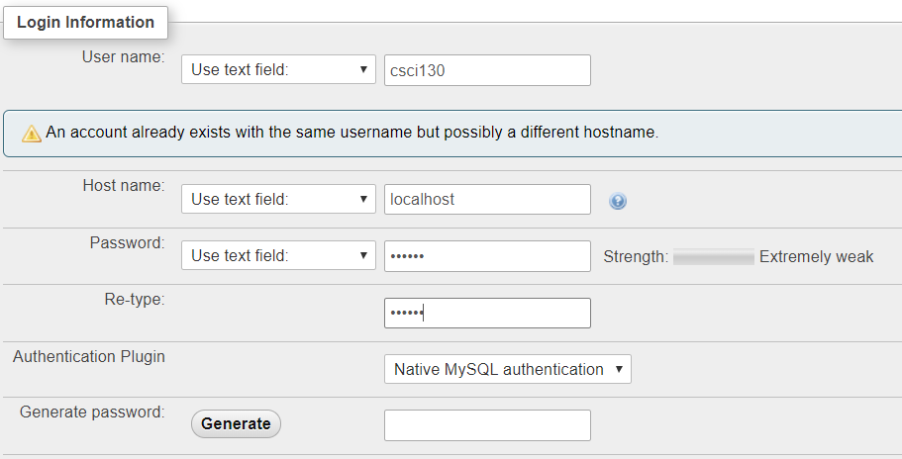

Scroll down and setup the permissions as follows:

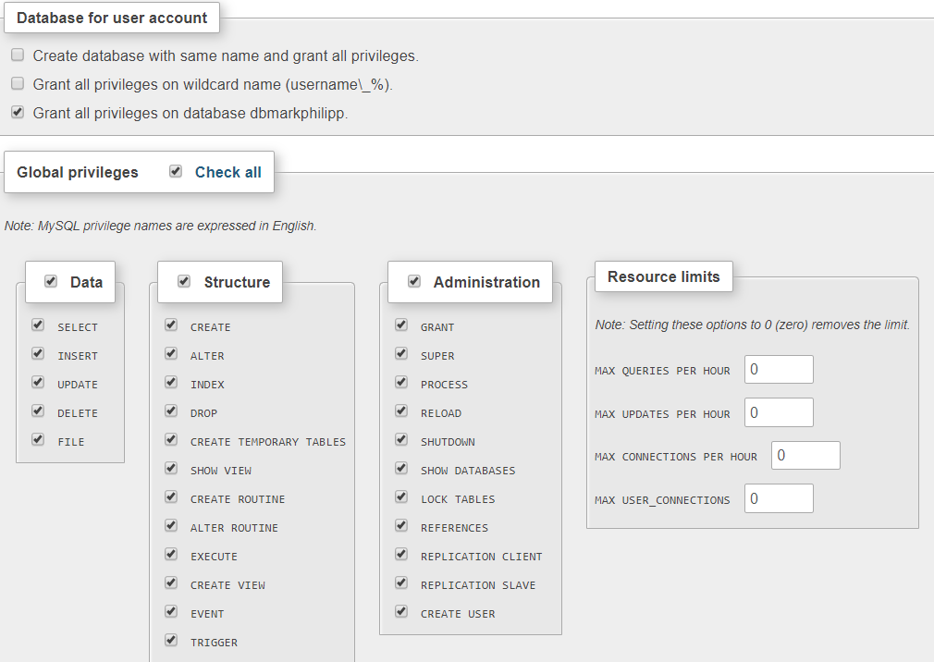

Scroll down and choose “Go” and the user will be created.

## Running the Site

Now that everything is ready to use, open your browser and navigate to **localhost/MarkPhilippPicross/HTML/Main.html**

You should now be good to go.