Retail Opportunity Inference from Nearby Cities

IBM Data Science Professional Certificate Capstone Project

Mitch Phillips

Introduction/ Business Problem

Across the country the retail landscape is constantly changing. Factors like consumer trends, neighborhood revitalization, and even demographic migration inform the success of different types of businesses in a particular neighborhood. We want to determine under-represented retail categories which would potentially succeed in a changing neighborhood. There are several key players in retail that would benefit from this insight. Property managers like to know what types of businesses would be wise for renting their space. Entrepreneurs with an eye on a particular neighborhood may want to know what retail void could be filled. Existing business owners seeking to expand their offerings may look to these insights as well. We will attempt to determine the under-represented retail categories for Church Hill, a neighborhood in Richmond, VA. This is a good neighborhood because it is in the early stages of revitalization. It’s also in a city that sits right in the middle of the state surrounded by several similar cities.

We can’t assume the current retail categories present in Church Hill represent the entirety of local customers’ wants. Often it is the case that consumers don’t know what they want. The problem property managers, entrepreneurs, and existing business owners face is looking beyond their neighborhood for deeper insight into what may be successful. This problem is commonly addressed in a limited way by exchanging information with people in nearby cities with similar markets. This process is cumbersome because it’s difficult to network beyond one’s city and it’s flawed because it relies too much on human perspective which is prone to bias.

To address the challenges of looking beyond Church Hill, we will compile and analyze retail category and location data from neighborhoods in nearby cities. Based on the category data, we will use clustering to determine which neighborhoods we may consider to be similar markets to Church Hill. Then we will generate a ranked list of retail categories present in those similar, nearby neighborhoods which are under-represented from Church Hill. It is important to note we make the assumption consumers in similar, nearby neighborhoods will behave similarly. Based on this assumption, our ranked list will tell us what retail categories have a high likelihood of success in Church Hill.

Data

Retail data will come from Foursquare’s Places API which maintains global point of interest data. We can retrieve a database of retail locations within a certain radius from a location given by latitude and longitude coordinates. I’ve determined that the center of Church Hill is (37.533310,-77.415351) with a radius of 700 meters. Below you can see what the first few rows of the database looks like for retail data in Church Hill. I’ve also mapped the retail locations and ranked the categories by count.

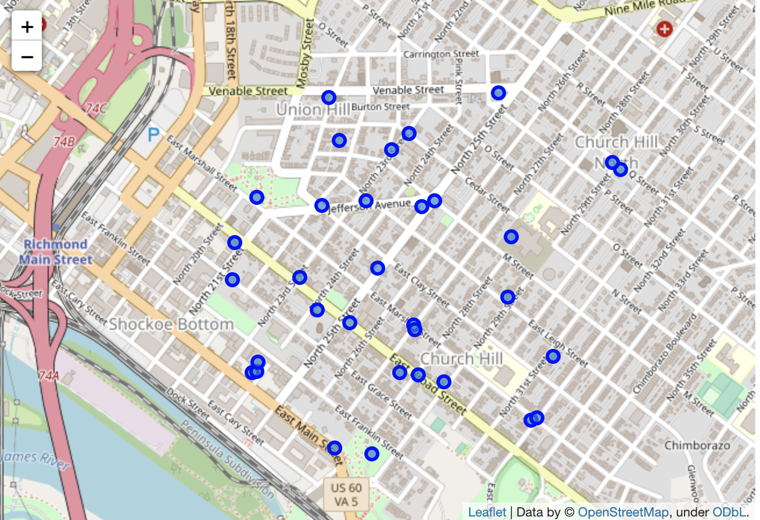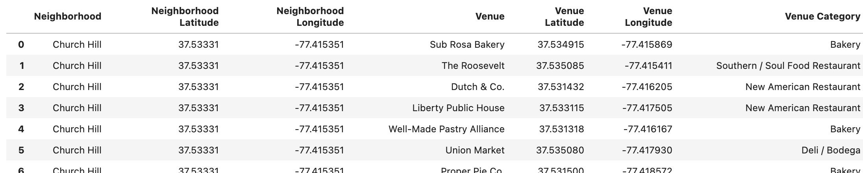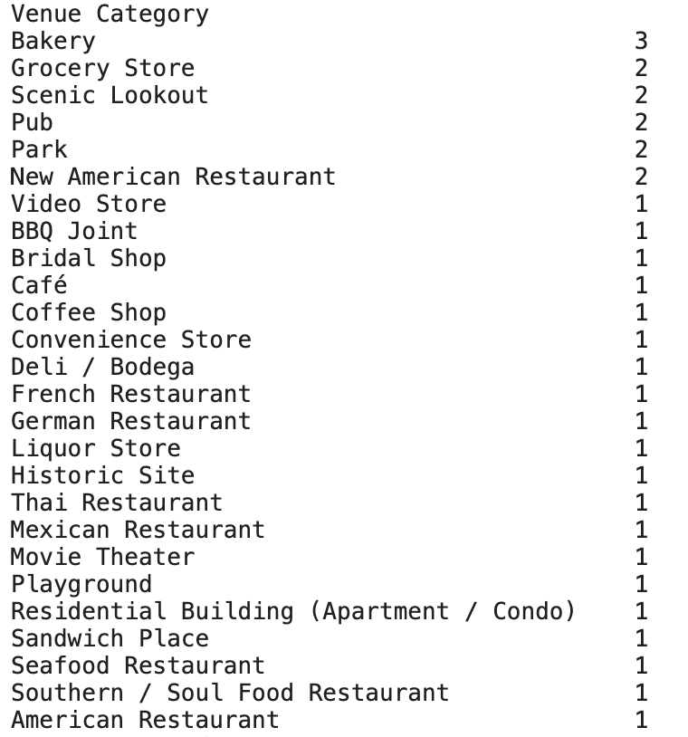

We will do that same thing for all the neighborhoods of several nearby cities such as Norfolk, Chesapeake, Virginia Beach, Fredericksburg, Fairfax, Washington, Baltimore, Durham, Raleigh, and Greensboro.

Mention foursuare geocoding doesnt work, switch to google cloud api.