# **Team Captain**

## Manel Phiseme

# **Team Name**

## Ministry of MongoDB

***The name Ministry of MongoDB is a play on words from the Harry Potter the Ministry of Magic. To keep the Harry Potter theme going the Ministry of Magic was blended with the database that is being used MongoDB. Thus, the Ministry of MongoDB was created.***

# **Mascot**

## Flying Mongoose

***To accompany the Wizarding World theme and the MongoDB database, the honorable and mighty Mongoose was chosen as the Team Mascot. To make it more magical this Mongoose can fly.***

# **Team Member Bio (minimum of 150 words per person)**

|  |  |
| --- | --- |
| **Manel Phiseme** | Hello, welcome to my portfolio. My name is Manel Phiseme. I am currently pursuing both an Associate degree in Front-End Web Development at Metropolitan Community college and a Bachelor degree in Web Development at Bellevue University. I have a passion for building websites. I am currently running two websites using WordPress. I used my skills in HTML and CSS3 coding on both websites. At the early stage of my education, I had the opportunity to be an intern at a well-known company, Gallup. There, my coding skills were put the uses by testing software codes.  After I earn my degree in Web Development, I have many ventures in mind. First, I will aim to secure a job as a web developer. Second, I will further my education in the field. While doing all that I plan to do freelancing works on the side, building websites. Alone with WordPress, HTML and CSS3 skills I also have skills in Java and photoshop. Please feel free to explore my portfolio. If you have any questions or need my experience and skills, please don’t hesitate to contact me. |
| **Andres Macias** | I am currently attending a full-stack web developer program offered by Bellevue University. I enjoy designing websites using Adobe XD and then building them using VSCode. When I am not building websites, I am playing music on my keyboard to my cat daisy or when I feel adventurous, I go out kayaking in the surrounding lakes. When I am not playing with my cats, I do enjoy watching movies and getting caught up on my gaming.  For my development experience I have created several websites with WordPress, creating brochure websites using HTML and CSS. I have developed dynamic websites using JavaScript. I have recently been exploring the MEAN development stack and will have projects to show for 2023.  Reach out to me if you would like to know more about my current work and for future development opportunities. I can be reached through my personal email that can be found on my portfolio page and GitHub account. |
| **William Watlington** | I'm a web developer fortunate enough to be a student in Bellevue University's web development program. I'm passionate about learning how to do new things and doing them well. I also love the meeting of logic and design that can be found in web development, whether it be in designing a stylesheet for a new site or taking on a complex project to improve a site's capabilities.  I currently work in electronic resources at Blue Ridge Regional Library in Virginia where I am leading a redesign of the organization’s website. I also assist in IT software assistance for staff and assist patrons with technological needs.  I have worked with HTML/CSS, JavaScript, Python, PHP, and C# as well as with the Unity game design engine, MongoDB databases, and Flask micro framework.  When I'm not coding or studying, you'll usually find me enjoying auto racing, classic video games or hanging out at my local comic book shop. |

# **Goals of the website**

* allows customers to browse their in-store book listing.
* allow customers to add books to a wish list.
* allow customers to view their wish list.
* show a listing of books by genre.
* show a listing of books by author.
* search for book by title.
* search for book by bookId.
* the interface must be as simplistic as possible.

# **Core Users**

* Middle-aged users with minimal computer experience.

# **Personas**

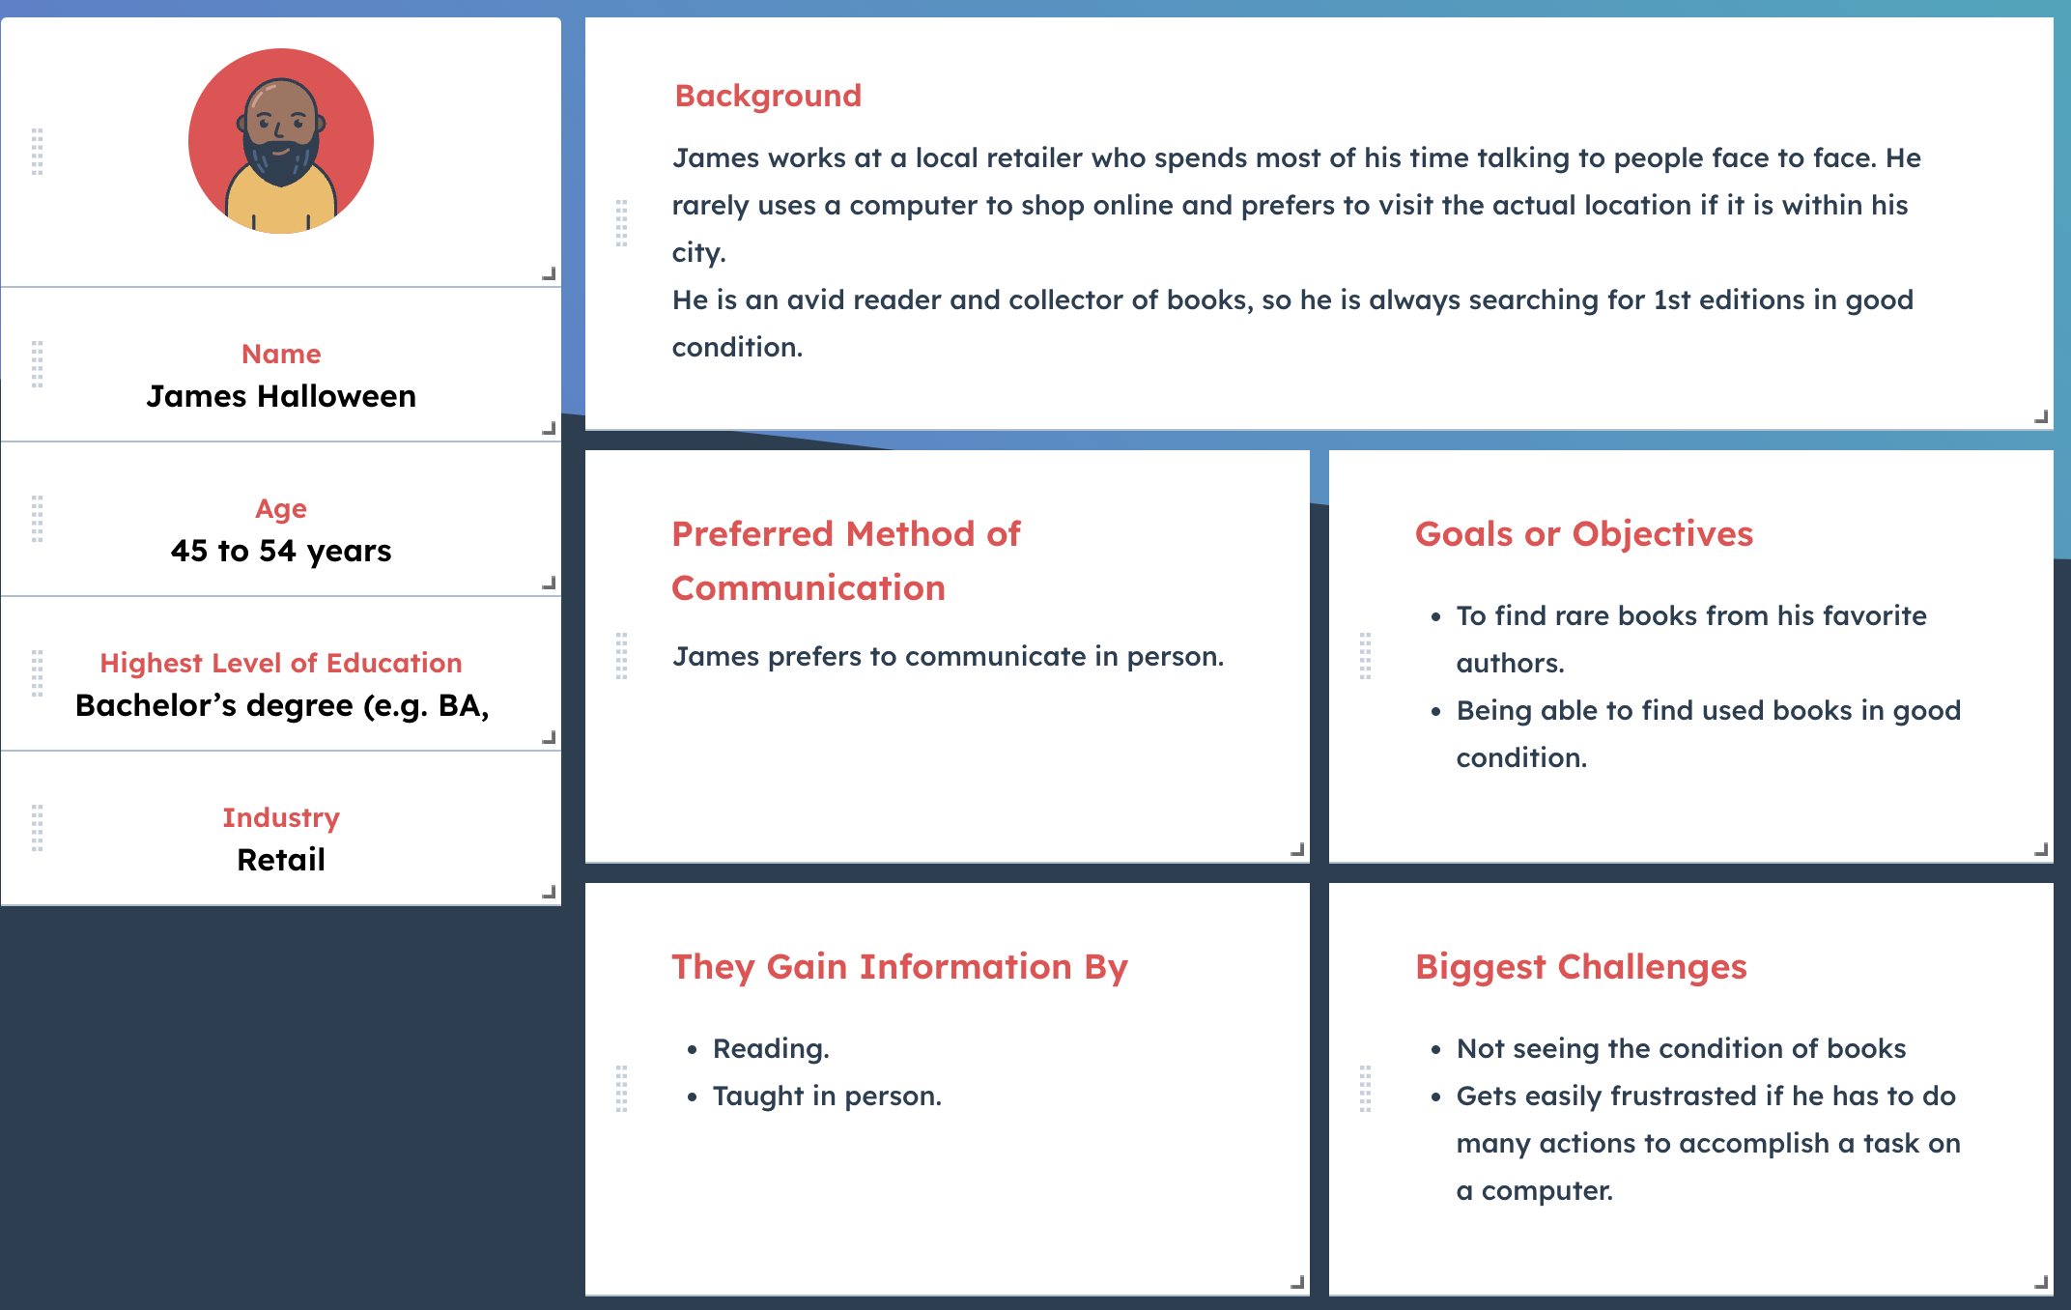

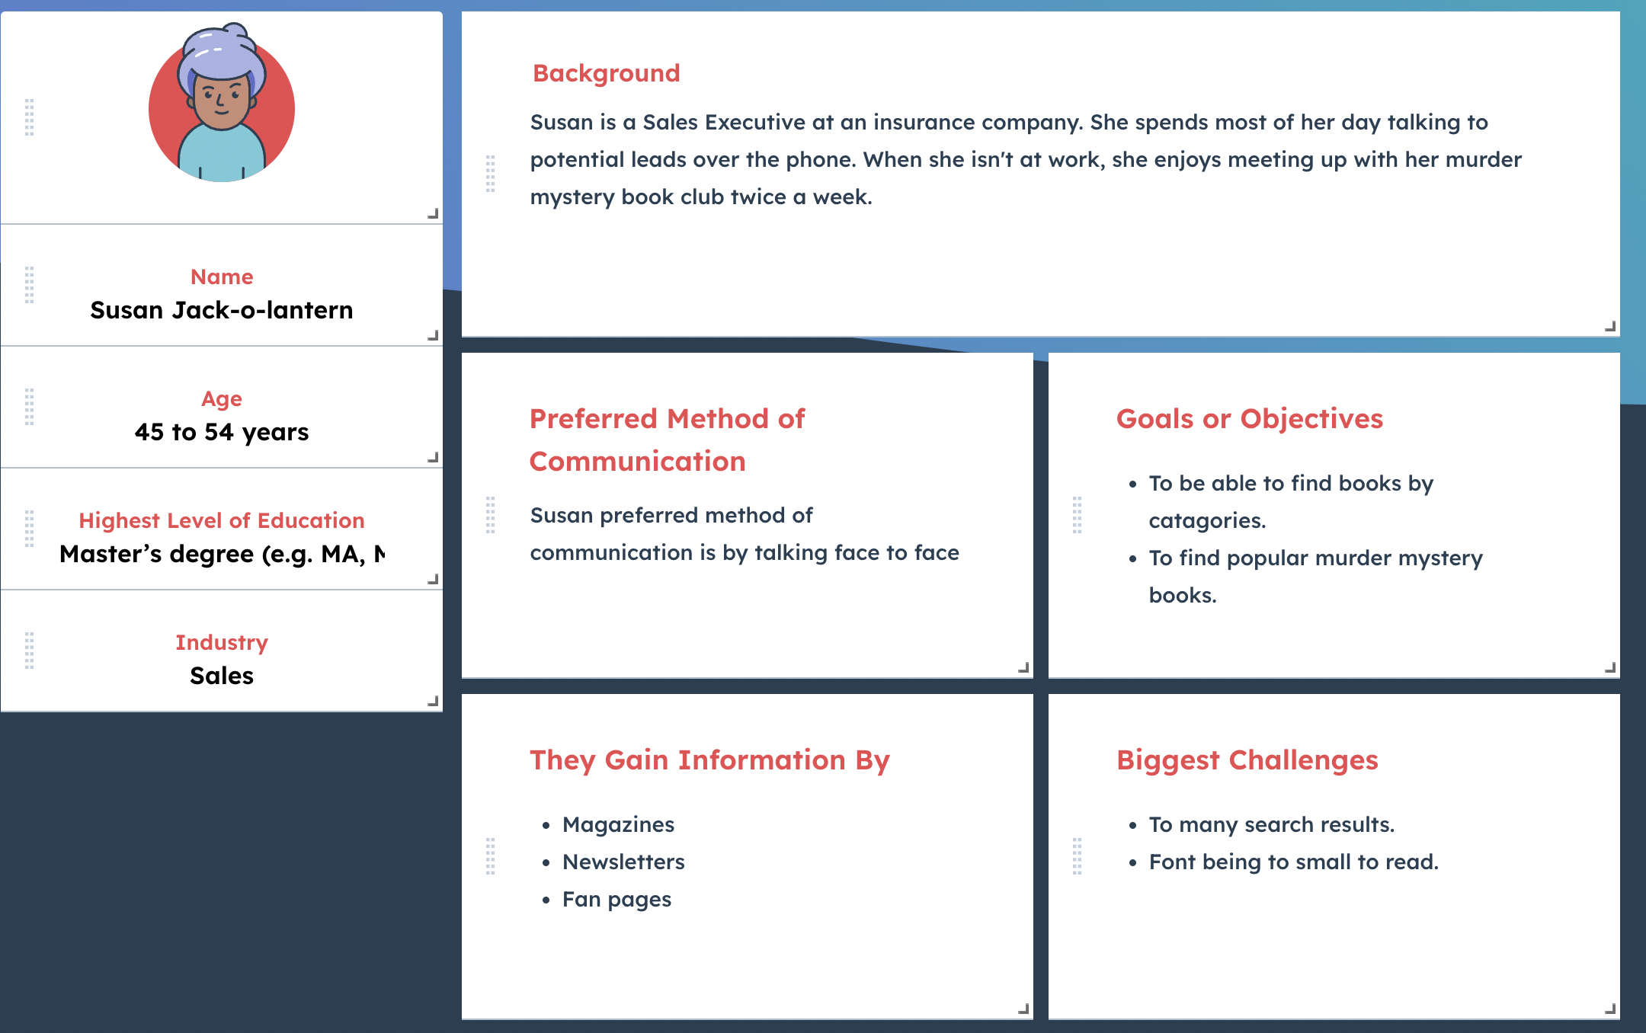

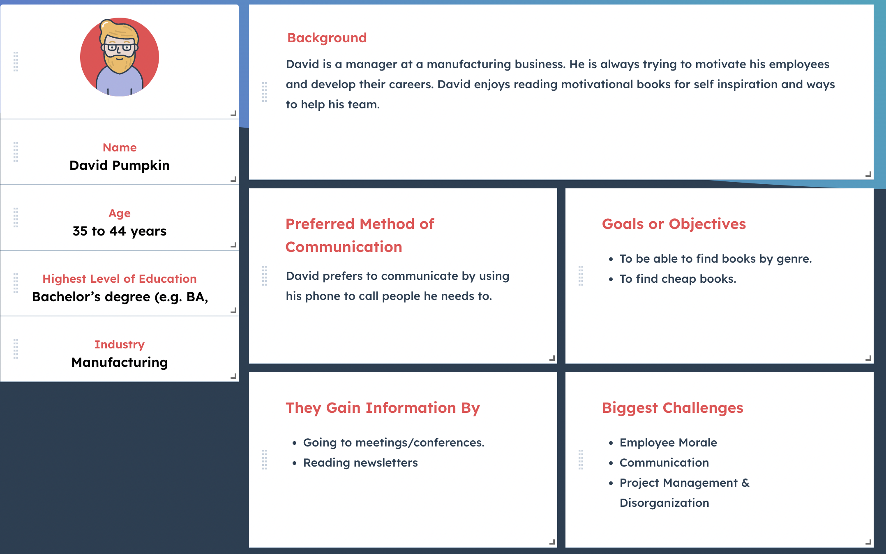

# **User Stories**

|  |  |
| --- | --- |
| **James Halloween** | |
| As a customer, I want to be able to search for books with the least number of actions. | 13 |
| As a customer, I want to be able to search for books by author name. | 2 |
| As a customer, I want to be able to filter by book condition. | 3 |
| As a customer, I want to be able to be able to pick up my purchase at the store. | 377 |
| As a customer, I want the interface to be simple and easy to navigate. | 144 |
| **Susan Jack-o-Lantern** | |
| As a customer, I want to be able to sort search results by popularity. | 233 |
| As a customer, I want to be able to filter books by genre. | 1 |
| As a customer, I want the interface to have easy-to-read text. | 8 |
| As a customer, I want to be able to limit the number of search results displayed. | 0 |
| As a customer, I want to be able to learn about new book releases via newsletter. | 89 |
| **David Pumpkin** | |
| As a customer, I want to be able to sort search results by price. | 1 |
| As a customer, I want to be able to view books by genre. | 5 |
| As a customer, I want to be able to search for books by key word searches. | 34 |
| As a customer, I want to be able to search for books by author. | 21 |
| As a customer, I want to be able to view motivational books as a genre. | 55 |

# **Business Rules**

1. WhatABook has many BOOK(s).

2. a CUSTOMER can add many BOOK(s) to their WISHLIST

3. a CUSTOMER can have many WISHLIST BOOK(s).

4. WhatABook has many CUSTOMER(s)

# **Database Diagrams**

## **ORD**

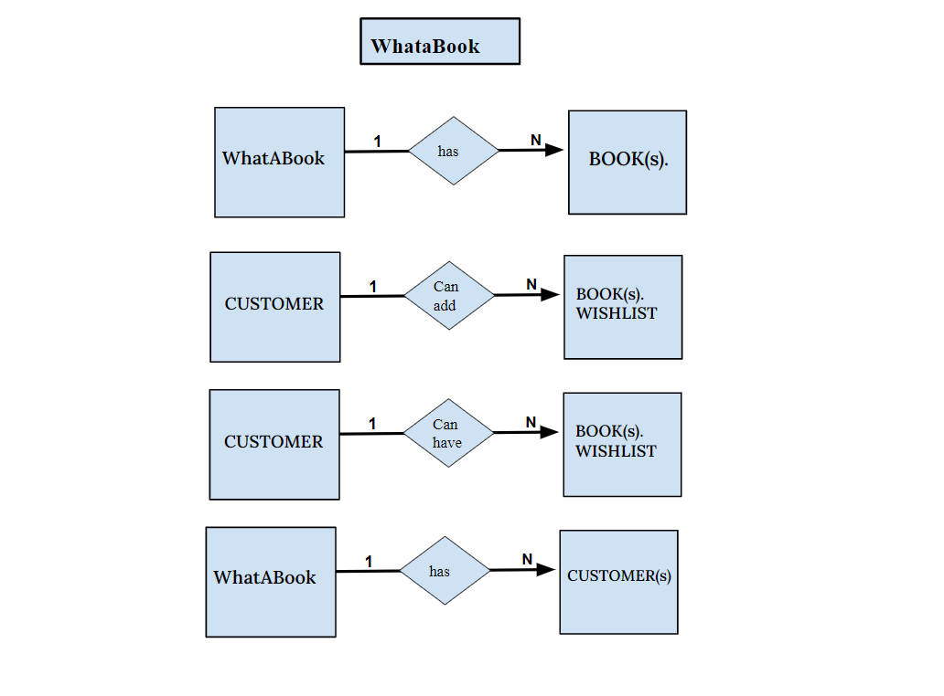

## **NoSQL Data Structure**

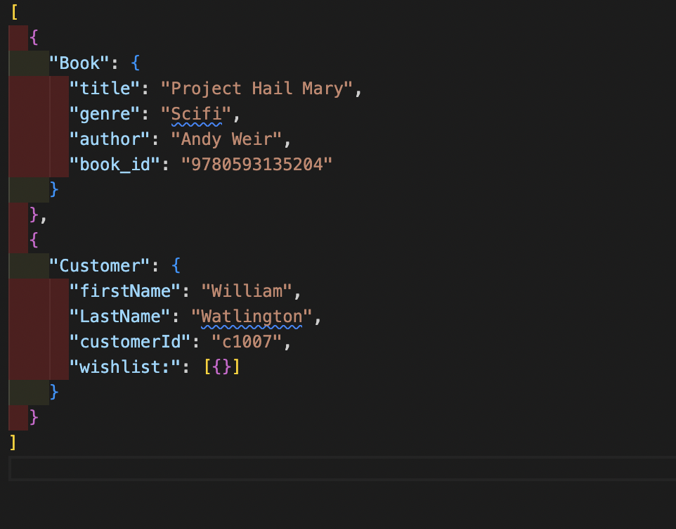

# 

# **Functional Prototype**

Adobe XD Link: <https://xd.adobe.com/view/d8cc3663-0445-43f5-acde-da298eeb344e-8d9f/>

