Organ shrinking instructions

All scripts in registration-pipeline/organ_shrinking

Segment organ in itk-snap

Get roi boinds of of lael with some padding > 5 voxels manually save coordinates in text file in directory

Save label → full_label.nrrd

Extract mask

Get data using:
$ipython
> import SimpleITK as sitk
> import numpy as np
> im = sitk.ReadImage('full_label.nrrd')
> arr = sitk.GetArrayFromImage(im)

or use impy.sh
$impy.sh full_label.nrrd (which will give you variables arr & im)**

> arr_roi = arr[z:z, y:y, x:x]
> img_roi = sitk.GetImageFromArray(arr_roi)
> sitk.WriteImage(img_roi, 'label_roi.nrrd')

** To use put impy.sh and ipyread.py into your path (these files are in sig/temp/ for now)

Run hill climbing algorithm

$hill_climber_c_run.py - This imports and runs the cyton c extension module
hill_climber_c_run.py label_roi.nrrd jac_value<float> output_dir number_of_generations<int>(up to 1M)

Below is an example of 1000000 generations on an adrenal gland

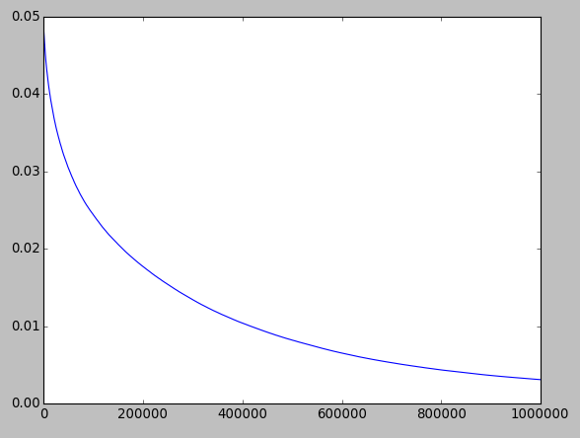

If run is not finished you can look at the current state in output_dir/intermediate_results

Put jac_1.nrrd in VPV to check if it looks OK

Check to see if near convergence

$mlplot.py /output_dir/chart_data.txt

When finished, we get jac_1.nrrd and def_1.nrrd in output_dir

Apply the resulting deformation field to image

$apply_def_field_to_image.py

Variables need to be set at the top of the file

- shrunk_array_dims -> roi bounds saved during creation of label
- image_to_warp_path -> The image you want to warp
- def_roi_path -> the output from the hill climber (def_1.nrrd)
- warp_out -> Where to put the warped image
- def_field_out_path -> where to put the ROI deformation field. Useful for viewing in vv (needs to have .mhd extension for vv)
- roi_mask_path -> path to the orginal roi mask (needed for masking out the vectors)

Modification of the hill_climber script

Make your changes to hill_climber_c.pyx
Then run:
python setup_hill_climber.py build_ext –inplace

Which generates the c code, which is imported by hill_climber_c_run.py

