# Table of Contents

1. Overview

2. Workflow

3. Glossary

4. Status Table

# 1. iMITS Overview

iMITS coordinates the production of mutant mice for high-throughput production pipelines to minimize overlap and maximize efficiencies. iMITS captures the intention of a particular consortium to produce mutant mice on a particular gene, the progress of mouse production and the progress of modified allele creation on the original mouse (leading up to the capture of phenotype data on the mouse).

iMITs serves mouse production facilities from around the world as part of its funded mission to support the KOMP2 project- a NIH Common fund project to generate and phenotype 2500 knockout mouse strains in the next five years (1U54HG006370). Mouse production and phenotype centers in the KOMP2 project are required to track mouse production through iMITS to minimize overlap and maximize efficiencies. KOMP2 production is coordinated with other mouse production centers through participation in the International Mouse Phenotyping Consortium (IMPC) whose goal is to generate a knockout mouse strain for every protein-coding gene in the mouse genome in the next 10 years. To ensure a common genetic background, IMPC partners use the targeted ES cells generated by the International Knockout Mouse consortium (IKMC). The majority of IMPC production centers use iMITs to track production to help prevent duplicate strain production and identify how their progress compares to other centers.

The information in iMITS is provided by each individual production center/consortia through the iMITS graphical interface. This is a trust system- iMITS does not have access to a center’s laboratory management system and thus cannot double check entries. Therefore it’s crucial that personnel entering in the information understand how the interfaces work. In this document we will provide a step-by-step guide. A glossary explains unique terms and a Status Table explains what is meant when iMITS assigns a status to a particular field.

2. WORKFLOW

iMITS warning

Assigned status

Withdrawn

Inactive

Deleted

ES QC started

Pass QC?

Prod. center

decision

continue

stop

no, final attempt

yes

Register Interest in a Gene(s)

Register MI

MI aborted

yes

Register PA

Rederiv. started

Cre exc. started

yes

no

Chimeras?

Genotype

confirmed?

yes

no, give up this attempt

Rederiv.

complete?

PA aborted

Cre exc.

complete?

Conflict?

no, give up this attempt

no, give up this attempt

Phenotyping

yes

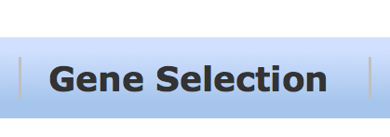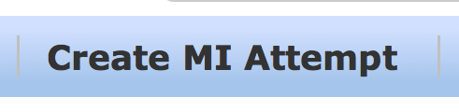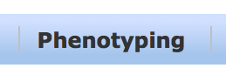

Data wranglers at Harwell set

phenotyping status

yes

no

yes

*optional*

*optional*

**Figure 1.**

* Workflow for iMits users from registering an interest to a gene to the entering of a mouse strain into a phenotyping pipeline.
* Dashed boxes indicate what iMits module(s) are used to enter in information.
* MI= microinjection,
* PA= phenotype attempt.

Founders & F1?

ES Cell

Injection

yes

no

no

Cas9/Crispr

Injection

no

yes

Modify Allele

Abandon

Gene?

## 

## 2A. Gene Selection: Selecting a gene for Mouse Production.

Users acting on behalf of consortia select genes for mouse production. Users will be alerted if mouse strains with targeted mutations of this gene are in production or have been produced/phenotyped by other IMPC partners. The process works in the following manner:

Users create a plan for the gene(s) of interest. When a plan is created, iMITS will check whether any other consortia have plans (or mice) for the gene. If not, the plan will be immediately put in status “Assigned”. If there are other existing plans or mice, iMITS will put the plan in status “Inspect – Conflict” or “Inspect – MI Attempt” or “Inspect – GLT Mice” depending on the known products.

Conflict statuses do not preclude the centre from actually acting (starting ES-QC or starting mouse production – see below). If the centre does start activity, the plan will be changed by iMITS to have status “Assigned – ES QC in progress” etc.

**NOTE: iMits’ role is not to stop production centres from creating duplicate mouse strains but rather to inform production centres of similar efforts so they may make informed decisions. Duplicate strain production is to be minimized under the KOMP2 funding mechanism.**

1. Select Gene(s) of interest. Here I have selected 1110002L01Rik and filled in the Consortium and Production Centre and Priority drop-downs.

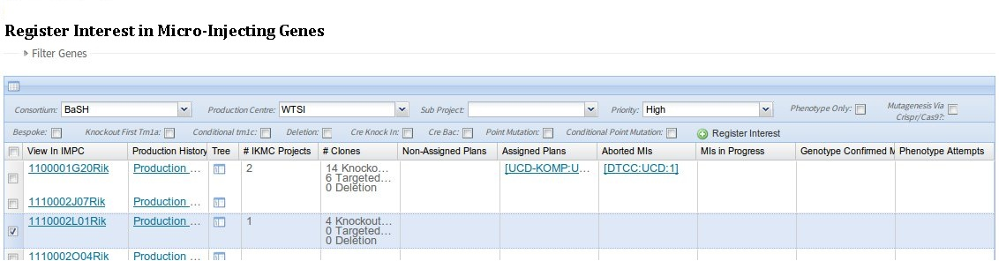

Figure 2. Registering interest in a Micro-Injecting genes

2. Push the “Register Interest” button. That should create the plan. In this case the plan has been *Assigned*, because there were no other competing plans or production.

3. Edit the plan – if necessary – to specify what kind of allele you are intending to make. Clicking on the plan will bring up the plan edit page. This page has a section that allows the user to select an allele type. (Figure 3) This is very useful if you want to distinguish intent – for instance if you want to make it clear to other users that you intend to make a Knockout First Tm1a allele (or a Cre-Knockin). In the following I’ve checked the ‘Knockout First Tm1a’ box to make it clear for reporting purposes that I am going to make a Knockout First Tm1a (in case there are any deletion clones around).

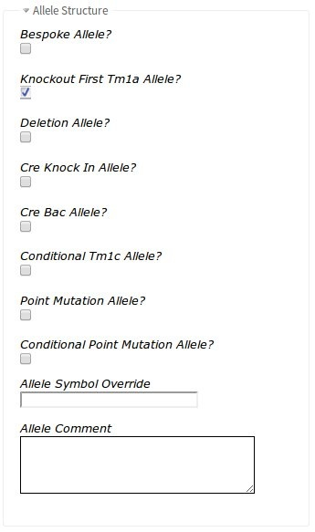

Figure 3. Dialogue for changing details for an ES cell clone.

An ES Cell distribution centre (or a mouse clinic doing data entry on behalf of an ES-distribution centre) can indicate the progress of ES-QC for a plan by editing the data on the plan. This edit page is also accessible from the Plans module.



## 2b. Plans: Editing plans for Mouse Production.

The “Plans” module is selected by clicking the “Plans” tab . The resulting grid can be searched by Marker Symbol, Consortium, Production centre etc clicking on the column headers for these fields and choosing to “Filter” on that field. By default, the grid is filtered on the Users’s Production Centre (Figure 4).

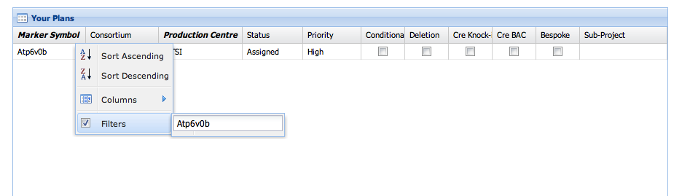

Figure 4. Filtering plans in your consortium.

Clicking ‘Edit Form’ on a Plan row will produce the Plan edit-form for the selected plan. Entering a non-zero value in “# ES Cells starting QC” will cause the plan to change state from it’s previous state (“Assigned” or “Inspect …” etc) to “ES QC in Progress” (Figure 5).

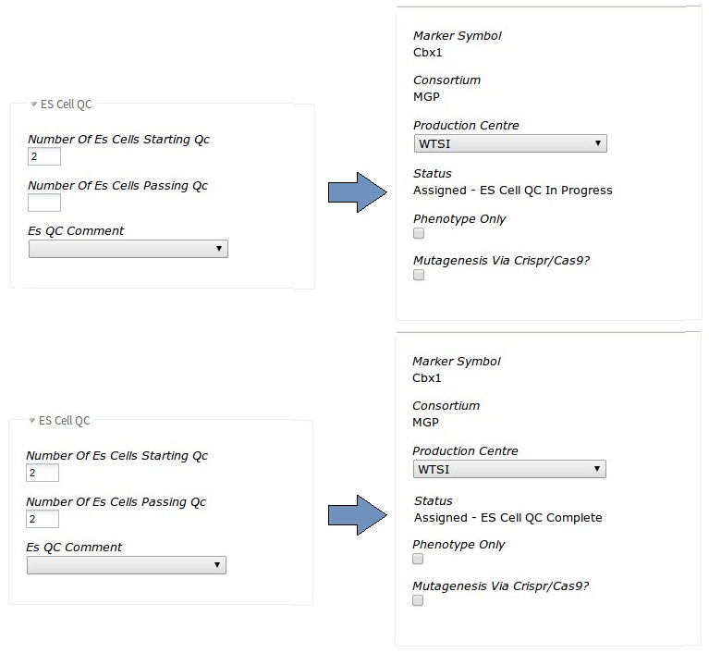

Figure 5. Status change of ES clone to 1. “ES Cell QC in Progress” (above)

2. “ES Cell QC Complete” (bottom)

Entering a non-zero value in “#ES Cells passing QC” will cause the plan to change state to “Assigned – ES QC Complete” (Figure 5). If the “# ES Cells passing QC” is set to zero, then the status of the Plan will change to “Assigned – ES QC Aborted”. This indicates that attempts to thaw / pass clones prior to Mouse production have failed for this consortium.

## 2c. Plans: Editing a plan to indicate crispr injection/ phenotyping

The Plans are not only used to show intent to produce mice from clones. They can also be used to show intent to:

* Create a mouse colony through mutagenesis via crispr injection (with or without a vector/Oligos).
* Phenotype an existing colony produced by another production centre.

These can be achieved though the edit plan page.

1. To show intent to create a mouse colony through mutagenesis via crispr injection tick the ‘Mutagenesis Via Crispr/Cas9’ tick box (figure 6) on the Plan and save.
2. To show intent to phenotype an existing colony produced by another production centre tick the ‘phenotype_only’ tick box (figure 6) on the Plan and save

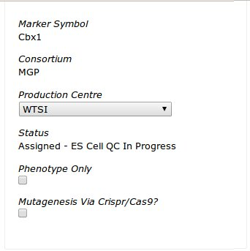

Figure 6. Showing intent to mutagenize Via Crispr injection or phenotype a mouse colony produced by another production centre

## 2d. Plans: Withdrawing interest in a gene, Inactivating a Plan, Deleting a Plan.

Consortia can

* Withdraw interest in a plan prior to the start of any mouse production
* Inactivate a plan with no *active* mouse production.
* Ignore Available Mice, hides mice from the public produced by this plan
* Delete an existing plan

By clicking on the obvious buttons on the plan’s edit page (figure 7).

All of these changes will mean the plan does not ‘compete’ with other consortia looking to make plans on that gene.

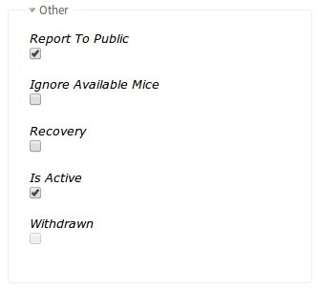

Figure 7. Withdrawing interest in a gene, aborting, deleting and hiding produced mice from the public

## 3a. Attempts: Initiating Mouse Production for a gene.

iMits tracks Mouse production through Micro Injections of ES Cells or Mutagenesis Factors (via Crispr/Cas9).

NB. Before starting check the appropriate Plans and Targeting/HDR vector (for Mutagenesis Factor [see Adding Alleles/Vectors section]) have been created.

To record the start of a single Microinjection click the “Create MI Attempt” tab. This will give you two options.

1. Select ES Cell or
2. Select/Create Mutagenesis factor

## Mouse Production using ES Cell.

ES Cells will be sent from the ES-distribution centre to the Mouse Clinic, where they will be prepared for Microinjection.

Click the ‘Select ES Cell’ button and search for clones that are visible for that gene, by either gene symbol or Clone name (Figure 8).

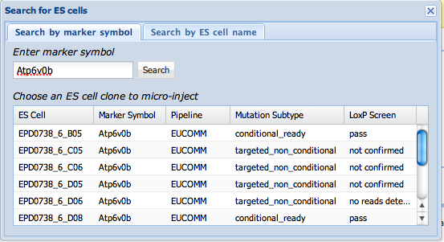

Figure 8. Searching for ES cell clones to choose for microinjection attempts

Choose the ES cell you have used for Microinjection (pay attention to the difference between conditional ready and targeted non-conditional clones, which is read from the IKMC targeting repository classification of these clones). I clicked on the row “EPD0738_6_B05”, which opens the Create form:

## Mouse Production using Mutagenesis Factor.

Click the ‘Select/Create Mutagenesis Factor’ button and type in the gene marker symbol (I entered Nxn) and click search. This will show you a list of exons which can be used to search for Crisprs/Crispr Pairs (Figure 9).

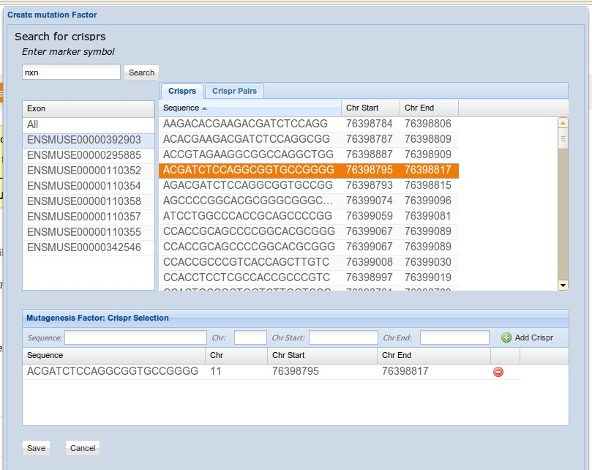

Figure 9. Crispr Selection using exon search

Alternatively you can manually enter (Figure 10) the 23 base sequence (this includes the PAM sites) and positional information of the Crispr.

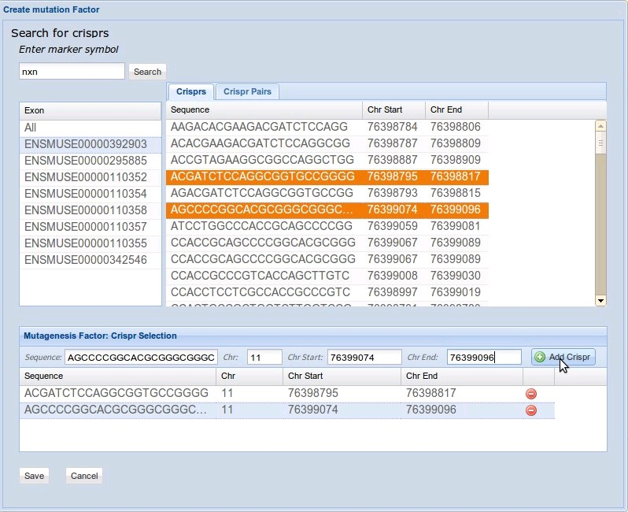

Figure 10. Manually entered crisprs

Here I selected all of the Crisprs for this microinjection and clicked ‘save’, which opened up the Create form where I selected the nxn_tv Oligos (figure. 11)

NB. At this point you can still edit your Crispr selection if incorrect.

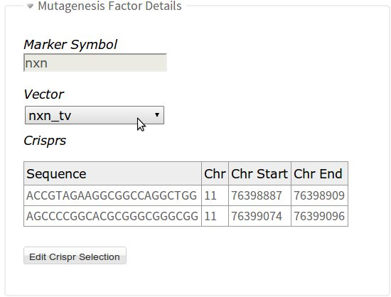

Figure 11. Selected the nxn_tv vector from the drop down

Once your ES Cell or Mutagenesis Factor are setup the minimum fields required are MI-date and colony name. You are also required to select a Plan from the list (figure. 12).

The MIDate is the microinjection date.

The Colony Name is a UNIQUE name CHOSEN BY YOU for the group of mice (the “mouse line”) that will arise from this microinjection. WTSI have colony names which are four-letter words such as “MECD”. UCD use colony names like “BL1253”. Typically this name is an “external” reference, determined by the name of the colony in the “real” mouse-tracking system available on the mouse clinic campus. This name will be transmitted to the outside world via portals, marts etc.

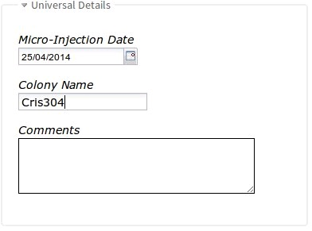

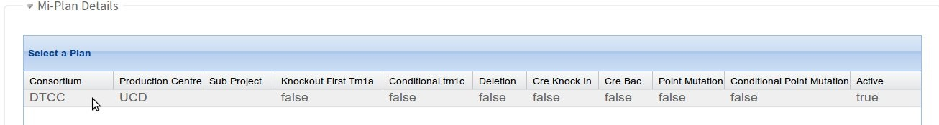

Figure 12. Adding microinjection details for a selected ES cell clone

Above I selected the UCD plan and entered the microinjection date and colony name. This successfully creates the Mi Attempt with status ‘Micro Injected in progress’ (figure. 13)

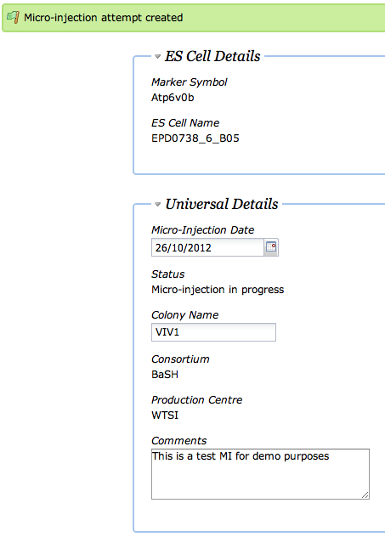

Figure 13. Green flag showing a microinjection attempt has been successfully entered



## 3b. Attempts: Indicating the production of chimeras/founders for a mouse line.

Mouse production attempts can be found and edited via the “Mouse Production” Grid.

The grid can be searched by colony name, Gene symbol, or ES cell name. In Figure 14 I used colony name. Note also you can filter by production centre. The Grid can be directly filtered by consortium (by clicking on the “Consortium” column header and choosing to “Filter”). The Grid can be sorted by MI-date.

Here I’ve found my MI by filtering by colony:

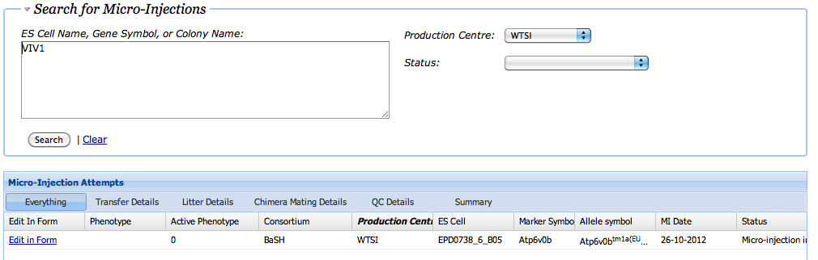

Figure 14. Searching through microinjection attempts

You can edit this Mouse production attempt by clicking on the row, which will make the fields in the row “Editable”. Here I’ve clicked on the row and scrolled the view to the right, showing the field with “Total Blasts Injected” ready to type in:

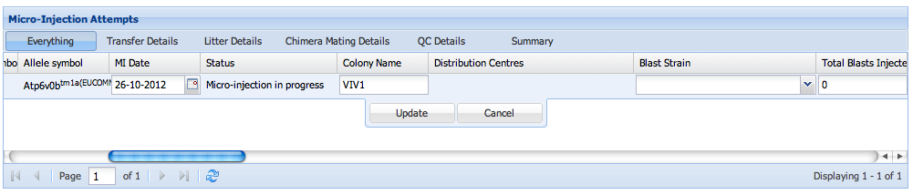

Figure 15. Editing within the mouse production grid

You can also click on the “Edit in Form” link to the left, which will show the MI Attempt in a traditional HTML page.

‘Chimeras Obtained’ (ES Cell micro-injection) and ‘Founders Obtained’ (Mutagenesis Factor) statuses are equivalent for the different micro-injections. Clicking on the “Edit in Form” link will display slightly different forms depending on the different micro-injections. Figure16 shows the two forms and the required fields to change the Mi Attempt to “Chimeras Obtains” or “Founders Obtained”

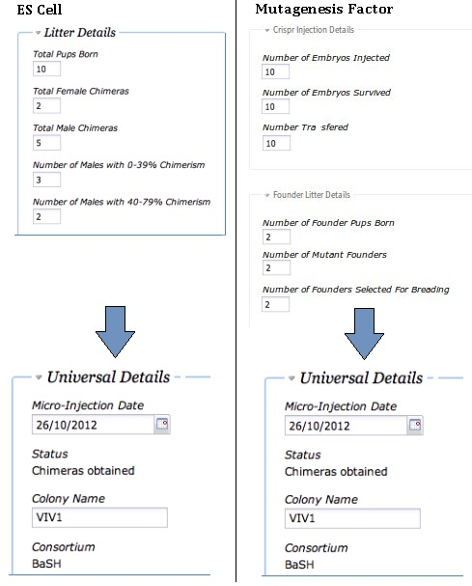

Figure 16. Changing status of mouse production to Chimeras/Founder obtained

## 3c. Attempts: Indicating Genotype Confirmed mice for a mouse line.

A mouse line changes status to Genotype Confirmed when either of two fields is set to > 0: “Number of Chimeras with GLT from Genotyping” OR “Number of Het offspring”.

The following fields must also be filled in, so that details of the mouse line can be used to yield a correct strain name:

1. Test Cross Strain Name: the name of the initial test-cross strain used for breeding to establish chimerism.
2. Colony Background Stain Name: the name of the back-cross strain (eventually the colony background) for the genotype confirmed mouse colony.
3. Number of Chimeras with GLT from genotyping. The number of chimeras (ie parents) which had germ-line-transmitting pups, where the GLT was established by genotyping the pups. A non-zero number here will set the MI Attempt status to “Genotype Confirmed”.
4. Number of chimeras with x – y % chimerism. These bins are for information purposes only (they can be reported on).
5. Number of Het offspring. A non-zero number here will set the MI Attempt status to “Genotype Confirmed”.
6. Mouse Allele Type: If the ES Cell is a “tm1a” – ie knockoutfirst – then there is some chance that genotyping a mouse will show that the mouse has a “Tm1e” allele. This could be due to a number of reasons, but in this field users can record that the mouse was “tm1e”. If this field is left BLANK then the mouse allele type will be inherited from the allele of the ES Cell.

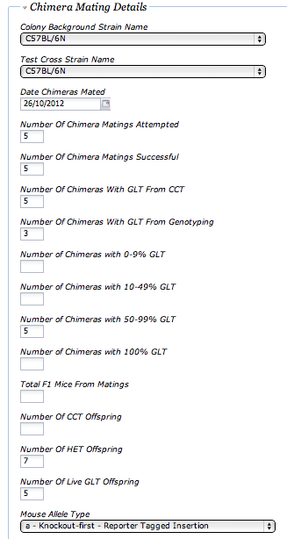

Figure 17. Changing status of mouse production to Genotype Confirmed

## 3d. Attempts: Distribution Centres for Genotype Confirmed Mice.

## A Genotype Confirmed line does not automatically inherit a distribution centre. These must be added manually by the mouse production centre (Figure 18).

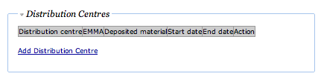

Figure 18. Adding distribution centre to genotype confirmed mice

In Figure 18, I have clicked the “Add distribution centre” link, and chosen WTSI to act as an EMMA “node”, serving live mice. This tells the IMPC portal to refer users to the EMMA repository. It also tells the EMMA repository to expect to advertise this mouse line as order-able:

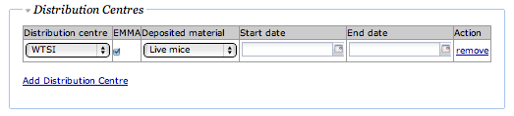

Figure 15. Distribution Centre selection choices- WTSI as distributor under the EMMA framework.

IMPORTANT NOTE – to actually add the centre, you have to push the “UPDATE” button at the bottom of the web page:

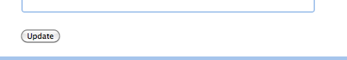

The following distribution centre (see Figure 19) would be appropriate if WTSI sent the line to UCD for distribution, as part of the KOMP2 resource:

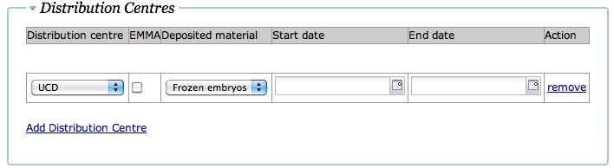

Figure 19. Selecting KOMP repository for archiving of frozen embryos.

## 4.A. Phenotyping Attempts: Registering a Genotype Confirmed Mouse for Modified Allele creation and Phenotyping

The Genotype Confirmed Atp6v0b mouse line (VIV1) can be registered for phenotyping by BaSH at WTSI, or by another consortium / centre.

Since it was made by BaSH / WTSI, to register it for BaSH at WTSI requires no further planning. Find the mouse line in the “Mouse Production” grid (see Figure 20) and click on the “Create” link in the “Phenotype” column:

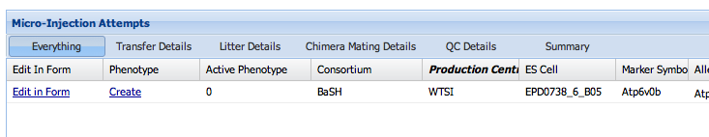

Figure 20. Selecting “Create” in the mouse production grid to start a phenotype attempt

You will be offered a Phenotype Attempt edit page (Figure 21), which allows you to Register a Phenotype Attempt for this mouse line.

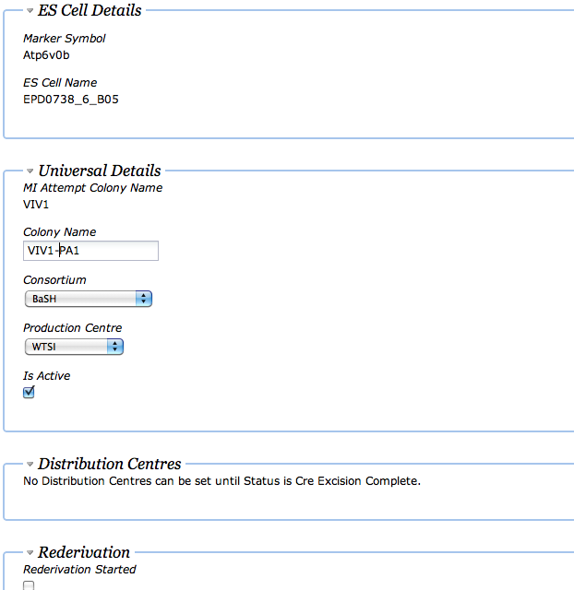

Figure 21. Creating a Phenotyping attempt, for the same Consortium and Production Centre as the generated mouse.

The COLONY NAME for the Phenotype Attempt is set BY YOU. **This name must match the colony name sent with your mouse clinic’s phenotyping data to the DCC.**

After I have pushed “create” for this Phenotype Attempt, it is in status “Registered”. You can find the Phenotype Attempt for update later by going to the “Phenotyping” tab:



You can search for an individual Phenotyping Attempts by entering their Gene in the search box (see Figure 22) . Alternatively, the columns of the grid will allow you to *filter* by consortium, production centre, colony name status etc. Below we have found the Phenotyping Attempt we just created for Atpv60b:

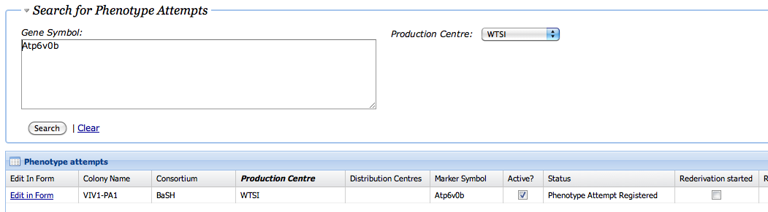

Figure 22. Searching for Phenotyping Attempts already created

Clicking on this row brings up the Phenotype Attempt edit form, which allows updates to the status of the Phenotype Attempt.

You can view the Production Graph (Figure 23) of this whole gene by selecting it in the “Gene Selection” tab, and clicking on the “Production Graph” link. You will see the gene, the plan, the mouse and the phenotype attempt all linked up:

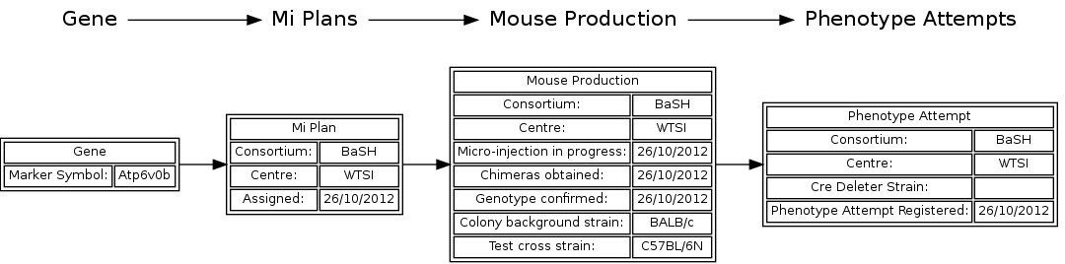Figure 23. The Production Graph for the mouse and phenotype attempt, visible via the Gene Selection Page.

## Phenotype Attempts: Having multiple Phenotype Attempts for a single mouse line (from different consortia or phenotyping centres)

What if BCM also wanted to Phenotype this same mouse line (VIV1)? Well, they could! But it would require the creation of a new PLAN.

Recall that the Plan we created for making the mouse “VIV1” was for BaSH / WTSI.

*First* we would have to create a *NEW* plan – this time for phenotyping – for BaSH / BCM: I have created a new PLAN for Atp6v0b for BaSH / BCM using the gene selection tab (see Figure 24).

Notice that it is in status “Inspect – GLT Mouse” because iMITS has observed the existing GLT mouse at WTSI, and is questioning BCM’s intention to produce. Note also that iMITS is showing the exising GLT mouse and the Phenotype Attempt already registered at WTSI.

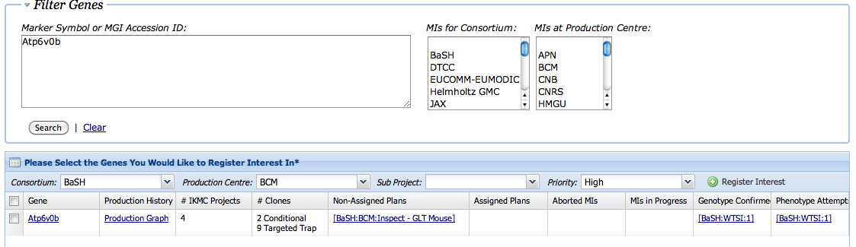

Figure 24. Creating a new plan for BaSH / BCM, for the Atp6v0b gene

Now that we have made a plan for BaSH / BCM, the NEXT thing to do is to actually FIND the mouse and make a Phenotype Attempt attached to the BaSH / BCM plan. Go to the Mouse Production Tab, and click on the ‘Create’ link in the Phenotype column (Figure 25).



Figure 25. Finding the original Atp6v0b mouse prior in order to create a BaSH / BCM phenotyping attempt.

THIS time you want to create a Phenotype Attempt for consortium: BaSH, production centre: BCM (Figure 26) –

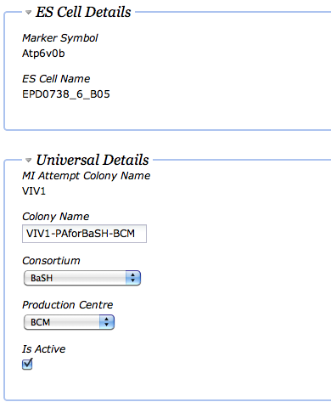

Figure 26. Selecting BaSH / BCM when creating a Phenotyping attempt for a BaSH/WTSI mouse.

After you create the PA (push “Create” at the bottom of the screen) then you can check your work by looking at the Production Graph for this gene via the row for the gene in GeneDetails page (Figure 27):

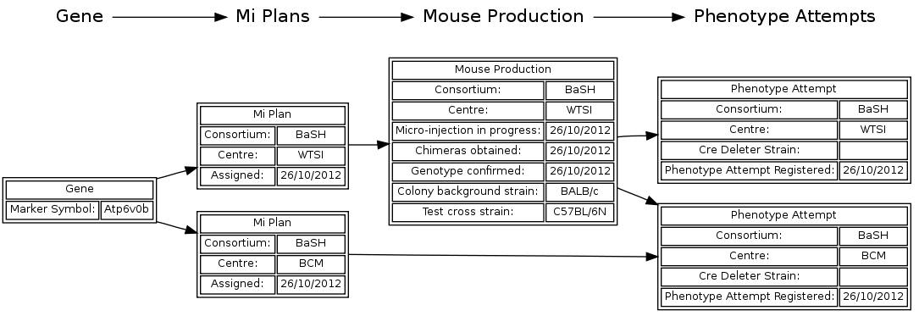

Figure 27. The Production graph for Atp6v0b after creation of the BaSH/BCM Phenotyping attempt on the BaSH/WTSI mouse.

You will see that there are two plans in the system: one for BaSH/WTSI which resulted in a Genotype Confirmed tm1a mouse (and a phenotype attempt registered), and the other for BaSH/BCM, which resulted in a *separate* Phenotype Attempt for the *same* mouse.

## 4b. Phenotyping Attempts: Indicating the start / finish of rederivation

Sometimes a mouse clinic will have to rederive a colony after the reception of cryo-preserved stock (embryos, sperm). iMITS allows the optional indication of that process by the checking of the “Rederivation Started” and “Rederivation Complete” checkboxes on the Phenotype Attempt edit page.

To get to this page, first navigate to the Phenotyping Attempts tab:



and search for the attempts we’ve just created by entering the gene name (remove the ‘Production Centre’ filter (Figure 28):

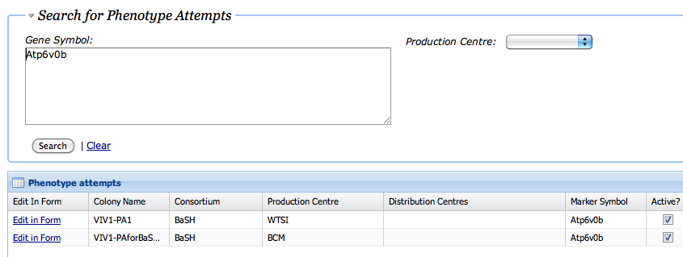

Figure 28. Finding the Phenotyping Attempts for Atp6v0b in the Phenotyping grid, in order to update the BaSH/BCM attempt.

Notice that we’re now finding both the Phenotype Attempts we created: one at WTSI and one at BCM. Click on the “*Edit in Form*” link for the BCM row. This will bring up the Phenotype Attempt Edit form. The middle of the form (Figure 29) has checkboxes for “Rederivation Started” and “Rederivation Complete”:

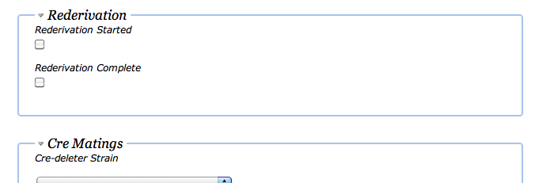Figure 29. The Rederivation started / complete fields in the Phenotyping attempt edit form.

Simply check these boxes on the dates when Rederivation of this mouse line has started / finished. We show the production graph (Figure 30) after this has happened at BCM. Notice the rederivation started / complete dates on the second PA on the right:

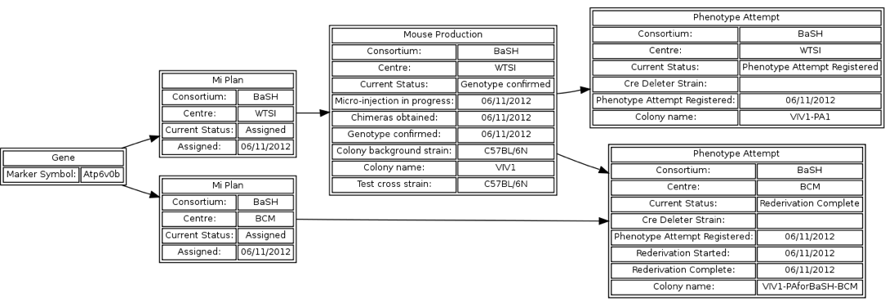

Figure 30. The Production Graph for Atp6v0b after the BaSH/BCM Phenotyping Attempt has become “Rederivation Complete”.

## Phenotyping Attempts: Indicating the start of Cre Excision

Cre-excision is the crossing of a “tm1a” or “tm1” mutant with a cre-expressing mouse strain in order to flox the critical exon (if this is applicable) and to remove any promoter from the trapping cassette. The *start* of cre-excision is indicated in iMITS by the *choice* of a cre-deleter strain. We have polled each mouse clinic and attempted to compile a list of strains currently in use. If your strain isn’t in this list, we have to add it – please contact us. I have indicated the strain in the Phenotyping Attempt edit form below (Figure 31), and pushed “Update”.

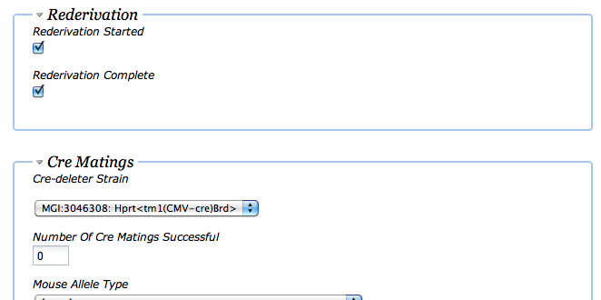

Figure 31. Specifying the cre-deleter strain to alter the status of the Phenotyping attempt to “Cre Excision Started”.

## Phenotyping Attempts: Indicating the finish of Cre Excision

The *finish* of Cre-Excision happens when a mouse clinic has genotyped the offspring of the cre-mating and determined which matings have successfully removed the promoter / floxed the critical exon(s).

To change to this status, the mouse clinic must indicate *all* of:

* A positive number of “cre matings successful” (this is a relic and will be replaced with a checkbox)
* A Mouse Allele Type (this should be a “b” for a conditional allele and a “.1” for a deletion)
* A Colony Background Strain. This is the colony background of the stain which will be phenotyped.

We have made choices in the form shown below (Figure 32): pushing “Update” will change the status of the Phenotype Attempt to “Cre Excision Complete”.

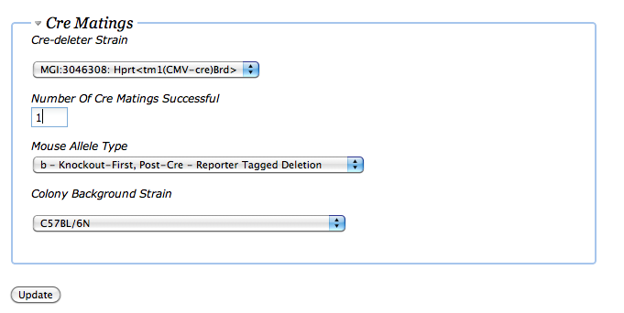

Figure 32. Specifying data to indicate that Cre Excision is Complete

I have shown part of the production graph again, with the BCM Phenotype Attempt now advanced to “Cre Excision Complete” (Figure 33):

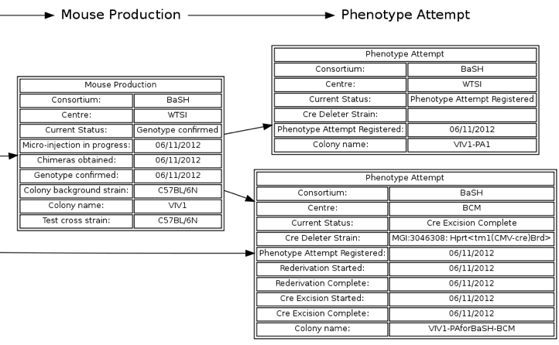

Figure 33. Production graph for Apt6v0b after BaSH/BCM attempt is CreExcision Complete.

## Phenotyping Attempts: Distribution Centres for Cre-Excised Mice.

A Cre-Excised mouse line. can be distributed as a resource available to the scientific community, just like the original conditional – ready mouse line.

Check the “Distribution Centres” panel for your Phenotype Attempt: you can add a distribution centre there - and indicate if it is to be distributed via the EMMA network - in the same way as the original mouse lines (Figure 34).

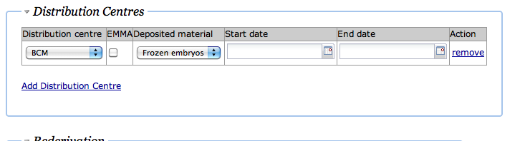

Figure 34. Specifying / adjusting the Distribution Centre for the Cre-Excised mouse on the Phenotype Attempt edit page.

## Phenotyping Attempts: Indicating the start and end of Phenotype Data Transfer

The iMITS status currently labeled “Phenotyping Started” and “Phenotyping Complete” represent the start and finish of phenotyping data transfer between the mouse clinic and the Pheno-DCC - – the body responsible for the compilation and quality-control of phenotype data from the entire KOMP2 / IMPC effort.

Mouse clinics cannot directly indicate the start and end of data transfer inside iMITS: This signal must be sent to iMITS directly by the data wranglers at the Pheno-DCC (Figure 35). Currently this coordination requires that the Phenotype Attempt Colony name recorded in iMITS match the Colony Name attached to the XML containing the procedure / parameter results in the data transferred to the Pheno-DCC:

Atp6v0b

tm1a

mouse colony:

VIV1

Tm1b (cre-ex)

mouse colony:

VIV1-PAforBaSH-BCM

XML Phenotype data transfer:

Labeled with colony name

“VIV1-PAforBaSH-BCM”

1

Pheno DCC

Reads and QCs

Phenotype Data

2

3

1. Data packet from mouse clinic contains PA colony name
2. Pheno DCC reads data packet
3. Pheno DCC updates iMITS to change status to “Phenotype Data Transfer Started” (and “Complete”)

Figure 35. Coordination between iMITS, Data coming from the Mouse Clinic and the PhenoDCC to indicate the flow of data via “Phenotyping Started / Finished” statuses

1. Adding Alleles/Vectors

The IKMC Targeting Repository (Targ Rep) Stores all the mutant ES Cells and Targeting Vectors made by the pipelines in the International Knockout Mouse Consortium (IKMC). The Targ Rep has also been adapted to stores the Targeting Vectors and Oligos created for Crispr/Cas9 microinjections.

Here we will cover how to add these new Targeting Vectors and Oligos.

**Targ Rep will infer most of the alleles structure from the information provided when entering the Targeting Vectors and Oligos. Therefore it is IMPORTANT that the information entered is correct to prevent an incorrect allele from being inferred.**

Targ Rep’s navigation bar has a Crispr and Cell section. The Crispr section has two options ‘Targeted Alleles’ and ‘HDR Alleles’. Click on ‘Targeted Alleles’ to add Vectors and click on ‘HDR Alleles‘ to add Oligos.

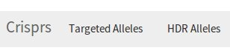

## Adding Targeting Vectors (Targeted Alleles)

Click on ‘Targeted Alleles’ and then select ‘new’. The following form will pop up.

Here I have filled in the gene as Nxn, the genomic information, design details, the targeting vectors Genbank file and the name of the targeting vector (figure 36). **NB.** You can enter more than one vector name if you have multiple copies of the vector. It is important that the Genbank file is accurately annotated as this will be used to infer the allele’s structure.

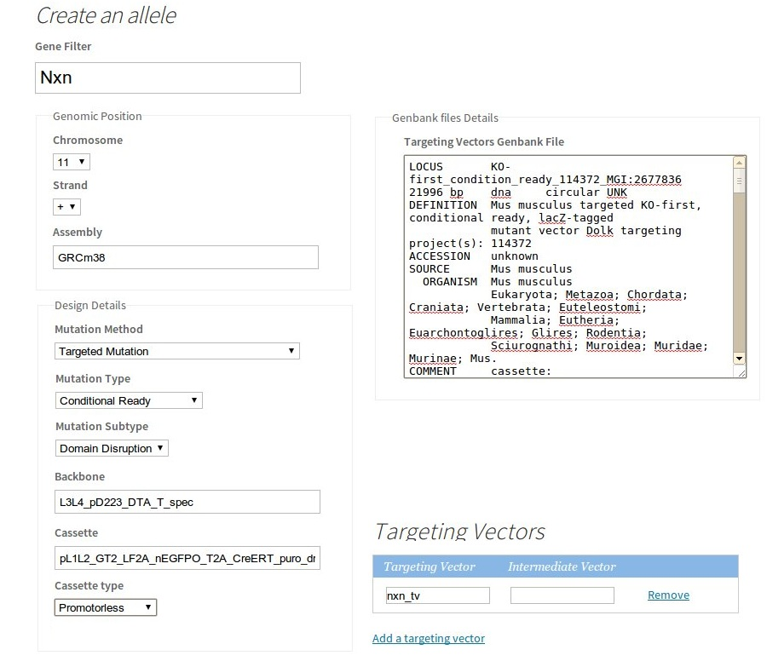

Figure 36. Creation of a targeting vector

Click ‘save’. Now this vector will appear when recording the microinjection of a Mutation Factor (Crisprs and vector)

## HDR Allele (Oligos)

Click on ‘HDR Alleles’ and then select ‘new’. The following form will pop up.

Here I have filled in the gene as Nxn and the genomic information. The design details default to ‘Point Mutation’ and I have entered the sequence of the oligos and the name of the vector (figure 37). **NB.** You can enter more than one vector name if you have multiple copies of the same vector. It is important that the Oligos sequence is accurately entered as this will be used to infer the allele’s structure.

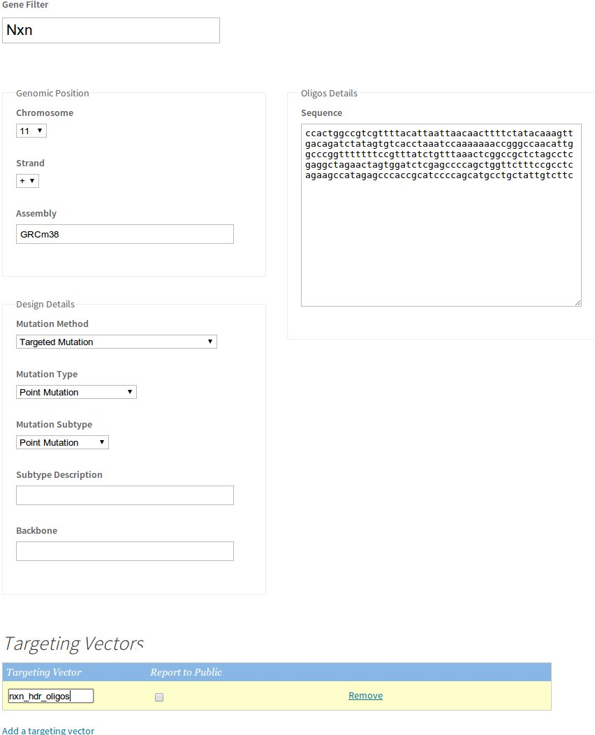

Figure 37. Creation of Oligos

Click ‘save’. Now this oligos will appear when recording the microinjection of a Mutation Factor (Crisprs and oligos)

1. GLOSSARY

## IKMC

The members of the International Knockout Mouse Consortium (IKMC) have worked together to mutate all protein-coding genes in the mouse using a combination of gene trapping and gene targeting in C57BL/6 mouse embryonic stem (ES) cells. The IKMC includes the following programs: The Knockout Mouse Project, The European Conditional Mouse Mutagenesis Program, The North American Conditional Mouse Mutagenesis Project, The Texas A&M Institute for Genomic Medicine, and the EUCOMMTools Program. See [www.knockoutmouse.org](http://www.knockoutmouse.org) for details of IKMC products, alleles and contributors.

## Genes

A mouse has (about) 20,000 *genes* inside every cell in its body, each encoded by a stretch of DNA. Each gene is labelled by an *MGI Accession Id*, which can be thought of as the logical key of the gene. The *Marker Symbol* is a human-readable string that labels the gene.

## ES Cells

iMITS contains a list of all IKMC ES Cells for a particular gene. When a user production center wants to start mouse creation, they must first pick a gene, and then an ES Cell from a list of possible ES Cells for that gene.

## Consortia

Mouse Production is funded by various Government and EU-related bodies known as Consortia. Each Consortium is granted money and held accountable for certain mouse-production goals. Examples of consortia include BaSH, the MGP, Phenomin, Helmholtz-GMC etc.

## Production Centres

Mouse production occurs in physical locations called Production Centres. These correspond to actual labs that receive ES Cells (from the ES Cell distribution centres) and then proceed to check the ES Cells and breed mice derived from them. Examples of production centres include WTSI, BCM, MRC Harwell etc.

One Consortium can have work done by many mouse production centres, and one mouse production centre can do work on behalf of many different consortia. The connection between the two is held by the MI Plans – see below.

## MI Plans (or just Plans, really)

The MI Plan encodes the *intention* of a consortium to produce a mouse for a particular gene at a particular production centre. The nature of the mutant mouse can be carefully specified by flags on the MI Plan.

## MI Attempts

These records are linked to MI Plans and ES Cells, and represent the creation / progress of colonies (groups of genetically identical) mice based on a single mutant ES cells. The records are linked to a single ES Cell, and proceed through statuses:

## Mutagenesis Factors

These are a combination of Crisprs/Cas9 and vectors that will be micro-injected into a mouse embryo to induce a mutation in the targeted gene.

## Phenotype Attempts (better called “Modified Alleles”)

These records are linked to MI Attempts (and independently to MI Plans if necessary) and represent the import of an existing mutant mouse, the modification (via cre-excision) of the allele in that mouse, and the start and end of phenotype data transfer to the DCC for that mouse.

## Statuses in iMITS

The overall progress of mouse production from planning to end of phenotyping is captured by status on Plans, MIAttempts and Phenotype Attempts for a gene:

|  |  |  |
| --- | --- | --- |
| Entity | Status | Description |
| Plan | Assigned | There are no other assigned plans for this gene (no other Consortia and Centres have plans for this gene) |
|  | Assigned – ES QC In Progress | ES Cells for this gene have started QC, either at the ES-cell-distribution centre or at the mouse clinic.  Triggered by selecting non-zero ES Cells entering QC on this gene.  Note – simply entering ES Cells for QC will cause the plan to enter this state, even if it was not assigned before. |
|  | Assigned – ES QC Complete | ES Cells for this gene have (successfully) finished QC prior to mouse production.  Triggered by selecting non-zero ES Cells finished QC on this gene. |
|  | Assigned – ES QC Aborted | All ES Cells starting QC for this gene have failed to pass QC. The plan is *not yet* inactive or withdrawn. |
|  | Inspect – Conflict | There are other plans from other consortia for this gene, but no visible mouse production. Note – the MI Plan can still be changed to status “Assigned” by starting ES QC, or by starting mouse production (MI) |
|  | Inspect – MI Attempt | There are other visible (active) mouse production attempts for this gene. Note – the MI Plan can still be changed to status “Assigned” by starting ES QC, or by starting mouse production (MI) |
|  | Inspect – MI Attempt / GLT Mouse | There are other visible Genotype Confirmed Mice for this gene. Note – the MI Plan can still be changed to status “Assigned” by starting ES QC, or by starting mouse production (MI) |
|  |  |  |
| MIAttempt | MI In Progess | Mouse production has commenced with Microinjection for this gene. There is a tracked mouse ‘colony’ – group of mice. |
|  | Chimeras Obtained | The mouse colony has produced Chimeras. Triggered by entering > 0 male Chimeras for the MI Attempt. |
|  | Founder Obtained | The mouse colony has produced founders from the micro-injection of the Mutagenesis Factor. Triggered by entering >0 Number of Mutant Founders |
|  | Genotype Confirmed (ES Cell) | The mouse colony has produced F1 pups which have been assayed and found genotype confirmed. All centres except WTSI: Triggered by > 0 numbers in either of these fields: “Chimeras with glt offspring established by genotype confirmation” or “Number of het offspring”. |
|  | Genotype Confirmed (Mutagenesis Factor) | Genotype confirmation of the F1 (bread from the founders). CURRENTLY NOT POSSIBLE |
|  | MI Aborted |  |
|  |  |  |
| Phenotype  Attempt | Phenotype Attempt Registered | This is the initial status on creation of a PhenotypeAttempt as a child of an MI Attempt |
|  | Rederivation Stated / Finished | Triggered by the selection of a checkbox on the Phenotype Attempt. |
|  | Cre Excision Started / Complete | Cre-started – triggered by selection of >0 for “Number of Cre Matings”. Cre-complete: triggered by choice of “Mouse Allele Type” to “b”. |
|  | Phenotype Data Capture Started / Complete | These are only set-able by the DCC – that is, they cannot be set by the Mouse Clinic |