*Title: DEXA

*Centre: IMPC

*Date_modified: 15-06-2012

*Last_modified_by: Westerberg, Henrik

*Version: 1

{Sections:}

## *1. Purpose:

Measure bone mineral content and density as well as body composition in mice using the DEXA (Dual Energy X-ray Absorptiometry) analyser.

## *2. Experimental Design

* **Minimum number of animals:** 7+7
* **Age at test :** adult
* **Sex:** males and females

## *3. Procedure

3.1 Calculate and record the volume of anaesthetic solution required for

intraperitoneal (IP) injection.

3.2 Anaesthetise the mice.

3.3 Monitor the animal carefully until unconsciousness by ensuring that the mouse is adequately sedated.

3.4 Weigh the mouse and record the value.

3.5 Measure the length of the mouse as follows and record the value (accuracy ±0.1cm)

3.5.1 Place the unconscious mouse on a disinfected ruler so that its nose is at zero

(figure 1).

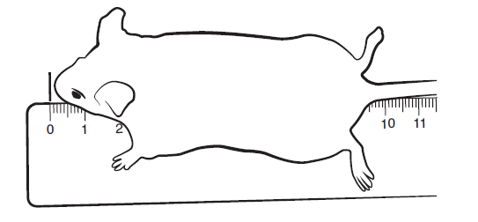

Figure 1

3.5.2 To measure the entire length of the head press gently against the ruler (figure 2) and gently pull the tail to ensure that the spine returns to its full length (figure 3).

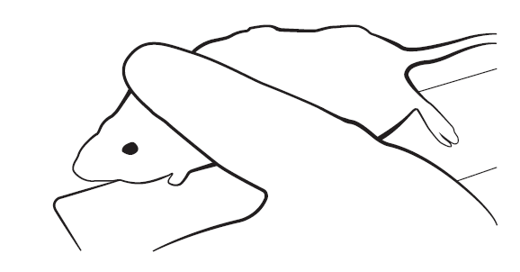

Figure 2 Figure 3

3.5.3 Measure the length starting from the nose (0cm) to the beginning of the tail

(figure 4). Record the measurement – the accuracy is within 0.1cm. For example in figure 4 the length of the mouse is 9.5cm.

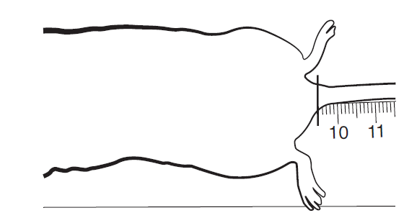

Figure 4

3.5.4 Disinfect the ruler and contact area after the measurement has been taken.

3.6 Place the unconscious mouse into the DEXA analyser.

3.7 Perform a scout-scan.

3.8 Optimise the area of interest and perform a measure-scan.

3.9 Note that the exposure dose per mouse is 300μSv.

3.10 For the analysis of the data, regions of interest must be defined. The standard

analysis comprises of a whole body analysis excluding the head area.

Continue with X-ray analysis or

3.11 Remove the mouse once the image is captured. Place the mouse on a heated mat,

set at 37°C, in a cage and monitor closely until consciousness is regained.

## *4. Notes

Dual-energy X-ray Absorptiometry (DEXA or DXA) is a method of quantifying bone mineral content and density. DXA uses an X-ray generator of high stability to produce photons over a broad spectrum of energy levels. Its photon output is filtered to produce the two distinct peaks necessary to distinguish bone from soft tissue.

The technique used for separating photon output into two distinct energy levels is known as ‘K-edge’ filtration. By placing a filter element in the beam path, energy levels reacting with the filter material are sharply attenuated. The filter effect gradually lessens at higher energy levels, and so a second peak is introduced. The tin filter material used in this system produces energy peaks at 28keV and 48keV. Two solid-state detectors and proprietary energy discrimination are used to determine high and low energy counts.

The count data is transformed by software into bone and non-bone components, thus generating the bone density values. Information is generated about body weight, body length, fat and bone mass, bone mass density, and lean mass of each mouse.

|  |  |  |  |
| --- | --- | --- | --- |
| **Meta Data** | **Example Value** | **Required for Upload** | **Require for Data Analysis** |
| Equipment ID |  | Yes | No |
| Equipment manufacturer | GE Medical Systems | Yes | Yes |
| Equipment model | Lunar Piximus II | Yes | Yes |
| Mouse status | Text | Yes | No |
| Anaesthesia | Ketamine+Xylazine | Yes | No |
| Date equipment last calibrated | A date | No | No |
| Experimenter ID |  | Yes | No |

### Data QC

Calibration of the system is done in daily intervals using the phantoms delivered by the manufacturer. The results from the calibration runs are recorded by the system.

## *6 . Measured Parameters - list

{Placed in Parameters spreadsheet}

## *7. MetaData Parameters - list

{Placed in Paramters spreadsheet