SOP Template

*Title: Heart Weight

*Centre: Sanger Institute

*Date_modified: 6-03-2012

*Last_modified_by: Redden, Matthew

*Version: 1

*Procedure Id:

## *1. Purpose: To evaluate cardiac size using heart weight and body weight.

## *2. Experimental Design

Minimum number of mutant animals required: 14

Minimum age of animals: 16 weeks

## * 3. Equipment

Equipment: Fine forceps, surgical scissors, fine surgical scissor, kim wipes (tissues) or surgical compress, laboratory balance, labelled jar with fixative, corkplate or wax board, pins, jar containing tap water to rinse the tools

## *4. Procedure

## Methods and procedures used not including centre-specific data entry methods.

1. Euthanize the mouse

2. Weigh and record total body weight

3. Place mouse on its back and pin the mouse onto board with extended extremities (inner side of hands and foot)

4. Wipe or wet the mouse with 70% ethanol to control hair and dander

5. Option A (for mice that are undergoing complete necropsy):

• Proceed with a complete necropsy and tissue collection according to Centre-specific technical SOP including removal of the heart by dissecting the aortic root immediately above the aortic valves and the superior vena cava above the atria

• Remove adjacent mediastinal fat pads from the excised heart carefully with forceps

• Empty heart blood by tapping the heart on a kim wipe (absorbent pad) or surgical compress. Repeat until the heart is totally dry

• Weigh the heart, record the weight in the Centre-specific database, and place the heart in fixative

• Carefully remove adjacent mediastinal fat pads from the excised heart with forceps

6. Option B (for mice that are not undergoing complete necropsy):

• Open the skin in the ventral midline and in the direction of the extremities and extend cut to hands and feet

• Open the muscular abdominal wall in the midline and along the lower margin of the rib cage with small forceps

• Open rib cage by removing the sternum and adjacent ribs

• Remove the heart by dissecting the aortic root immediately above the aortic valves and the superior vena cava above the atria

• Remove adjacent mediastinal fat pads from the excised heart carefully with forceps

• Empty heart blood by tapping the heart on a kim wipe (absorbent pad) or surgical compress. Repeat until the heart is totally dry

• Weigh the heart and record the weight in the Centre-specific database

• Discard the heart

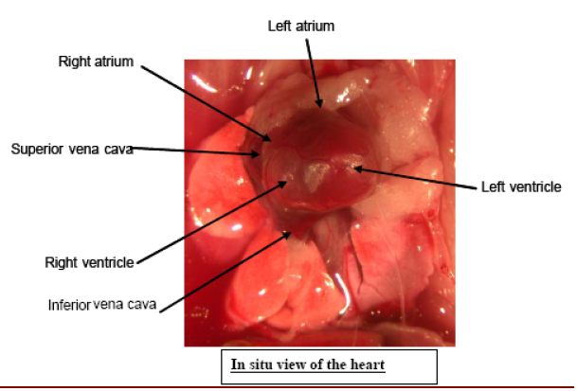

## *5. Notes

All data are collected at a local workstation in the necropsy room (attached to a digital balance) and uploaded to the Centre-specific pathology data capture system.

### Data QC Mouse weight between 5 grams and 150 grams

### IMPC Parameters (+ontology annotations) Weight (in mg)

### Data Analysis, annotation and display (+statistics)

Statistics: ANOVA/Wilcoxon test using normalized heart weights (for body weight) displayed in boxplots

## *6 . Measured Parameters - list

Body weight (g)

Heart weight (mg)

## *7. MetaData Parameters - list

|  |  |  |  |
| --- | --- | --- | --- |
| **Metadata** | **Levels required** | **Required for data upload** | **Required for data analysis** |
| Animal numbers | At least 14 mice | YES | YES |
| Age | At least 16 weeks | YES | YES |
| Experimenter ID |  | YES | NO |
| Date of experiment | DD/MM/YYYY | YES | NO |
| Euthanasia | Method | YES | NO |
| Equipment ID |  | YES | NO |