Ruby Demo

For instructor use

1. Create variable “name” and “age”
   1. Puts name and age
   2. Change name
   3. Puts again
   4. 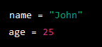
2. Use string methods
   1. Create variable uppercase_name
      1. 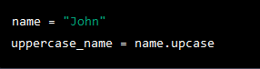
   2. Puts uppercase name
3. Iterate using number.times
   1. 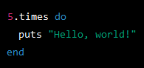
4. Define methods
   1. Create greet(name) method
      1. 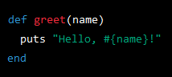
   2. Execute method
5. Method with defaults
   1. Create greet method with default greeting
      1. 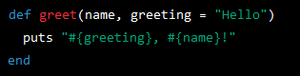
   2. Execute method
6. Return a value from a method
   1. Create double(number) method
      1. 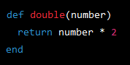
7. Use conditionals in a method
   1. Create positive_or_negative(number) method
      1. 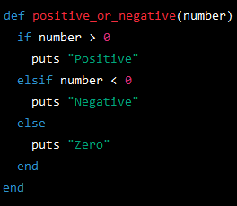
8. Define a Class
   1. Create Person class
      1. 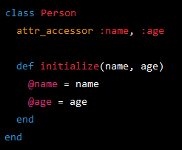
9. Inherit a Class
   1. Create Employee Class that inherits from Employee
      1. 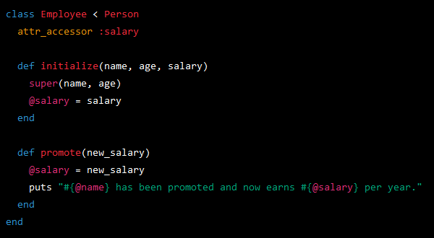
      2. Create employee, then give promotion
         1. 