# RAREFAN (RAyt/REpin Finder and ANalyzer) Manual

## Using the online tool

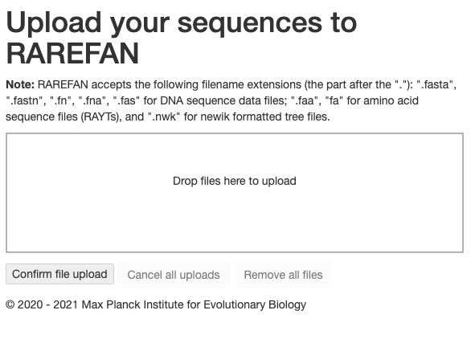

Here you can upload the genomes that are to be analyzed for their REPIN content. The genomes should be in fasta format and only have the specified file extensions.

You can also upload RAYT query sequences. These should be fasta files containing aminoacid sequences and should end in “.fa” or “.faa”. If these are not provided then you can select a RAYT gene from *P. fluorescens* SBW25 (Group 3 RAYT (1)) or one from *E. coli* (Group 2 RAYT (1)) provided by the server on the next screen.

Finally, it is possible to upload a phylogenetic tree in Newick format for your fasta sequences. For the webserver to be able to use the provided tree the leaves of the tree have to match the sequence file names. If the tree is not provided then a tree will be reconstructed using andi (2).

1. 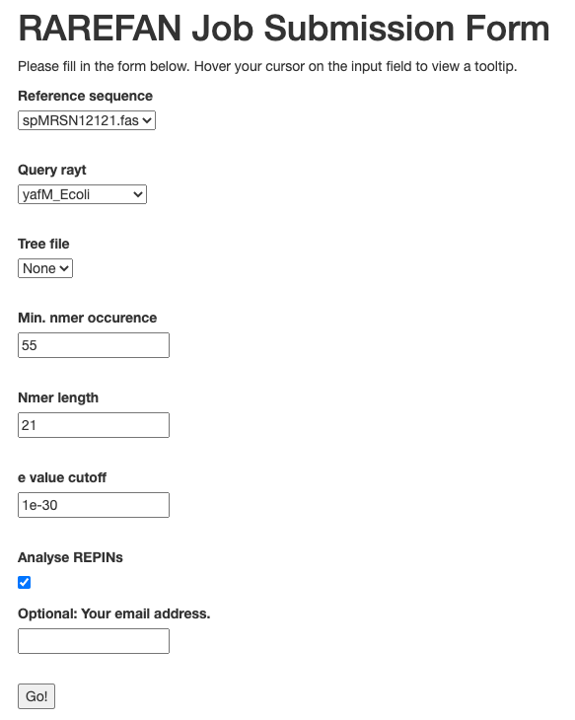Please select a reference sequence from the sequence files you submitted. The reference sequence will be used to identify a maximum of six seed sequences. The seed sequences have to occur at least n times (specified in (3)) and are of length N (specified in (5)) and are the basis for determining sequence groups. The way sequence groups are created is described in detail here (3), in the section “Grouping of highly abundant oligonucleotides in SBW25”. If sequence groups are part of REPINs, then each sequence group can be used to define a REPIN type.

(8)

(7)

(6)

(5)

(4)

(3)

(2)

(1)

1. There are two very divergent RAYT groups (*E. coli*  group and *P. fluorescens* group). If you do not know what kind of RAYT is present in your genome then you may have to run RAREFAN twice, once with the SBW25 and once with the *E. coli* RAYT. If you have supplied a RAYT protein yourself you should be able to select it here. These sequences are then used as query proteins in a TBLASTN (4) search of the provided genomes. All sequences that are identified below the e-Value threshold set in (6).
2. If you have provided a tree file in the previous step then you can select it here.
3. This parameter is required for identifying REPINs. Only sequences that occur more frequently than this value will be considered when identifying REPINs.
4. The seed sequence length for identifying REPINs.
5. This e-Value determines, which genes are identified as RAYTs in the genome.
6. If this box is ticked then REPINs are identified. REPINs are defined as sequences that consist of two seed sequences in inverted orientation that are found at a distance of less than 130 bp. If the box is unticked then the seed sequences (REPs) identified as described in (1) are used for all further analyses. This can be useful if REPINs are asymmetric (i.e. there is for example a deletion/insertion in either the 5’ or 3’ REP sequence). This is for example the case for *E. coli* REPINs.
7. If you provide an email address here you will be notified once the job is finished. This is particular useful when applying RAREFAN to large datasets.



Once the job is submit, it is assigned a unique identifier. If you have not supplied an email address you will either need to keep the site open or remember the unique ID to access the website later. If you have closed the website but know the unique ID you can access your data by calling this address http://rarefan.evolbio.mpg.de/results?run_id=

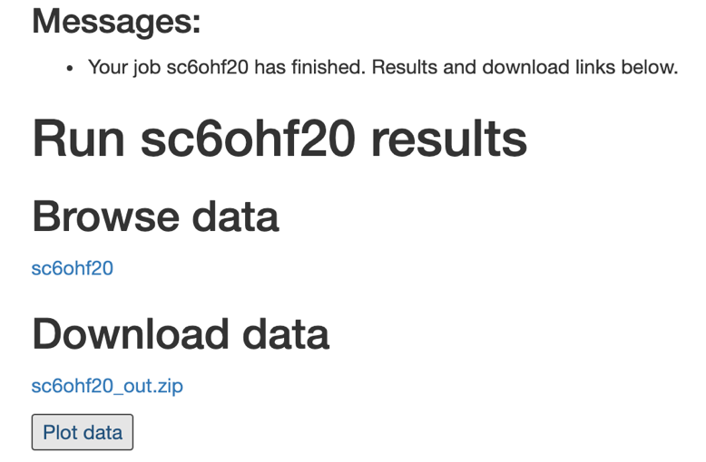

(1)

(3)

(2)

Once the job is finished you can access your data either by browsing through the folder structure online (1); by downloading the data and viewing it on your hard disk (2); or by directly plotting the data (see below for a description of the plots) (3).

## File output

All output data is located in a folder called out/.

The output files include the following:

A phylogenetic tree "tmptree.nwk" of all genomes generated with andi (<http://github.com/evolbioinf/andi/>) and clustDist (<http://guanine.evolbio.mpg.de/problemsBook/node1.html>).

A file containing the frequencies of all 21bp long sequences found in the designated reference genome.

[reference].overrep Contains all 21bp long sequences that occur more frequently than n (default 55) times in the reference genome:

prox.stats Contains information on the RAYTs and their cooccurrence with different REPIN populations.

A file containing the nucleotide sequences of all RAYT relatives identified with BLAST+ in all provided genomes: yafM_relatives.fna

maxREPIN_[0-5] Contains the most frequent REPIN identified for each sequence type in each  strain.

presAbs_[0-5].txt Contains for each strain information on the number of RAYTs, the number of REPINs, the master sequence, the number of master sequences, the entire REP/REPIN population size, the number of REPIN clusters that contain more than 10 sequences, all REPINs in the population as well as all REPINs that differ to the master sequences in at most three nucleotides.

rayt_[strain name].tab contains location information for each identified RAYT relative for each strain. The files can be viewed with artemis (5).

results.txt Contains for each strain the frequency of the six identified 21bp long seeds.

There is one folder called groupSeedSequences, which includes the data for identifying the most common 21 bp long sequences in the reference genome. All 21bp long sequences in the genome that occur more frequently than 55 times are sorted into 6 sequence groups. These sequence groups are stored in the files Group_[reference]_*.out and .out.fas. There is also a [reference]_words.tab file, which contains the locations of all overrepresented 21bp long sequences in the reference genome. This file can be viewed in artemis (https://www.sanger.ac.uk/tool/artemis/) together with the reference genome file. The most common sequence in each group is used as a seed sequence to determine REPIN populations across all submitted sequence files.

For each genome there are six output folders (ending in _0 to _5), for each sequence group one.

Each folder contains the following files:

*.dd: Degree distribution of the REPIN network, where each REPIN is a node. A REPIN is connected to another REPIN if they differ in exactly one position. The degree distribution is a histogram of the number of connections of all the nodes.

*.hist For the largest sequence cluster determined by mcl (6) that consists of REPINs (two REPs in inverted orientation) this file contains the number of REPINs in each sequence class. Sequence class 0 is the master sequence. By definition the most common REPIN in the sequence population. Sequence class 1 contains all REPINs differing in exactly one position to the master sequence. Sequence class 2 contains REPINs differing in 2 positions etc.

*.mcl Contains the clustering output by mcl. Each line contains the member of a cluster. Lines are sorted by cluster size.

*.mw Contains the most common 21bp long sequence and its frequency in the genome, which is the basis for identifying all related REP sequences and from those the REPINs formed by these REP sequences.

*.nodes The identity and frequency of all REPINs and REP sequences for either all sequences or only for the largest sequence cluster.

*.ss Contains REPINs and REP sequences as well as their positions in fasta format. Position information starts with the location in genome fasta file (first sequence is 0...) followed by the start and end position of the entire REPIN/REP sequence.

*.ss.REP REP sequence information in fasta format.

*.tab Location in tab format. Can be used to display locations of REPs and REPINs in the genome via artemis.

*_[0-9].ss Contains REPIN/REP sequence information for each subcluster separately.

*_[0-9].tab Contains the location of REP/REPINs for each subcluster separately for viewing in artemis.

*allSeed.nw Contains network connections between nodes of all sequences. Can be used to view network in for example R or cytoscape together with the nodes file.

*largestCluster.nodes Information on nodes only from the largest REPIN cluster.

*largestCluster.ss *.ss file for the largest REPIN cluster.

*largestCluster.tab *.tab file for the largest REPIN cluster.

*_rayt_repin_prox.txt shows which REPIN/REP cluster is in proximity to any of the RAYT genes identified in the genome (within 200bp).

And a subfolder that contains the complete sequences (including the variable region) for all identified REPs and REPINs.

## Data Plots

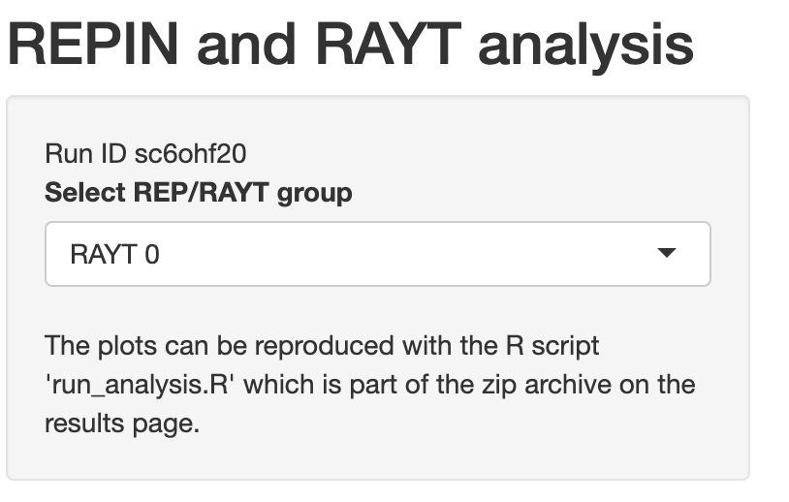

Here you can select the REPIN/RAYT type that is being plotted. This is, for example, the data that is stored in the file presAbs_[number].txt.

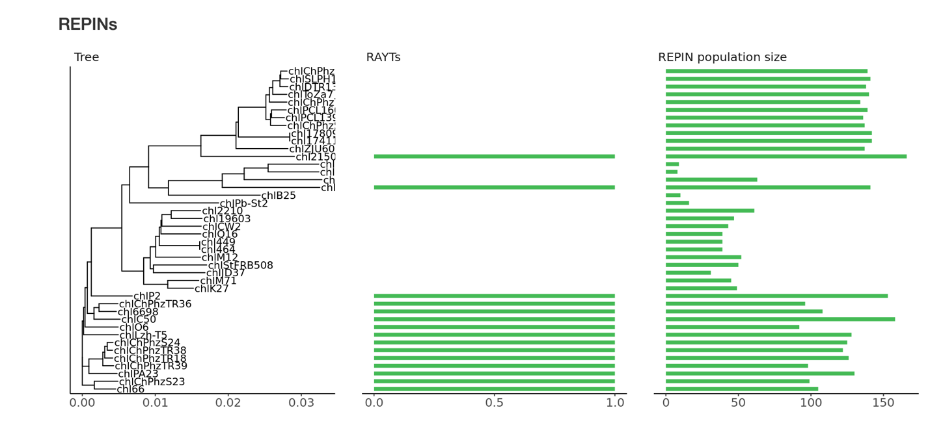

The tree on the left side of the figure shows the phylogeny of the submitted genomes. The tree was built applying neighbor joining (7) to a distance matrix generated with the program “andi” applied to whole genomes (2). The next column shows the presence and absence of the associated RAYT transposases. A RAYT transposase is considered associated when a REPIN of the type is found within 200bp of the transposase. The REPIN population size in each of the genomes is shown in the last column.

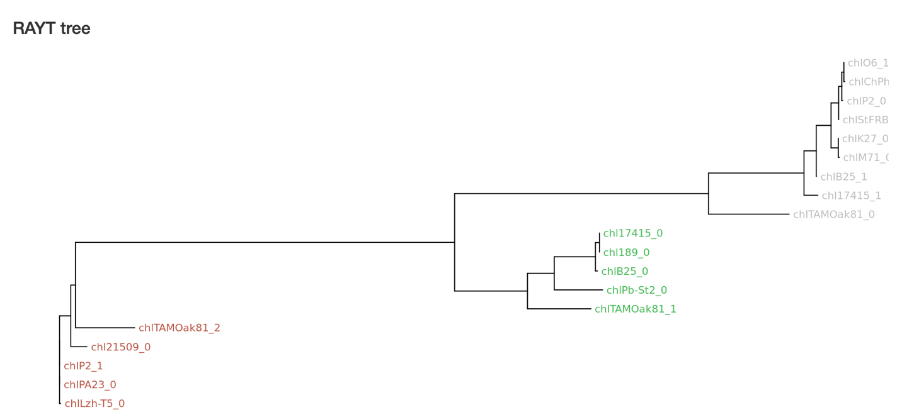

The second plot shows the relationship between the RAYT genes. The tree was generated from a multiple sequence alignment of RAYT proteins using the program XXX. The tree itself is built using XXX. The colors of the tip labels correspond to the associated REPIN types. Colors are usually monophyletic due to a strong association between RAYT and REPIN type.

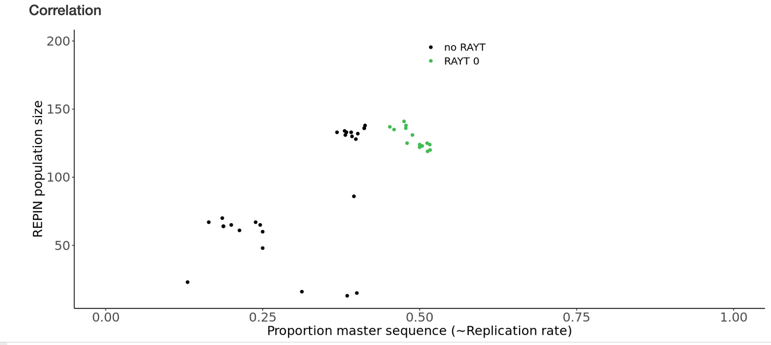

The proportion of master sequences (indicates sequence conservation) in a REPIN population and the REPIN population size. According to Quasispecies theory or mutation-selection balance (8, 9), the higher proportion of master sequences (the most common sequence in the population) correlates with higher duplication rates of the sequence population. The closer populations are to the lower left of the plot, the smaller and more decayed they are and the less likely they are to be alive (i.e. actively replicating). Only populations that are colored are associated with a RAYT transposase.

## References

1. F. Bertels, J. Gallie, P. B. Rainey, Identification and Characterization of Domesticated Bacterial Transposases. *Genome Biol. Evol.* **9**, 2110–2121 (2017).

2. B. Haubold, F. Klötzl, P. Pfaffelhuber, andi: fast and accurate estimation of evolutionary distances between closely related genomes. *Bioinformatics* **31**, 1169–1175 (2015).

3. F. Bertels, P. B. Rainey, Within-Genome Evolution of REPINs: a New Family of Miniature Mobile DNA in Bacteria. *PLoS Genet.* **7**, e1002132 (2011).

4. C. Camacho, *et al.*, BLAST+: architecture and applications. *BMC Bioinformatics* **10**, 421–9 (2009).

5. K. Rutherford, *et al.*, Artemis: sequence visualization and annotation. *Bioinformatics* **16**, 944–945 (2000).

6. A. J. Enright, S. Van Dongen, C. A. Ouzounis, An efficient algorithm for large-scale detection of protein families. *Nucleic Acids Res.* **30**, 1575–1584 (2002).

7. N. Saitou, M. Nei, The neighbor-joining method: a new method for reconstructing phylogenetic trees. *Mol. Biol. Evol.* **4**, 406–425 (1987).

8. F. Bertels, C. S. Gokhale, A. Traulsen, Discovering Complete Quasispecies in Bacterial Genomes. *Genetics* **206**, 2149–2157 (2017).

9. F. Bertels, P. B. Rainey, “REPINs are facultative genomic symbionts of bacterial genomes” (2021).