

**Designing a tool for early diagnosis for dementia from neuroimaging data using machine learning**

*Mert Pinar*

*MSc. Business Intelligence and Analytics*

*W1642104*

# Abstract

# Acknowledgment

Contents

Abstract 1

Acknowledgment 1

Introduction 2

1. Dementia 2

a. Epidemiology 2

b. Alzheimer’s disease (AD) 3

2. Image processing on Diagnosis 5

Objective 6

Methods 7

1. Data Handling 7

a. Use of Big Data Techniques 7

2. Image Processing 8

a. Spherical Brain Mapping 8

b. Brain extraction using FAST-BET library 9

3. Machine Learning 10

a. Unsupervised Learning (Clustering) 10

b. Support Vector Machine 11

c. Add all the other machine learning techniques here 11

Results 12

1. Results for each methods used 12

2. Method 2 12

Discussion 13

Conclusion 14

References 15

# Introduction

## Dementia

Dementia is a cumulative term for a variety of changes that affect brain physiology, those effect person’s daily activities by causing long term and often progressive diminishing on capability of thinking and remembering (Burns and Iliffe, 2009). In addition to these symptoms, there are emotional disturbances, difficulty on speech and motivational decrease (Burns and Iliffe, 2009). For diagnosis there should be distortions on person’s mental functioning and one expected to have a significant decrease than projected due to aging (Budson et al., 2016). Until late 19th century, dementia had a vague description and a simple clinical concept, that at that time it can described as anyone who had lost their ability to think and reason (Berrios, 1987). Moreover, the term was also used for defining the mental illnesses and incapacities those can be reversible by right treatment (Berrios, 1987). In several studies, it is stated that there is no known cure for dementia (Iliffe et al., 2009). However, there are some medications that could help people where disease is at mild to moderate stage, but overall expectation of positive feedback is unlikely (Comission de la transparence, 2012). Despite the challenges of diagnosis and treatment of dementia, Zaccai et al. (2006) are believed that population-focused experiments can break the existing walls of biological indicators for cognitive and behavioural changes, and can provide further information for clinical and neuropsychological developments (Zaccai et al., 2006).

### Epidemiology

Since the population on the Earth is growing old, dementia has become one of the biggest concerns globally, which causes a significant burden for the people themselves besides their families and social and health care groups (Prince et al., 2014). Estimated population with dementia is 135 million within 2050, and the cost of care calculated as $604 billion globally in 2010 and it is expected to rise around $1 trillion by 2050 (Prince et al., 2014). The majority of dementia patients are diagnosed with Alzheimer’s disease, followed by vascular dementia and Lewy body dementia (Bermejo-Pareja et al., 2008). Out of 10-15 thousand patients, 5-8 thousand of them are suffering from Alzheimer’s disease (Bermejo-Pareja et al., 2008). Another study carried out that 0.4% of world’s total population (26.6 million) is diagnosed by Alzheimer’s in 2006, and with its expanding rate, currency of AD will increase three times and the number of people suffering to be quadrupled by 2050 (Brookmeyer et al., 2007).

### Alzheimer’s disease (AD)

Alzheimer’s disease is a neuro-degenerative disorder, which affects multiple brain areas, and demonstrates a progressive disease course with broad range of symptoms changes within the individual patient (Masters et al., 2015a). Disease symptoms are usually spotted in frontal and temporal lobes of the brain tissue, then it spreads to the other areas of the cortex (Masters et al., 2015a). The incidence rate of the disease amongst the population with the age over 65 years old ranges between 10-30% based on gender and ethnicity (Bachman et al., 1993). The disease progresses and spreads exponentially within the brain cells of more than 90% of the patients, which are generally varies between the age of 80-90 years (Masters et al., 2015a). Average duration of the AD is approximately 10 years after diagnosis, yet the initiation of symptoms extends the duration over two decades (Evans et al., 2003).

***Pathophysiology.*** The pathophysiology of the AD can be related the formation of amyloid β (Aβ) plaques and tau fibrils as a result of protein aggregation (Golde et al., 2000, Selkoe, 2001). These accumulation of insoluble plaques in extracellular spaces promote the formation of neurofibrillary structure of the brain (Spielmeyer et al. 1922). In addition, disease also has strong genetic connections via increased production of apolipoprotein E (APOE), which is a crucial risk factor for AD that make individuals more susceptible to disease (Fernandez-Miranda et al., 1997). In overall, these changes in the brain physiology result synaptic and neuron loss, and also decrease in the production of neurotransmitters which are the chemical messengers of neural cells (Masters et al., 2015a). The interrupted communications between the brain cells, or complete loss of these cells can cause the condition called brain atrophy, which is also known as “shrinkage” of the brain (Pini et al., 2016).

***Diagnosis and Monitoring***. Diagnosis of Alzheimer’s disease can be challenging for physicians, since patients in the late stages can develop dementia addition to cognitive symptoms (Knopman et al., 2001). In England, there was a study introduced to find the cases who are in the high risk group such as people older than 75, since age is the most significant factor for dementia, and people with high vascular risk, Parkinson’s disease and learning impairment, were effected either in wrong way or right way by the policy (Bamford et al., 2007). The policy emphasized memory assessment of people who may or may not have the symptoms, which raised the stress of the patients and questioned itself as if it is cost effective (Iliffe et al., 2009). As stated before diagnosing either dementia and Alzheimer’s disease can be difficult due to subject not accepting that he/she forgets at their earlier stages, similarity of symptoms with memory loss that comes with normal ageing process and diversity of other indications as well, for example uncertainty on making decisions and hassle to find the words whilst speaking (Kostopoulou et al., 2008). On the other hand, co-morbidies (i.e. cerebrovascular disease) and hippocampal sclerosis are very common within the age range of AD, which makes diagnosis really complicated, in addition to that Alzheimer’s disease have many characteristics in common with other neuro-degenerative diseases, for example Parkinson’s disease (Duncan et al., 2014). With all the symptoms and the progress of sickness brings one question upfront, which is Alzheimer’s disease is a normal part of aging or it is a discrete disease process.

Aβ PET imaging contains a technique (Pittsburgh compound B (PiB)) that uses radioactive analogue of the fluorescent amyloid dye thioflavin-T, which goes through the blood-brain barrier (BBB), binding Aβ (Mathis et al., 2002). In the past ten years, studies with PiB helped people to understand the correlation between Aβ accumulation and cognitive decline, neuro-degeneration and dementia phases of Alzheimer’s disease (Masters et al., 2015b). The studies show that accumulation of Aβ starts years before dementia and being followed by cognitive decline and brain atrophy, and also in long term studies Aβ PET is a significant marker on forecasting the progression from mild cognitive impairment to Alzheimer’s disease (Rowe et al., 2013, Villemagne et al., 2013). That causes clinical misdiagnoses (%35), that patients with negative Aβ PET scans were misdiagnosed as having Alzheimer’s disease, moreover co-morbidies and hippocampal sclerosis makes it difficult to judge and diagnose (Salloway et al., 2014). Hippocampal volume is measured by the neuronal counts, in early, mild stages of AD Hippocampal volume is already decreased 15-30% whereas, in a converting type of Mild Cognitive Impairment which turns into AD on later stages, the volume is decreased by 10-15% (Shi et al., 2009). However, atrophy values vary with the progression of the severity of AD, in contrast as shown in Figure 1 Aβ markers are more likely to be effected than structural markers to conversion of MCI to mild stages of AD (Sluimer et al., 2008).

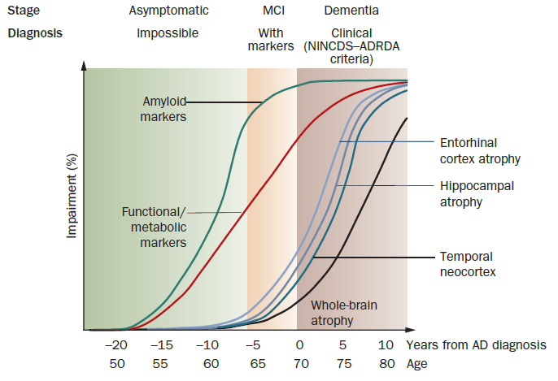

**Figure 1: Difference of the changes between the biomarkers during the advance of Alzheimer’s disease.**

Theoretical model of biological markers in Alzheimer’s disease, X axis indicates the ages of the patients and years before/after their diagnosis of Alzheimer’s disease, Y axis shows the percentage changes of the biological markers whereas lines indicates the biological markers including; Amyloid marker (green), Funtional/metabolic markers (red), Entorhinal cortex atrophy (light blue), Hippocampal atrophy (purple), Temporal neocortex (blue) and Whole-brain atrophy (black). On the graph, green layout parts are the stage that there are no symptoms exist whereas, orange part indicates mild cognitive impairment and brown part is where all the samples are diagnosed with Alzheimer’s disease. Figure is obtained from Frisoni et al. (2010).

## Image processing on Diagnosis

# Objective

# Methods

## Data Processing

Data was the collection of T1-weighted MR images which were in nii format, gathered from ADNI* (Alzheimer’s disease Neuroimaging Initiative) database. In dataset, there were total of 479 patients and 1314 MR images. 415 of those images were belong to healthy participants, 657 of those images were whom are suffering from mild cognitive impairment and, finally 242 images with patients of AD. The age of study subjects were varying between X to Y years, which the participant demographics are given in Table X.

*Data used in preparation of this study were obtained from the Alzheimer’s Disease Neuroimaging Initiative (ADNI) database (adni.loni.usc.edu). As such, the investigators within the ADNI contributed to the design and implementation of ADNI and/or provided data but did not participate in analysis or writing of this report. A complete listing of ADNI investigators can be found at: <http://adni.loni.usc.edu/wp-content/uploads/how_to_apply/ADNI_Acknowledgement_List.pdf>

### Use of Big Data Techniques

After data was obtained from ADNI database, it was stored in a folder size of 90 GB. First approach to organize the data for smart loops for the image processing part. Extract, Transform and Load approach was used for the images. There were two image processing techniques examined, that changed the course of the transform stage and generated different output, but for both experiments group of the patients were gathered from the headers of the images.

For the first image processing trial, images were extracted from pile and transformed into huge arrays with 10 million elements in it, then those arrays were stored in a dataset to be loaded by the machine. For the second approach, images were directly transformed into meaningful values; i.e brain volume, volume of gray matter, etc. After processing the images values for each patient stored in a dataset with patients’ ID, group respectively. Datasets were ready to be used by machine learning techniques.

## Image Processing

After sorting the data, images should turn into some values those are meaningful, so that computer could relate mathematical formulas by the pattern of the advancing disease. Goal of the image processing part was to convert images to large sized arrays.

### Spherical Brain Mapping

Spherical Brain Mapping (SBM) is a technique that focuses on the spherical coordinates of the brain and convert brain image from 3D to 2D map which first used by Martinez-Murcia et al. (2016). Central point of the MRI image set as a base point and a mapping vector (v) of length of N created and populated for each angles covering the brain (Figure 2). After getting Vθ,ϕ populated with each voxel by the mapping vector v there can be some formulas applied to get certain values such as brain surface or thickness of the tissue.

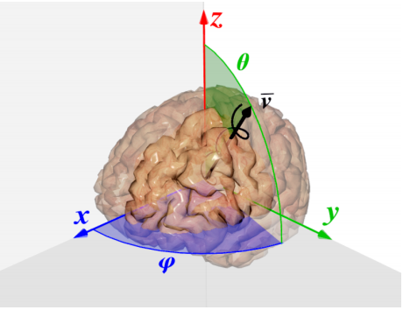

**Figure 2: Computation of the mapping vector**

Illustration of populating the mapping vector v, as the angles θ and ϕ embraces the brain on every angle, with that there won’t be any missing point in the output of the model. The figure is obtained from Martinez-Murcia et al. (2016)

First parameter is the brain surface. Surface can be calculated as it is the sum of every last tissue voxel of each Vθ,ϕ. Tissue loss on the surface or worsening on structural model could be measured by using the formula:

$$v_{surf}= \max_{i}{{(V}_{θ, ϕ}(i)) ADDIN EN.CITE ADDIN EN.CITE.DATA } ∀i∈1,…P$$

Then, for measuring white matter and grey matter of the brain tissue, first the thickness of the tissue was calculated by differentiating the every last point of each vectors from the starting point of their first. Hence the distance between the starting point and the ending point was assessed using the formula below.

$$v_{thick}= \max_{i}{{(V}_{θ, ϕ}(i))}- \min_{i}{{(V}_{θ, ϕ}(i))} ∀i∈1,…P$$

Results of the calculations was the value $v$ mapped for every direction ranging θ and ϕ, and each pixel was the $v$ value. These $v$ vectors were divided to $n$ equal parts so that we would have brain in layers, which we called layered approach. Then these layers were kept in huge datasets as samples for Support Vector Machines.

### Brain extraction using FAST-BET library

Second approach used was extracting the brain and calculate the volume of white matter, grey matter and volume of the brain. To extract the relevant information fslr library had been used which heavily uses oro.nifti package that is commonly used on processing and analysing the Neuroimaging Informatics Technology Initiative (NIfTI) format. Library also provides functions for plotting and manipulating the images which was frequently used in this project. Fslr workflow was ‘nifti’ object was passed to the fslr function, with that an FSL command was created and executed.

fslbet(infile = “ADNIDataset$mriAddress[i]”,

outfile = “ADNIDataset$extractedBrain[i]”,

opts = “-B -f 0.1 -v”, # from Popescu et al.

Brain extraction as call as skull stripping is very important in various analyses, for that FSL’s brain extraction tool was used with the parameters recommended by Popescu et al. (2012). BET was ran on the T1 with the option –B for inhomogeneity correction and the option –f 0.1 indicates the fractional intensity parameter in BET, which is within the range of 0 and 1 and determines the brain image’s edge location smaller values sets larger brain masks. After applying those masks to the T1 image, images shown in Figure 3 was obtained. With those images and the output values of BET, numerous analysis such as volume of brain tissue can be run. FAST (FMRIB’s Automated Segmentation Tool) was used for further analysis in this project. FAST separated the 3D image of the extracted brain into different tissue types (grey matter, white matter, CSF, etc.), at the same time it was corrected the intensity variations also known as bias field. Algorithm uses hidden Markov model, and the whole process was fully automated, which generated a bias field-corrected input image and ran a partial volume and tissue segmentation.

Volume of white matter, grey matter and brain tissue was extracted for this project. Output was written and read into R and stored for the next steps.

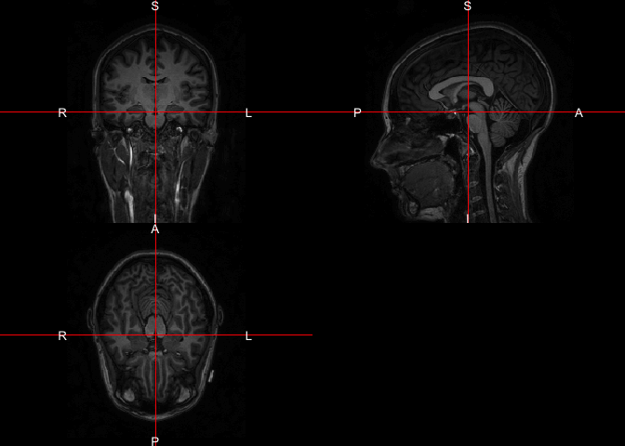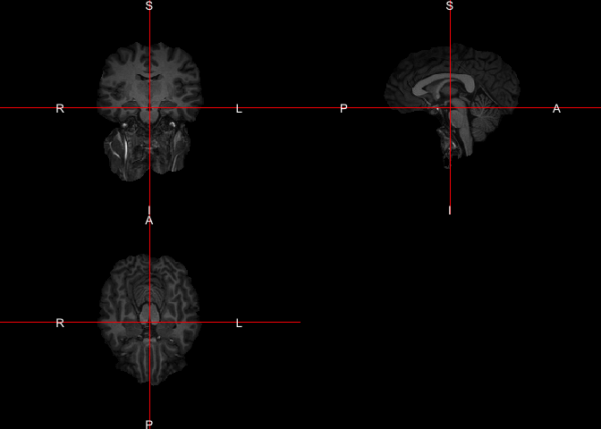

**Figure 3 Results from BET**

On the left hand side, T1 image is shown, on the right hand side extracted brain was displayed as the image does not include any areas of skull or neck.

## Machine Learning

After organizing the data, an array consists of patient IDs, groups and MRI values, such as volume of brain tissue, white matter and grey matter, was obtained. Steps in this part was calculating the clusters by unsupervised learning then determining the machine learning technique which was SVM with Leave One Out Cross Validation to make the model more accurate.

### Unsupervised Learning (Clustering)

First step to determine which machine learning technique to use was clustering the data to see it visually. To do this, group column was deleted from the initial dataset, then ran the NbClust function to obtain how many clusters should there be according to various algorithms.

clusterSuggestion = NbClust(dataset, max.nc = 5, min.nc=2,

method = “kmeans”)

The goal was to cluster the rows of dataset based on the variables on selected columns, i.e volume values of brain, and let available indices to spot the ideal amount of clusters in the original data. The amount of cluster set to be between 2 and 5. As a parameter to the function method was chosen to be k-means as it is the one of the most popular partitioning algorithms since it was used in numerous packages in R, such as cclust, clustTool, clue, among others.

### Support Vector Machine

Since there was 3 classes, those were Normal Control, Alzheimer’s Disease and Mild Cognitive Impairment, separation of classes was needed, hence Support Vector Machines were used. Two types of SVM were tested in this project, and both were developed as Leave One out Cross Validated SVMs, those were linear and polynomial. C hyper parameter was 1 as default for both models and for polynomial kernel function degree was 3, scale was 0.1 and offset was 1. Number of support vectors for polynomial model was 262 whereas it was 261 for linear model. Since SVM is a margin binary classifier which’s function can be represented as below;

$$y\left(x\right)= \sum_{n=1}^{N}{w_{n}.t_{n}. k\left(x,x_{n}\right)+b}$$

Where N is the number of the subjects in the dataset, $w_{i}$ is the weight of the value which was assigned by the SVM during the training step and $k\left(x,x_{n}\right)$ is the kernel function that shapes the separating hypert-plane, and b is a bias. $y\left(x\right)$ is the predicted label for the subject. Caret library was used for SVM training and classification, all of the codes were written in R.

# Results

## Results for Data Processing

Study participants were separated into groups of healthy volunteers (Normal Control, NC), mild cognitive impairment (MCI) and Alzheimer’s disease (AD). The information of patient demographics are shown in the ***Table 1***, below.

**Table 1.** Demographic information of images used in the study

|  |  |  |  |
| --- | --- | --- | --- |
|  | NC | MCI | AD |
| Number of images | 96 | 151 | 45 |
| Gender (Female %) | 13.4% | 21.2% | 6.3% |
| Age (Mean) |  |  |  |
| Age (Range) |  |  |  |

In the dataset provided by ADNI, XX% percent of the patients were females, who have in total of XXX images out of 292. Amongst female images %21 of them are diagnosed with mild cognitive impairment, which is 51.7% in total dataset. 6.3% of images belong to females who are diagnosed as Alzheimer’s disease, with an average age of XX.X years, while healthy images were 13.4% within the range of XX-XX years of age.

## Results of Image Processing

### Spherical Brain Mapping

With Spherical Brain mapping approach, T1 images were put under some operations explained before and obtained a large-sized array. That process took about 3 minutes for each image and output of the function was an array consists of 10.9 million elements. Summary of the output was shown below.

NIfTI-1 format

Type : nifti

Data Type : 16 (FLOAT32)

Bits per Pixel : 32

Slice Code : 0 (Unknown)

Intent Code : 0 (None)

Qform Code : 1 (Scanner_Anat)

Sform Code : 0 (Unknown)

Dimension : 256 x 256 x 166

Pixel Dimension : 0.95 x 0.94 x 1.2

Voxel Units : mm

Time Units : Unknown

Unfortunately this method could not applied to the whole dataset, reasons will be discussed.

### Results of Brain Extraction using FSL-BET and FAST

Same as the spherical brain mapping fslbet also took the address of the image as an input and finds the NIfTI image and processes it. First step was to load the image to FSL which took ~1 minute, then bet function was used to extract the brain out of the skull, that process lasted around 3 minutes. As an output FSL function returns a Large nifti file type which is approximately 45 MB, that is almost as same as the raw image. The output was a brain mask image that covers the brain but extracts the skull as this mask image was binary, i.e 0 was outside of the brain whereas 1 was inside. This mask was used for later processing as the masks were generated from the original related image. Output of the function was eliminating the areas which wasn’t covered by the mask explained before.

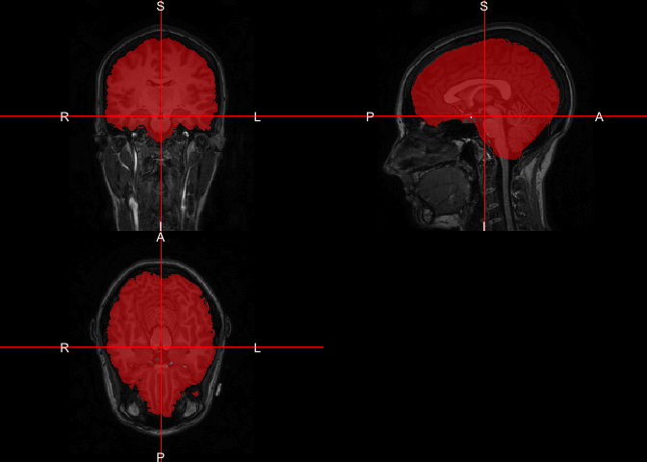

**Figure 4**: Image of the mask overlaid on the original image

Then fast function was called with 3 classes chosen, those classes were white matter, grey matter and CSF. For this project only volume of white and grey matter was used. It gave us the options to print out various images, first of them was the partial volume maps, that was the partial volume image for each class, where each voxel contains a value in range of 0 to 1 that represents the proportion of the relative class’ tissue in that voxel. Second output was binary segmentation that was one image per class, this was a binary also known as hard segmentation where each voxel was classified into only one class. Any correction option for input wasn’t selected and no information of estimated bias field was used.

### Results of Support Vector Machines

In this project 4 different Support Vector Machines were created and every model were used Leave-One-Out cross validation as resampling. First of them was with the linear kernel and used white matter ratio, grey matter ratio and the total volume of the brain as the formula. Output of the training model was given below;

Support Vector Machines with Linear Kernel

292 samples

3 predictor

3 classes: 'AD', 'CN', 'MCI'

No pre-processing

Resampling: Leave-One-Out Cross-Validation

Summary of sample sizes: 291, 291, 291, 291, 291, 291, ...

Resampling results:

Accuracy Kappa

0.5171233 0

Tuning parameter 'C' was held constant at a value of 1

Model was tested with the last 90 elements of the total dataset. Accuracy of the machine was observed as 60%, but it diagnosed every image with mild cognitive impairment. Confusion matrix of the output was given below;

Confusion Matrix and Statistics

Reference

Prediction AD CN MCI

AD 0 0 0

CN 0 0 0

MCI 8 28 56

Overall Statistics

Accuracy : 0.6087

95% CI : (0.5014, 0.7088)

No Information Rate : 0.6087

P-Value [Acc > NIR] : 0.5455

Kappa : 0

Mcnemar's Test P-Value : NA

Statistics by Class:

Class: AD Class: CN Class: MCI

Sensitivity 0.00000 0.0000 1.0000

Specificity 1.00000 1.0000 0.0000

Pos Pred Value NaN NaN 0.6087

Neg Pred Value 0.91304 0.6957 NaN

Prevalence 0.08696 0.3043 0.6087

Detection Rate 0.00000 0.0000 0.6087

Detection Prevalence 0.00000 0.0000 1.0000

Balanced Accuracy 0.50000 0.5000 0.5000

To test if the predictor amount decreases, will the machine be more accurate. For that since Alzheimer’s disease can be basically explained as shrinkage of the brain, only changes on the volume of the brain was taken as an input to the machine.

Support Vector Machines with Linear Kernel

292 samples

1 predictor

3 classes: 'AD', 'CN', 'MCI'

No pre-processing

Resampling: Leave-One-Out Cross-Validation

Summary of sample sizes: 291, 291, 291, 291, 291, 291, ...

Resampling results:

Accuracy Kappa

0.5171233 0

Tuning parameter 'C' was held constant at a value of 1

Then model was tested with the last 90 objects in the dataset. Accuracy was exactly same as the machine with the three predictors, and this machine also diagnosed every image as mild cognitive impairment. Confusion matrix of the output of the machine is given below;

Confusion Matrix and Statistics

Reference

Prediction AD CN MCI

AD 0 0 0

CN 0 0 0

MCI 8 28 56

Overall Statistics

Accuracy : 0.6087

95% CI : (0.5014, 0.7088)

No Information Rate : 0.6087

P-Value [Acc > NIR] : 0.5455

Kappa : 0

Mcnemar's Test P-Value : NA

Statistics by Class:

Class: AD Class: CN Class: MCI

Sensitivity 0.00000 0.0000 1.0000

Specificity 1.00000 1.0000 0.0000

Pos Pred Value NaN NaN 0.6087

Neg Pred Value 0.91304 0.6957 NaN

Prevalence 0.08696 0.3043 0.6087

Detection Rate 0.00000 0.0000 0.6087

Detection Prevalence 0.00000 0.0000 1.0000

Balanced Accuracy 0.50000 0.5000 0.5000

Then different built machines were tried to increase the accuracy of the models. Instead of tuning the linear kernel support vector machine, support vector machine with polynomial kernel and let the model to choose the optimal degree, scale and the C value. First machine was given the formula with white matter and grey matter ratio and brain volume.

Support Vector Machines with Polynomial Kernel

292 samples

3 predictor

3 classes: 'AD', 'CN', 'MCI'

No pre-processing

Resampling: Leave-One-Out Cross-Validation

Summary of sample sizes: 291, 291, 291, 291, 291, 291, ...

Resampling results across tuning parameters:

degree scale C Accuracy Kappa

1 0.001 0.25 0.5171233 0.00000000

1 0.001 0.50 0.5171233 0.00000000

1 0.001 1.00 0.5171233 0.00000000

1 0.010 0.25 0.5171233 0.00000000

1 0.010 0.50 0.5171233 0.00000000

1 0.010 1.00 0.5171233 0.00000000

1 0.100 0.25 0.5171233 0.00000000

1 0.100 0.50 0.5171233 0.00000000

1 0.100 1.00 0.5171233 0.00000000

2 0.001 0.25 0.5171233 0.00000000

2 0.001 0.50 0.5171233 0.00000000

2 0.001 1.00 0.5171233 0.00000000

2 0.010 0.25 0.5171233 0.00000000

2 0.010 0.50 0.5171233 0.00000000

2 0.010 1.00 0.5171233 0.00000000

2 0.100 0.25 0.5171233 0.00000000

2 0.100 0.50 0.5171233 0.00000000

2 0.100 1.00 0.5171233 0.00000000

3 0.001 0.25 0.5171233 0.00000000

3 0.001 0.50 0.5171233 0.00000000

3 0.001 1.00 0.5171233 0.00000000

3 0.010 0.25 0.5171233 0.00000000

3 0.010 0.50 0.5171233 0.00000000

3 0.010 1.00 0.5171233 0.00000000

3 0.100 0.25 0.5171233 0.00000000

3 0.100 0.50 0.5068493 -0.01720009

3 0.100 1.00 0.5205479 0.03040653

Accuracy was used to select the optimal model using the largest value.

The final values used for the model were degree = 3, scale = 0.1 and C = 1.

It selected degree value as 3, scale as 0.1 and C as 1 for a more accurate model, with accuracy of 52%. Model was tested with the same 90 elements those were used to test the other models.

Confusion Matrix and Statistics

Reference

Prediction AD CN MCI

AD 0 0 0

CN 1 4 1

MCI 7 24 55

Overall Statistics

Accuracy : 0.6413

95% CI : (0.5346, 0.7387)

No Information Rate : 0.6087

P-Value [Acc > NIR] : 0.2987

Kappa : 0.1276

Mcnemar's Test P-Value : 2.073e-06

Statistics by Class:

Class: AD Class: CN Class: MCI

Sensitivity 0.00000 0.14286 0.9821

Specificity 1.00000 0.96875 0.1389

Pos Pred Value NaN 0.66667 0.6395

Neg Pred Value 0.91304 0.72093 0.8333

Prevalence 0.08696 0.30435 0.6087

Detection Rate 0.00000 0.04348 0.5978

Detection Prevalence 0.00000 0.06522 0.9348

Balanced Accuracy 0.50000 0.55580 0.5605

This model’s accuracy is slightly higher than linear kernel model as this model’s accuracy is 64% and machine was diagnosing most of the images as mild cognitive impairment. Model was tested with one predictor, as done the same for the linear kernel-ed model. Polynomial kernel model was trained with one predictor. Machine had chosen degree as 1 with scale of 0.001 and C value 0.25 to maximize the accuracy of the model, but the output was not different from the output of the linear kernel model with the same formula, i.e using brain volume to train the model. Machine acted same as it did when it was working on linear kernel as it diagnosed every image as mild cognitive impairment. Confusion matrix for the model was given below.

Confusion Matrix and Statistics

Reference

Prediction AD CN MCI

AD 0 0 0

CN 0 0 0

MCI 8 28 56

Overall Statistics

Accuracy : 0.6087

95% CI : (0.5014, 0.7088)

No Information Rate : 0.6087

P-Value [Acc > NIR] : 0.5455

Kappa : 0

Mcnemar's Test P-Value : NA

Statistics by Class:

Class: AD Class: CN Class: MCI

Sensitivity 0.00000 0.0000 1.0000

Specificity 1.00000 1.0000 0.0000

Pos Pred Value NaN NaN 0.6087

Neg Pred Value 0.91304 0.6957 NaN

Prevalence 0.08696 0.3043 0.6087

Detection Rate 0.00000 0.0000 0.6087

Detection Prevalence 0.00000 0.0000 1.0000

Balanced Accuracy 0.50000 0.5000 0.5000

### Results of Decision Tree

### Results of Unsupervised Learning

# Discussion

In this part, effectiveness of Spherical Brain Mapping on texture measures on prediction of MCI patients’ conversion rate to AD (Martinez-Murcia et al., 2016). Since MR images are used frequently on diagnosis of AD by inspecting the decrease of the grey matter and white matter, yet decay is mainly been seen in the grey matter tissue (Baron et al., 2001, Misra et al., 2009).

Reasons to use k-means: 1. Select as many points as the number of desired clusters to create initial centers. 2. Each observation is then associated with the nearest center to create temporary clusters. 3. The gravity centers of each temporary cluster are calculated and these become the new cluster centers. 4. Each observation is reallocated to the cluster which has the closest center. 5. This procedure is iterated until convergence.

# Conclusion

# References

BACHMAN, D. L., WOLF, P. A., LINN, R. T., KNOEFEL, J. E., COBB, J. L., BELANGER, A. J., WHITE, L. R. & D'AGOSTINO, R. B. 1993. Incidence of dementia and probable Alzheimer's disease in a general population: the Framingham Study. *Neurology,* 43**,** 515-9.

BAMFORD, C., ECCLES, M., STEEN, N. & ROBINSON, L. 2007. Can primary care record review facilitate earlier diagnosis of dementia? *Fam Pract,* 24**,** 108-16.

BARON, J. C., CHETELAT, G., DESGRANGES, B., PERCHEY, G., LANDEAU, B., DE LA SAYETTE, V. & EUSTACHE, F. 2001. In vivo mapping of gray matter loss with voxel-based morphometry in mild Alzheimer's disease. *Neuroimage,* 14**,** 298-309.

BERMEJO-PAREJA, F., BENITO-LEON, J., VEGA, S., MEDRANO, M. J., ROMAN, G. C. & NEUROLOGICAL DISORDERS IN CENTRAL SPAIN STUDY, G. 2008. Incidence and subtypes of dementia in three elderly populations of central Spain. *J Neurol Sci,* 264**,** 63-72.

BERRIOS, G. E. 1987. Dementia during the seventeenth and eighteenth centuries: a conceptual history. *Psychol Med,* 17**,** 829-37.

BROOKMEYER, R., JOHNSON, E., ZIEGLER-GRAHAM, K. & ARRIGHI, H. M. 2007. Forecasting the global burden of Alzheimer's disease. *Alzheimers Dement,* 3**,** 186-91.

BUDSON, A. E., SOLOMON, P. R. & BUDSON, A. E. 2016. Memory loss, Alzheimer's disease, and dementia : a practical guide for clinicians.

BURNS, A. & ILIFFE, S. 2009. Dementia. *BMJ,* 338**,** b75.

COMISSION DE LA TRANSPARENCE 2012. Drugs for Alzheimer's disease: best avoided. No therapeutic advantage. *Prescrire Int,* 21**,** 150.

DUNCAN, G. W., KHOO, T. K., COLEMAN, S. Y., BRAYNE, C., YARNALL, A. J., O'BRIEN, J. T., BARKER, R. A. & BURN, D. J. 2014. The incidence of Parkinson's disease in the North-East of England. *Age Ageing,* 43**,** 257-63.

EVANS, D. A., BENNETT, D. A., WILSON, R. S., BIENIAS, J. L., MORRIS, M. C., SCHERR, P. A., HEBERT, L. E., AGGARWAL, N., BECKETT, L. A., JOGLEKAR, R., BERRY-KRAVIS, E. & SCHNEIDER, J. 2003. Incidence of Alzheimer disease in a biracial urban community: relation to apolipoprotein E allele status. *Arch Neurol,* 60**,** 185-9.

FERNANDEZ-MIRANDA, C., CANCELAS, P., DE LA CALLE, A., GOMEZ, R., MORENO, E., GOMEZ-GERIQUE, J. & DEL PALACIO, A. 1997. Changes in phenotypes of apolipoprotein E and apolipoprotein(a) in liver transplant recipients. *Clin Transplant,* 11**,** 325-7.

FRISONI, G. B., FOX, N. C., JACK, C. R., JR., SCHELTENS, P. & THOMPSON, P. M. 2010. The clinical use of structural MRI in Alzheimer disease. *Nat Rev Neurol,* 6**,** 67-77.

GOLDE, T. E., ECKMAN, C. B. & YOUNKIN, S. G. 2000. Biochemical detection of Abeta isoforms: implications for pathogenesis, diagnosis, and treatment of Alzheimer's disease. *Biochim Biophys Acta,* 1502**,** 172-87.

ILIFFE, S., ROBINSON, L., BRAYNE, C., GOODMAN, C., RAIT, G., MANTHORPE, J., ASHLEY, P. & DE, N. P. C. C. S. G. 2009. Primary care and dementia: 1. diagnosis, screening and disclosure. *Int J Geriatr Psychiatry,* 24**,** 895-901.

KNOPMAN, D. S., DEKOSKY, S. T., CUMMINGS, J. L., CHUI, H., COREY-BLOOM, J., RELKIN, N., SMALL, G. W., MILLER, B. & STEVENS, J. C. 2001. Practice parameter: diagnosis of dementia (an evidence-based review). Report of the Quality Standards Subcommittee of the American Academy of Neurology. *Neurology,* 56**,** 1143-53.

KOSTOPOULOU, O., DELANEY, B. C. & MUNRO, C. W. 2008. Diagnostic difficulty and error in primary care--a systematic review. *Fam Pract,* 25**,** 400-13.

MARTINEZ-MURCIA, F. J., GORRIZ, J. M., RAMIREZ, J., ORTIZ, A. & FOR THE ALZHEIMER'S DISEASE NEUROIMAGING, I. 2016. A Spherical Brain Mapping of MR Images for the Detection of Alzheimer's Disease. *Curr Alzheimer Res,* 13**,** 575-88.

MASTERS, C. L., BATEMAN, R., BLENNOW, K., ROWE, C. C., SPERLING, R. A. & CUMMINGS, J. L. 2015a. Alzheimer's disease. *Nat Rev Dis Primers,* 1**,** 15056.

MASTERS, M. C., MORRIS, J. C. & ROE, C. M. 2015b. "Noncognitive" symptoms of early Alzheimer disease: a longitudinal analysis. *Neurology,* 84**,** 617-22.

MATHIS, C. A., BACSKAI, B. J., KAJDASZ, S. T., MCLELLAN, M. E., FROSCH, M. P., HYMAN, B. T., HOLT, D. P., WANG, Y., HUANG, G. F., DEBNATH, M. L. & KLUNK, W. E. 2002. A lipophilic thioflavin-T derivative for positron emission tomography (PET) imaging of amyloid in brain. *Bioorg Med Chem Lett,* 12**,** 295-8.

MISRA, C., FAN, Y. & DAVATZIKOS, C. 2009. Baseline and longitudinal patterns of brain atrophy in MCI patients, and their use in prediction of short-term conversion to AD: results from ADNI. *Neuroimage,* 44**,** 1415-22.

PINI, L., PIEVANI, M., BOCCHETTA, M., ALTOMARE, D., BOSCO, P., CAVEDO, E., GALLUZZI, S., MARIZZONI, M. & FRISONI, G. B. 2016. Brain atrophy in Alzheimer's Disease and aging. *Ageing Res Rev,* 30**,** 25-48.

POPESCU, V., BATTAGLINI, M., HOOGSTRATE, W. S., VERFAILLIE, S. C., SLUIMER, I. C., VAN SCHIJNDEL, R. A., VAN DIJK, B. W., COVER, K. S., KNOL, D. L., JENKINSON, M., BARKHOF, F., DE STEFANO, N., VRENKEN, H. & GROUP, M. S. 2012. Optimizing parameter choice for FSL-Brain Extraction Tool (BET) on 3D T1 images in multiple sclerosis. *Neuroimage,* 61**,** 1484-94.

PRINCE, M., ALBANESE, E., GUERCHET, M. & PRINA, M. 2014. Dementia and risk reduction: an analysis of protective and modifiable risk factors. . *Alzheimer’s Disease International.*

ROWE, C. C., BOURGEAT, P., ELLIS, K. A., BROWN, B., LIM, Y. Y., MULLIGAN, R., JONES, G., MARUFF, P., WOODWARD, M., PRICE, R., ROBINS, P., TOCHON-DANGUY, H., O'KEEFE, G., PIKE, K. E., YATES, P., SZOEKE, C., SALVADO, O., MACAULAY, S. L., O'MEARA, T., HEAD, R., COBIAC, L., SAVAGE, G., MARTINS, R., MASTERS, C. L., AMES, D. & VILLEMAGNE, V. L. 2013. Predicting Alzheimer disease with beta-amyloid imaging: results from the Australian imaging, biomarkers, and lifestyle study of ageing. *Ann Neurol,* 74**,** 905-13.

SALLOWAY, S., SPERLING, R. & BRASHEAR, H. R. 2014. Phase 3 trials of solanezumab and bapineuzumab for Alzheimer's disease. *N Engl J Med,* 370**,** 1460.

SELKOE, D. J. 2001. Alzheimer's disease: genes, proteins, and therapy. *Physiol Rev,* 81**,** 741-66.

SHI, F., LIU, B., ZHOU, Y., YU, C. & JIANG, T. 2009. Hippocampal volume and asymmetry in mild cognitive impairment and Alzheimer's disease: Meta-analyses of MRI studies. *Hippocampus,* 19**,** 1055-64.

SLUIMER, J. D., VAN DER FLIER, W. M., KARAS, G. B., FOX, N. C., SCHELTENS, P., BARKHOF, F. & VRENKEN, H. 2008. Whole-brain atrophy rate and cognitive decline: longitudinal MR study of memory clinic patients. *Radiology,* 248**,** 590-8.

VILLEMAGNE, V. L., BURNHAM, S., BOURGEAT, P., BROWN, B., ELLIS, K. A., SALVADO, O., SZOEKE, C., MACAULAY, S. L., MARTINS, R., MARUFF, P., AMES, D., ROWE, C. C., MASTERS, C. L., AUSTRALIAN IMAGING, B. & LIFESTYLE RESEARCH, G. 2013. Amyloid beta deposition, neurodegeneration, and cognitive decline in sporadic Alzheimer's disease: a prospective cohort study. *Lancet Neurol,* 12**,** 357-67.

ZACCAI, J., INCE, P. & BRAYNE, C. 2006. Population-based neuropathological studies of dementia: design, methods and areas of investigation--a systematic review. *BMC Neurol,* 6**,** 2.