
International Journal of Computer Sciences and Engineering Open Access
Survey Paper Vol.-6, Issue-9, Sep 2018 E-ISSN: 2347-2693

A Survey of Travel Recommender System

Roopesh L R^{1*}, Tulasi.B¹

¹ Dept. Computer Science, CHRIST Deemed to be University, Bengaluru, India

*Corresponding Author: Roopesh.lr@cs.christuniversity.com, Ph.: +91-7676813642

Available online at: www.ijcseonline.org
Received: ………./2018, Revised: ………..2018, Accepted: ………2018, Published: 30/Sep/2018
Abstract— Recommender Systems is one of the most useful application of machine learning. They are collection of simple algorithms which tend to provide most relevant and accurate data as per user’s requirement. Travel and Tourism domain is one of the important economic area of a nation and recommender systems in this domain would cater to not only the tourists but also to the governments. This paper is a study of the various recommender systems available in the field of travel and tourism.

Keywords— Point of Interst(POI), Collaborative filtering, Hybrid Filtering, Recommender System, weather condition

,

Introduction
Recommender systems are encountered every day in different forms to serve various purposes. The effectives of recommender systems are seen in the amount of revenue generated through it. Recommender systems finds relationships between users and things they need is just based on the actions, there is no human curation involved at all, and it uses many patterns.
Recommendations systems are not only to buy items online, but there are recommender systems which recommend content. This is quite popular like a newspaper in United States it looks at the articles that are read by any reader in past to recommend other articles the reader might enjoy reading. By just looking at the patterns in the articles people read, instead of patterns in the things people buy, there is a slight difference between search engines and Recommender systems, search results are personalized. It is not only doing information retrieval also it is looking at past behaviors as in individual to find out what search results are most suitable for the person searching.
Recommender systems just filter the content which based on past actions. Recommender systems are everywhere and they play the important role in building modern economy. There are different types of Recommender Systems which uses any of the below mentioned filtering techniques: Collaborative filtering, Content-based filtering, Context filtering, Hybrid filtering, Demographic filtering, Knowledge, Social filtering, Utility Recommender System, Market Basket Analysis, Community-based filtering, Trust based recommender systems.
Recommender Systems where implemented in many domains like Social websites like Facebook, Entertainment like Netflix, YouTube, Ecommerce like Amazon, Flipkart, In Travel Domain like TripAdvisor, Trivago.
In this section it says about the organization of the paper which as follows, Section I contains Introduction of Recommender System, Section II contains overview of Travel Recommender System, Section III contains related work of Recommender System with respect to Travel and Tourism, Section IV concludes with future scope.

Travel Recommender System Overview
Travel Recommender System is a recommendation system which is used by the tourist and travelers to fulfil their needs which makes user to take decisions easy like deciding the travel destinations, finding nearby Point of Interest (POI), restaurants, shortest distance to travel, accommodation. Generally, travel recommender system is of different types like generic type recommender system, personalized recommender system. Generic type of recommender system would consist of destination details like example tourist attractions near Kashmir. Personalized recommender system would require personal preferences like gender, type of vacation, number of people, number of days and many more [1].
Recommendation system in the field of travel and tourism domain is very less compared to other domains. This came into existence when people started thinking about their own private space apart from the busy work or the daily routine. Tourism is a part of revenue generation in any nation. As many tourists prefer using online services instead of Tours and Travel package for vacations to local places within the State or Country, also for booking the bus, flight, hotel.
Here are the few insights which says travel and tourism plays an important role in the economic performance of a country [2].
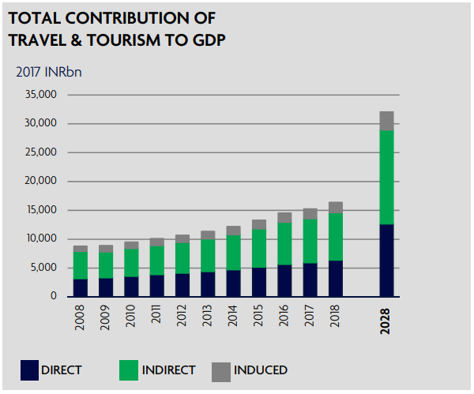
Figure 1. GDP through Tourism
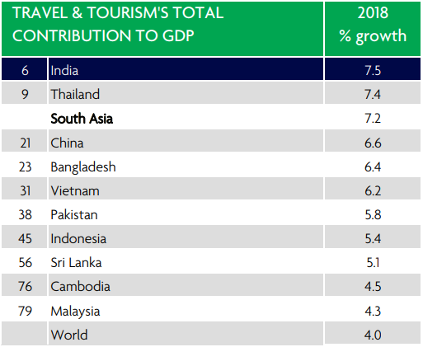
Figure 2. GDP growth in India
There are different categories in tourism they are listed as below.
- Atomic tourism
- Cultural tourism
- Echo tourism
- Geo tourism
- Industrial Tourism
- Medical Tourism
- Religious Tourism
- Rural Tourism
- Space Tourism
In general Recommender Systems are categorized in different types in which they got its name because the system displays results based on the user requirement.
- Content-Based Filtering.
Content-based recommendation system refers to the description or information of items which are used to make suggestions, or recommendations through buying pattern and ratings of the of the users, despite the fact that the model is generally centered around the evaluations of a solitary client as opposed to those all things considered [3].
- Collaborative Filtering
Collaborative filtering model uses the collaborative intensity of the ratings given by different clients to make suggestions. The aim of collaborative filtering is to foresee how well a user will like a thing that he has not evaluated given a lot of chronicled inclination decisions for the group of users [8].
- Hybrid Filtering
Every filtering method will utilize diverse source of information, and they have distinctive qualities and shortcomings, and appear to be somewhat prohibitive in isolation, particularly when various source of information are accessible.
Hybrid recommendation frameworks have been intended to investigate these potential outcomes in which one might want to make utilization of all the knowledge accessible in various information sources and furthermore utilize the algorithmic intensity of different recommender frameworks to make hearty inferences [3].
- Context-Based Filtering
Context based recommendation framework take different sort of logical data into consideration, while making suggestions which includes temporal data, time, location, social data and weather data.

- Demographic Filtering
Demographic filtering will categories the users as per their demographic data like age, gender, nationality it will use the user attributes and will provide the recommendations accordingly [4].
- Knowledge Filtering
Knowledge filtering is especially valuable with regards to the things or items that are not obtained all the time. It gives the recommendations based on user’s particular specification details and based on the attributes [3].
- Social Filtering
Social filtering Recommender System which filters the data according to the data from the social media like Facebook, Twitter, Instagram, Flickr and other Social media for personal recommendations by using the user behavior and interaction, tags, check-in data, photos, friends likes, videos, comments, social bookmarks are helpful data for naturally investigating and discovering users interests by without adding additional undertakings to users.
- Utility based Filtering
In utility-based recommendation frameworks, a utility capacity are characterized on the item includes so as processing the likelihood of a user prefers the item or product. In this framework, this utility esteem depends on a function that is known from the earlier. Utility function is utilized habitually in different courses for positioning things in Knowledge-based recommender frameworks [3].
- Community based Filtering
Community-based Recommendation system it suggests items based on the preferences by users, this verification proposes that individuals will in general depend more on suggestions from their companions than on proposals from comparative individuals [5].
- Typicality based Recommender System.
Typicality based filtering is that it discovers, neighbours of users dependent on user commonality degrees in users gatherings. It first gathers the things into a few clusters. In view of each cluster, users grouping are shaped with users having same degree of typicality in one gathering. At that point a user typicality network is built to quantify closeness of users and afterward select neighbours for the users. As indicated by the ratings for an item by the neighbours, the ratings is given by the users for that item can be anticipated.
- Trust Based Recommender System
Trust based Recommendation System (TRS) is an upgrade of the traditional suggestion procedures that meant to enhance the precision of the suggestion results taken from the notable Collaborative Filtering strategies The rationale behind TRS is the utilization of diagrams speaking to the connection among different users and things dependent on their association on specific qualities TRS are regularly utilized in social networking where countless are associated inside the system and normally the users are associated in light of a reason [6].
In the Table 1 Different types of recommender systems used in Tourism is listed.

Related Work
Recommender Systems in Travel and Tourism: In Travel and tourism there are distinctive sort approaches and which uses different types of concepts in recommendations systems, there are different kinds of recommendations made in tourism we list few of them like recommending tourist packages using users likelihood, similar tastes, tourist types, tourist activities, tourist expenses, tourist experiences, travel area, time, location, photos, user attributes so on which helps for collaborative filtering to find the better relationship with the items chosen [1, 7, 8, 9].
Social filtering is more widely used when it comes to tourism and travel industry, where all the information is being posted in social media like Facebook, Instagram, Flickr, Twitter, YouTube, Quora. This all information helps in giving the personalized recommendation to the tourist, as a location check-in data, number of likes, comments [10]. Tourism is most likely will depend on climate, sunlight, nature of landscape which are atmosphere related fiasco, floods, storms in case of coastal tourism[11], also social information is used to build the travel recommendation systems, numerous obscure spots have the right to be visited however individuals don't think about their reality, because of the absence of open data which is made available through mobile devices it captures the tourist information like Point of Interests(POI), location, availability of POI, geo-tagged photos, recommending travel patterns[12, 13].
Tourist information is also collected in the form of browsers behavior as mentioned by previous researchers through K-Means Clustering by using the attributes like tourist destination, location, rating, price we can say that in paper[15] they are using Hybrid filtering in which Social information and users browsers behavior information is being used and similarly using user context information along with social data[16], many recommendation systems are being developed by using more than one algorithm and making a system with Hybrid functionality with all features made available like using Collaborative Filtering, Demographic filtering, content-based filtering and K-NN algorithms[17, 18] to beat the cold start issue utilizing weighted, switching approach and to determine ranking of tourist attractions. Hybrid filtering is applied in tourism with help of Commonsense reasoning algorithm like common things in spending money, avoiding traffic, nearest path and so on to generate the intelligent travel scheduler Recommender Systems this helps for the independent traveler where tourist is not required to depend on the Package tourism [19].
Context filtering approach in travel and tourism has a unique way of making personalized recommendation, context information is like travelers information from distinct sources can be taken from travel and tourism websites an experience travelers [25]. Context Information includes user contexts and environmental contexts which are used for Data gathering [26] with contents like Virtual Reality, POI tags and social context information like ratings, location, time, family and friends are also considered as context information [27]. The things concerns with the contextual data, for example location, time, or social and with certain climate circumstances appealing to be distinguished, climate information of tourist is taken as context information of one location and use this to recommend in another location[29].
Below Figure 3 shows context information in Tourism [28].

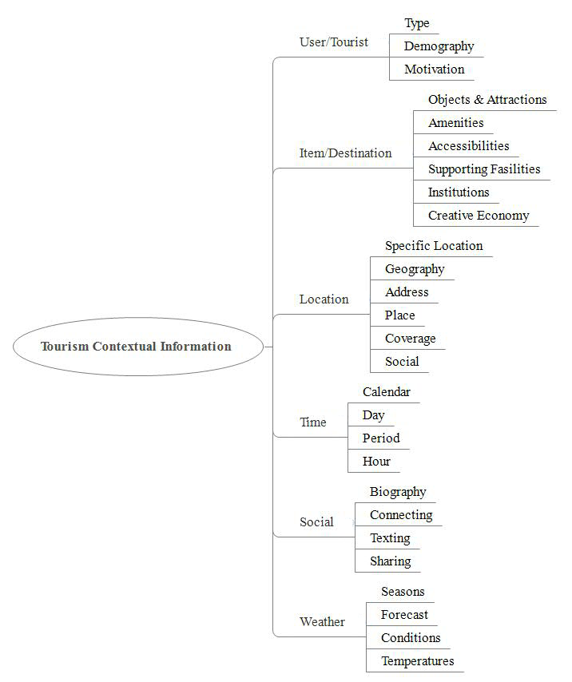
Figure 3. Context Information in Tourism
Table 1. Different types of recommender systems in travel and tourism
Analysis of Travel Recommender System
Types of Models Applied in Tourism | Title
Collabrative filtering | Intelligent travel recommendation system by mining attributes from community contributed photos [1].
Collabrative filtering | A Cocktail Approach for Travel Package Recommendation [7].
Collabrative filtering | A Collaborative Awareness Framework for Mobile Tourist Recommender System [8].
Collabrative filtering | A Context-Aware Proactive Recommender System for Tourist [9].
Collabrative filtering | Comparison of Various Metrics Used in Collaborative Filtering for Recommendation System [21].
Collabrative filtering | Recommendation of Tourist Attractions Based on Slope One Algorithm [22].
Collabrative filtering | A Two-Tiered Recommender System for Tourism Product Recommendations [24].
Social filtering | Personalized Attraction Recommendation System for Tourists Through Check-In Data [10].
Social filtering | Coastal Tourism and Climate-Related Disasters in an Archipelago Country of Indonesia: Tourists’ Perspective [11].
Social filtering | GuideMe - A Tourist Guide with a Recommender System and Social Interaction [12].
Social filtering | A Framework for Tourist Recommendation System  Exploiting Geo-Tagged Photos [13].
Social filtering | Influential Factors on Travel Decision in E-Tourism [14].
Social filtering | A Suggestive Recommendation Method to Make Tourists”Feellikegoing” [23]
Hybrid Filtering | “TripBuddy” Travel Planner with Recommendation based on User‘s Browsing Behaviour [15]
Hybrid Filtering | A Collaborative Location Based Travel Recommendation System through Enhanced Rating Prediction for the Group of Users [16]
Hybrid Filtering | A personalized hybrid tourism recommender system [17]
Hybrid Filtering | M-Guide: Hybrid Recommender System Tourism in East-Timor [18]
Hybrid Filtering | Intelligence Traveling Schedule Recommender Based on Commonsense Reasoning Algorithm [19]
Hybrid Filtering | Automatic Generation of Temporal Feature Vectors with Application to Tourism Recommender Systems [20].
Context Based Filtering | Adaptive tourist recommendation system: conceptual frameworks and Implementations [25].
Context Based Filtering | Data gathering system for recommender system in tourism [26].
Context Based Filtering | Linking Multidimensional Context to Support Tourism Recommender System [27].
Context Based Filtering | Tourism Contextual Information for Recommender System [28].
Context Based Filtering | Trip Similarity Computation for Context-Aware Travel Recommendation Exploiting Geotagged Photos [29]
Context Based Filtering | Tourism guide cloud service quality: What actually delights customers [30].
Content Based Filtering | Intelligent tourism recommender systems: A survey [31].
Clustering | Ontology construction and application in practice case study of health tourism in Thailand [32].
Ontology based | Ontology-Based Tourism Recommendation System[33]

Conclusion
Different types of recommender systems are being used in the field of travel and tourism It is observed that 44% of systems are based on collaborative filtering. Social filtering is also predominantly being used as either individually or in hybrid recommender system. It is used in around 21% of the systems. One of the major observations during the study was that the weather attribute has not been considered. While giving recommendations for tropical regions like India, parameters like temperature, precipitation, cloudiness, sunshine play an important role. Similarly parameters like snowfall, snow depth, moisture and wind need to be considered for European or Western destinations.

References
- V. Subramaniyaswamy, V. Vijayakumar, R. Logesh and V. Indragandhi, "Intelligent Travel Recommendation System by Mining Attributes from Community Contributed Photos", Procedia Computer Science, vol. 50, pp. 447-455, 2015. Available: 10.1016/j.procs.2015.04.014.
- C. Aggarwal, Recommender Systems. Cham: Springer International Publishing, 2016.
- R. Iateilang and C. L, "Recommender Systems: Types of Filtering Techniques", International Journal of Engineering Research & Technology (IJERT), vol. 3, no. 11, pp. 251 - 253, 2014.
- K. Nagwekar and P. Shirsat, "A Community Detection and Recommendation System", IJARCCE, vol. 6, no. 1, pp. 7-13, 2017. Available: 10.17148/ijarcce.2017.6102.
- G. A. Sielis, A. Tzanavari, and G. A. Papadopoulos, “Recommender Systems Review of Types, Techniques, and Applications,” Encyclopedia of Information Science and Technology, Third Edition, pp. 7260–7270
- Q. Liu, E. Chen, H. Xiong, Y. Ge, Z. Li, and X. Wu, “A Cocktail Approach for Travel Package Recommendation,” IEEE Transactions on Knowledge and Data Engineering, vol. 26, no. 2, pp. 278–293, 2014.
- L. T. Yong, “A collaborative awareness framework for mobile tourist recommender system,” 2011 3rd International Conference on Computer Research and Development, 2011.
- E. Ashley-Dejo, S. Ngwira, and T. Zuva, “A context-aware proactive recommender system for tourist,” 2016 International Conference on Advances in Computing and Communication Engineering (ICACCE), 2016.
- K. Kesorn, W. Juraphanthong, and A. Salaiwarakul, “Personalized Attraction Recommendation System for Tourists Through Check-In Data,” IEEE Access, vol. 5, pp. 26703–26721, 2017.
- N. Wijaya and A. Furqan, “Coastal Tourism and Climate-Related Disasters in an Archipelago Country of Indonesia: Tourists’ Perspective,” Procedia Engineering, vol. 212, pp. 535–542, 2018.
- A. Umanets, A. Ferreira, and N. Leite, “GuideMe – A Tourist Guide with a Recommender System and Social Interaction,” Procedia Technology, vol. 17, pp. 407–414, 2014.
- M. Thenmozhi, S. Harshitha, M. Gayathidevi, and C. S. Reddy, “A framework for tourist recommendation system exploiting geo-tagged photos,” 2016 10th International Conference on Intelligent Systems and Control (ISCO), 2016.
- Titan, L. S. Sanjaya, and Ferdianto, “Influential factors on travel decision in e-tourism,” 2016 International Conference on Information Management and Technology (ICIMTech), 2016.
- M. Sumardi, Jufery, Frenky, R. Wongso, and F. A. Luwinda, “‘TripBuddy’ Travel Planner with Recommendation based on User‘s Browsing Behaviour,” Procedia Computer Science, vol. 116, pp. 326–333, 2017.
- L. Ravi and S. Vairavasundaram, “A Collaborative Location Based Travel Recommendation System through Enhanced Rating Prediction for the Group of Users,” Computational Intelligence and Neuroscience, vol. 2016, pp. 1–28, 2016.
- M. E. B. H. Kbaier, H. Masri, and S. Krichen, “A Personalized Hybrid Tourism Recommender System,” 2017 IEEE/ACS 14th International Conference on Computer Systems and Applications (AICCSA), 2017.
- J. D. C. L. Soares, Suyoto, and A. J. Santoso, “M-Guide: Hybrid Recommender System Tourism In East-Timor,” 2017 International Conference on Soft Computing, Intelligent System and Information Technology (ICSIIT), 2017.
- C.-S. Wang, C.-C. Yeh, and C.-Y. Li, “Intelligence traveling schedule recommender based on commonsense reasoning algorithm,” International Conference on Computer and Communication Engineering (ICCCE10), 2010.
- G.-S. Fang, S. Kamei, and S. Fujita, “Automatic Generation of Temporal Feature Vectors with Application to Tourism Recommender Systems,” 2016 Fourth International Symposium on Computing and Networking (CANDAR), 2016.
- A. Kumar, S. Gupta, S. K. Singh, and K. K. Shukla, “Comparison of various metrics used in collaborative filtering for recommendation system,” 2015 Eighth International Conference on Contemporary Computing (IC3), 2015.
- H. Hu and X. Zhou, “Recommendation of Tourist Attractions Based on Slope One Algorithm,” 2017 9th International Conference on Intelligent Human-Machine Systems and Cybernetics (IHMSC), 2017.
- T. Izumi, T. Kitamura, and Y. Nakatani, “A Suggestive Recommendation Method to Make Tourists ‘Feel like going,’” IFAC-PapersOnLine, vol. 49, no. 19, pp. 573–578, 2016.
- I. Y. Choi, J. K. Kim, and Y. U. Ryu, “A Two-Tiered Recommender System for Tourism Product Recommendations,” 2015 48th Hawaii International Conference on System Sciences, 2015.
- L. Etaati and D. Sundaram, “Adaptive tourist recommendation system: conceptual frameworks and implementations,” Vietnam Journal of Computer Science, vol. 2, no. 2, pp. 95–107, 2014.
- G. Hirakawa, G. Satoh, K. Hisazumi, and Y. Shibata, “Data Gathering System for Recommender System in Tourism,” 2015 18th International Conference on Network-Based Information Systems, 2015.
- K. A. Achmad, L. E. Nugroho, Widyawan, and A. Djunaedi, “Linking multidimensional context to support tourism recommender system,” 2017 3rd International Conference on Science and Technology - Computer (ICST), 2017.
- K. A. Achmad, L. E. Nugroho, Widyawan, and A. Djunaedi, “Tourism contextual information for recommender system,” 2017 7th International Annual Engineering Seminar (InAES), 2017.
- Z. Xu, “Trip similarity computation for context-aware travel recommendation exploiting geotagged photos,” 2014 IEEE 30th International Conference on Data Engineering Workshops, 2014.
- S.-P. Lin, C.-L. Yang, H.-C. Pi, and T.-M. Ho, “Tourism guide cloud service quality: What actually delights customers?,” SpringerPlus, vol. 5, no. 1, 2016.
- J. Borràs, A. Moreno, and A. Valls, “Intelligent tourism recommender systems: A survey,” Expert Systems with Applications, vol. 41, no. 16, pp. 7370–7389, 2014.
- C. Chantrapornchai and C. Choksuchat, “Ontology construction and application in practice case study of health tourism in Thailand,” SpringerPlus, vol. 5, no. 1, 2016.
- C.-I. Lee, T.-C. Hsia, H.-C. Hsu, and J.-Y. Lin, “Ontology-based tourism recommendation system,” 2017 4th International Conference on Industrial Engineering and Applications (ICIEA), 2017.
- C. Zhang, “The design of Scenic tourist service system,” Procedia Computer Science, vol. 131, pp. 1253–1259, 2018.
- Patel, M. and Barot, P, “Optimization of Cold Start Problem in Recommendation Systems : A Review” International Journal of Scientific Research in Computer Science, Engineering and Information Technology(IJSRCSEIT), vol. 5, no. 7, 2019.
- Bheema Shireesha, Navuluri Madhavilatha, and Chunduru Anilkumar, “Movie Recommended System by Using Collaborative Filtering” International Journal of Scientific Research in Computer Science, Engineering and Information Technology(IJSRCSEIT), vol. 5, no. 1, 2019.
- N. Rajganesh, C. Asha, A. T. Keerthana, and K. Suriya, “A Hybrid Feedback Based Book Recommendation System Using Sentiment Analysis” International Journal of Scientific Research in Computer Science, Engineering and Information Technology(IJSRCSEIT), vol. 3, no. 3, 2018.
Authors Profile
Mr. Roopesh L R pursued Bachelor of Science
from CHRIST Deemed to be University and now currently pursuing M.Sc. Computer Science and Application, CHRIST Deemed to be University, Bangalore (India).

Ms.Tulasi B pursued Masters of Computer Science and Applications from Osmania University and MPhil from Bharathidasan University, currently pursuing PhD in Jain University and currently working as an ASSOCIATE PROFESSOR in Department of Computer Science, CHRIST Deemed to be University, Bangalore(India).
Areas of Interest is learning analytics and big data


