PROBLEM 1 SOLUTON
MEHAK PIPLANI

1 Training loss and accuracy curves for the simple neural network training
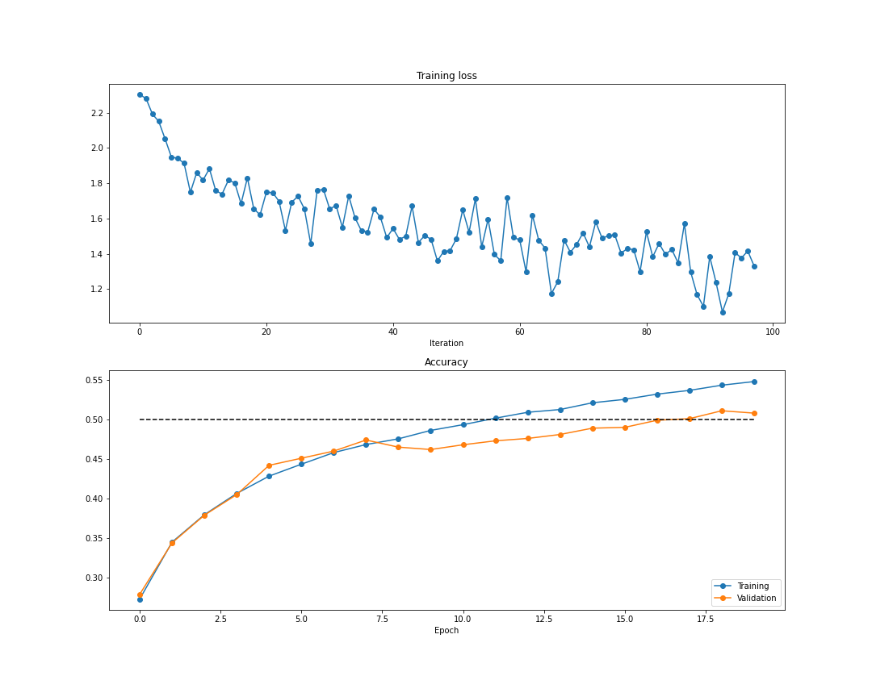

2 Plots for comparing vanilla SGD to SGD + Momentum
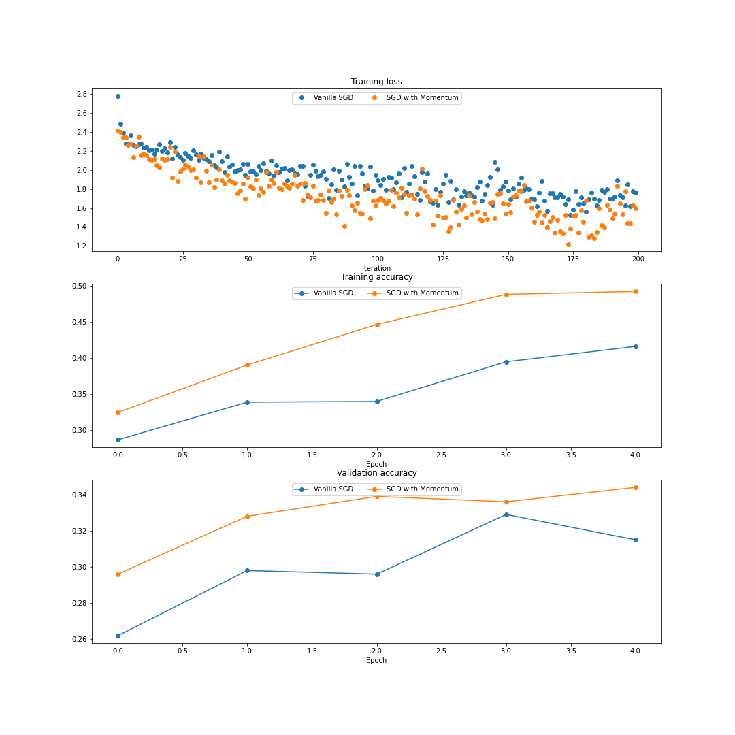

3 "Comparing different Optimizers" plots
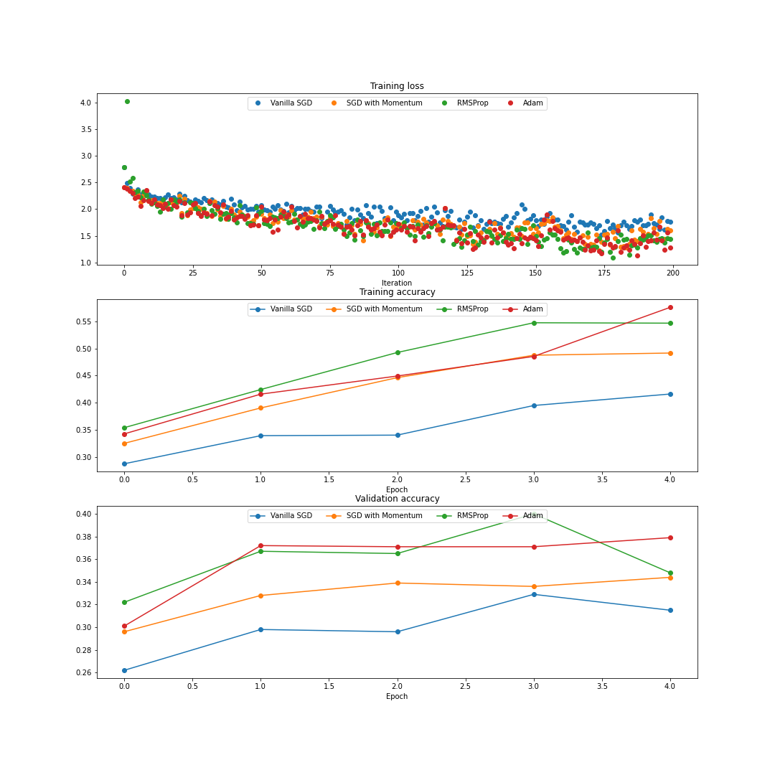

4 Dropout comparison plots
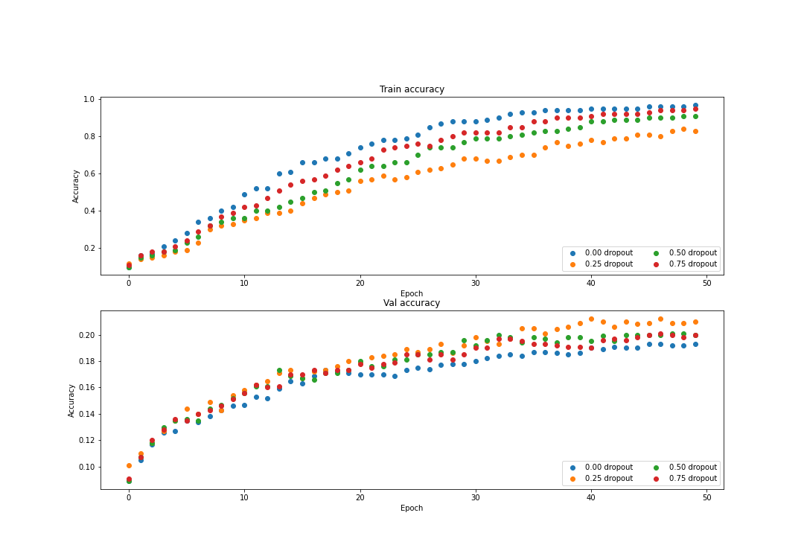
5 Describe what you observe from the above results and graphs about dropout + give an explanation. [2pt]
Ans:
We observe that when dropout is 0, the model is overfitting and not able to generalize well on the validation set. We can also observe that as we introduce dropout to the network by increasing the value of keep probability, there is a reduction in the overfitting on the model. For the value of dropout of 0.25 although the train accuracy is less, as it has reduced parameters for the model to learn, but the validation accuracy has increased depicting the model is not overfitting and generalizing well.

6 Activation function plot
