PROBLEM 2 SOLUTON
MEHAK PIPLANI

1 Training loss / accuracy curves for vanilla RNN training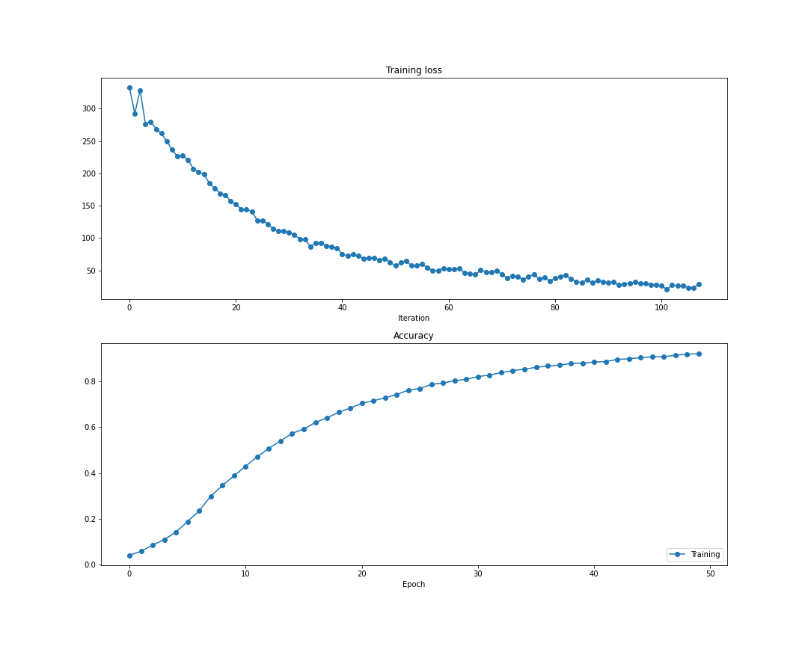2 Sample text generation from a trained model (RNN)

he had tired herself out with trying, the poor little thing sat down and she tried to look down and she tried to look down and she tried to look down and she tried to look down and she tried

3 Training loss / accuracy curves for LSTM training

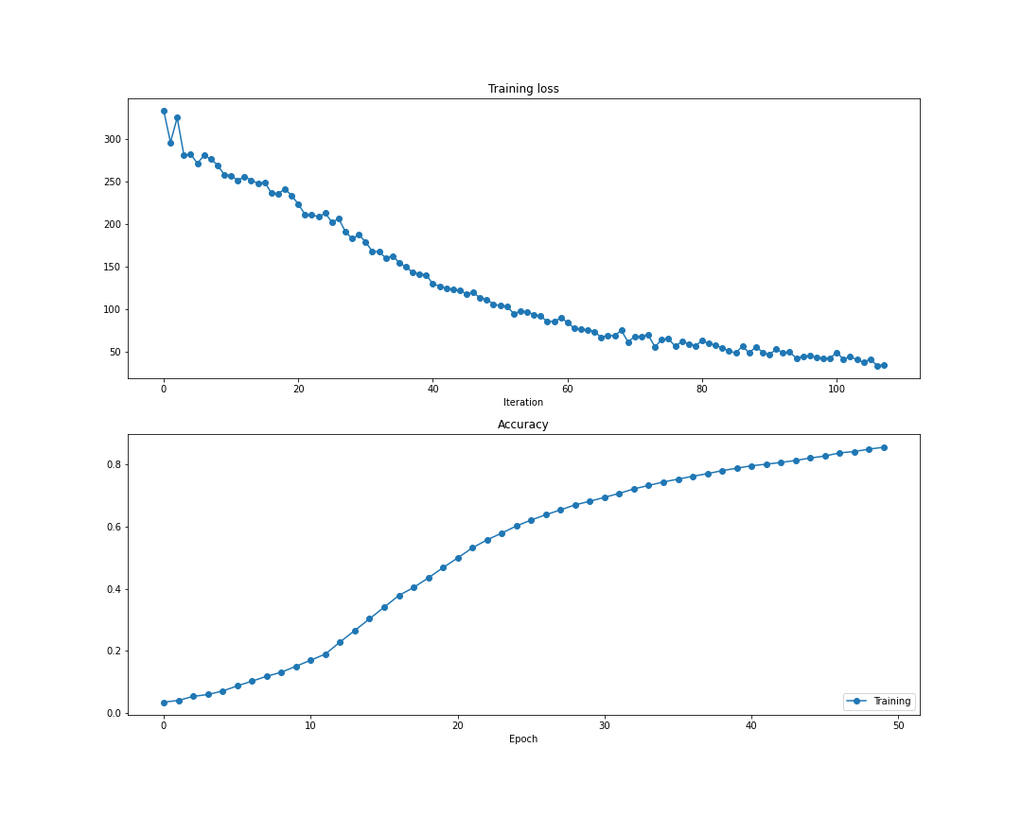
4 Sample text generation from a trained model (LSTM)
she was not a moment to be lost: away went alice had taught them: such as, that a red-hot poker will burn you if you hold it too long; and that dark hall, and wander about among those beds of

5 Play around with different settings to get better understanding of its behavior and describe your observation.
Ans:
I observed that with lower values of D (input sequence length), increase in timestep (from 40 to >100) causes an increase in training time of both the models. It is also observed RNNs perform better than LSTM while comparing the repetitiveness in the generated text.
But for higher values of D, LSTMS work better than RNN as expected due to two reasons: vanishing gradient for RNNs and better memory retaining power of LSTMs.
Limitations: The task of sequence modelling requires sequential learning; it takes a lot of time to train the models. Training time increases if we increase the size of dataset.

