How to Install the Program
=======================
-Copy the the project AATinkers
-Paste it inside the the 'www' folder found inside the wamp location{C:\wamp\www\AATinkers}
-Run your wamp server
-In the wamp server run phpMyAdmin just like as below
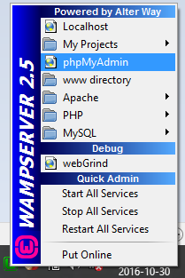
-In phpMyAdmin create a new database called 'a_a_tinkers_db'
-Click 'a_a_tinkers_db' and import the db script called 'a_a_tinkers_db.sql' that found on the db folder inside the 'AATinkers' project{C:\wamp\www\AATinkers\db}
-Run the project 'AATinkers' on the localhost, by copping the link and paste it, in your browser{http://localhost/AATinkers/HomePage.html}
-root folder would be AATinkers(Please leave the root folder name as it is to avoid
any conflicts with the paths of certain files)
-Login as customer{username: root@gmail.com
password: root}
-Login as administrator{username: admin@gmail.com
password: admin}
===========================================================================
Name of the database: a_a_tinkers_db
Username: root
Password: root
============================================================================

