

MPJ Express Profiler

User Guide

15th April, 2014

**Document Revision Track**

|  |  |  |
| --- | --- | --- |
| **Version** | **Updates** | **By** |
| 1.0 | Initial version document | Rizwan Hanif, Amjad Aziz, Aamir Shafi |
| 1.1 | Complete configuration details, Profiles and Traces generation steps | Aleem Akhtar, Aamir Shafi, Mohsan Jameel |
|  |  |  |

**Table of Contents**

1 Getting Started with MPJ Express 5

1.1 Pre-requisites 5

1.2 Configuration of MPJ Express Profiler 5

1.3 Profiling of MPJ Express 7

1.3.1 Profiling in Multicore Mode 7

1.3.2 Profiling in Cluster Mode 10

1.4 Tracing of MPJ Express 12

2 Known Issues and Limitations 13

3 Contact and Support 14

**List of Figures**

Figure 1‑1: Example of command line format 9

Figure 1‑2: Example of graphical format in multicore mode 10

Figure 1‑3: Example of graphical format in niodev mode 11

Figure 1‑4: Example of graphical format in hybdev mode 11

Figure 1‑5: Example of Jumpshot window 12

Figure 2‑1: State Partition Error 13

# Getting Started with MPJ Express

This section outlines how to configure MPJ Express Profiler and TAU with Java support. This section also covers how to generate profiles and traces of MPJ Express programs in multicore and cluster configuration using MPJ Express Profiler. Current version of MPJ Express Profiler does not support profiling of applications using native device.

Complete video guide can be found at <http://vimeo.com/88968631>

Note: This document only covers basic configuration of TAU with Java support and how to generate profiles and traces of MPJ Express applications. To use advance features of TAU i.e. manual instrumentation, Vampir output and PerfExplorer output, please follow TAU users guide and TAU reference guide. You can get these documentations from TAU official [website](http://www.cs.uoregon.edu/research/tau/docs.php).

## Pre-requisites

* Java 1.6 (stable) or higher
* MPJ Express (version 0.40 or higher)
* TAU (version 2.23.1b or higher)
* Apache ant 1.6.2 or higher (For those who are interested in compiling MPJ Express source code)
* Perl (Optional): MPJ Express needs Perl for compiling source code because some of the Java code is generated from Perl templates. The build file will generate Java files from Perl templates if it detects Perl on the machine. It is a good idea to install Perl if you want to do some development with MPJ Express.

## Configuration of MPJ Express Profiler

1. Download [MPJ Express](http://sourceforge.net/projects/mpjexpress/files/releases/) and setup environment to write MPJ Express applications. You can follow section-2 of “Linux User Guide” for setting up environment for MPJ Express.
2. Download [TAU](http://www.cs.uoregon.edu/research/tau/tau_releases/) and unpack it in user directory.
3. Move to TAU root directory.
4. To configure TAU follow below mentioned steps or you can also follow README.JAVA to configure TAU with Java support.
5. Configure TAU with this command

./configure –jdk=path_to_jdk

For example:



1. After successful configuration message use “make clean” command to clean previous configurations (if any)

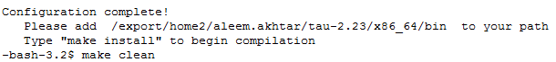

1. After successful clean of previous configurations use “make install” command to install new configuration  
   

TAU configuration will create a new directory depending on architecture of your operating system in TAU root directory. For Linux 64 Bit OS, it will create x86_64 directory.

1. After successful configuration of TAU you can set following Environment Variables in .bashrc or .bash_profile

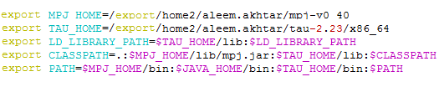

1. Once Environment Variables are set, test whether TAU has been configured correctly or not
2. Move to TAU root directory.
3. Now move to examples/java/pi
4. Use tau_java command to run Pi class. If it prints value of Pi then TAU has been configured properly otherwise check Environment Variables.

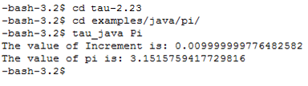

At this point you have configured TAU and MPJ Express. Proceed with profiling and tracing of MPJ Express applications

## Profiling of MPJ Express

User can generate profiles for MPJ Express applications in multicore mode and cluster mode.

1. Create a new directory for MPJ Express applications
2. Create a new MPJ Express application and write “HelloWorld” code in it.

**import mpi.*;**

**public class HelloWorld {**

**public static void main(String args[]) throws Exception {**

**MPI.Init(args);**

**int me = MPI.COMM_WORLD.Rank();**

**System.out.println("Hi from <"+me+">");**

**MPI.Finalize();**

**}**

**}**

1. Save and compile HelloWorld.java

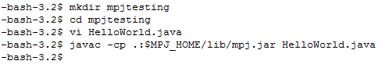

### Profiling in Multicore Mode

Process of using profiler for any device is exactly same. Providing “–profile” switch in MPJ Express run command generates profiles for particular device.

For example following command is used for starting a job in multicore mode:

mpjrun.sh -np 4 -dev multicore HelloWorld

Similarly, for starting a job in multicore device with MPJ Express Profiler following command is used

mpjrun.sh -np 4 -dev multicore -profile HelloWorld

This command will execute your application and will generate profiles for each process in the current directory.

You can use pprof to visualize profiles in command line format. Or you can use paraprof to visualize profiles in graphical format.

* **Using pprof**

To visualize profiles in command line format type pprof

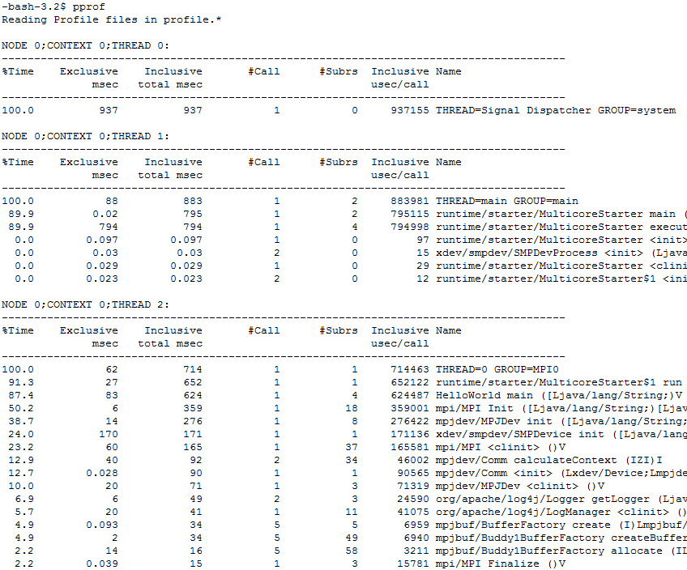

Figure ‑: Example of command line format

* **Using paraprof**

Type paraprof to visualize profiles in graphical format

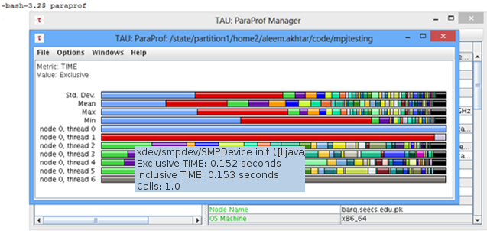

Figure ‑: Example of graphical format in multicore mode

### Profiling in Cluster Mode

This section outlines steps to generate profiles for MPJ Express applications in the cluster configuration with niodev communication device driver.

1. Create a machines file and write IP address or machines names in it and start daemons. You can follow section-2.3 of “Linux User Guide” on how to create a machines file and start daemons.
2. Once daemons get started, use this command to start application in cluster mode.

mpjrun.sh -np 4 -dev niodev -profile HelloWorld

This will generate profiles for all processes in the current working directory.

Once profiles are generated you can then use pprof or paraprof to visualize profiles.

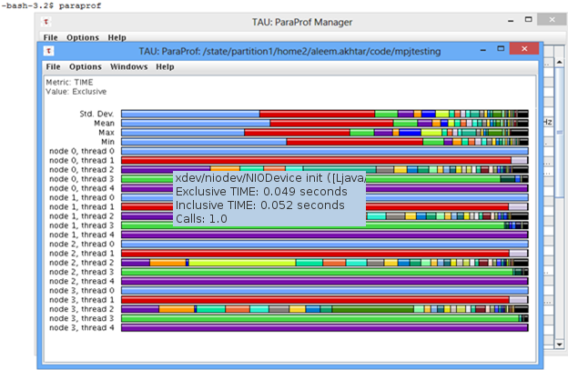

Figure ‑: Example of graphical format in niodev mode

Similarly using mpjrun.sh -np 4 -dev hybdev -profile HelloWorld will generate profiles for hybdev mode in current working directory.

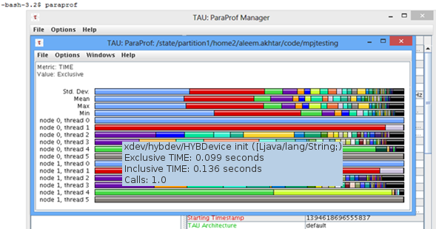

Figure ‑: Example of graphical format in hybdev mode

## Tracing of MPJ Express

Procedure to generate trace files for MPJ Express applications is the same as for profiling.

1. Enable Tracing in .bashrc or .bash_profile and disable Profiling



1. Now you can generate trace files using same steps as explained above for profiling.

Multicore Mode: mpjrun.sh -np 4 -dev multicore -profile HelloWorld

Niodev Mode: mpjrun.sh -np 4 -dev niodev -profile HelloWorld

Hybdev Mode: mpjrun.sh -np 4 -dev hybdev -profile HelloWorld

1. Using any of above mentioned command will generate trace files in the current working directory. You can use Jumpshot to visualize trace files.

* **Using Jumpshot**

This section outlines how to visualize trace files using Jumpshot

1. Merge all trace files using tau_treemerge.pl command
2. tau_treemerge.pl command will merge all trace files into one tau.trc file and one tau.edf file in the same directory.
3. Now use tau2slog2 command to create slog2 file which is supported by Jumpshot

tau2slog2 tau.trc tau.edf -o hello.slog2

1. Type jumpshot on command line. Jumpshot window will open
2. Click File 🡪 Select 🡪 hello.slog2 file to visualize traces along timeline

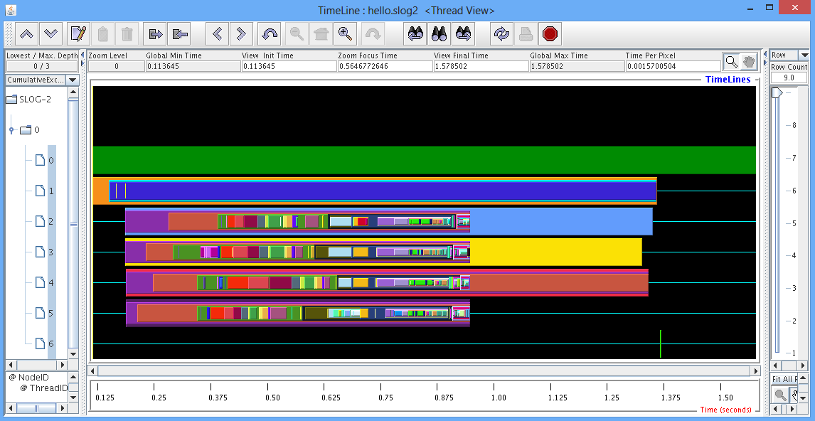

Figure ‑: Example of Jumpshot window

# Known Issues and Limitations

A list of known issues and limitations of the MPJ Express Debugger are listed below.

1. Users of the Windows Vista and 7 might find install mpjd-windows.bat script not working directly. In such case, try executing with “Run as Administrator”. If the issue still persists, try executing the script mpjdaemon.bat directly or turning off the firewall.
2. If you are running your applications on Rocks cluster then you might get below mentioned error. To solve this just add “-wdir =absolute path to your current working directory” switch in your mpjrun command.

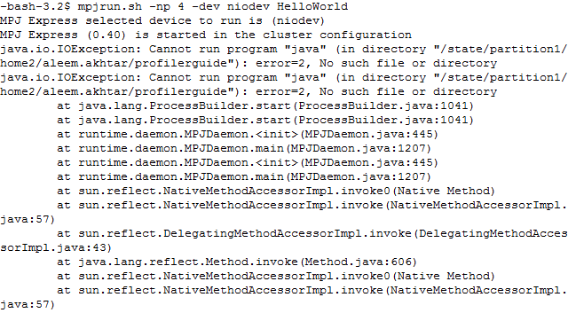

Figure ‑: State Partition Error

mpjrun.sh -np 4 -dev niodev –wdir (absolute path to current working directory) HelloWorld

For example:



# Contact and Support

For help and support, join and post on the MPJ Express mailing list (mpjexpress-users@lists.sourceforge.net). Alternatively, you may also contact us directly:

1. Aamir Shafi ([aamir.shafi@seecs.edu.pk](mailto:aamir.shafi@seecs.edu.pk))
2. Mohsan Jameel ([mohsan.jameel@seecs.edu.pk](mailto:mohsan.jameel@seecs.edu.pk))
3. Bryan Carpenter ([bryan.carpenter@port.ac.uk](mailto:bryan.carpenter@port.ac.uk))
4. Mark Baker (<http://acet.rdg.ac.uk/~mab>)
5. Guillermo Lopez Taboada (<http://www.des.udc.es/~gltaboada>)