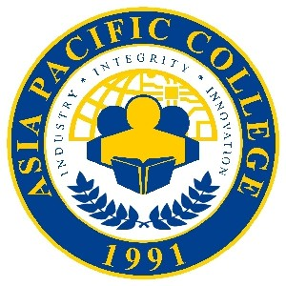

**Simbang Gabi: Isang PAGhahandog**

**Photo Liking Contest**

**♫ What fun it is to post and win movie tickets tonight! ♫**

**Mechanics:**

1. The contest is open to everyone (APC Student, APC Employee, APC Alumni, Shell-Magallanes Crew, etc.).
2. Post a T-Shirt design (in colors Red, Yellow, Blue, Orange, and Light Blue) with the theme “**RAM**”.

* #WeAreRams
* #RAMPride
* #ProudToBeRam

1. Like the official Facebook page of Asia Pacific College: <https://www.facebook.com/asiapacificcollege.edu/>
2. Submit entries by posting your photo (make sure to change your settings to Public) on your Facebook account and tag **Asia Pacific College**.
3. The photo with the most number of Likes (reactionsincluded) will win five (5) SM Movie tickets with a total worth of PHP1,000!   
   Two (2) runner-ups will get two (2) SM Movie tickets each.
4. Deadline of entries is on January 31, 2018, 5:00 P.M.
5. Winners will be announced via APC FB on February 3, 2018.