|  |  |
| --- | --- |
| **DATE** | December 14, 2017 |
| **TIME** | 11:30AM – 1:00PM |
| **VENUE** | APC Board Room |

|  |  |
| --- | --- |
| **ATTENDEES** | |
| *Name* | *Unit/Organization/Office* |
| Vincent C. Barcelona | SAO |
| *---------* | Admissions |
| Katherine Gale Hernandez | SHS |
| Krisper Jane H. Bariuan | SOAR |
| Manuel F. Magbuhat | SoM |
| Johanna Minglana | ERC-SoMA/ SS-ER |
| Mary Anne Romero | Marketing |
| Deeno Lapira | ERC-SoMA/ SS-Publishing |

|  |  |  |
| --- | --- | --- |
| **PROCEEDINGS** | | |
| **Agenda** | **Notes/Issues** | **Resolution** |
| Seminars in APC | Replacement for the Word “Seminar” | Implementation of the Seminar Application developed by SoCIT |
| T-Shirt Design Contest (OFFICIAL APC WEEK 2018 – T SHIRT DESIGN CONTEST) | Same design but different color per school | The T-Shirt will be in the colors representing each School (Blue, Red, Yellow, Orange, and Light-Blue)  Mechanics:   1. The Contest is open to everyone. 2. Post a T-Shirt design with the theme “**RAM**” 3. Like the official FB Page of Asia Pacific College 4. Submit entries by posting the photo and tag Asia Pacific College 5. The Photo with the most number of reacts will win 5 SM Movie Tickets 6. Deadline of entries: January 31, 2018 7. Winners will be announced on February 3, 2018 |
| Opening of APC Week | Audience? Talk to Miss Tata about the students being excused for their first class | WHEN: March 12, 2018 (Monday) – 7:30AM – 9:30AM  SM Movie Tickets for the Early Birds (who arrived early during the Opening Ceremony) – c/o Marketing Department  Ramp of the Pageant contestants (wearing the T-Shirt from the T-Shirt Design Contest) |
| Mini Mercato | Start collecting contact numbers/calling cards of concessionaires in Mercato Places (BlueBay, BGC, Bazaars)  Activity Proposal Sheet | Maximum of 8 Booths  Contact RJ Ledesma (Mercato owner) |
| Sportsfest for the Faculty and Staff | Mechanics? Get the mechanics from the sportsfest for the students  Schedule? Depends on the number of the participants, but the order will be similar to the sportsfest for the students (Badminton & Table Tennis 🡪 Volleyball 🡪 Basketball) | WHEN: March 14, 2018 (Wednesday of the APC Week)  Coordinator per Sport   1. Badminton – Ms. Johanna Minglana 2. Volleyball – Sir. Osler Aquino and Sir. Arnel Aragon 3. Basketball – (to be followed) 4. Table Tennis – Sir Kim   Submission of Teams is via MS Forms  Sir Vince will be talking to the HR for the Prizes |
| Photoshoot for the Sportsfest (Faculty and Students) | Who are the Top 4 schools?? | Target Date: 2nd Week of February 2018  Photog and Processing 🡪 Contact sir deeno |
| Cheering Competition | Per School representative? Or Voluntary?  Who will be cheered? (School?)  Mechanics?  Theme?  Prize? | WHEN: March 13, 2018 |
| RAMS Night | Program Flow?  Criteria for the Best Organizer? (c/o SAO and SOAR)  Delegation of Tasks: revise 🡪 Add SoM and SoE Organizations | THEME: Hawaiian (LUAU)  Contact PAG (Performers) on the 2nd Week of January  Contact Sponsors for this Event   * Taters * San Miguel Corporation   Alumni are Invited   * Coordinate with APCRAA   Awarding of the Best Organizer (Student Organization) with the criteria being “on-time”, etc.  Delegation of tasks   * Venue Layout (Man power): SMS and Pwersa * Registration: SHS AdHoc * Food: SOAR * Host: Speaks * Technical Committee: MSC, GG, Cipher * Photobooth: Flickers, BB, AnimSoc, CinemaSoMA * Ushers and Man Power: JPCS, Rotaract, and Pwersa |
| Pageant |  | Photoshoot 2nd Week of February 2018  Wednesday – Talent Portion in the Cafeteria  Thursday – Whole program in the Auditorium |

|  |  |  |
| --- | --- | --- |
| **ACTION POINTS** | | |
| **Tasks** | **Person-in-Charge** | **Target Date** |
| Implementation of the Seminar Mobile App | SoCIT | March 12, 2018 (APC Week Seminars) |
| Announcement for the Student Organizations that SAO will start accepting Activity Proposals for the APC Week Starting **January 6, 2018** | Gila Reyes | December 26, 2017 |
| Send the mechanics to the APC Week Committee | Marc Adrian Jimenez | December 27, 2017 |
| Poster for the T-Shirt Design Contest (with the Mechanics) | Katherine Camacho | December 30, 2017 |
| MS Forms for the Faculty Sportsfest (to be proofread by the Committee) | Jason Adriano | January 5, 2018 |
| Announce that there will be a Photoshoot for the Sportsfest Top 4 | Krisper Bariuan | 4th Week of January 2018 |
| Coordinate with the Photographer | APC-SOAR | 3rd Week of January 2018 |
| Coordinate with PAG for the RAMS Night performance | Mariane Viray | 2nd Week of January 2018 |
| Coordinate with APCRAA for the RAMS Night (point person: Jacob Catayoc) | Marc Jimenez | 2nd Week of February 2018 |

**APPENDIX 1**

* **Proposed Schedule of Activities: MARCH 12-16**

|  |  |  |  |  |
| --- | --- | --- | --- | --- |
| Monday | Tuesday | Wednesday | Thursday | Friday |
| Fun run  • Student and faculty  -• 6:30 AM | **Who wants to be a millionaire?**  • AM  • ERC | **Faculty Staff Friendship**  • Gym  • Whole day | **Sports fest Battle for the 1st Place**  • Gym  • Whole day | **Mass** |
| Opening Ceremony  • 8: 00 AM  • APC DC  • APC Pageant Candidates | **RAMS Got Talent**  **•** Lunch time  **•** MPH1 | **Talk at Audi**  • Audi  • Contact Miss | **Sports fest awarding**  **• Gym** | **RAMS NIGHT** |
| Sports fest Battle for 3rd Place  • Gym  • Whole day | **APC IDOL**  **•** PM  • Auditorium  • Find organization who will handle this event• |  | **Pageant (Summer Theme)**  **•** Auditorium  • 6PM – 8PM |  |
|  | **APC OPEN HOUSE**  • Whole Day |  |  |  |

**APPENDIX 2**

* Theme: LUAU

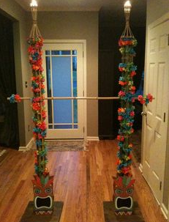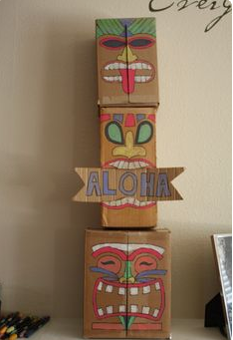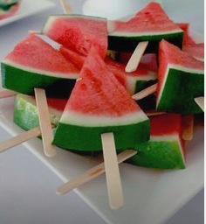

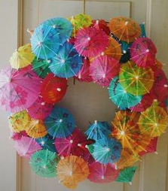

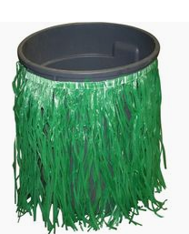



* Suggested clothing for the theme wear of the candidates:



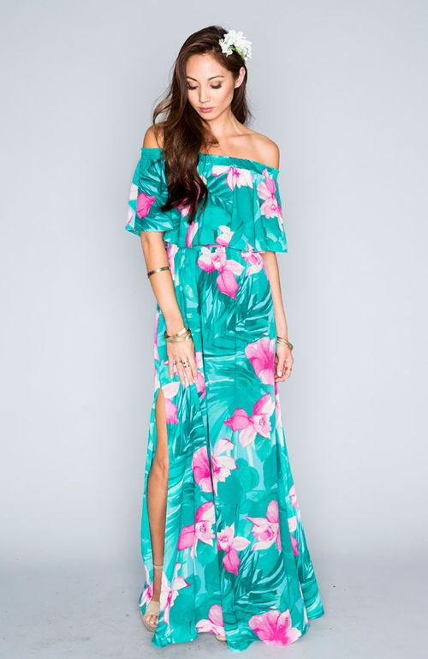



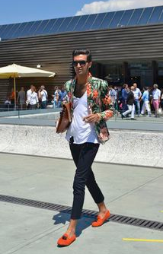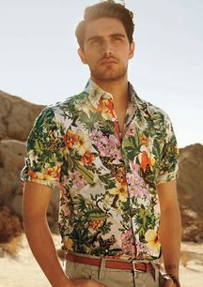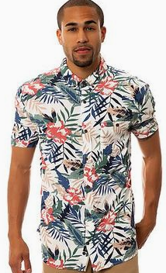

Prepared by:

**Krisper Jane H. Bariuan**

**________________________**

Secretary, APC-SOAR