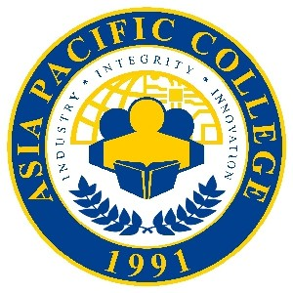

**Simbang Gabi: Isang PAGhahandog**

**Photo Liking Contest**

**♫ What fun it is to post and win movie tickets tonight! ♫**

**Mechanics:**

1. The contest is open to everyone who will be at the Simbang Gabi: Isang PAGhahandog Christmas Concert.
2. Take a selfie or groufie in the event’s photo booth / PAG exhibit area on December 1 or 2, 2017.
3. Like the official Facebook page of Asia Pacific College: <https://www.facebook.com/asiapacificcollege.edu/>
4. Submit entries by posting your photo (make sure to change your settings to Public) on your Facebook account and tag **Asia Pacific College**.
5. The photo with the most number of Likes (reactionsincluded) will win five (5) SM Movie tickets with a total worth of PHP1,000!   
   Two (2) runner-ups will get two (2) SM Movie tickets each.
6. Deadline of entries is on December 3, 2017, 5:00 P.M.
7. Winners will be announced via APC FB on December 4, 2017.