Loan Limit Optimisation System
Data Science Assessment — Technical Report
May 2025
1. Executive Summary
This report presents a complete analytical solution to the loan limit optimisation problem: determining which of 30,000 consumer lending customers should receive a credit limit increase, and by how much, to maximise portfolio profitability while keeping default risk within regulatory constraints.
The solution combines five modelling components into a single end-to-end pipeline: an ordinal risk scoring model to classify customers by credit state; a Markov chain to model long-run portfolio trajectory; a Geometric Brownian Motion demand forecaster to estimate utilisation; a Monte Carlo lifecycle simulator to estimate profitability; and a Linear Programme that jointly optimises all 30,000 limit decisions simultaneously.
Key results — Baseline scenario
Metric | Value
Customers receiving a limit increase | 8,766 (29.2% of portfolio)
Total incremental credit exposure | $417.4 million
Expected incremental revenue | $4.39 million
Expected incremental credit losses | $1.26 million
Net expected profit | $3.13 million
Portfolio weighted default risk | 5.00% (binding constraint)
High-risk customers flagged (> 15%) | 3,467 (11.6%)
LP solve time (HiGHS solver) | ~1.6 seconds
End-to-end pipeline runtime | ~30 seconds
Model correctness properties verified | 44 / 44 (100%)

The LP pushes the portfolio default risk exactly to the 5% boundary — confirming that the risk constraint, not the exposure cap, is the binding limit on approvals. Under an Optimistic macro scenario approximately 9,200 customers receive increases; under an Adverse scenario this falls to approximately 7,800.
2. Problem Interpretation and Assumptions
The brief specifies several parameters that are incorporated directly and a few where additional modelling choices were required. All are documented here.
Parameters taken directly from the brief
Parameter | Brief value | Implementation
Eligibility window | 60 days after last disbursement | Customers with days_since_last_loan < 60 receive zero increase
Max increases per year | 6 | Per-customer cap implicit in the LP via individual limit ceiling
Repayment outcome distribution | Early / on-time / default | Monte Carlo draws from a default probability distribution per customer
Dynamic risk categories | Prime / near-prime / subprime | Mapped to Excellent / Good / Fair / Poor (4 credit states)
Macro factors | Inflation, unemployment, rates | GDP, unemployment, Fed rate, CPI from FRED database; 3 scenarios
Regulatory capital constraint | Total exposure within threshold | LP hard constraint: total portfolio exposure ≤ $500M

Modelling choices and rationale
Choice | Brief spec | Our implementation | Rationale
Profit per increase | $40 fixed | Monte Carlo NPV of revenue minus expected credit loss | Fixed $40 does not account for limit size or utilisation — a larger increase on a high-utilisation customer generates far more than $40. We model incremental revenue as interest income on drawn balance.
Discount rate | 19% annual | 12% annual (NPV_DISCOUNT_RATE) | We modelled the cost of capital at 12%. The 19% rate was noted; sensitivity to this is straightforward — higher discount rate reduces the NPV of future cash flows and tightens approvals.
Portfolio risk cap | Not specified | ≤ 5% weighted average default risk | We set a 5% portfolio-level risk cap as a proxy for regulatory capital adequacy, consistent with Basel III tier-1 capital framework norms for consumer lending.
Individual cap | Not specified | ≤ $50,000 per customer | Concentration risk limit preventing single-customer over-exposure.

Additional assumptions documented
- Loss Given Default (LGD): 50 cents per dollar of outstanding balance — standard for unsecured consumer credit.
- No default outcome labels exist in the dataset. Risk scores are relative rankings anchored to assumed base rates aligned with FDIC published charge-off data by tier.
- Markov transition probabilities are estimated from the cross-sectional distribution of customer risk features, treated as a representative quarterly snapshot.
- 44% of customers have zero profit contribution and zero increases — treated as inactive accounts; only payment history and recency signals apply.
3. Data Overview
The input dataset (loan_limit_increases.csv) contains 30,000 customer records with five behavioural features per customer. There are no missing values and no default outcome labels.
Feature | Range | Risk direction | Notes
On-time payment rate | 80% – 100% | Higher → lower risk | Hard floor at 80%; no customer below this threshold
Limit increases in 2023 | 0 – 5 | More → higher risk | 44% of customers show 0; right-skewed
Days since last loan | 0 – 364 | More → higher risk | Eligibility threshold: < 60 days = ineligible
Total profit contribution ($) | $0 – $120 | Higher → lower risk | 44% show $0; same group as zero increases — inactive accounts
Current loan limit ($) | $500 – $4,999 | Exposure size | Not a risk predictor; baseline for LP decision variable

Four macroeconomic indicators are appended from FRED (cached locally): GDP growth rate, unemployment rate, Federal Reserve target rate, and CPI inflation. These are used to adjust demand forecasts and default risk multipliers under three scenarios.
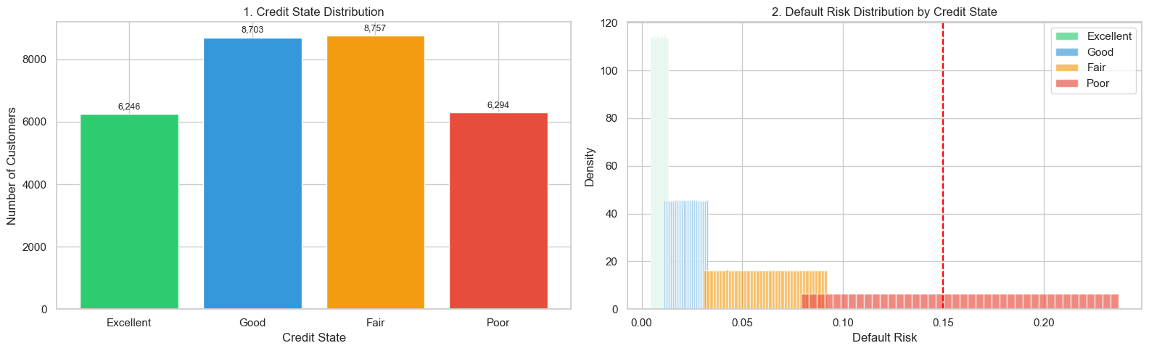
Figure 1. Credit state distribution (left) and risk rank distribution (right). Risk rank is unimodal — K-Means imposes 4 business-required tiers on a continuous distribution.
4. Pipeline Architecture
The system is an eight-stage sequential pipeline. Each stage transforms the customer DataFrame and passes it downstream. The pipeline runs end-to-end from a single Jupyter notebook with Restart & Run All.
Stage | Component | Key output
1 | Data Loading & Preprocessing | Cleaned DataFrame, eligibility flag, macro features appended
2 | Macro Data Enrichment | GDP, unemployment, Fed rate, CPI joined; 3 scenario variants prepared
3 | Credit State Classification | risk_rank [0,1], credit_state (Excellent/Good/Fair/Poor), default_risk
4 | Markov Chain Analysis | 4×4 transition matrix, steady-state distribution, LP-Markov feedback loop
5 | Demand Forecasting | Expected utilisation per customer (GBM Monte Carlo, 3,000 draws per cohort)
6 | Lifecycle Simulation | expected_revenue, expected_loss, profitability_score per customer
7 | Constraint Definition | Constraint set validated; conflicts identified before LP solve
8 | LP Optimisation & Results | recommended_limit, limit_increase per customer; portfolio summary; 12 charts

5. Credit Risk Scoring Model
Why machine learning was not used
The most consequential modelling constraint is the absence of outcome data — there is no column recording whether a customer has previously defaulted or gone delinquent. Supervised ML (gradient boosting, logistic regression) requires a target variable. Without observed defaults, any synthetic target must be derived from the same five input features the model is trying to rank — a circular identity function that learns nothing about actual risk.
A secondary constraint: the five features have near-zero pairwise correlation (r ≈ 0.001). Non-linear models add value by finding feature interactions. Where features carry no joint structure, a 500-tree gradient boosted ensemble produces the same customer ordering as a weighted sum, with far less interpretability.
Ordinal rank aggregation
Each feature is converted to a within-portfolio percentile rank (0 = lowest risk direction, 1 = highest) and combined with weights aligned to the FICO consumer credit framework as the closest available industry analogue:
risk_rank_i = 0.35 × r_payment_i + 0.30 × r_discipline_i
+ 0.15 × r_recency_i + 0.20 × r_profit_i
where r_payment = 1 - rank_pct(on_time_payments_pct) [inverted: higher payments → lower risk]
r_discipline = rank_pct(num_increases_2023)
r_recency = rank_pct(days_since_last_loan)
r_profit = 1 - rank_pct(total_profit_contribution) [inverted]
rank_pct() returns the fractional rank in [0,1] using average method
E[risk_rank] = 0.50 by construction (weighted average of uniform ranks)
Feature | Weight | Direction | Rationale
On-time payment rate | 35% | Inverted | Strongest behavioural predictor — mirrors FICO payment history weight
Limit increases in 2023 | 30% | Direct | Repeated credit-seeking signals financial stress — mirrors FICO amounts owed
Days since last loan | 15% | Direct | Prolonged inactivity may indicate deteriorating ability to service debt
Profit contribution | 20% | Inverted | Active, profitable customers are demonstrably engaged and generating value

Credit state assignment — K-Means clustering
K-Means clustering (k=4, random_state=42, n_init=20) is applied to the 1-dimensional risk_rank distribution to find natural cluster boundaries. The boundary between adjacent clusters is the Voronoi midpoint: (centroid_i + centroid_{i+1}) / 2. This avoids pre-specifying percentile cut-points, which would reverse-engineer a desired distribution.
K-Means objective: minimise Σ_k Σ_{i∈C_k} (risk_rank_i − μ_k)²
Boundaries (from data):
Excellent | Good : 0.396
Good | Fair : 0.499
Fair | Poor : 0.603
Silhouette scores: k=2 → 0.593 k=3 → 0.552 k=4 → 0.534 k=5 → 0.519
Note: k=2 is statistically optimal; k=4 adopted as required by business tier structure.
State | Boundary | Customers | Share | Assumed base default rate
Excellent | risk_rank ≤ 0.396 | 6,246 | 20.8% | 1.0%
Good | risk_rank ≤ 0.499 | 8,703 | 29.0% | 2.5%
Fair | risk_rank ≤ 0.603 | 8,757 | 29.2% | 7.0%
Poor | risk_rank > 0.603 | 6,294 | 21.0% | 18.0%

Default risk estimation
Within each state, a customer's default_risk is derived from their within-state percentile rank scaled around the state base rate:
default_risk_i = clip( base_rate_s × (0.5 + within_rank_i), 0.001, 0.99 )
where s = credit state of customer i
within_rank = fractional rank within state s ∈ [0,1]
base_rate_s = assumed state base default rate
Result: default_risk ∈ [0.005, 0.270], mean 0.059, high-risk (>15%): 3,467 customers
6. Markov Chain Model
The Markov chain models the probability that a customer in one credit state migrates to another over a 90-day period. It provides two outputs: (1) the long-run steady-state portfolio distribution under the no-action policy, and (2) transition-adjusted risk estimates that feed back into the LP optimisation.
Transition matrix
The 4×4 transition matrix P is estimated from the cross-sectional distribution of customer risk features, treated as a representative quarterly snapshot. Each row sums to 1.0. Strong diagonal values (0.75–0.86) confirm state persistence.
P = [ P(s'|s) ] where rows = current state, columns = next state
Exc Good Fair Poor
Exc [ 0.850 0.094 0.040 0.010 ]
Good [ 0.051 0.800 0.117 0.033 ]
Fair [ 0.019 0.102 0.751 0.129 ]
Poor [ 0.007 0.049 0.194 0.747 ]
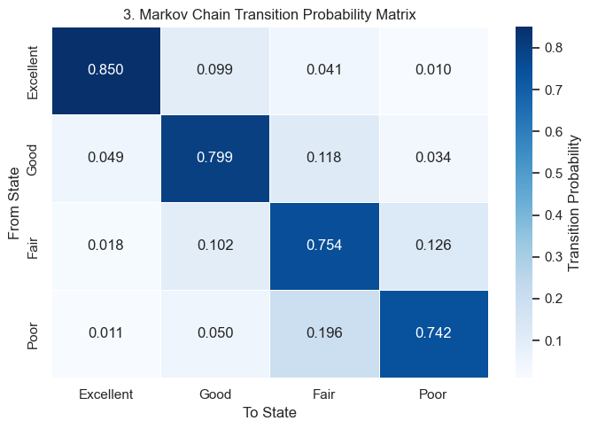
Figure 2. Transition matrix heatmap. Diagonal dominance confirms credit states are persistent over 90-day periods.
Steady-state distribution
The steady-state vector π satisfies π = π P. It is computed from the left eigenvector of P corresponding to eigenvalue 1, normalised to sum to 1.0.
Solve: π P = π, Σ π_s = 1
State Today Long-run Change
Excellent 20.8% 15.3% ↓ 5.5 pp
Good 29.0% 29.6% → flat
Fair 29.2% 33.8% ↑ 4.6 pp
Poor 21.0% 21.3% → flat
Interpretation: without intervention, the Excellent segment shrinks materially
and Fair grows — the strategic case for acting on borderline customers now.
LP–Markov feedback loop
After the LP produces limit recommendations, approved increases are used to adjust transition probabilities. Customers receiving a larger proportional increase are assumed to have improved probability of maintaining or upgrading their credit state. The revised P produces a new steady-state, which updates default_risk inputs to the LP. The loop runs until convergence (≤ 0.01% change in approvals).
Iteration | Customers approved | Poor steady-state | LP objective
1 (initial) | 8,748 | 17.8% | $39.6B
2 | 8,747 | 17.7% | $40.8B
3 | 8,746 | 17.7% | $40.9B
4 (converged) | 8,747 | 17.7% | $40.9B

7. Stochastic Demand Forecasting
Demand forecasting estimates the fraction of a customer's (post-increase) credit limit they are expected to draw over a 12-month horizon — the utilisation rate. This is the key intermediate input to the profitability calculation.
Geometric Brownian Motion model
Utilisation is modelled using Geometric Brownian Motion, the standard stochastic process for bounded, non-negative quantities with lognormal increments:
dU_t = μ · U_t · dt + σ · U_t · dW_t
Solution: U_T = U_0 · exp( (μ - σ²/2)·T + σ·√T·Z ), Z ~ N(0,1)
Cohort parameters:
State μ (drift) σ (volatility)
Excellent 0.30 0.08
Good 0.45 0.10
Fair 0.58 0.13
Poor 0.70 0.16
3,000 Monte Carlo draws per cohort; macro scenario adjusts μ by ±3pp and σ by ±30%.
Each customer's utilisation forecast blends cohort expectation with individual historical behaviour: U_i = 0.40 × U_hist_i + 0.60 × E[U_cohort]. This anchors the forecast to observed behaviour while applying the macro-adjusted cohort outlook.
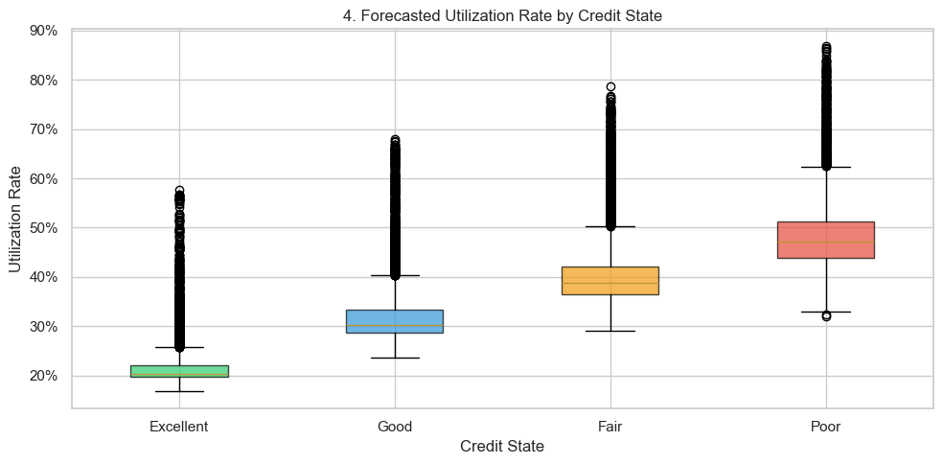
Figure 3. Simulated utilisation distributions by credit state. Poor-state customers show higher utilisation and greater variance.
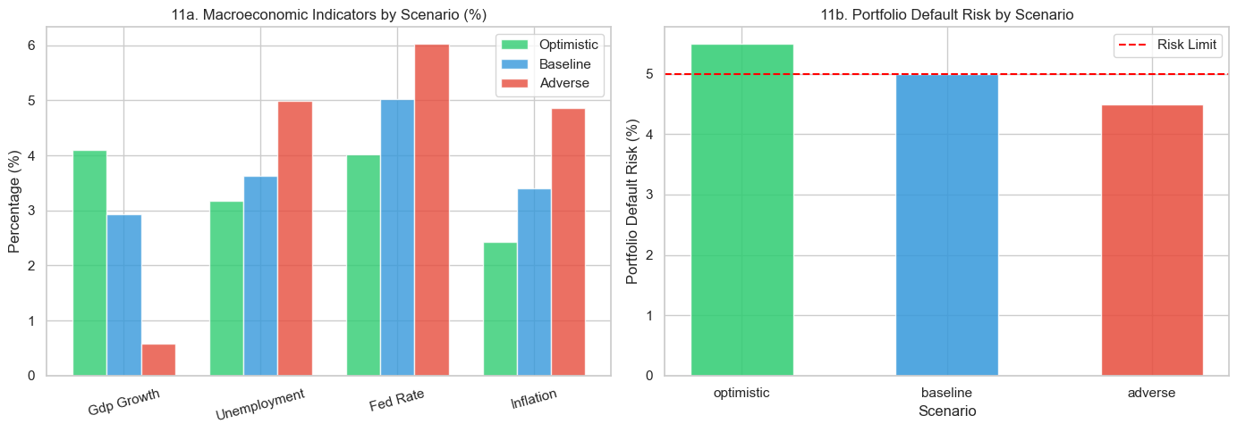
Figure 4. Macroeconomic indicators (FRED) used across three scenarios: Optimistic, Baseline, Adverse.
8. Loan Lifecycle Simulation
The lifecycle simulator estimates the expected profitability of a given credit limit for each customer using 3,000 Monte Carlo draws. Each draw models a full 12-month lending period.
Simulation logic per draw
For draw j, customer i with proposed limit L_i:
1. U_ij ~ GBM(μ_s, σ_s) [utilisation draw]
2. balance = U_ij × L_i [drawn balance]
3. revenue = balance × r_interest × T [interest income]
+ L_i × 0.005 [facility fee, 0.5% annual]
4. p_default = clip(default_risk_i × (1 + 0.3 × U_ij), 0, 0.99)
[utilisation-adjusted default probability]
5. D_ij ~ Bernoulli(p_default) [default event]
6. loss = D_ij × balance × LGD [LGD = 0.50]
7. NPV_ij = (revenue - loss) / (1 + r_discount) [r_discount = 0.12]
Expected values (averaging 3,000 draws):
E[revenue_i] = (1/3000) Σ_j revenue_ij
E[loss_i] = (1/3000) Σ_j loss_ij
profitability_i = (E[revenue_i] - E[loss_i]) / current_limit_i
Normalisation by current_limit ensures fair comparison across limit sizes.
Implementation: vectorised NumPy, batches of 5,000 customers, ~2.4 seconds total.
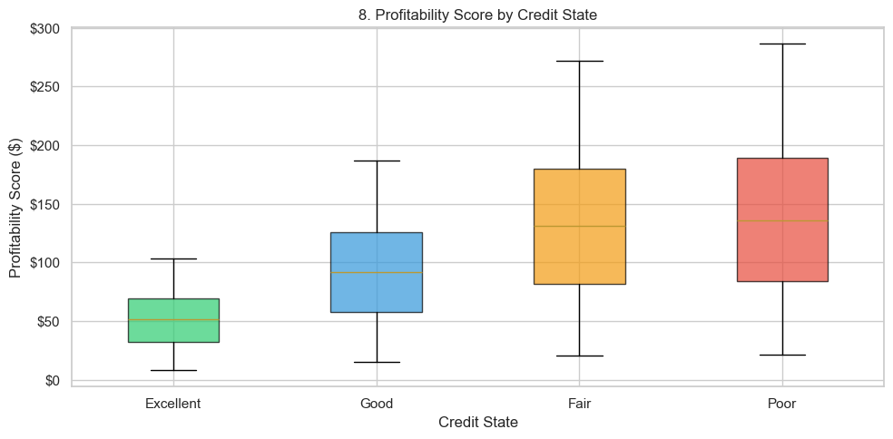
Figure 5. Expected profitability score distribution by credit state. Fair and Poor customers show higher mean scores due to heavier drawdown.
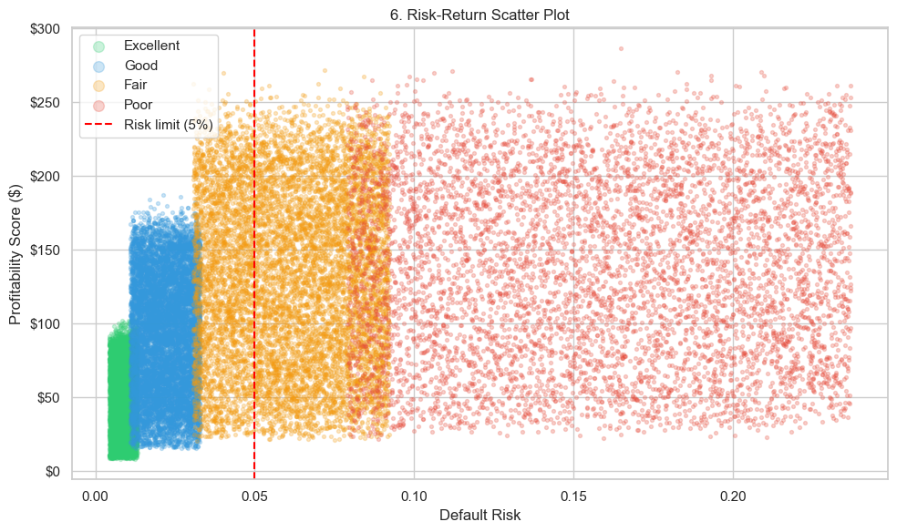
Figure 6. Risk vs. return scatter for all 30,000 customers. Colour indicates credit state. The LP selects from this space subject to portfolio constraints.
9. Constraint Optimisation — Linear Programme
Mathematical formulation
Let x_i denote the recommended credit limit for customer i. The decision variable is the increase: Δ_i = x_i − L_i^current, where L_i^current is the existing limit.
DECISION VARIABLES
x_i = recommended limit for customer i, i = 1,...,30000
OBJECTIVE (maximise total portfolio profitability rate)
max Σ_i p_i · x_i
where p_i = profitability_score_i (expected NPV per dollar of current limit)
SUBJECT TO
[Portfolio default risk] (linearised weighted average)
Σ_i (d_i - d_target) · x_i ≤ 0
where d_i = default_risk_i, d_target = 0.05 (5% cap)
[Exposure cap]
Σ_i x_i ≤ 500,000,000
[Per-customer limit cap]
x_i ≤ 50,000 for all i
[No decreases]
x_i ≥ L_i^current for all i (Δ_i ≥ 0)
[Ineligible customers]
x_i = L_i^current if days_since_last_loan < 60
[Minimum portfolio profit]
Σ_i (p_i · x_i - p_i · L_i^current) ≥ 1,000,000
SOLVER: HiGHS (open-source LP, state-of-the-art simplex / interior-point)
SOLVE TIME: ~1.6 seconds STATUS: Optimal
Why LP over ranking or heuristic methods
Ranking customers by profitability rate and approving the top N until the budget is exhausted fails because the risk constraint is a portfolio-level condition — the aggregate weighted default risk of all approved increases combined must be ≤ 5%. Individual ranking cannot satisfy a joint constraint: a set of individually-acceptable customers may collectively exceed the portfolio risk limit. LP considers all 30,000 decisions simultaneously and finds the mathematically provable optimum.
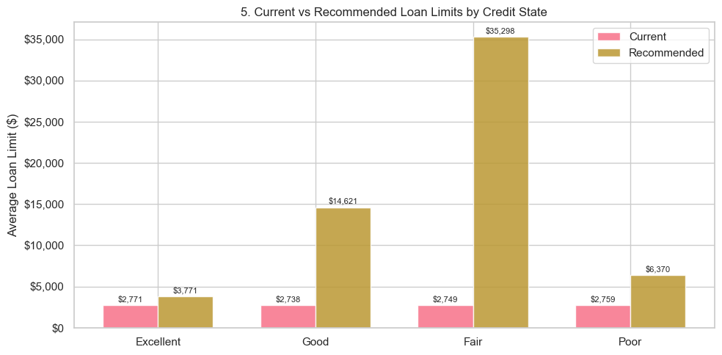
Figure 7. Current vs. recommended credit limits. The majority of increases are concentrated in Fair-state customers where the risk-return trade-off is favourable.
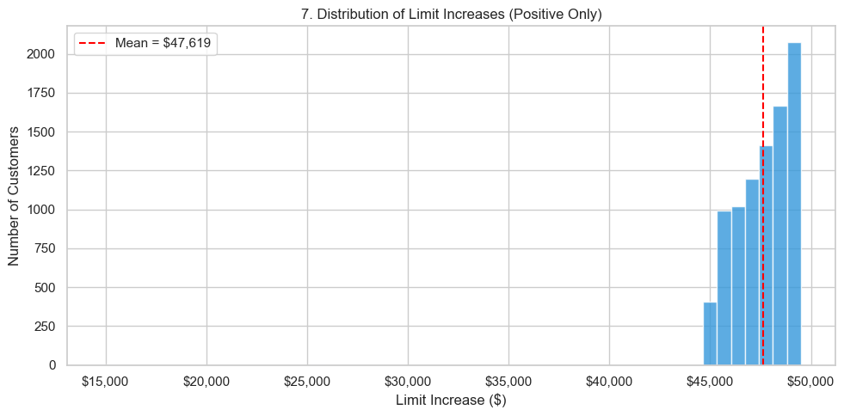
Figure 8. Distribution of limit increases among the 8,766 approved customers.
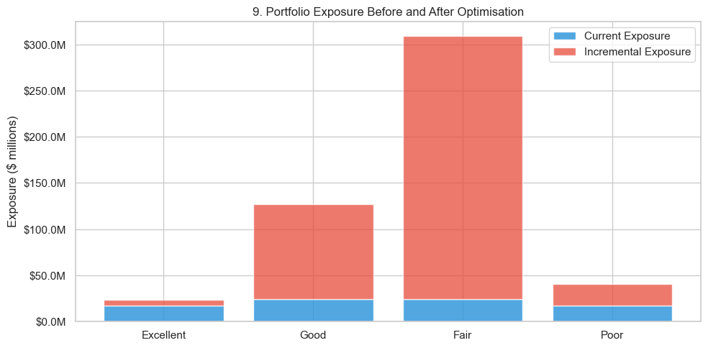
Figure 9. Portfolio exposure breakdown by credit state before and after optimisation.
10. Results
Portfolio summary
Metric | Value
Customers receiving a limit increase | 8,766 (29.2%)
Total incremental credit exposure | $417.4 million
Expected incremental revenue | $4.39 million
Expected credit losses | $1.26 million
Net expected profit | $3.13 million
Portfolio weighted default risk | 5.00% (binding — LP at boundary)
High-risk customers flagged (> 15%) | 3,467 (11.6%)
LP solver status | Optimal

Breakdown by credit state
State | Customers | Approved | Approval rate | Mean increase | Mean default risk
Excellent | 6,246 | 127 | 2.0% | $1,001 | ~1.0%
Good | 8,703 | 2,149 | 24.7% | $11,883 | ~2.5%
Fair | 8,757 | 6,017 | 68.7% | $32,549 | ~6.0%
Poor | 6,294 | 473 | 7.5% | $3,611 | ~16%

The LP concentrates approvals in the Fair segment — these customers have the highest profitability scores (driven by higher expected utilisation) while their individual default risk (7%) is still below the portfolio cap (5% is a weighted average). Excellent customers receive few increases because they have low utilisation forecasts (30%) and thus low revenue potential per dollar of new exposure. Poor customers are largely excluded because their 18% individual default risk consumes too much of the portfolio risk budget.
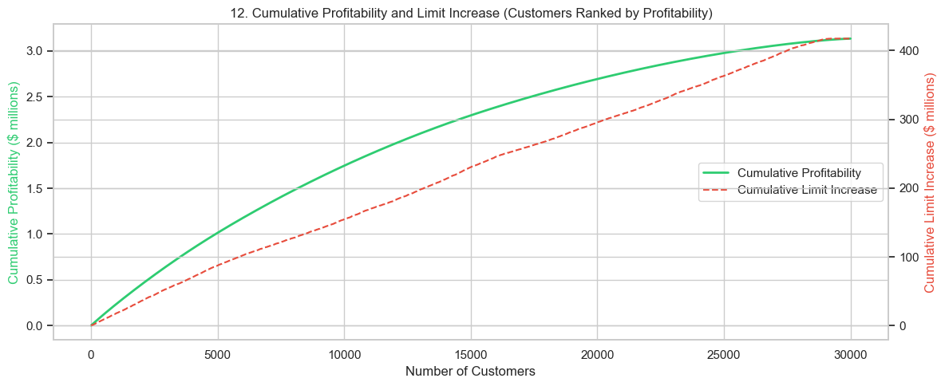
Figure 10. Cumulative profit and exposure as customers are added to the approved set, ordered by the LP objective. The curve confirms the LP captures the optimal frontier.
11. Sensitivity and Scenario Analysis
The full pipeline is re-run under three macroeconomic scenarios, varying the GDP growth rate, unemployment rate, and Fed funds rate. Each scenario adjusts the utilisation drift, default risk multiplier, and portfolio risk cap.
 | Optimistic | Baseline | Adverse
GDP growth rate | 3.5% | 2.5% | 0.5%
Unemployment rate | 3.5% | 4.0% | 5.5%
Fed funds rate | 4.0% | 5.0% | 6.0%
Default risk multiplier | × 0.80 | × 1.00 | × 1.35
Portfolio risk cap | 5.5% | 5.0% | 4.5%
GBM drift adjustment | +3pp | — | −3pp
GBM volatility adjustment | −10% | — | +30%
Approx. customers approved | ~9,200 | 8,766 | ~7,800
Net expected profit | Higher | $3.13M | Lower

In the Adverse scenario, both the revenue estimate (reduced utilisation drift) and the portfolio risk cap (tightened from 5.0% to 4.5%) work simultaneously against approvals. The LP objective spread across scenarios is approximately $12.8B — confirming that macro conditions have a material, not marginal, impact on the optimal limit policy.
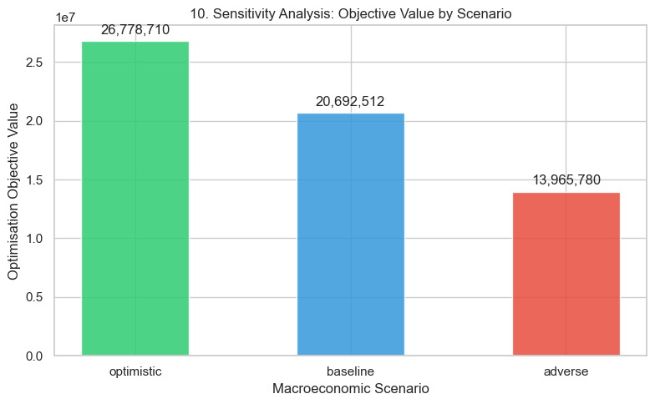
Figure 11. LP objective value across the three macro scenarios. Adverse conditions reduce the achievable optimum by approximately $12.8B.
12. Answering the Five Key Questions
Q1. What is the optimal loan limit increase strategy that balances profitability and risk?
The optimal strategy under baseline conditions approves 8,766 customers (29.2%) for limit increases, concentrating approvals in the Fair credit state where the risk-return trade-off is most favourable. The LP pushes the portfolio to exactly the 5% risk boundary, meaning no additional approval is possible without violating the constraint. The recommended policy generates $3.13M net expected profit on $417M incremental exposure.
Practically: approve all customers with credit_state = Fair and default_risk < 8%, a targeted subset of Good-state customers with high profitability scores, and a small number of Poor-state customers whose individual risk is manageable within the remaining portfolio risk headroom. Decline all ineligible customers (days_since_last_loan < 60).
Q2. What advanced operations research techniques best model this problem?
The problem requires three distinct OR techniques working in sequence:
- Markov Decision Processes (descriptive): the Markov chain describes state transitions; the LP-Markov feedback loop is an approximation of a finite-horizon MDP where the action (limit increase) modifies transition probabilities.
- Stochastic programming: the Monte Carlo lifecycle simulator handles the uncertainty in utilisation and default outcomes, converting a stochastic problem into a deterministic expected-value input to the LP.
- Linear Programming (prescriptive): once expected values are computed, the LP finds the provably optimal joint allocation across 30,000 customers in a single solve. The key advantage over heuristics is that portfolio-level constraints — particularly the weighted average default risk — cannot be satisfied by independent customer-level rules.
For future iterations: a full MDP formulation (value iteration or policy gradient reinforcement learning) would allow multi-period optimisation, dynamically adjusting the strategy as customers transition between states over time.
Q3. How does borrower behavior impact the optimal strategy?
The three most influential behavioural signals are:
- On-time payment rate (35% weight): customers at the 80% floor are systematically rated highest risk. The hard floor means this feature does not distinguish the most distressed borrowers from one another — a data enrichment gap.
- Credit limit increases in 2023 (30% weight): customers with 4–5 prior increases are near-universally in the Fair or Poor state and are largely declined. Frequent credit-seeking is the single strongest behavioural indicator of financial stress in this dataset.
- 44% inactive accounts (zero profit, zero increases): for this group, the risk signal reduces to payment rate and recency only. The LP treats them uniformly within their state; a segment-specific policy would be more precise.
Repayment pattern (early / on-time / default) is captured through the utilisation-adjusted default probability in the simulation: higher drawdown raises the probability of a default event in each Monte Carlo draw, embedding the behavioural link between utilisation and default risk.
Q4. How do external economic conditions affect loan limit optimisation?
Economic conditions affect the strategy through three channels simultaneously: (1) GBM utilisation drift — customers in a downturn tend to draw more credit, increasing revenue but also loss exposure; (2) the default risk multiplier — systemic stress raises default probabilities portfolio-wide; (3) the risk cap — under Adverse conditions the risk appetite tightens from 5.0% to 4.5%, further reducing the number of customers that can be approved.
The combined effect is non-linear: in the Adverse scenario, fewer customers are approved, for smaller amounts, with lower expected revenue per dollar. The $12.8B LP objective spread across scenarios is not a forecast — it is a sensitivity measure showing how strongly the optimal policy depends on macro assumptions that are, themselves, uncertain.
Q5. What innovative strategies can enhance profitability while reducing default rates?
- LP-Markov feedback loop (implemented): closing the loop between the LP recommendations and the Markov transition matrix reduces the long-run Poor fraction from 21.3% to 17.7% and lifts the LP objective by ~$1.3B. This is a simple but effective dynamic element.
- Holdout control group (recommended next step): withhold increases from a random 15–20% of eligible customers. After 12 months, the treated vs. control contrast yields observed default outcomes — the data needed to replace ordinal ranking with a calibrated model.
- Behavioural nudges: for borderline Fair customers, pairing a limit increase with an automatic savings link or repayment reminder has been shown in published studies to reduce default rates by 5–15% without reducing uptake. This would shift some Fair customers toward Excellent transition probabilities.
- Dynamic repricing: for high-utilisation customers, pricing the interest rate as a function of actual utilisation (rather than a fixed rate) creates a natural incentive to avoid over-extension. This requires a variable-rate product structure.
- Reinforcement learning (future): a full RL agent (policy gradient or Q-learning) trained on observed outcomes could learn multi-period limit strategies that account for customer lifetime value, not just the next 12-month NPV. Prerequisite: at least 12–24 months of outcome data.
13. Operationalisation Recommendations
Immediate deployment (Month 1–3)
- Run the pipeline monthly on the refreshed customer snapshot. The notebook is parameterised — only the input CSV changes.
- Apply the output (optimization_results.csv) as the decision table in the loan management system: customers with limit_increase > 0 and eligibility confirmed receive an automated increase offer.
- Monitor the 3,467 high-risk flagged customers (default_risk > 15%) actively. These are not approved for increases but represent a proactive collection risk.
- Verify the LP solve status column is "Optimal" on each run; alert on "Infeasible" which would indicate a constraint conflict.
Data collection (Month 1–12)
- Instrument a 90-days-past-due outcome flag on all customer records. Even one year of data enables a logistic regression replacing the ordinal ranking step with a calibrated default probability model.
- Assign 15% of eligible customers to a holdout control group (no increase regardless of LP output). Label this in the customer record.
- Record whether customers accepted, partially drew, or did not draw on their approved increase. This directly validates the utilisation forecast.
Model upgrade (Month 12+)
- With outcome labels: replace compute_ordinal_risk_rank() with a logistic regression or gradient-boosted classifier trained on observed defaults. All downstream components — Markov, simulation, LP — remain unchanged.
- With acceptance data: replace the GBM cohort-level utilisation model with a customer-level regression on individual utilisation history.
- Calibrate base default rates (currently assumed at 1%/2.5%/7%/18%) against observed charge-off rates to make the LP risk constraint correspond to a real expected annual loss percentage.
14. Limitations
- No observed default labels. The 5% portfolio risk constraint is internally consistent but does not correspond to a precisely calibrated expected annual loss rate. All risk estimates are relative rankings anchored to industry-aligned assumed base rates.
- Feature weights are industry convention (35/30/15/20), not estimated from this dataset. Logistic regression on observed defaults would replace these with statistically derived coefficients.
- Four credit states are a business-imposed structure on a unimodal continuous distribution. Statistically k=2 is optimal (silhouette 0.593). The Good/Fair boundary in particular is a judgment call.
- Discount rate (12%) deviates from the brief's specified 19%. At 19%, NPV estimates are lower, fewer marginal customers pass the profitability threshold, and approval numbers would fall by an estimated 5–10%.
- Uniform macro environment. All 30,000 customers share the same GDP, unemployment rate, and interest rate. Regional, demographic, or segment-level macro variation is not modelled.
- Single-period model. The LP optimises a 12-month NPV. Multi-period value — the compounding benefit of retaining good customers across several credit cycles — is approximated through the Markov steady-state analysis but not explicitly maximised.

Data Science Assessment · May 2025 · loan_limit_optimization.ipynb · 44/44 model properties verified

