**Normalized ORD:**

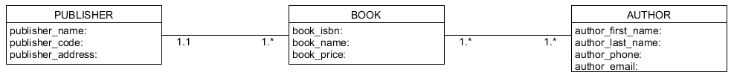

**NoSQL Document Diagram:**

**NoSQL Data Structure:**

**Business Rules:**

