**Bijlage 1**

**Format for Information Collection - Results Report 2009-2010 (bilateral aid program)**

**Embassy**: Maputo

**Country**: Mozambique

**Strategic Goal**: Contribute to poverty reduction in Mozambique in an aligned and effective way

**Sub-goal/ programme selected for this form**: Improved social protection for HIV/AIDS victims, with a focus on strengthening the cash transfer program managed by the Ministry of Women and Social Action (MMAS) and on clearing the backlog in birth registration.

**This form is completed by**: Eleásara Antunes

Max 1200 words.

**1. CONTEXT**

**a. Country context**

The number of people living below the poverty line has stagnated at 54% between 2003 and 2009, poverty line is estimated at 18.4 Mts[1] (USD 0, 69) (IOF2008/2009)[2], with a significant share of the burden for women. Inequality is also increasing; the national Gini coefficient is 0.414 with significant rural/urban variations, ranging from 0.323 in Tete province and 0.512 in Maputo city. On the other hand, non income related indicators have shown signs of progress since 2003, such as the access to education, health and water, whereas, child malnutrition and stunting related indicators have shown very small improvements. The Human development index for Mozambique is 0.284, which places Mozambique below the SSA region average which is 0.389.

Graph : Poverty distribution by sex

Nonetheless, the performance of the national economy has been very good, growing at a rate of 7.8% a year in the last 3 years, while the average rate for the other southern African countries was 4.8%[3], however with very little impact in poor households.

b. **Sector (or thematic) context**

One of the priorities defined in the National Action Plan for Poverty Reduction (PARPA II) is income redistribution, through the provision of welfare related services to the poorest households. The social protection strategy approved in 2010 has the aim to: (i) increase the coverage and the impact of the programs directed to the most vulnerable people; (ii) increase the efficiency of the social protection program; and (iii) ensure harmonisation and coordination of the different existing social protection programs.

Mozambique’s cash transfer program, *Programa de Subsídio de Alimentos* (PSA_Food Subsidy Programme), was established by decree on 25 August 1993, The program aims to provide direct assistance to individuals permanently unable to work in order to create minimum conditions for survival and of access to satisfy the basic needs of target groups in absolute poverty.

Poverty is also exacerbated by poor access to basic services and benefits, such as social protection. Lack of adequate identification is a very big obstacle particularly for vulnerable and orphaned children, as they cannot be enrolled at school or in the PSA as indirect beneficiaries. In order to overcome the lack of identification documents, GoM designed a campaign to provide registration services at community level. This initiative is financed by the Netherlands Embassy since 2006.

**c. Description of the problem**

The economic strategy adopted by the Mozambican government has been successful in reaching sustained economic growth. However the impact of this economic growth has not been significant in terms of reducing the number of people below the poverty line. Social protection policies and programs aim to reduce household’s risks and vulnerabilities increasing their opportunities to fully engage in the economy.

**d. Intervention logic**

As the coordination of the social protection response is mainly the remit of MMAS, the Embassy has chosen to support this ministry to improve their implementation capacity; the Embassy also supported and some civil society partners to reinforce the system:

* + The embassy has supported Help Age International to implement an alternative model to deliver the transfer to the beneficiaries;
  + Support to UNICEF to reduce the number of children without identification, trough the birth registration campaign.

**2. RESULTS AND LESSONS LEARNED**

1. **What was achieved and why? What made it happen? (Please base on your results chain/ other intervention logic and please include gender aspects where relevant**)

For the Cash transfer program the following changes have occurred:

* Long term additional funding to the program has prompted a rapid expansion, a double fold increase in the number of beneficiaries from 2007 to 2010 (217.000 beneficiaries), around 70% of the beneficiaries are elder women.
* This significantly contributed for the design and approval of the regulatory framework for the Basic Social Protection sub System (November 2009), and the approval of the National strategy for Basic Social Protection (March 2010).
* The impact evaluation study of PSA[4] reflects that the programme has had a positive benefits on food share expenditure of the households, particularly for female headed households. It also shows that meal regularity, one of the dimensions of food security, has also been positively affected, at least for adult women and boys. It was also found a weak evidence of positive impact on nutrition outcomes for children below the age of 5. It is important to highlight that this trend is verified even with the very small amount of the transfer (average 110Mts per month which is equivalent to US $3), which is less than the amount in similar countries (Zambia US$ 5 monthly, Kenya US $21 and Malawi on average US $14)[5].

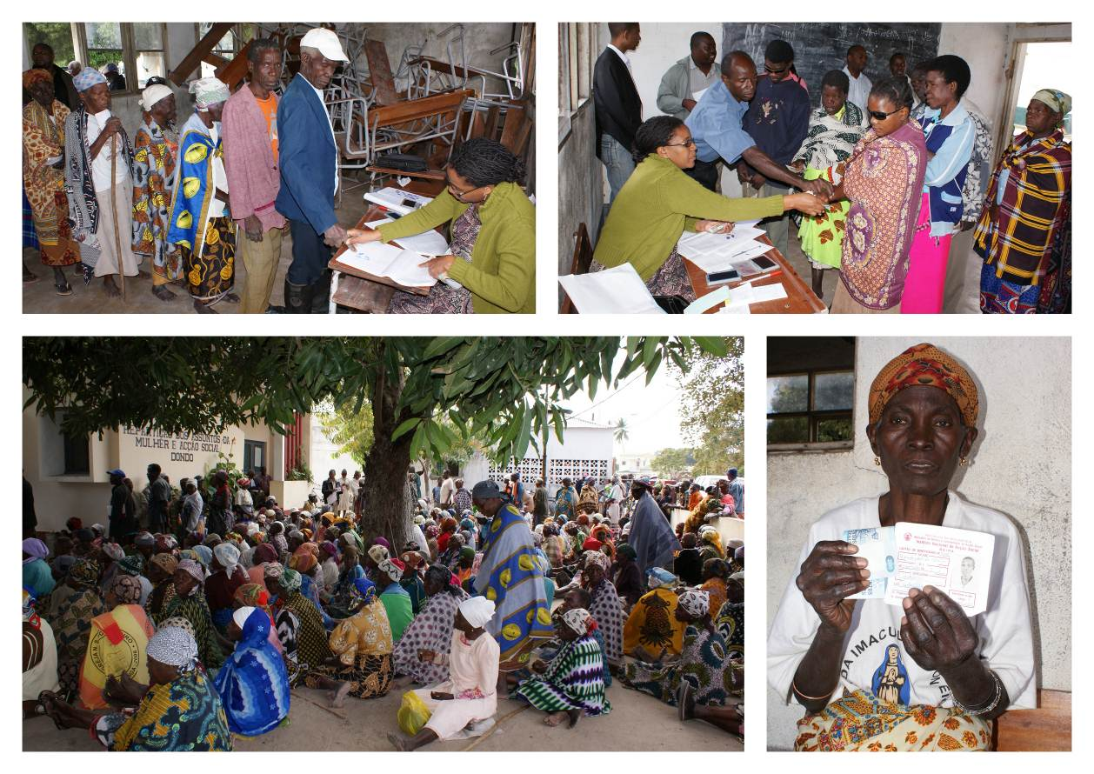

Figure : PSA Payments in Dondo District, Sofala province. Images kindly provided by INAS.

The financing of the Birth registration campaign allowed the Ministry of justice to achieve the following results:

* a second place award was granted to the Mozambican National Directorate of Registry and Notary (DNRN). The African Association of Public Administration Management (AAPAM) attributed the prize for the innovative approach adopted by DNRN, the use of mobile brigades in delivering registration services.
* Since 2006, the birth registration program has registered some 6.000.000 children under 18,.
* Significant increase of the number of children with a birth certificate. In Mozambique, the proportion of children under five whose birth was registered is 31% (MICS 2008) and the 2007 census shows that the percentage of registered children, under 18 as 49%[6] . The situation has remarkably improved when compared with the 2004 DHS figures, where only 8% of children under five were registered.
* Strengthening of inter-ministerial cooperation between the Ministry of Justice, the Ministry of Education, the Ministry of Health, the Ministry of Women and Social Action and the Ministry of State Administration which is sought to increase birth registration rates, especially at birth.
* Modernisation of the Birth registration process.

Graph 2: Children under 18, birth registration data,



Source: MICS and Census 2007 report

.

1. **What went less well and why?**

Social protection was not considered by The Government has one of the countries’ poverty reduction strategy. To illustrate this, in 2009 and 2010 when fuel and food prices increased government put in place subsidies which are very costly and fiscally not sustainable. And above all, it had smaller impact on the poorest households. A least costly alternative could have been the increase of the scale of the cash transfer program, for instance. Nonetheless, it is important to mention that since the end of 2010 the government is getting aware of the relevance of social protection policies.

1. **What has been learned?**

MMAS and INAS must be able to use evidence in order to influence policy, especially to support dialogue for the finance of social protection. It is important to have all donors working in the field of social protection to speak with one voice, this reinforces the position of MMAs as a coordinating institution and strengthens the message that call attention for the need to better invest in social protection.

**3. RESOURCES SPENT (ODA and FTEs)**

|  |  |
| --- | --- |
| Dutch ODA disbursed during 2009-2010 as contribution to this strategic goal (approximately) | € 6.500.000 |
| Average amount of Embassy FTEs allocated during 2009 and 2010 to this goal (for delegated aid) | 0.65 |
|  |  |
| Piramide numbers of relevant Activities | 17224  15382  18208 |

**4. OVERALL TRAFFIC LIGHT SCORE**

The overall achievement of results is:

(Please tick **√**)

|  |  |  |  |
| --- | --- | --- | --- |
|  | Off-track | 1 |  |
|  | In danger to be off track | 2 |  |
|  | On track | 3 | √ |

1. This is around 540 Mts a month. The average exchange rate from metical do dollar was in 2009 26.71, source <http://www.bancomoc.mz/Files/DEM/Cambios_Anuais_2003.xls>
2. Poverty assessment survey 2008/2009, <http://aec.msu.edu/%5C/fs2/mozambique/caadp/THIRD_NATIONAL_POVERTY_ASSESSMENT_october1.pdf>
3. IMF country report 2010, available at <http://www.imf.org/external/pubs/ft/scr/2010/cr10375.pdf>
4. [http://www.ipc-undp.org/pub/IPCPolicyResearchBrief17.pdf](http://portal.rijksweb.nl/irj/portal?login_submit=true&j_authscheme=singlesignon)
5. http://www.chronicpoverty.org/uploads/publication_files/handa_et_al_multidimensional.pdf
6. The rate from the MICS report is lower because it most probably an underestimation as campaign activities had taken place in 32-52 of the 130 districts (depending on the time the survey data were collected) and some of the enumeration areas of the survey were located in districts that had not yet undergone campaign activities, resulting in an under-representation of the actual situation. In addition, the MICS report only captures under five registration, while the census captures under 18 registration rates.