**UGANDA JLOS**

**Embassy (for delegated aid)**: Kampala

**Thematic Department (for non-delegated aid)**: DMH, DVB/EFV; DSO

**Country**: Uganda

**Strategic Goal**: Increased safety and security & increased access to justice

**Sub-goal/ programme selected for this form (where relevant)**: Justice, Law and Order

**This form is completed by**: Judith Maas

**1. CONTEXT**

**a. Country or regional context + b. Sector (or thematic) context**

After almost two decades of political, civil and economic regression in Uganda, the country faced a breakdown of the functions of the state, including the administration and the maintenance of law and order in the late 1980s. There was a loss of public confidence in the justice system and the system suffered from lack of finance, infrastructure, logistics, from a demoralised staff accepting bribes, a lack of proper legal and policy direction and a delivery of low quality services. There was effectively no access to justice for all.

The institutions within the Government of Uganda involved in providing justice, law and order started working together in the JLOS sector. Currently, the sector is implementing its second Strategic Investment Plan (2006-2011), that has five objectives: 1. To promote the rule of law and due process 2. To foster a human rights culture across all the sector institutions 3. To enhance access to justice for all especially the poor and the marginalised; 4. To reduce incidence of crime 5. To enhance the JLOS contribution to economic development. There are four focus areas, Family Justice, Land Justice, Criminal Justice and Commercial Justice. For further information on the JLOS see: [www.jlos.go.ug](http://www.jlos.go.ug).

**c. Description of the problem**

Security and stability are absolute preconditions for development as such. They are at the same time prerequisites for further democratisation, which in turn can contribute to further development.

**d. Intervention logic**

Justice, law and order is one of the elementary tasks of a state. Any long term support should therefore involve the government. For a well-functioning JLOS, especially in the context of a regime striving for survival, a vibrant civil society that provides civilian oversight through monitoring police, prisons, and the judiciary is key. Additionally, EKN intends to link its human rights focus to its interventions and active involvement in JLOS so that in addition to close monitoring (criticism-approach) there is also support for development and improvement (positive-advice-approach).

Given the above mentioned intervention logic, next to sector budget support to the JLO sector EKN has supported CSOs in the areas of human rights, police accountability and rehabilitation of victims of torture.

To enable the JLOS to build up their presence in Northern Uganda, after the end of the civil war there five years ago, EKN made considerable contributions towards the JLOS Peace Recovery and Development Plan (PRDP).

The Netherlands, together with Ireland, Sweden, Norway and Austria, supports the sector with 26,6 mln US Dollar through Sector Budget Support. EKN has traditionally been one of the leading donors in this sector. In 2011 it again is chairing the JLOS Development Partners Group (DPG). This position gives EKN an important entry point for a policy and political dialogue with key actors within the JLO sector.

**2. RESULTS ANDS LESSONS LEARNED**

**a. What was achieved and why? What made it happen?**

The intervention strategy of EKN in the JLO sector, working on a professionalization of JLOS institutions while at the same time strengthening civilian oversight, shows good results. Although democratic policing is still facing challenges, the strengthening of public order management, introduction of human rights standards and a complaint procedure for the public are all positive developments.[1] The police review, financed by EKN and finalized at the end of 2010, will provide more inputs for reform to be implemented in the coming years.

The judiciary has demonstrated independence and professionalism in 2011: examples include the Constitutional Court rulings on the crime of sedition and the unconstitutionality of the Besigye case[2] as well as the high court ruling banning a tabloid news paper that published names of alleged homosexuals under the heading ‘hang them’.[3]

In the year under review, the sector has witnessed a reduction in human rights violations by JLOS institutions. This was made possible by mainstreaming human rights education within JLOS institutions and the proactive stand taken by the Uganda Human Rights Commission[4], that is now a full member of the JLOS, to deal with human rights violations in the country.

Case backlog has been a huge challenge to the sector for years. This caused human rights abuses: people staying in prison for years without a fair trial. In 2010 a Case Backlog Quick wins programme was initiated, under which around 40,000 cases were cleared through regular sessions and by stopping work on unmeritorious cases.[5]

In the last year, many laws were revised and introduced. Especially from a gender perspective, efforts were made, such as the introduction of the anti Female Genital Mutilation act and the Domestic Violence Act. The functionality of Local Council Courts and the Family and Children’s Court is critical to the sector because they improve access to justice for the poor and marginalized groups e.g. children and women. [6] Besides that, official procedures shortened – varying from the reduction of the average time to get a passport to the time it takes to cross the border.

Crime statistics show a downward trend, especially in the crime incident to population ratio. The police piloted community policing and improved on “citizen friendly’ public order management skills.

The contribution to PRDP for Northern Uganda has given a considerable boost to the delivery of JLOS services in Northern Uganda and Karamoja. [7]

**b. What went less well and why?**Though law reform is successful, the implementation of the acts that were passed is still lacking.

Respecting human rights is still a challenge, especially during these times when terrorism is a serious threat. During the riots in September 2009 and on other occasions, people are held in custody on suspicion of terrorism, with limited access to them. Human rights activists regularly level serious allegations of torture by special agencies such as the Rapid Response Unit. [8] The Uganda Human Rights Commission is quite active in following up on complaints in this area.

Though many old court cases have been dropped, it is not clear what the impact is on the poor and vulnerable. In addition, because of the increased accessibility of the JLOS and the population growth, the net result is that the total case load increased.

An anti corruption court was established but impunity for high level persons involved in corruption cases continues to exist[9]. Furthermore, the sector failed to formulate and implement an anti-corruption strategy for (personnel in) the JLOS institutions.

**c. What has been learned?**

The fact that there (still) is a shared agenda between Uganda and the Netherland in the area of peace, security and rule of law has contributed to the positive results of EKN interventions.

Given the context of a regime pursuing survival at all costs and the neo-patrimonial character linked to this, political interference into the JLO sector continues unabated. Therefore the importance of supporting countervailing forces is increasing. In order to harmonise and strengthen interventions, 8 donors including EKN have decided to create a joint Democratic Governance Facility (DGF) that will support CSOs in the area of democratisation, justice and accountability. EKN acknowledges the added value of the collaboration with other donors, not only on government level, but also when it comes to civil society. CSOs that work on for example Police Accountability or the protection of Human Rights Defenders can work more efficiently if they have to deal with one donor partner. Also, the joint programming of the DGF will avoid duplication and enhance harmonisation and coordination.

Though the sector has been focusing on vulnerable groups (poor, women, children), and some concrete results in this area have been reached, it is not clear what the overall impact of these efforts has been, because data divided by gender, social background, age, etc is lacking.

The sector could benefit from a more results based approach as has been introduced in the education sector though the Joint Assessment Framework. As chair of JLOS, EKN will work towards this goal in 2011.

**3. RESOURCES SPENT (ODA and FTEs)**

|  |  |
| --- | --- |
| Dutch ODA disbursed during 2009-2010 as contribution to this strategic goal (approximately) | € 14.2 mln |
| Average amount of Embassy FTEs allocated to this goal during 2009-2010 (for delegated aid) | 1,5 FTE |
| Amount of Thematic Department FTEs allocated to this goal/ programme during 2009-2010 (for non-delegated aid | Unknown |
| “Piramide numbers” of relevant activities | 19556, 16652, 21903, 21908, 16971, 22077, 18492, 18066, 17955, 17001, 17955, 16906, 15785, 15050 |

**4. OVERALL TRAFFIC LIGHT SCORE**

The overall achievement of results is:

(Please tick **√**)

|  |  |  |  |
| --- | --- | --- | --- |
|  | Off-track | 1 |  |
|  | In danger to be off track | 2 |  |
|  | On track | 3 | **√** |

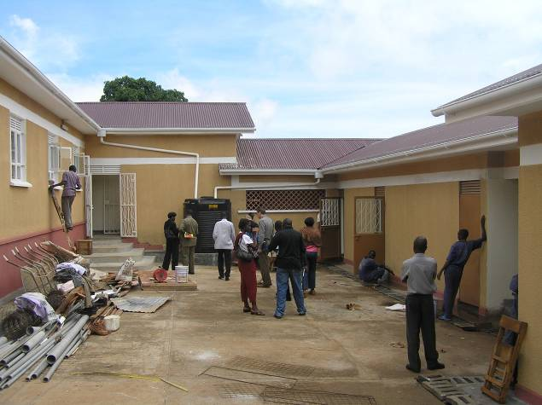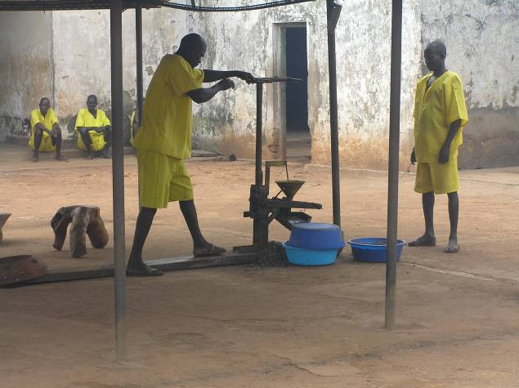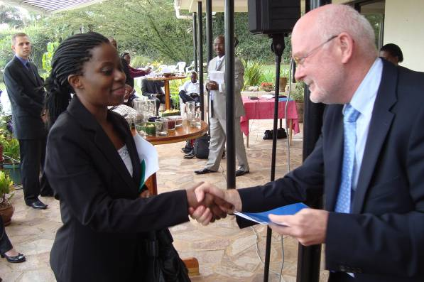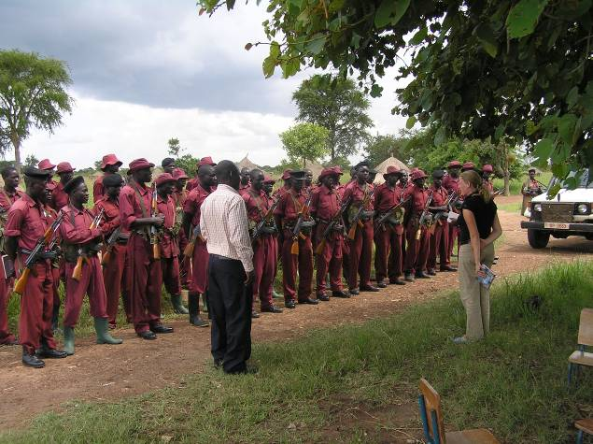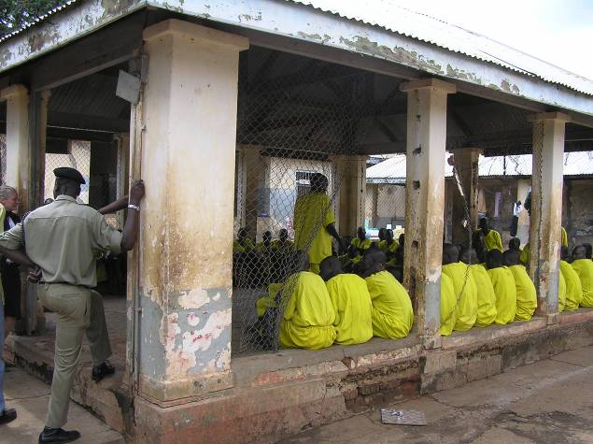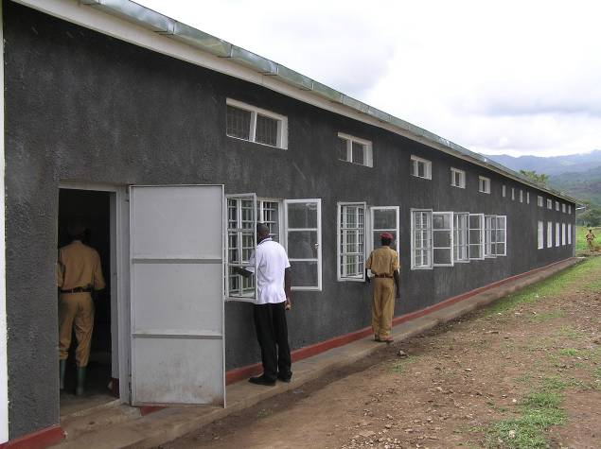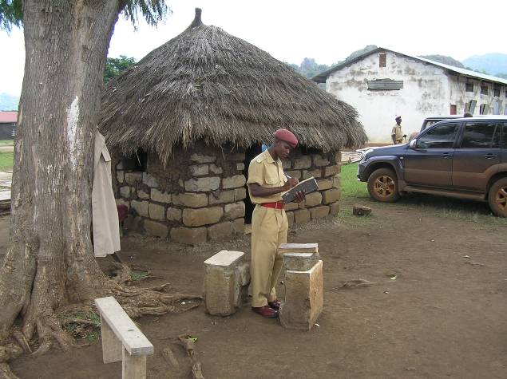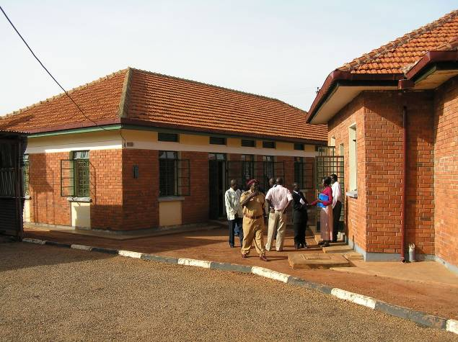

1. http://www.jlos.go.ug/page.php?p=achieve
2. http://www.crestedjournal.com/news/36-in-the-news/447-besigye-treason-case-quashed-by-constitutional-court-
3. <http://www.bbc.co.uk/news/world-africa-11666789>

   http://nos.nl/artikel/195487-krant-uganda-mag-geen-homofotos-plaatsen.html
4. http://www.uhrc.ug/
5. http://www.jlos.go.ug/page.php?p=curnews
6. http://www.un.org/special-rep/ohrlls/ldc/MTR/Uganda.pdf
7. http://www.ugandaclusters.ug/prdp.htm
8. <http://www.hrw.org/en/news/2010/09/10/uganda-investigate-2009-kampala-riot-killings>
9. http://www.trust.org/trustlaw/country-profiles/good-governance.dot?id=89a4af8e-0495-4ac2-90e8-02125ca1834d