Bisson - Report Specification no 1

We need a report using standard letter paper in landscape mode to show three graphs. The first will be the number of leads, the second the number of proposals and the third the number of contracts.

Input parameter:

Ending fiscal year (label : Année financière de fin)

If possible, use the standard picklist of CRM for the fiscal years.

The report header should be:

SOMMAIRE NOMBRE PROPOSITIONS VS NOMBRE CONTRATS  
POUR LA PÉRIODE SE TERMINANT LE <<input the Ending fiscal period here >>

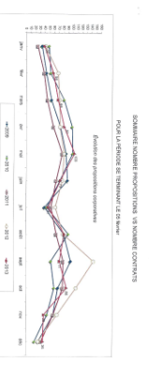

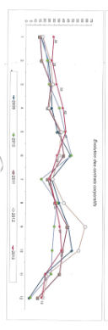

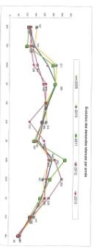

Graph 1 – Show a count of all opportunities per month/year. Include all opportunities for the selected fiscal period and the preceeding 4 (five years in total). Use the opportunities entity and new_dateproposition. Label: Évolution des propositions corporatives

Graph 2 – Show a count of all contracts per month/year. Include all opportunities for the selected fiscal period and the preceeding 4 (five years in total). Use the contrat-travaux entity and new_datecontrat. Label: Évolution des contrats corporatives

Graph3 – Show a count of all leads per month/year. Include all leads that are open or converted for the selected fiscal period and the preceeding 4 (five years in total). Do not include rejected leads. Use the lead entity and new_dateappel. Label: Evolution des demandes retenues par année. Put the year legend at the bottom like the other two graphs.