Bisson - Report Specification no 2

We need a report using standard letter paper in landscape mode to show three graphs. The report will have two parts. The top part and the bottom part.

Input parameter:

Fiscal year (label : Année financière)

LastFiscalPeriod (label : Dernière période)

If possible, use the standard picklist of CRM for the fiscal years and periods.

Region (label: Région d’affaires) – Picklist based on the xxx option set)

WorkType (label: Type de travaux) – based on the entity with the same name

SalesRep (label: Représentant) – based on new_vendeur table. Can be a multi-select

Data set

We will use the new_budget entity for which you wrote the EXE for. You must filter on the fiscal year, take all the fiscal periods upto the selected fiscal period, select only the budget records with the correct region (xxx), worktype (new_typede travaux) and salesrep (new_vendeur).

The report header should be:

Ventes totales << fiscal year>>

Du début d’année à la période <<fiscal period>>

Pour les regions <<region>>

Pour les types de travaux <<worktype>>

Pour les représentants <<Sales rep>>

Top part:

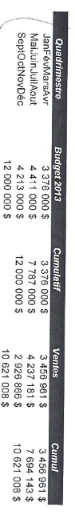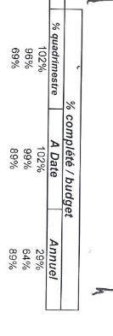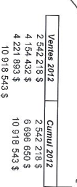

This is a mockup – the actual report should have the lable section all in a black border.

Here is the detail of each of the components



Quadrimestre: This is a four month period (jan-april, May-August and September to December)

If doing the report by four month periods is too difficult, let me know and I will try to to convince the customer to do it by quarter.

Budget 2013 – (change label to Budget) - the total budget – Sum field new_objectif

Cummulatif – (change label to Cumul) it is the running total for the budget

Ventes – this is the accual sales – sum the field new_reel AC

Cumul– this the running total for the sales



% quadrimestre: Percent sales / budget

A Date : running total sales / running total budget

Annuel: running total sales / total budget



Ventes 2012 (change label to : Ventes A.P.) – Sales for last year – new_reelAP

Cumul 2012 (change label to : Cumul A.P.) – Running total of sales for last year.

Bottom part:

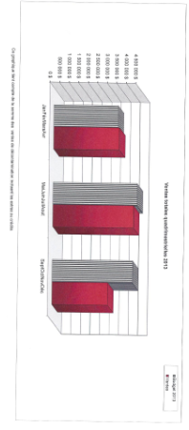

Label : Ventes totales mensuelles <<fiscal year >>

If possible, group per 4 months (january – april, may to august and september to december. If this cannot be done, group by quarter (3 months). But the top part of the report must have the same grouping as the bottom part of the report.

Using the budget table you updated with the EXE, show the budget versus the actual for the current year (entity: new_budget, compare the sum of new_objectif and new_reelAC). Take only the budget records for the corresponding fiscal year.