Aalto University School of Science
Nintendo Game & Watch Shop
T-106.4300 Web Software Development
Final Report

Markku Laine, 48605D, markku.laine@gmail.com
Juha Loukko, 57929V, jloukko@gmail.com
Kalle Säilä, 64775E, kjsaila@gmail.com
Table of Contents
1 Basic Information 3
1.1 Project Size 3
1.2 Group Information 3
2 Overall Description 3
3 Who Did What? 3
4 Project Functionality 4
4.1 How to Setup the Software 4
4.2 How to Use the Software (and What Kinds of Functionality is There to Use) 4
5 Program Structure 4
6 Known Faults and Missing Features in the Program (if any) 4
7 The Three Best and the Three Worst Parts of the Code 4
8 Diversions from the Original Plan 5
9 References 5
10 Introduction to the Topic 6
11 Requirements 6
12 Structure of the Web Site 6
13 Project Goals, Group Members, and Responsibilities 8
14 Web Application Architecture 9
14.1 Database Schema 9
15 Schedule 12
16 Resources 14

Basic Information

Project Size
The original plan was to complete the 5 cr version of the course. However, from the very start we decided that unexpected issues have to be taken into account in one way or another. Therefore, we first implemented all functional requirements for the 4 cr version prior moving on those of the 5 cr version. Personally, we think that this was a wise decision as we actually run into some unexpected issues, such as Kalle’s weeklong work trip to the States just before the final deadline.
Anyhow, we managed to implement all functional requirements for the 5 cr version except [TODO].

Group Information
Group information—including names, student numbers, and email addresses—can be found from Table 1.
Table 1: Group information
Name | Student Number | Email Address
Markku Laine | 48605D | markku.laine@gmail.com
Juha Loukkola | 57929V | jloukko@gmail.com
Kalle Säilä | 64775E | kjsaila@gmail.com

Overall Description
[TODO]

Who Did What?
[TODO]
Detailed information about who did what and when is available at: https://code.google.com/p/nintendo-gw-web-shop/updates/list

Project Functionality

How to Setup the Software
In addition to software listed on the slide 11/14 of the lecture 16, the deployment environment has to support the following external libraries:
- libjpeg 8c: For supporting image uploads (ImageField) in the JPEG format in the administration user interface
- Python Imaging Library (PIL) 1.1.7: For supporting image uploads (ImageField) in the administration user interface
For more detailed information regarding the installation of the aforementioned software on Mac, please refer to the following tutorials: http://paul.annesley.cc/2007/11/django-and-python-imaging-library-pil-on-leopard and http://stackoverflow.com/questions/1398701/problems-with-snow-leopard-django-pil.
[TODO]: Describe the fixtures

How to Use the Software (and What Kinds of Functionality is There to Use)
[TODO]

Program Structure
[TODO]

Known Faults and Missing Features in the Program (if any)
[TODO]

The Three Best and the Three Worst Parts of the Code
[TODO]

Diversions from the Original Plan
[TODO]

References
Books and web sites:
- Course web site: https://noppa.tkk.fi/noppa/kurssi/t-106.4300/etusivu
- Django Documentation 1.2: http://docs.djangoproject.com/en/1.2/
- The Django Book 2.0: http://www.djangobook.com/en/2.0/
- Nullege: http://nullege.com/codes/show/src%40p%40y%40python_blog_engine-HEAD
- Google Code: https://code.google.com/
- Eclipse: http://www.eclipse.org/
- Pydev: http://pydev.org/
- Subversion: http://subversion.tigris.org/
- Base 2: http://menial.co.uk/software/base/
- jQuery: http://jquery.com/
JavaScript libraries:
- jQuery 1.4.2: For simplifying web development on the client-side
- jQuery UI 1.8.9: For advanced effects and widgets in the user interface
- jQuery Validation plugin 1.7: For validating forms on the client-side
- jQuery Quicksand plugin: For sorting series
- jQuery Flip! plugin: For flipping the product information
- Modernizr 1.5: For better browser support
- HTML5 JavaScript shiv: For recognizing and styling the HTML5 elements in Internet Explorer
Snippets of code:
- Nicer Django Messages Output: For rendering nice Django messages
Content:
- Mike’s Nintendo game&watch forum - FAQ: For gathering/double checking information about Nintendo Game & Watch games

Introduction to the Topic
The objective of the project is to develop a web shop with social media features, as stated in the instructions. The products to be sold in our web shop are Nintendo Game & Watch handheld games. All 61 different games in 11 series will be available through our imaginary web shop, even tough the production of the games has been stopped nearly two decades ago. Got to be prepared for the second coming :)

Requirements
Basic requirements for the project have been set by the course staff and are available at:
  - https://noppa.tkk.fi/noppa/kurssi/t-106.4300/harjoitustyot/T-106_4300_project_info.pdf

Structure of the Web Site
The structure of the web site is illustrated in Figure 1. The web site has been divided into two main areas: Public and Administration.
In the Public area, users are allowed to search and browse products (games) arranged by categories (series), read product details, read and write product reviews as well as comment and rate them. Products can be added to a shopping cart and when ready, the user can checkout to purchase his/her selected products. Users can also register to the system (not required, though), which might become handy when shopping often in our web shop, as then they do not need to fill in their user information every time they place an order. Another benefit from the registration is that the user is able to browse his/her order history.
The Administration area, on the other hand, is accessible only to users with the administration role. The area contains necessary tools for managing users, their orders, products, reviews, and comments. This is only a rough draft of the web pages in the Administration area, and will likely see some changes as the work progresses.
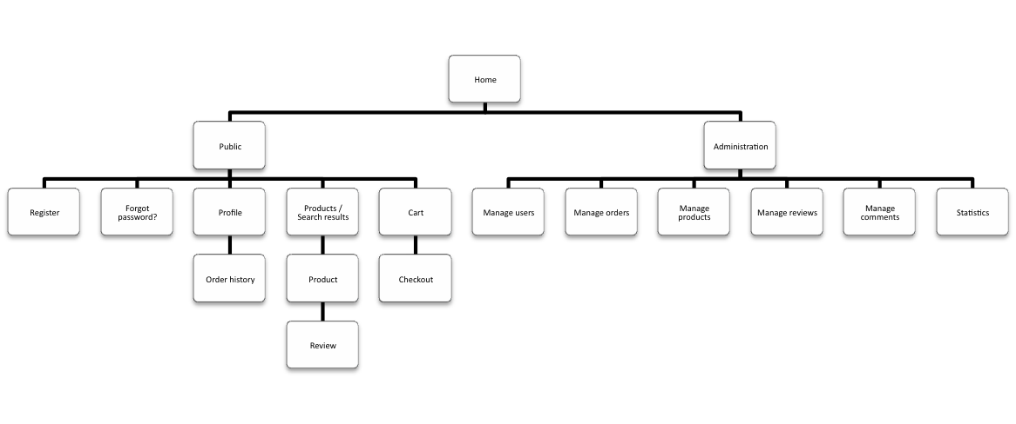
Figure 1: Web shop conceptual web site diagram
The following table lists details (name, URL, type of the content area) about each web page of the web site. The different types of the content area are: static and dynamic, in which dynamic means that the content area has been dynamically generated, whereas static means that the content area is static.
Table 2: List of web pages with details
Name | URL | Type
Home | / | static
Register | /register/ | static
Forgot password? | /forgotpassword/ | static
Profile | /profile/ | dynamic
Order history | /profile/orderhistory/ | dynamic
Search results | /search/ | dynamic
Product | /products/{productid}/ | dynamic
Review | /products/{productid}/reviews/{reviewid}/ | dynamic
Cart | /cart/ | dynamic
Checkout | /checkout/ | dynamic
Manage users | /admin/users/ | dynamic
Manage orders | /admin/orders/ | dynamic
Manage products | /admin/products/ | dynamic
Manage reviews | /admin/reviews/ | dynamic
Manage comments | /admin/comments/ | dynamic
Statistics | /admin/statistics/ | dynamic

In addition to the above web pages/URLs, the web site also provides a RESTful API for accessing various resources. As an example, the following lists all “get a list of all XXXXX” URLs supported by the RESTful API: /api/users/{userid}, /api/orders/{orderid}, /api/products/{productid}, /api/reviews/{reviewid}, /api/comments/{commentid}, and /api/statistics/.

Project Goals, Group Members, and Responsibilities
Our team consists of three experienced web developers: Markku Laine, Juha Loukkola, and Kalle Säilä.
We are all committed to complete the project by the schedule of the course, even tough that might require some extra effort from us, as all the members of our group have a day job. Furthermore, we are aiming at a good/excellent grade. Detailed information about our group can be found below.
Table 3: Group information
Name | Student Number | Email | Credits Needed
Markku Laine | 48605D | markku.laine@gmail.com | 5
Juha Loukkola | 57929V | jloukko@gmail.com | 5
Kalle Säilä | 64775E | kjsaila@gmail.com | 5

Considering the responsibilities within our group, we are all trying to do everything as equally as possible, as stated in the instructions. Nevertheless, we have assigned a responsible group member for each sub task (a kind of a mini project manager for that particular sub task) in order to better organize and manage who should do what and when. Below is a detailed table of the responsibilities within our group.
Table 4: Group responsibilities
 | Templates | Models | Views | Styling | Inter-  action | Graphics | Content
Markku Laine |  |  |  |  |  | x | x
Juha Loukkola |  | x | x
Kalle Säilä | x |  |  | x | x

Web Application Architecture
As all Django-based applications, also this one is based on the Model-View-Controller (MVC) pattern, although in Django the pattern is called Model-Template-View. The Model is responsible for the data, templates are responsible for the representation of the data, and views are responsible for the business logic.

Database Schema
Because our application is a web shop, it is self-evidence that we need users and products in our model. Furthermore, because the application needs to be social (products can be commented and rated) we need a model for comments, comment threads and ratings. Lastly, because we need to see the shopping history of users and products, we have a model for orders as well.
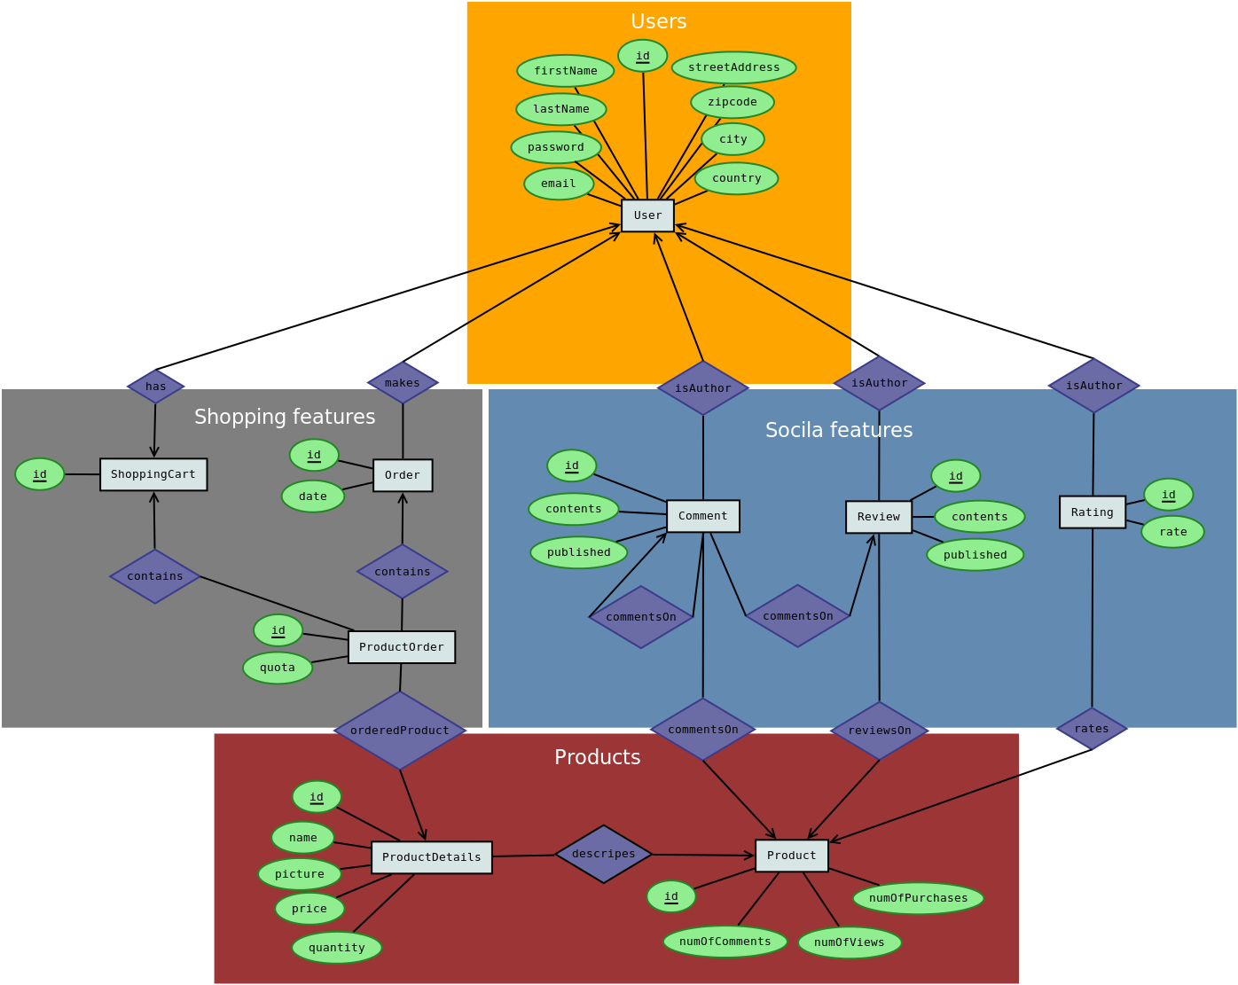
Figure 2: ER diagram
Below is a detailed representation of our models.
User {
id : Integer
firstName : String
lastName : String
streetAddress : String
zipcode : String
city : String
country: String
email : String
password : String
shoppinCart : IDREF
}
Product {
id : Integer
Details : IDREF
numOfComments : integer
numOfViews : integer
numOfPurchases : integer
comments : Collection of Comment objects
ratings : Collection of Rating objects
reviews : Collection of Review objects
}
ProductDetails {
id : Integer
product : IDREF
name : String
picture : String
price : Double
quantity : Integer
}
Comment {
id : Integer
user : IDREF
published : Date
contents : Text
comments : Collection of Comment objects
}
Rating {
id : Integer
rate : Integer
user : IDREF
}
Order {
id : Integer
date : Date
user : IDREF
productOrders : Collection of ProductOrders objects
}
ShoppingCart {
id : Integer
productsOrders : Collection of ProductOrders objects
}
ProductOrder {
id : Integer
quota : integer
productDetails : IDREF
}
Review {
id : Integer
user : IDREF
published : Date
contents : Text
threads : Collection of Thread objects
}

Schedule
Implementing will be done so that all functional requirements for the 4 cr version will be met prior moving on those of the 5 cr version. This will allow us to return successfully the 4 cr version of the project, even if something unexpected happens and we would not be able to complete the 5 cr version in time or with adequate quality.
Table 5: Project schedule
Task | Starts | Ends
Project plan | January 21, 2011 | January 28, 2011
Setup version control | January 29, 2011 | January 30, 2011
Setup project template | January 29, 2011 | January 30, 2011
Implement URL patterns | January 31, 2011 | February 1, 2011
Implement models | January 31, 2011 | February 6, 2011
Implement RESTful API views | January 31, 2011 | February 6, 2011
Content: product details | February 4, 2011 | February 6, 2011
Graphics: layout and product images | February 4, 2011 | February 6, 2011
Implement dummy views and templates | February 7, 2011 | February 10, 2011
Check-point submission | February 10, 2011 | February 11, 2011
HTML & CSS | February 12, 2011 | February 20, 2011
Authentication and access control | February 12, 2011 | February 16, 2011
Register, Forgot password?, and Profile | February 12, 2011 | February 17, 2011
Search result, Product, Review, and Cart | February 12, 2011 | February 18, 2011
Checkout and Order history | February 19, 2011 | February 24, 2011
Admin: Statistics | February 25, 2011 | February 27, 2011
Admin: Manage views | February 25, 2011 | March 2, 2011
Testing | January 31, 2011 | March 2, 2011
Final submission | March 2, 2011 | March 3, 2011
Project demonstration | March 14, 2011 | March 18, 2011

Resources
  - Course information, web site, https://noppa.tkk.fi/noppa/kurssi/t-106.4300/etusivu
  - Project information, web site, https://noppa.tkk.fi/noppa/kurssi/t-106.4300/harjoitustyot/T-106_4300_project_info.pdf
  - Project FAQ, web site, https://wiki.aalto.fi/x/r_pMAw
  - The Django Book, web site, http://www.djangobook.com/
  - Django Documentation, web site, http://docs.djangoproject.com/en/1.2/
  - jQuery API, web site, http://api.jquery.com/

libjpeg 8c, Software, http://www.ijg.org/files/jpegsrc.v8c.tar.gz
Python Imaging Library (PIL) 1.1.7, Software, http://www.pythonware.com/products/pil/
jQuery 1.4.2, Software, http://jquery.com/
jQuery UI 1.8.9, Software, http://jqueryui.com/
jQuery Validation plugin 1.7, Software, http://bassistance.de/jquery-plugins/jquery-plugin-validation/
jQuery Quicksand plugin, Software, http://razorjack.net/quicksand/
jQuery Flip! plugin, Software, http://lab.smashup.it/flip/
Modernizr 1.5, Software, http://www.modernizr.com/
HTML5 JavaScript shiv, Software, https://code.google.com/p/html5shiv/
Nicer Django Messages Output, Snippet of code, https://github.com/mrben/nicer_django_messages_output
Mike’s Nintendo game&watch forum – FAQ, Web site, http://mpanayiotakis.proboards.com/index.cgi

