1/11/2013
Mega Man 2 does indeed playable throughout most if not all of the game. The other MMC1 games use WRAM, also known as PRG-RAM. This is 0x2000 bytes of space mapped to the 0x6000-0x7FFF range. Earlier, I was writing this section of the mapper incorrectly, inverting the bit that controls whether PRG-RAM is enabled or not. Strangely enough, fixing this makes Metroid crash before the title screen and does not make anything work better. CHR-ROM may or may not work correctly, the games I have been testing either use CHR-RAM or rely on PRG-RAM, so they crash before they could get to using CHR-ROM.

I also was able to write the code for save states, a feature found in most emulators. This allows the user to save the state of the currently running game to a file, so that it can be loaded later, returning the game to where it was when the file was made. I am missing something from MMC1, because some savestates using this mapper become corrupted.

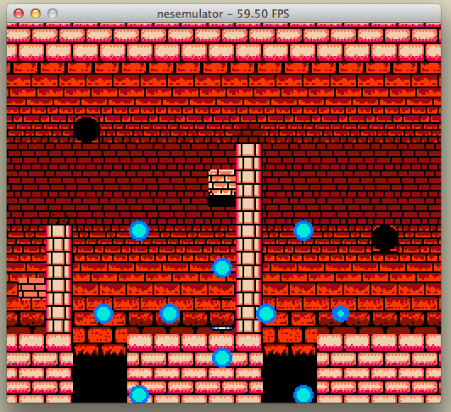
I have implemented screen scaling, where I can set a scale factor for the output window. This was not too difficult to write – I simply mapped each PPU output pixel to a 2x2, 3x3, or whatever region of pixels on the actual screen. This is a great improvement. Now I can actually see the game well, and graphical glitches are also more obvious and thus easier to debug. The iMac that I am using for development can run any game at x2 scale at 60 FPS, and most games at x3 scale.

After a bit of work, I got Legend of Zelda to work. The same fix also made Metroid functional. What was happening was that when the game wrote to PRG-RAM in 0x600-0x7FFF, the mapper also interpreted that as a write to the shift register, messing up any later writes to this register. Adding in one “return” statement fixed this, making LoZ and Metroid both work.
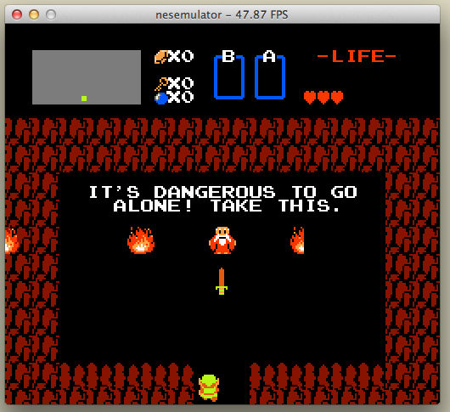
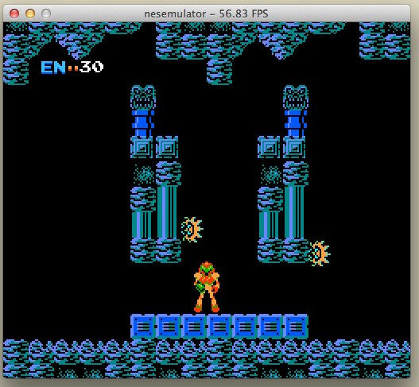

1/3/2013
After a little bit of work, I have implemented MMC1, the mapper used in games such as Metroid, Castlevania 2, Mega Man 2, Legend of Zelda 1 and 2, and a few others. So far, Metroid's graphics are rather messed up, but Mega Man 2 seems to work perfectly. Needs more testing for me to say for sure.

12/20/2012
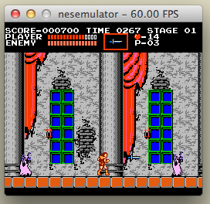
Well, I implemented CHR-RAM, and now Castlevania and Mega Man work. Both are very hard games.

8x16 sprites now work. It was an issue in the rendering code, where the second layer of the first 8x8 block was interpreted as the first layer of the second 8x8 block. An if statement and an offset fixed this issue. Now Castlevania and Galaga look much better.
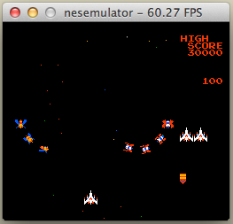

12/19/2012
Mapper 2 is now correctly implemented (as far as I can tell). Castlevania and Mega Man still do not work, however. Castlevania, I believe, does processing outside of NMI. Thus, if my NMI timing is off, it may not work as it should. This is mostly speculation, because I don't have hard evidence of what the problem is. Mega Man, however, appears to do its processing inside of NMI just like Super Mario Bros does. I don't know what I am doing wrong there.
Nearly every game starts with an LDA/BPL loop to wait for the PPU to initialize itself. When I'm going through the logs, this is very annoying because it can go on for thousands of cycles.
It turns out that each scanline is a fractional number of cpu cycles long, but I was using an integer to represent this. This means that 2/3 of a cycle was lost per scanline, which may or may not have an effect. My current solution is kind of a hack, so I might want to fix that later.

Further research discovers that Castlevania has 0 banks of CHR ROM in the cartridge. This indicates that it instead uses CHR RAM. So basically, the game runs, but nothing is displayed on the screen because there are no CHR banks for it to work with.

12/13/2012
After redoing some of my cpu code to better fit usage.txt that came with Blargg's audio library, I have succeeded in adding audio to my emulator. Unfortunately, sound doesn't print well, so I can't show it here. It is strangely about a quarter second delayed, but it is pretty good overall.

12/10/2012
I gotta learn more about computer audio.

12/6/2012
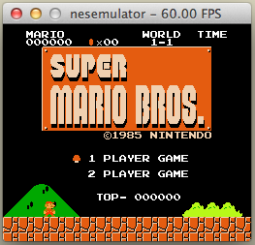
Mario's title screen displays properly now, except for the black background issue. The error from before was that I was not incrementing PPUADDR on reads from 0x2007. Someone on the nesdev forums had this same issue with the same cause, so that was helpful.

We have blue sky. The error was that 0x3F10, the universal background color, is mirrored down to 0x3F00 for both reads and writes. I only mirrored it for reads. Super Mario Bros set it through writes to 0x3F10. Thus, black background.
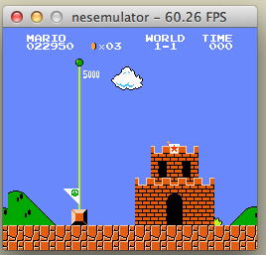
12/5/2012
Previously, I rearranged the main loop so that the main while(true) loop basically just tells allegro to look for events. This lets me use an allegro timer to regulate the framerate. This is good, because you can't play Super Mario at 160 FPS, so allegro will limit that to the 60 that the hardware runs at (see 11/28).
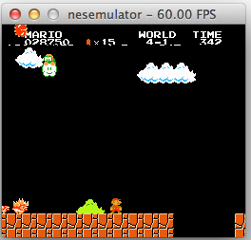
Also, I have been going through a log of PPU writes to try to determine how Mario does background scrolling. There is just one instant when the status bar is not displayed, which causes the sprite 0 infinite loop.
The Mario scrolling/freezing/sprite0 error is definitely due to an error in my scrolling code. Someone else on the nesdev forums had the same problem as I did. Following Disch's suggestion, I added a hack to reset the scrolling registers when PPUADDR is set to 0. This fixed the error, but it is a ugly hack. It looks like I need to examine loopy's scrolling documents in detail to get my emulator to closely match the way the hardware actually works. Also, this hack is not perfect. I assume that I have the timing incorrect by a scanline or so, because the bottom bit of the status bar scrolls with the background (see picture to the right). I also still need to implement hiding the left 8 columns, because random graphical glitches appear there if that is not done.
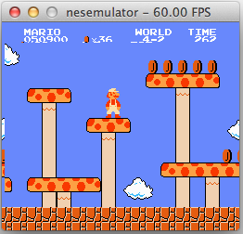
Earlier, I wrote that world 4-2 showed up with a blue background, but the clouds had black backgrounds. This is now fixed, 4-2 appears to be the only area with a properly blue background. This might be because the color changes in-level. The cloud color fix was probably the change that made palette colors 0, 4, 8, and 12 all refer to the same color, stored at 0x3F00.

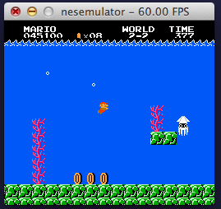
Water levels look real funky with the black background, but are mostly correct.
Side-by-side comparison isn't too bad.
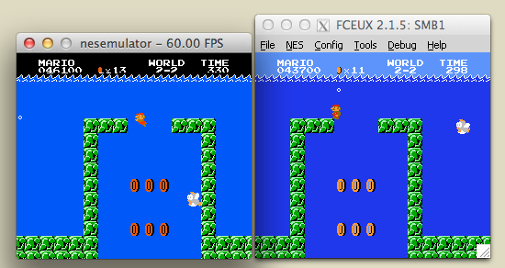

11/30/2012
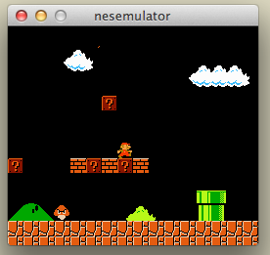
I found out why sprites hidden behind the background weren't working. The bool backgroundPoints[] variable was never initialized, only declared. Thus, it was initialized to unpredictable values. However, setting the array to all false at the start of each frame breaks the sprite 0 hit test sometimes, so Super Mario Bros freezes (see picture to the right). The emulator is still running, but the game is stuck in an infinite loop waiting for a sprite 0 hit that never comes. On the other hand, sprites hidden behind the background display properly now (see Galaga to the right).

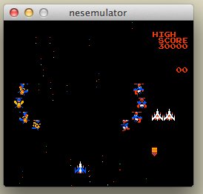
OK, the Mario error is due to the status bar disappearing for a brief instant as the PPU switches which nametable is currently being rendered. Thus, sprite 0 hit doesn't happen for that brief instant, and the game stalls. Could this be a scrolling error? I will need to examine a log of PPU operations to find more information on this.

Anyways, this is the end of Trimester 1. In my independent study contract, I said that my emulator would be capable of playing at least one NES game. At this point, it can play both Super Mario Bros and Galaga (and probably a few others that I haven't found yet). For Trimester 2, I said that my emulator must be able to run multiple NES games (already done) and support audio. Audio will probably be added through Blargg's libraries. Other than those goals, I will continue to solve the obvious bugs plaguing the emulator, and just generally improve compatibility.

11/28/2012
It has been a while since I've updated this, mostly because there hasn't been much to say. I still have all the same problems as I discussed in the previous entry. I have been focusing on the black Mario background issue. As far as I can tell, this is because the value at ppu memory location 0x3F00 is set incorrectly. This value represents the global background color across all background palettes.
My first suspicion was that this error was due to some sort of timing issue between the CPU and PPU. I spent a great deal of time working out issues like NMI timing, the startup state of the CPU and PPU, what happens on what scanline, CPU cycle counts, CPU vs PPU cycle ratios, and other tasks. None of this solved the Mario background problem, so I don't think I am approaching it from the right angle. However, some of the scanline changes led to major cleanups of the main loop in NESEmulator.cpp, so there has been some benefit to all this. After today's changes, my emulator's log output matches up line-for-line, cycle-for-cycle, scanline-for-scanline with Nintendulator's output for Super Mario Bros, but only for the first 60,000 instructions or so. At some point, RAM becomes inconsistent, which I think is the cause of the background color error. This will be more difficult to debug than CPU registers because RAM is not as easily logged.
Yesterday, I used the Valgrind/Callgrind profiling tool to check my program for any huge bottlenecks. This is mostly because I noticed that I was getting only 11 FPS or so even when I had the nametable, palette, and CPU debugging features turned off. Viewing the Callgrind output via QCacheGrind showed that al_map_rgb was taking up most of the execution time. It turned out that the emulator was remaking the palette-index-to-rgb table for every pixel. Once I declared this variable static, I got a 16x speedup. That is a 16x speedup from just adding “static “. Anyways, I have to add a framerate limiter now, because Mario is unplayable at 160 FPS.
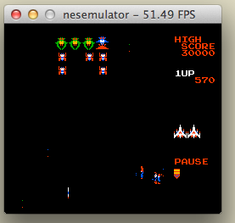
11/8/2012
And now, for some pictures!

This is an example of some of the difficulties I am having
right now. The sprites on the bottom of the screen are a bit
messed up. This is due to the sprite/background priority
flag, which is not entirely implemented yet. The picture
below shows the same problem in Super Mario Bros.

The screenshot of Galaga also shows an error in the
handling of 8x16 sprites. The stars appearing in the
background do not render properly. This also affects
player and enemy ships.
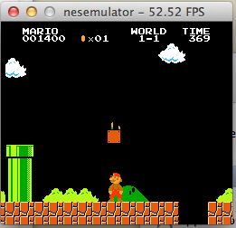

In both of these screenshots, there are some errors with
the nametables. Galaga uses the nametables in a rather
unique way. When an enemy is not flying down towards
the player, the enemy's graphic is stored within the
nametable, not as a sprite. This circumvents the
8-sprites-per-scanline restriction. Nametable rendering is
not perfect, as the top-right enemy ship in this picture
is distorted and mis-colored. Also, Mario is adventuring
under a black sky.

For some unknown reason, some levels work better than
others. In the secret area of world 4-2, for example, the
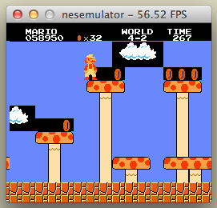
sky appears mostly blue. What is different here?

Despite these problems, I have a working NES emulator
that can play games with an actual NES controller as an
input device. It runs at about 60 FPS, the framerate of
the actual NES.

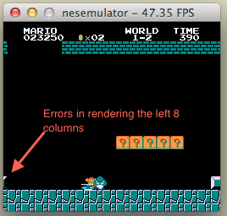

11/1/2012
Stuff is getting better. For the most part, I have PPU scrolling figured out. The strategy I went with is to have the PPU handle subtile scrolling, while the MMU handles tile-level scrolling. This allows the MMU to handle nametables, which makes since because nametables are just another form of memory. Even past this point, there were still a large number of issues to work out. Mostly stupid little things, like passing pixel-level data to a function expecting tile-level data. One thing that really helped to fix much of this was a debugging window that I created. It displays the two nametables side by side, and the PPUSCROLLX value is represented by a red line. This showed me that, at one point, the nametables were being written correctly, but the scrolling was corrupting the data being sent to the PPU, resulting in garbage on the screen. The biggest obstacle to successful scrolling is the attribute table. It does not scroll perfectly yet, so some things (like clouds or pipes in scrolling5.nes) change color as they move across the screen.

10/24/2012
I don't really know what to say. The PPU is just really confusing. I am trying to get scrolling to work. What I've found out so far is that when the PPU is set to vertical write (VW) mode, it does not try to do any fancy wrapping stuff. It just increments PPUADDR by 32, letting the program do the limiting work. Scrolling, I think, does have to do fancy stuff with nametable reads when the screen is scrolled between two nametables. This part, I'm not completely sure about yet. I think I might be writing to the nametables incorrectly as well, but I don't know yet. Needs more testing.

10/22/2012
It has only been a few days since the last entry, but I thought I'd write down what I'm doing on the Mega Man side of things. Nintendulator is an NES emulator that tries to be 100% accurate, down to the hardware quirks. I am going to use a log file from this emulator to find out when NMI starts, where interrupt vectors point to, and other stuff like that.
It turns out that the main problem with the startup was that the PPU was completely ignoring the PPUCTRL register. Bit 7 in this register determines whether or not NMI is enabled. Thus, the game itself decides when NMIs begin to be sent.

10/18/2012
This week, I continued the nestest.nes madness. I found a few more errors, specifically with the PHP and PLP commands. When these are used, there is some unintuitive behavior involving the B flag. Also, I just completely ignored the D flag because the NES does not actually support BCD mode. Thus, a few changes were necessary. Besides these issues, there were a whole bunch of undocumented opcodes to be implemented. They were all basically combinations of two documented opcodes, so they were easy to write, but time-consuming. At this point, my emulator passes nestest.nes!
Despite the CPU working (I am pretty sure. As I read earlier, testing can only prove the presence of bugs, not their absence), the funny background colors persisted. It wasn't a CPU bug at all, but an error in an assumption I was making about the nametables. I assumed that the nametables started at 0x2400, when in reality they began at 0x2000. This caused one array index to become negative, returning basically random values from an array of all zeros. Fixing this caused the background to appear as it should. In addition, fixing the CPU seems to have stopped the emulator from randomly crashing when it was left on for more than a minute or so. The pong1.nes example works now.
Having read that Mega Man uses only basic PPU functions, I will give it a try on my emulator. It uses mapper 2, which I tried implementing. I think I got something wrong there. On reset, the NES starts at the RESET vector, and the first command is an ISB, an undocumented opcode. From there, it reaches a KIL opcode within 10 instructions. I might be doing something wrong. Maybe. I think that the mapper is reading the second PRG bank incorrectly, causing the RESET vector to be something crazy. I don't have evidence to back this up, but that is my current hypothesis. I'm sure that I will have this figured out for next week's entry.

10/11/2012
First of all, I found a weird programming language today. It is called Funge. The code for a Funge program is written in 1, 2, 3, 4, or even more dimensions, and the shape of the code is just as important as the characters chosen. It is interesting to think about the language from an interpretation standpoint – how could I write an interpreter that would run this language? It was designed to be difficult to compile, but wouldn't interpretation be easier? There are a few interesting parallels between this and emulator development, which at this point is really just another interpreter.
On the NES side of things, I have been working my way through nestest.rom. I have turned up countless bugs in my CPU code, from forgetting to set the N and Z flags on a specific LDA addressing mode to messing up boundary cases on nearly every addressing mode there is. I even had the stack writing to the wrong place. Also, I added all of the NOPs to the CPU interpreter. There is one documented NOP code and 27 undocumented NOP codes. Nestest uses a few of these undocumented codes. Fun. None of these fixes has colored the background correctly yet, but I remain hopeful that I will get there eventually. I am about halfway through nestest.rom, so progress is being made.

10/04/2012
This week, I focused mostly on the less-fun part of independent study – the paperwork at the beginning. I spent some time on the contract and summary. On a better note, I found the bug causing the palette to be set incorrectly. The processors CPX instruction, and actually any CP* instructions, were off by 1. This led to one extra write to the palette, which led to the sky being grey. Now, the attribute table is showing similar weirdness. I don't really know what the cause is, but if I set the attribute table forcibly to 0 past the first four rows of background tiles, the funny colors don't appear. I suspect another CPU bug. Anyways, I am running my emulator through the nestest rom now, and comparing the output with the correct results. I have already found a couple of bugs, specifically the PLA instruction. The 6502.txt file I have been referencing said that it doesn't affect flags, but it should.
Overall, a confusing week. That attribute table.

9/27/2012
Last week, when I said that the NES controller was a project for later, I didn't really mean it. This week, I added NES controller support to my emulator. After a few problems with the Arduino not detecting the A button, I got it to transmit the NES controller state over a serial connection. Borrowing from the firmata_test program, I found c++ source using WxWidgets that communicated with an Arduino over a serial connection. I removed the WxWidgets references and added it to the GamepadState. The only current problem is that it probably only works on Mac right now, and the Arduino dev filename needs to be specified in code. This would obviously hinder functionality in a released program, so it will need to be fixed at some point in the future. On the subject of rendering, I switched from using al_put_pixel once per pixel to simply setting a value in an array and then using al_draw_prims, passing a point list. This works much faster, increasing background render framerate from .09 to 58 or so. This is approximately a 600x speedup.
I have also gotten background rendering about halfway complete, I would say. The first challenge was making the right tiles appear at the right locations. My error here was that I was using the sprite pattern table instead of the background pattern table. I had a similar issue with the palettes, using the sprite palettes instead of the background palettes. Nobody wants to see pink and purple Mario bricks! There are still multiple issues with background rendering. First of all, when background.nes is run, it writes to the palette 33 times, with one write wrapping around to palette[0], setting its value to 128. I don't know what causes this error, but I wrote the ugliest little hack ever to stop this (this hack will NEVER see git). This fixes the issue where the sky, palette[0], was rendering as grey instead of blue. I do, however, need to find the root cause of this problem. Also, the rest of the background below the four rows defined in background.nes is filled with 0's. They should be a uniform color, but instead they are a bunch of weird colors. The pattern of colors stays constant, however. It might not be important, but it probably is. Audio has been untouched, mostly.

9/20/2012
This week, I worked on various aspects of my independent study. I had decided on continuing last year's project, an NES emulator. It is still missing a number of things, such as full graphics support, input, audio, save states, and many many mappers. This week, I worked on a number of these issues. Input was by far the easiest; it is now working properly using the keyboard. One really cool thing to do would be to connect an actual NES controller to the computer via Arduino, but that is a project for later. Anyways, I also worked on the PPU. Mostly, the background rendering part of it. Currently, drawing one scanline takes about .0005 seconds. It needs to be less than .00007 seconds, or else I will not be able to run at 60 fps. On the other hand, rendering just a sprite without a background runs at a whole 500-some fps. No problems there (with 4 sprites on screen).

