Pandas Challenge - Analysis

## M. Lemaire

# Observable Trends from the School Data

1. Charter schools outperform District schools. In fact, all top 5 schools were charter schools, those at the bottom of the list were uniformly district schools.

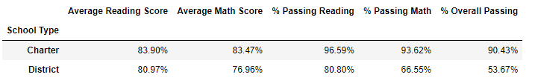

Top Preforming Schools by Overall Passing

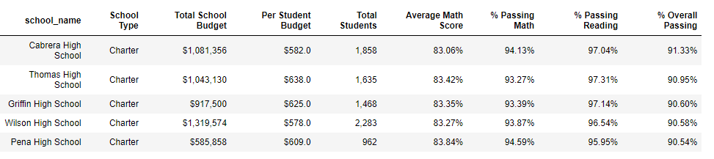

Bottom Preforming Schools by Overall Passing

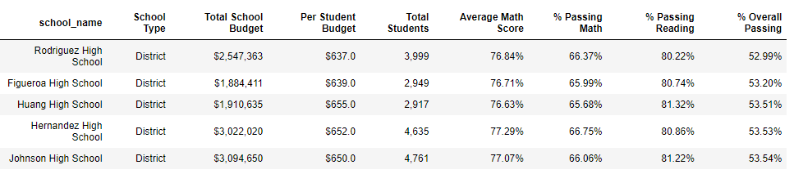

1. Additional funding per student does not appear to result in performance

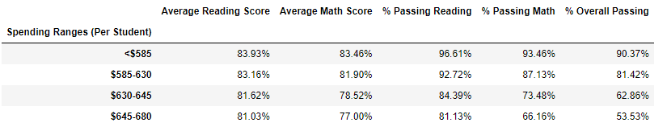

3. Large school size appears to have a negative impact on overall passing achievement.

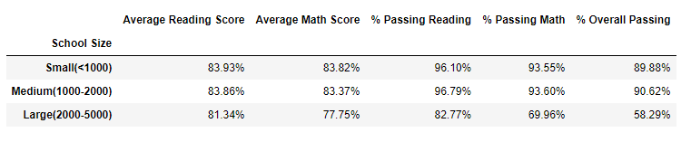

1. Within the context of a given school year on year performance is relatively flat across reading and math.

**Reading**:

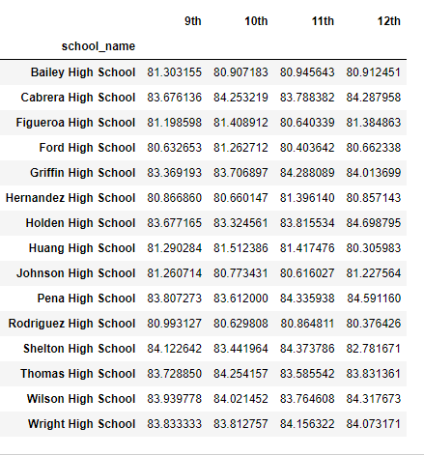

**Math**:

