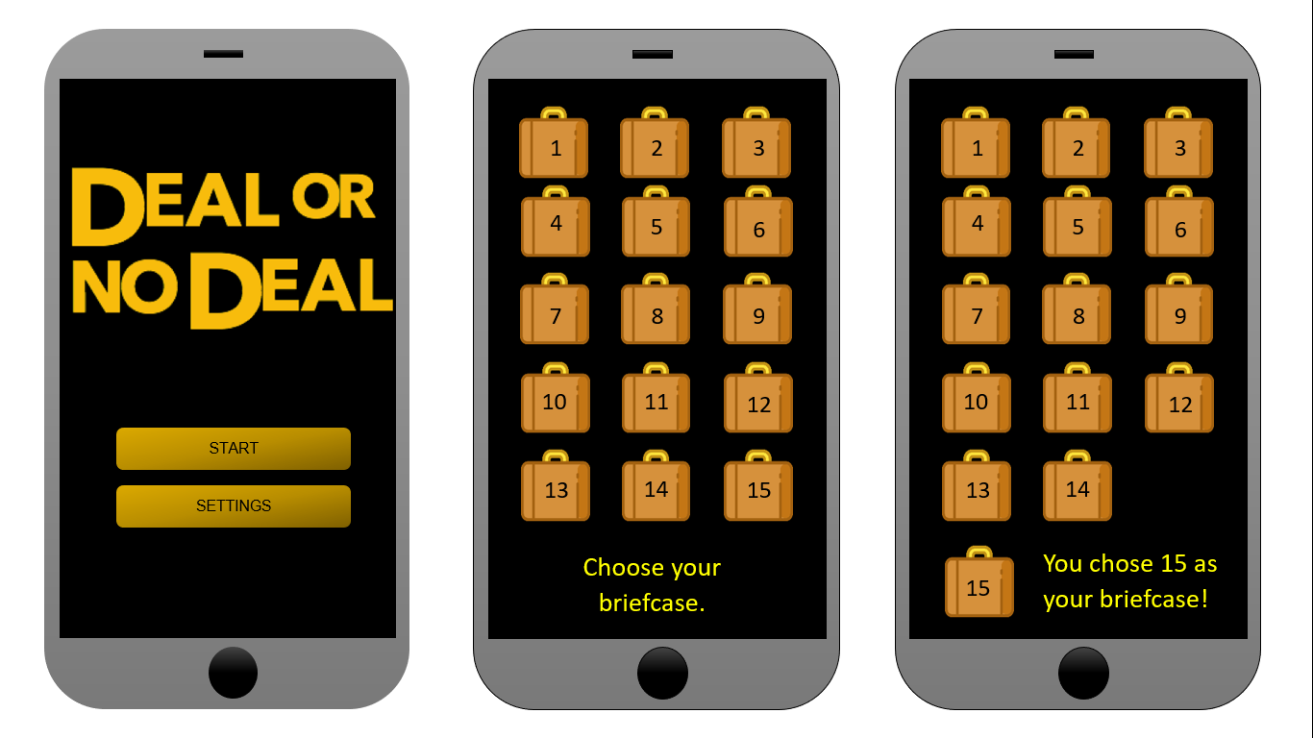

START



SETTINGS

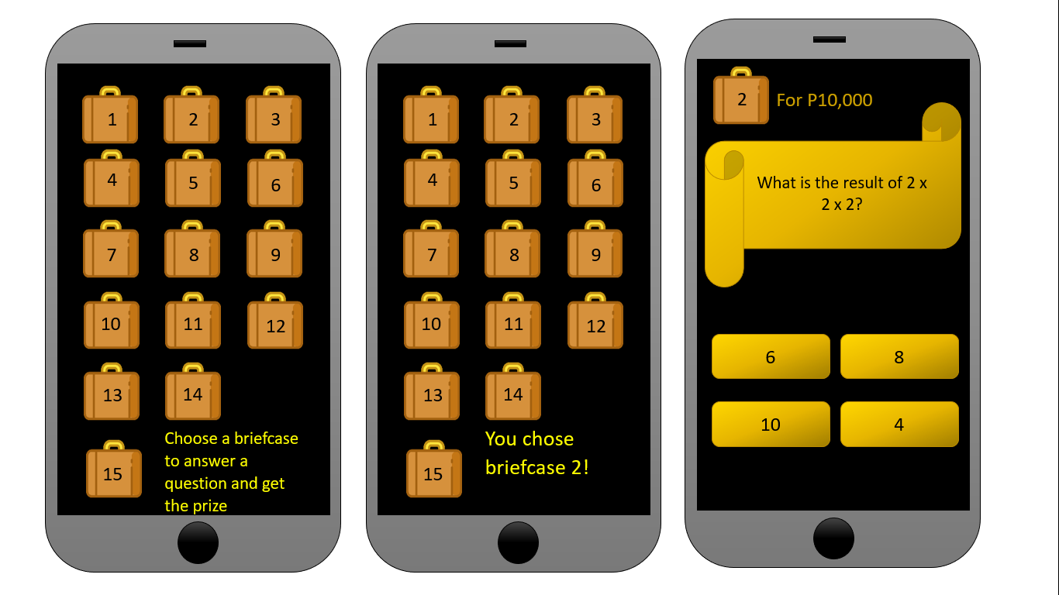



1

2

3

4

5

6

7

8

9

10

11

12

13

14

15

Choose a brief case to open. Answer to get reward



