

Congratulations! Your forms are ready.

## **{{cover_sheet_top_message }}**

{{ cover_sheet_complete_1 }}

{{ cover_sheet_complete_1a }}

{{r resource_page_link | inline_markdown }} ({{ resource_page_url_only }}).

Make sure to **select your county** for full results.

## **{{ cover_sheet_share }}**

{{ cover_sheet_complete_2 }}

{{r cover_sheet_survey_link | inline_markdown }} ({{ survey_link_url_only }}), or scan the survey QR code below:

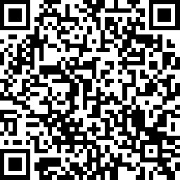

{{ cover_sheet_thanks }}