|  |
| --- |
|  |
| Tunnel-K Software Requirements Specification (SRS) |
|  |
|  |
| **Josh Calahan, Wes Cothran, Chris Davis, Michael Lynch, Brian Pittman** |
| **9/27/2011** |

|  |
| --- |
|  |

Contents

1. Scope 5

1.1. Identification 5

1.2. System overview 5

1.3. Document overview 5

2. Referenced documents 5

3. Requirements 5

3.1. Required states and modes 5

3.2. Software item capability requirements 6

3.3. Software item capability 7

3.4. Software item external interface requirements 7

3.5. Interface identiﬁcation and diagrams 7

3.6. Project-unique identiﬁer of interface 8

3.7. Software item internal interface requirements 8

3.8. Software item internal data requirements 8

3.9. Adaptation requirements 8

3.10. Safety requirements 8

3.11. Security and privacy protection requirements 8

3.12. Software item environment requirements 8

3.13. Computer resource requirements 8

3.14. Computer hardware requirements 8

3.15. Computer hardware resource utilization requirements 8

3.15.1. Computer software requirements 8

3.15.2. Computer communications requirements 8

3.15.3. Software quality factors 8

3.16. Design and implementation constraints 8

3.17. Personnel-related requirements 8

3.18. Training-related requirements 8

3.19. Logistics-related requirements 8

3.20. Other requirements 8

3.21. Packaging requirements 8

3.22. Precedence and criticality of requirements 8

4. Qualification provisions 8

5. Requirements traceability 8

6. Notes 8

7. Annexes 8

This page left intentionally blank

### Scope

### Identification

Tunnel-K is an effort by graduate software engineering students at the University of Alabama in Huntsville aimed at building a small-scale wind tunnel and associated software systems. The wind tunnel and its subsystems are intended to be used by science museums, schools, etc. for educational purposes, and it is being built in association with the Hands-On Science Center in Tullahoma, TN.

### System overview

The overall Tunnel-K system consists of a wind tunnel structure along with associated computer hardware and software, wiring, sensors, motors, fans, power supplies, etc. used for controlling and monitoring the operation of the tunnel. Additionally, a two-dimensional flow solver application suite will provide the opportunity for experimentation with various shapes in a virtual wind tunnel environment and graphically displayed mach and pressure gradients. The suite will also provide integration with the physical wind tunnel controls so that simulated conditions and be illustrated in the real world.

### Document overview

This document addresses all Tunnel-K system requirements.

### Referenced documents

Include ROM reference here

### Requirements

Terminology note: the requirements below are stated in a manner that the word “shall” means threshold and the word “should” implies objective. Threshold requirements represent the minimum functionality for a working wind tunnel system. Objective requirements represent the full, desired, or advanced functionality the Tunnel-K team is aiming for.

### Required states and modes

A use case approach was taken for determining system behavior and eliciting requirements from our customer. The following use case diagram show the high-level functions of the system along with the external actors that will supply command and control to those functions. The actors are:

* Tunnel Administrator
  + Person(s) within an science center designated to install, upgrade, or maintain the tunnel exhibit
* Power System
  + Energy source for the wind tunnel system
* Younger Child
  + Exhibit visitor interested in performing basic wind tunnel operations
* Older Child
  + Exhibit visitor interested in performing advanced wind tunnel operations

The high-level modes are:

* + 1. Tunnel Startup
    2. Tunnel Configuration
    3. Tunnel Shutdown
    4. Loss of Power
    5. Timeout
    6. Perform Physical Tunnel Functions
    7. Time History Data Display
    8. Perform Standalone Virtual Tunnel Functions
    9. Perform Integrated Tunnel Functions

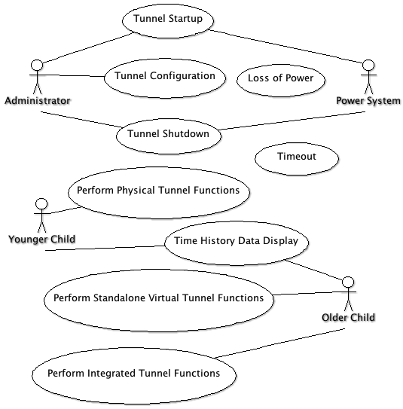

### Software item capability requirements

* + 1. The system shall implement a small-scale physical wind tunnel.
    2. The system shall implement a virtual wind tunnel, also known as a two-dimensional computational fluid dynamics flow solver.
    3. The system shall provide a "big button" interface to the physical and virtual wind tunnels.
    4. The system shall include method of applying input wind tunnel conditions. For example: air speed, angle of attack, temperature, et al.
    5. The system shall include methods for tunnel operation feedback. For example: time history plots, light-emitting diodes, et al.
    6. The system shall be suitable to a range of children, teenagers, and young adults in the capacity of visitors to a science center.
    7. The system shall be resilient to power surges.
    8. The wind tunnel system shall include reporting capabilities to select social networks.
    9. The virtual wind tunnel system shall include reporting capabilities to select social networks.
    10. The system should provide a level of synchronization between the physical and virtual wind tunnels. That is, applying conditions to the physical (or virtual) wind tunnel should automatically apply conditions to the virtual (or physical) tunnel.
    11. The system should include a computational geometry input method similar to a whiteboard app to the virtual tunnel via modern hand held devices.
    12. The project shall provide durable child proof physical controls
    13. The hardware and software interfaces shall be highly reliable and intuitive, suitable for use by children.
    14. The power on, power off, and reset procedures shall be simple enough to be performed by an untrained layperson.
    15. The wind tunnel shall reset itself to a default initial state after a period of no input.
    16. The hardware sensors and instruments used by the tunnel shall be off-the-shelf and easily obtainable a third party attempting to recreate the tunnel design.
    17. The software components of the system shall be open source or freely available to a third party attempting to recreate the tunnel design.
    18. The virtual wind tunnel should gracefully fail when given malformed inputs.
    19. The virtual wind tunnel should run a complete visualization and display the outputs in less than 1 minute on a modern hand held device.
    20. The virtual wind tunnel should provide outputs such as lift, drag, mach number, pressure, etc.
    21. The project should produce designs, code, and lessons learned to replicate the system by other teams.

### Software item capability

### Software item external interface requirements

### Interface identiﬁcation and diagrams

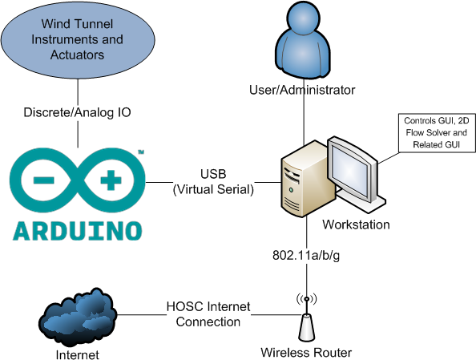

### Project-unique identiﬁer of interface

Not applicable.

### Software item internal interface requirements

Deferred to future design documents.

### Software item internal data requirements

Deferred to future design documents.

### Adaptation requirements

### Safety requirements

### Security and privacy protection requirements

### Software item environment requirements

### Computer resource requirements

### Computer hardware requirements

### Computer hardware resource utilization requirements

### Computer software requirements

### Computer communications requirements

### Software quality factors

### Design and implementation constraints

### Personnel-related requirements

### Training-related requirements

### Logistics-related requirements

### Other requirements

### Packaging requirements

### Precedence and criticality of requirements

### Qualification provisions

### Requirements traceability

### Notes

### Annexes