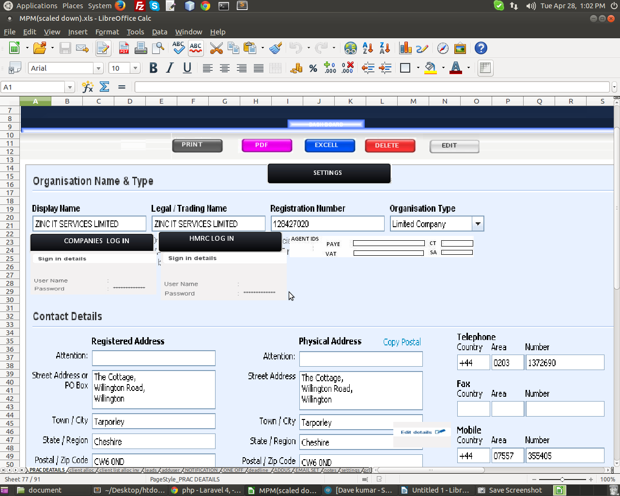
1. What will be the functionality of 'Companies Login', 'Hmrc Login' and 'Agent ids'.
2. How the edit functionality will work.
3. How many times a user can add practice details(means how many practice details can have for one user).

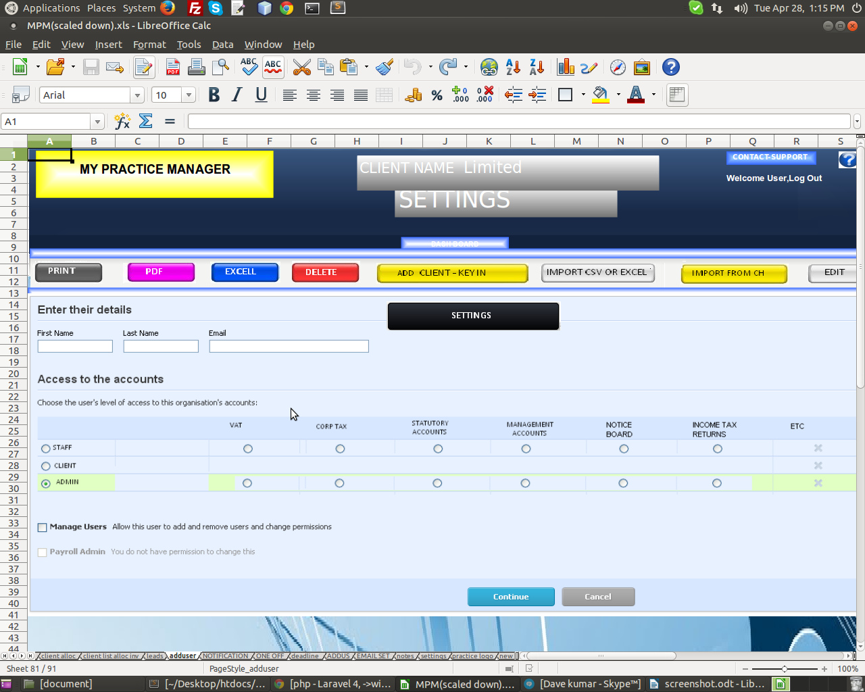
1. What is the roll of those users and who can add user.
2. What will be the functionality of those above button (Print, Pdf, etc) in this page.
3. What is the form like for adding user ( need format of three forms for staff, client and admin )
.
4. Where are we adding clients(INDIV)?
5. Where are we adding clients(ORGAN)?
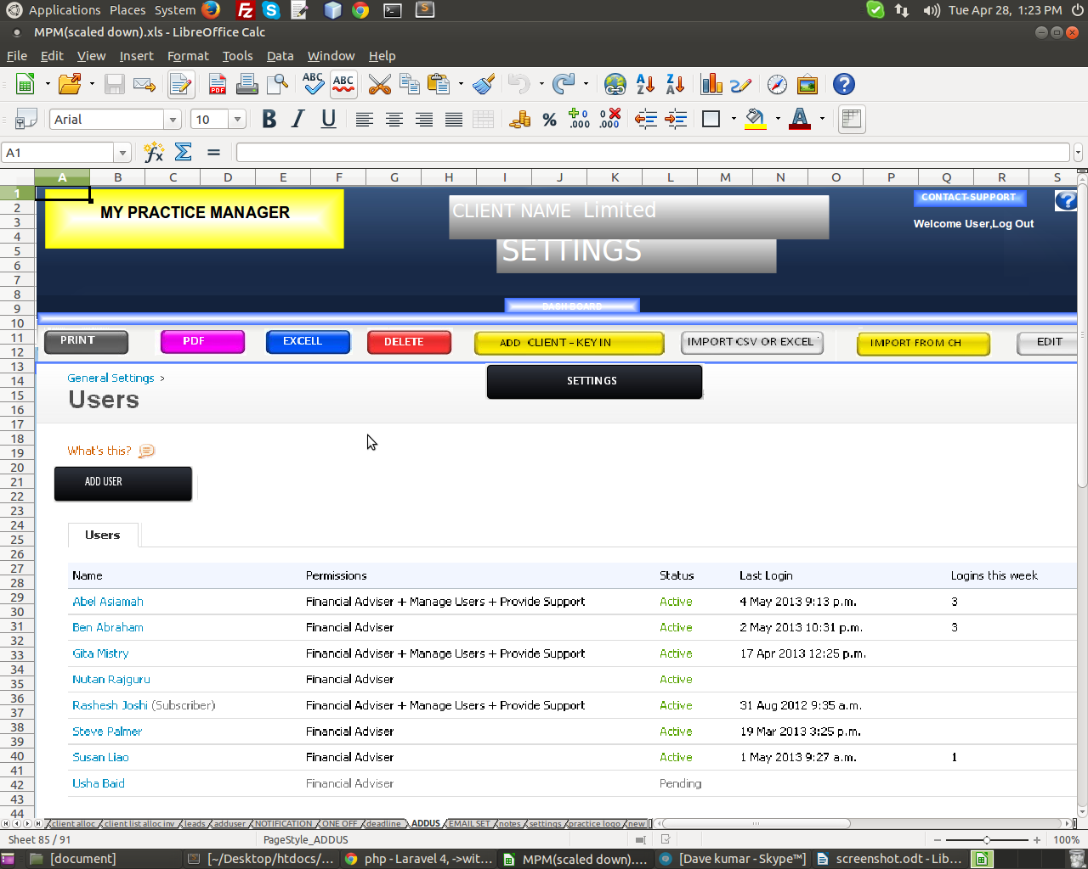
1. What will be the functionality of 'DELETE', 'Add Client- Key In' and 'Import From CH' button in this page and how the delete will work in this page.
2. How the status column will work.

