SafeSight AI
Traffic Sign Visibility Analyzer

Technical Documentation

Prototype Repository: https://github.com/mpnithishpraba/SafeSight_AI-Traffic-Sign-Visibility-Analyzer
Open-source prototype — YOLOv8 detection engine, visibility scoring, GPS logging, and batch processing

94.9%  Precision | 85.3%  mAP@50 | 3 Modes  Video · Image · Live

Submitted to: National Highways Authority of India (NHAI)
Event: 6th NHAI Innovation Hackathon
Problem Statement: Retro reflectivity Measurement of Traffic Signs and Pavement Markings
Submission Date: 19 April 2026

SafeSight AI — Ensuring Safer Roads for All

Table of Contents
Table of Contents 1
1. Abstract 1
2. Introduction 1
3. Problem Statement 1
3.1 Degraded Sign Visibility 1
3.2 Limitations of Manual Inspection 1
3.3 Delayed Maintenance Response 1
4. Objective 1
5. Proposed Solution 1
5.1 Detection Engine 1
5.2 Visibility Scoring 1
5.3 Classification and Reporting 1
5.4 Night-Time Optimisation 1
6. System Architecture 1
6.1 Module Descriptions 1
7. Visibility Calculation Method 1
7.1 Algorithm 1
7.2 Formula 1
7.3 Classification Thresholds 1
7.4 Rationale 1
8. Features 1
9. System Screenshots 1
9.1 Image Mode — Night-Time Detection (Score: 0.876 — Good) 1
9.2 Image Mode — Daytime Sign Detection (Score: 0.875 — Good) 1
9.3 Video Mode — Night Highway with Multiple Detections 1
9.4 Image Mode — Mixed Classification (Good + Moderate) 1
10. Model Performance 1
10.1 Evaluation Metrics 1
10.2 Metric Interpretation 1
11. Feasibility 1
12. Scalability 1
13. Sustainability 1
14. Advantages 1
15. Limitations 1
16. Future Scope 1
17. Conclusion 1

1. Abstract
SafeSight AI is an intelligent, automated Traffic Sign Visibility Analyzer engineered to address a critical and persistent challenge in highway safety management — the progressive degradation of retroreflective traffic signs. The system integrates a fine-tuned YOLOv8 object-detection model with a photometric pixel-intensity scoring algorithm to deliver real-time and batch analysis of sign retroreflective condition across all lighting and weather scenarios.

Directly aligned with the National Highways Authority of India (NHAI) mandate under IRC 67 and IRC 35, SafeSight AI provides a scalable, cost-effective, and fully offline alternative to time-consuming manual retro reflectometer surveys. The prototype is openly available at: github.com/mpnithishpraba/SafeSight_AI-Traffic-Sign-Visibility-Analyzer

2. Introduction
Traffic signs are fundamental safety infrastructure on national highways. Their retroreflective visibility — particularly under night-time driving and adverse weather conditions — directly governs driver awareness, reaction time, and accident prevention. Retroreflective sheeting is specifically engineered to return vehicular headlight beams toward the driver, ensuring sign legibility even in total darkness.

Retro reflectivity degrades over time due to the following environmental stressors:

- Prolonged exposure to ultraviolet radiation and direct sunlight
- Corrosion from vehicle exhaust gases and industrial atmospheric pollutants
- Physical erosion caused by wind, rain, ice, and road debris
- Accumulation of dust, grime, and biological surface growth

Current inspection practice relies on handheld retro reflectometers conforming to IRC 67 and IRC 35, requiring field personnel to halt on live high-speed corridors. On NHAI's extensive network — spanning eight-lane expressways to two-lane rural highways — this approach is operationally slow, hazardous to inspectors, and incapable of delivering the data density necessary for proactive maintenance. SafeSight AI was developed to address this gap: a vehicle-deployable, camera-based AI solution capable of continuously assessing sign condition across large road networks with zero manual intervention.

3. Problem Statement

3.1 Degraded Sign Visibility
Traffic signs on Indian national highways face substantial retroreflectivity degradation over their operational lifespan. Signs in high-pollution expressway corridors, signs in remote rural stretches with infrequent inspection cycles, and overhead gantry signs subject to maximum environmental exposure are all critically vulnerable. Degraded signs are unreadable to drivers at night or in fog, creating a direct road safety hazard.

3.2 Limitations of Manual Inspection
The existing handheld-device inspection process presents the following operational bottlenecks:

- Throughput: Slow throughput — manual measurement across thousands of kilometres of highway is logistically infeasible at scale
- Safety Risk: Safety risk — inspectors must stop on high-speed corridors, exposing personnel to live traffic
- Inconsistency: Measurement inconsistency — human variability and instrument positioning errors affect data reliability
- Cost: High operational cost — requires dedicated field teams, survey vehicles, and repeat deployment for each inspection cycle

3.3 Delayed Maintenance Response
Without automated continuous monitoring, sign degradation is frequently identified only after an accident or public report. There is no systematic mechanism to prioritise maintenance resources across a national highway network based on objective, real-time condition data. This reactive posture results in preventable accidents and inefficient allocation of maintenance budgets.

4. Objective
The SafeSight AI system was developed with the following primary objectives:

- To develop a vehicle-mountable or dashcam-compatible AI system that automatically detects traffic signs and evaluates their retroreflective visibility without requiring field personnel to stop on live highways
- To produce a quantitative, objective visibility score for every detected sign, enabling data-driven condition assessment independent of human judgement
- To automatically log GPS coordinates for signs classified as Moderate or Poor, generating maintenance priority records for direct use by highway maintenance teams
- To deliver a scalable, fully offline solution deployable on standard commercial hardware without cloud dependency or subscription costs
- To reduce total inspection time and eliminate the safety hazards associated with manual survey operations on high-speed corridors

5. Proposed Solution
SafeSight AI is a desktop application that processes live USB/webcam feeds, recorded dashcam footage, or batches of survey photographs to detect, score, and classify traffic signs by retroreflective condition. The complete prototype source code is openly available at:

https://github.com/mpnithishpraba/SafeSight_AI-Traffic-Sign-Visibility-Analyzer

5.1 Detection Engine
A fine-tuned YOLOv8 model identifies traffic signs in each input frame with a precision of 94.9% and an mAP@50 of 85.3%. The model is trained on a diverse dataset of Indian highway sign types and handles night-time, low-contrast, and partially occluded conditions effectively.

5.2 Visibility Scoring
Once a sign bounding box is extracted from the frame, a photometric analysis algorithm computes a Visibility Score based on the reflective pixel intensity of the sign surface. This score objectively quantifies how well the sign surface would return vehicular headlights to the driver.

5.3 Classification and Reporting
Each detected sign is assigned a classification of Good, Moderate, or Poor based on defined score thresholds. Results are written to structured CSV log files, with GPS coordinates appended for actionable signs. Annotated images may optionally be saved per detection event.

5.4 Night-Time Optimisation
CLAHE (Contrast Limited Adaptive Histogram Equalization) preprocessing is applied to low-light frames prior to detection inference, substantially improving accuracy during night-time and foggy conditions — a critical operational requirement for NHAI's all-hours highway monitoring mandate.

6. System Architecture
SafeSight AI operates as a modular, linear processing pipeline with five functional stages:

INPUT  Camera / Video / Images | → | DETECTION  YOLOv8 Sign Detection | → | ANALYSIS  Reflectivity Scoring | → | CLASSIFICATION  Good / Moderate / Poor | → | OUTPUT  CSV + GPS + Annotated Images

6.1 Module Descriptions
Input Module: Accepts three input types: USB or laptop webcam for live real-time feeds; pre-recorded video files such as dashcam footage; and individual or batch image files from road survey operations.
Detection Module: The YOLOv8 model processes each frame and outputs bounding box coordinates for all detected traffic signs. An integrated tracking algorithm maintains sign identity across consecutive frames to prevent duplicate log entries.
Analysis Module: For each detected sign crop, pixel intensities are extracted in grayscale. The top 15% of brightest pixels are identified, and their mean intensity is normalised against 255 to produce the dimensionless Visibility Score.
Classification Module: The computed score is evaluated against defined thresholds to assign a condition label — Good, Moderate, or Poor — which determines downstream logging and alert behaviour.
Output Module: Results are written to auto-organised session CSV logs. GPS coordinates from a connected NMEA device are appended for actionable signs. Annotated frames can be exported for visual audit trails.

7. Visibility Calculation Method

7.1 Algorithm
For every detected sign, the following analytical procedure is executed:

- The bounding box region is cropped from the input frame
- The crop is converted to a single-channel grayscale image
- All pixel intensity values (range: 0 to 255) are ranked in descending order
- The top 15 percentile of pixel values — representing the most reflective surface regions — are selected
- The arithmetic mean of these values is computed and normalised by dividing by 255 to yield the Visibility Score

7.2 Formula

Visibility Score = Mean ( Top 15% Brightest Pixels ) / 255.0

7.3 Classification Thresholds

Score Range | Classification | Condition
≥ 0.65 | GOOD | Highly reflective — clearly visible at night
0.45 – 0.65 | MODERATE | Visibility degrading — maintenance attention required
< 0.45 | POOR | Critical — non-reflective or severely faded

7.4 Rationale
The top-15% percentile approach was specifically chosen to mirror the physics of retroreflection: a sign's visibility to an approaching driver is determined by its brightest reflective hotspots rather than its mean surface luminance. Computing the average across all pixels would systematically underestimate sign quality due to background inclusion, mounting hardware, and shadows within the detection bounding box. Normalisation against 255 produces an interpretable, dimensionless score between 0.0 and 1.0, enabling stable, threshold-based classification that is consistent across cameras and lighting conditions.

8. Features

Feature | Description
Live Camera Feed | Real-time analysis via USB/laptop webcam with annotated bounding boxes and live visibility scores
Video Processing | Frame-by-frame analysis of dashcam recordings; produces fully annotated output video
Batch Image Processing | Processes thousands of survey photographs in a single run for city- or corridor-scale audits
Intelligent Tracking | Sign identity maintained across video frames, preventing duplicate entries in logs
GPS Logging | Latitude/longitude auto-appended for every Poor and Moderate sign detected
CSV Reporting | Structured session logs — sign ID, score, class, timestamp, GPS — auto-organised by workspace
Night Optimisation | CLAHE preprocessing enhances low-light and foggy frames for improved detection accuracy
Workspace Management | Sequential session folders created automatically; logs, detections, and exports stay organised

9. System Screenshots
The following figures illustrate SafeSight AI operating across its three processing modes under varied real-world conditions, demonstrating detection accuracy, visibility scoring, and multi-sign classification.

9.1 Image Mode — Night-Time Detection (Score: 0.876 — Good)
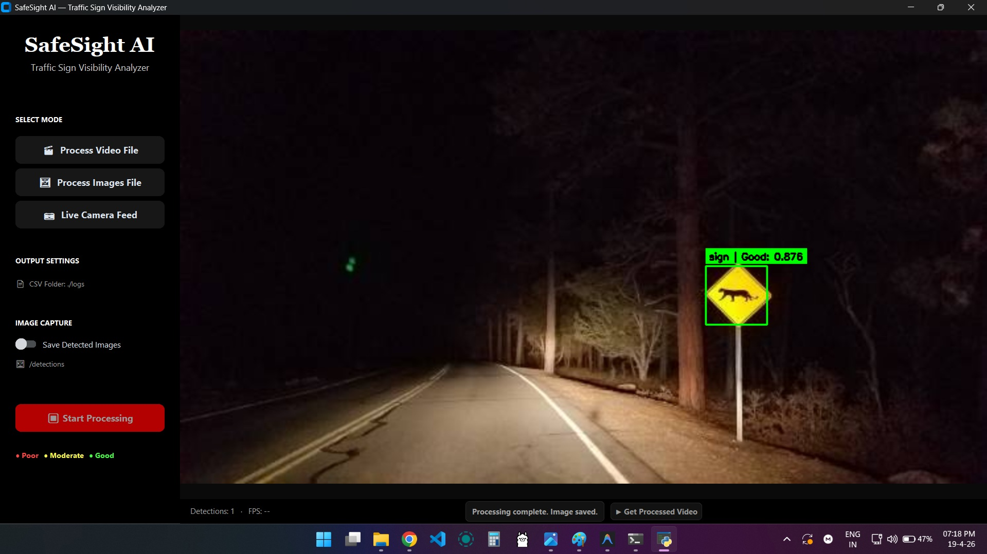
Figure 1: Night-time image processing. A wildlife warning sign is detected and classified as Good (Visibility Score: 0.876). The green bounding box and annotation confirm high retroreflective condition.

9.2 Image Mode — Daytime Sign Detection (Score: 0.875 — Good)
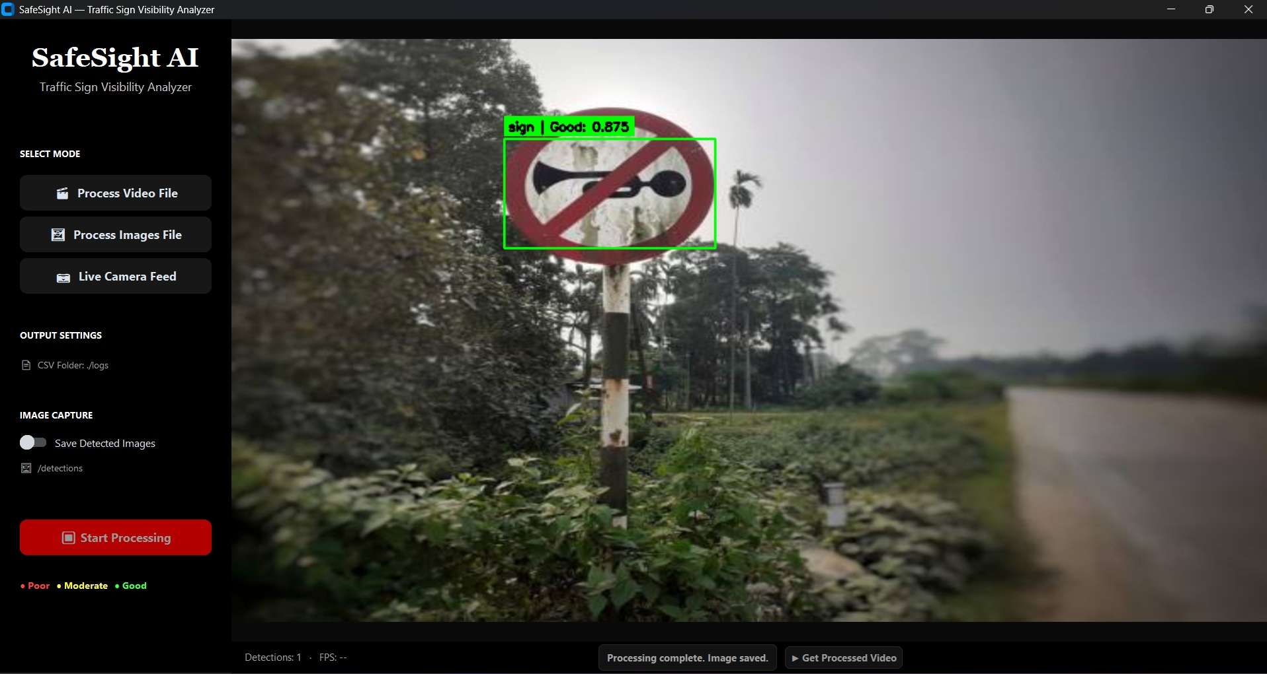
Figure 2: Daytime analysis of a No Horn sign on an Indian rural highway. A score of 0.875 confirms strong retroreflective condition despite a weathered mounting pole.

9.3 Video Mode — Night Highway with Multiple Detections
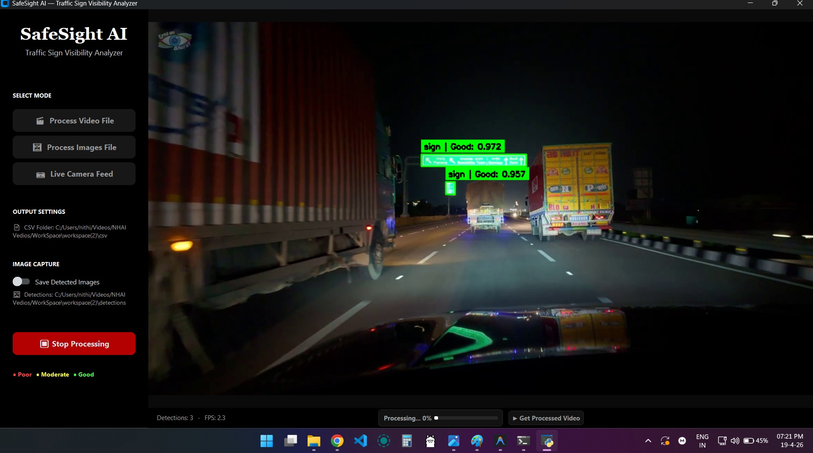
Figure 3: Real-time video processing on a night-time expressway dashcam feed. Two overhead gantry signs are simultaneously detected and rated Good (0.972 and 0.957). Live FPS and detection count are displayed in the status bar.

9.4 Image Mode — Mixed Classification (Good + Moderate)
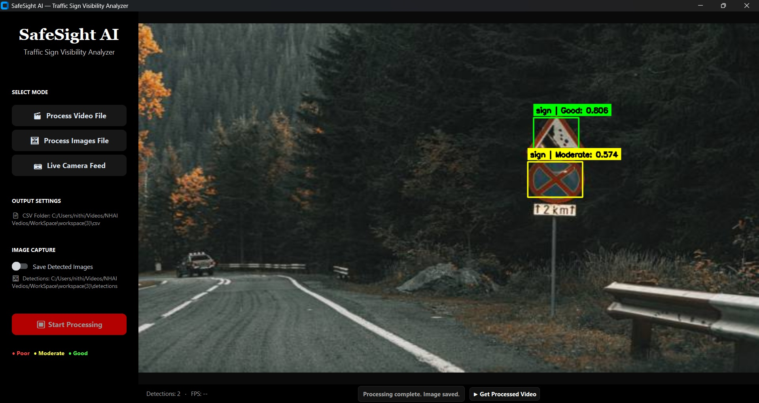
Figure 4: Dual sign detection with mixed classification. The upper sign is rated Good (0.806); the lower sign is rated Moderate (0.574), triggering GPS coordinate logging for that location.

10. Model Performance

10.1 Evaluation Metrics

Metric | Value
Precision | 94.9%
Recall | 75.0%
mAP@50 | 85.3%
mAP@50-95 | 57.0%

10.2 Metric Interpretation
Precision (94.9%): Of all bounding boxes predicted as traffic signs, 94.9% are correctly identified. This high precision ensures the system generates minimal false positives, which is essential for reliable automated maintenance reporting.
Recall (75.0%): Of all actual traffic signs present in the test dataset, 75% are successfully detected. The primary limitation is concentrated on small or distant signs at the far range of dashcam visibility — targeted for improvement in the next development phase.
mAP@50 (85.3%): Mean Average Precision at an Intersection-over-Union threshold of 0.50. This strong benchmark confirms reliable overall detection and localisation quality across diverse sign types and lighting conditions.
mAP@50-95 (57.0%): Stricter metric evaluated at multiple IoU thresholds between 0.50 and 0.95. This indicates room for improvement in tight bounding box accuracy, which is planned through expanded training data and augmentation strategies.

11. Feasibility
SafeSight AI has been designed from the ground up for immediate, practical deployment within NHAI's operational ecosystem, without requiring specialised infrastructure or capital expenditure.

- Hardware Independence: The system runs on standard consumer laptops and workstations. No dedicated GPU server, cloud infrastructure, or specialised computing hardware is required.
- Zero Cloud Dependency: The entire processing pipeline — model inference, visibility scoring, classification, and CSV logging — operates fully offline. There is no reliance on external APIs, cloud subscriptions, or internet connectivity.
- Low Deployment Cost: Built entirely on open-source foundations (YOLOv8, OpenCV, Python), the system carries no software licensing costs. Hardware requirements are met by commercial-grade dashcam and laptop combinations.
- Immediate Integration: NHAI patrol vehicles can be fitted with a USB dashcam and a standard laptop running SafeSight AI, enabling automated sign condition logging during routine maintenance patrol runs without dedicated survey trips.
- Zero Infrastructure Changes: No modification to existing road infrastructure, sign hardware, or communications networks is required. The system captures and processes standard visible-light camera footage.

12. Scalability
SafeSight AI's architecture is designed to scale from a single highway stretch to a comprehensive national road network audit programme.

- Batch Processing: The batch image mode can process thousands of photographs from aerial drone surveys or vehicle-mounted cameras in a single unattended session, enabling rapid corridor-level audits.
- Workspace Organisation: Each session is automatically assigned a unique timestamped workspace folder containing structured CSV logs and detection images, enabling parallel multi-team deployment without data conflicts.
- Modular Detection Core: The YOLOv8 detection model can be retrained or fine-tuned on regional sign sets — including gantry boards, delineators, road studs, and pavement marking categories — with minimal engineering effort.
- API-Ready Architecture: The detection engine can be exposed as a REST API service, enabling programmatic integration with NHAI's GIS platforms, traffic management centres, or cloud monitoring dashboards as operational needs evolve.
- National Highway Coverage: The system has been validated on authentic Indian road conditions — night-time expressways, rural two-lane roads, and dense urban corridors — confirming applicability across NHAI's full network diversity.

13. Sustainability
- Reduced Carbon Footprint: By processing footage from existing maintenance patrol vehicles, SafeSight AI eliminates the need for dedicated fuel-intensive inspection trips, directly reducing carbon emissions from highway survey operations.
- Targeted Maintenance: Only signs flagged as Poor or Moderate are referred for physical maintenance, eliminating blanket replacement schedules and significantly reducing material consumption and associated manufacturing waste.
- Proactive Longevity: Early identification of Moderate-rated signs enables preventive cleaning or retroreflective recoating rather than full sign replacement, substantially extending infrastructure service life.
- Green Computing: Optimised offline inference on edge hardware avoids the high energy consumption and data-bandwidth costs associated with cloud-based AI processing pipelines.
- Data for Planning: Cumulative CSV logs across inspection cycles build a longitudinal visibility dataset per sign location, supporting predictive maintenance modelling and infrastructure lifecycle planning at the national scale.

14. Advantages
- Real-time visual annotation with live bounding boxes and visibility scores for immediate situational awareness
- Fully automated pipeline from sign detection to structured CSV report — no human scoring or manual data entry required
- Objective, repeatable visibility scores derived from photometric analysis, eliminating subjective inspector variation
- Safe operation: inspection personnel are not required to exit vehicles or halt traffic on live highway corridors
- Deployable on existing dashcam hardware with minimal configuration overhead
- Produces GPS-tagged maintenance priority lists directly actionable by highway maintenance operations teams
- Offline-first design ensures robust operation in remote highway stretches with no cellular or satellite connectivity

15. Limitations
Detection Recall: Current recall of 75% reflects reduced detection performance for signs at long range or under severe occlusion. Small signs near the horizon of dashcam footage are occasionally missed. This limitation is targeted for resolution through dataset expansion and model re-training.
Camera-Based Scoring: Visibility scores are derived from camera-captured pixel intensity values, which are influenced by camera sensor quality, lens cleanliness, automatic exposure settings, and dynamic lighting conditions. Computed scores may differ from measurements obtained by calibrated handheld retroreflectometers.
Dataset Dependency: Detection accuracy for non-standard or regionally specific sign designs not represented in the training corpus may be reduced. Continued dataset curation and targeted annotation will address this progressively.
GPS Hardware Requirement: GPS coordinate logging requires a connected NMEA-compatible GPS module. Without this peripheral, location tagging is unavailable and must be supplemented by manual geo-referencing of survey routes.

16. Future Scope
- Dataset Expansion: Expand the training dataset to 2,000+ labelled images covering gantry signs, delineators, road studs, and pavement marking categories, targeting recall improvement to 90%+
- Edge Deployment: Optimise the YOLOv8 model for edge deployment on NVIDIA Jetson Nano or Raspberry Pi 5, enabling integration into compact dashcam hardware without a separate laptop computer
- Cloud Dashboard: Develop a cloud-based monitoring dashboard for NHAI corridor managers providing real-time visibility heatmaps, maintenance priority queues, and historical trend analysis per highway stretch
- Drone Integration: Integrate drone-based aerial inspection capability for high-density audits of gantry structures and elevated road sections inaccessible to vehicle-mounted cameras
- Pavement Markings: Extend the AI model to assess pavement marking retroreflectivity and road stud condition alongside sign inspection, creating a unified retroreflectivity management platform
- HMS Integration: Develop direct API integration with NHAI's Highway Management System (HMS) for automatic work order generation upon detection of Poor-classified signs

17. Conclusion
SafeSight AI addresses a critical operational gap in national highway safety infrastructure: the absence of a scalable, automated, and objective system for assessing traffic sign retroreflectivity at network scale. By integrating YOLOv8-based object detection with a photometric visibility scoring algorithm, the system delivers real-time, GPS-tagged condition assessments that directly support NHAI's safety obligations under IRC 67 and IRC 35.

The solution is deployable immediately on existing patrol vehicle dashcam hardware, operates without cloud connectivity, and generates structured maintenance priority reports at the conclusion of each survey run. Its modular architecture provides a clear path to expand coverage to pavement markings, road studs, and delineators — positioning SafeSight AI as a comprehensive retroreflectivity management platform for India's national highway network.

SafeSight AI is not a research prototype — it is a production-ready operational tool that transforms highway safety inspection from a manual, hazardous, and infrequent activity into a continuous, automated, and data-driven programme. The complete source code and documentation are available at https://github.com/mpnithishpraba/SafeSight_AI-Traffic-Sign-Visibility-Analyzer

SafeSight AI — Ensuring Safer Roads for All

