Calibration Gailtal

Number of Runs: 2.3 Mio, Euclidean Distance best 100: 0.165-0.171
- taking 1 or 2 Mio Runs does not make a real difference (0.167 – 0.1725)
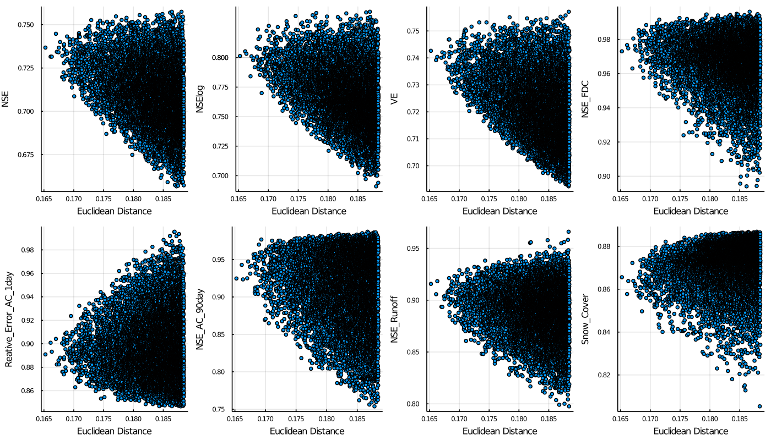

The figure shows the best 10000 fit based on the Euclidean Distance. It shows how the fits perform based on the individual objective functions that contribute to the overall fit. It can be seen that the flow duration curve, the autocorrelation curve and the representation between the division in runoff and evaporation are very well represented. Also, the snow cover is well represented. The log NSE also performs well, whereas the NSE and the VE perform okay.
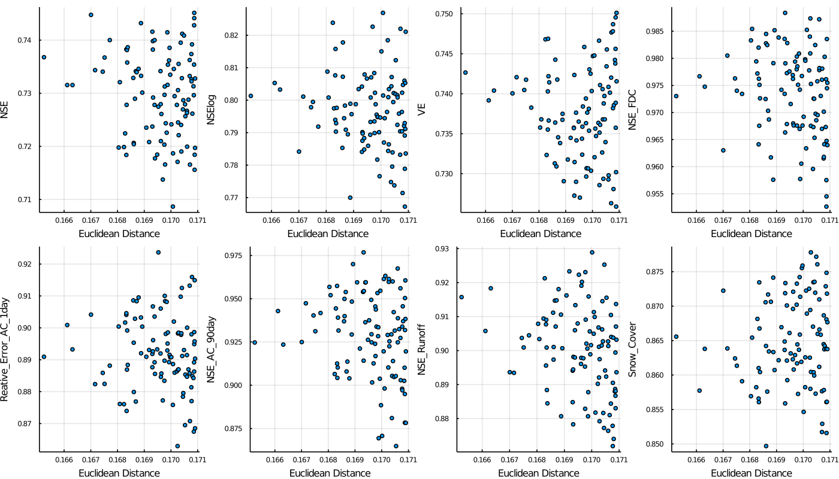
Looking at the 100 best parameter fits it can be seen that the NSE and log NSE are also above 0.7. The fit therefore seems good.
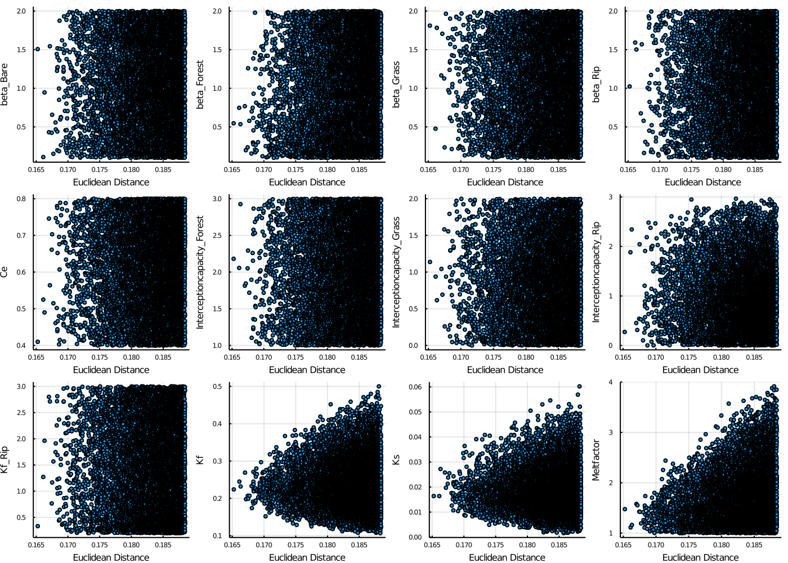
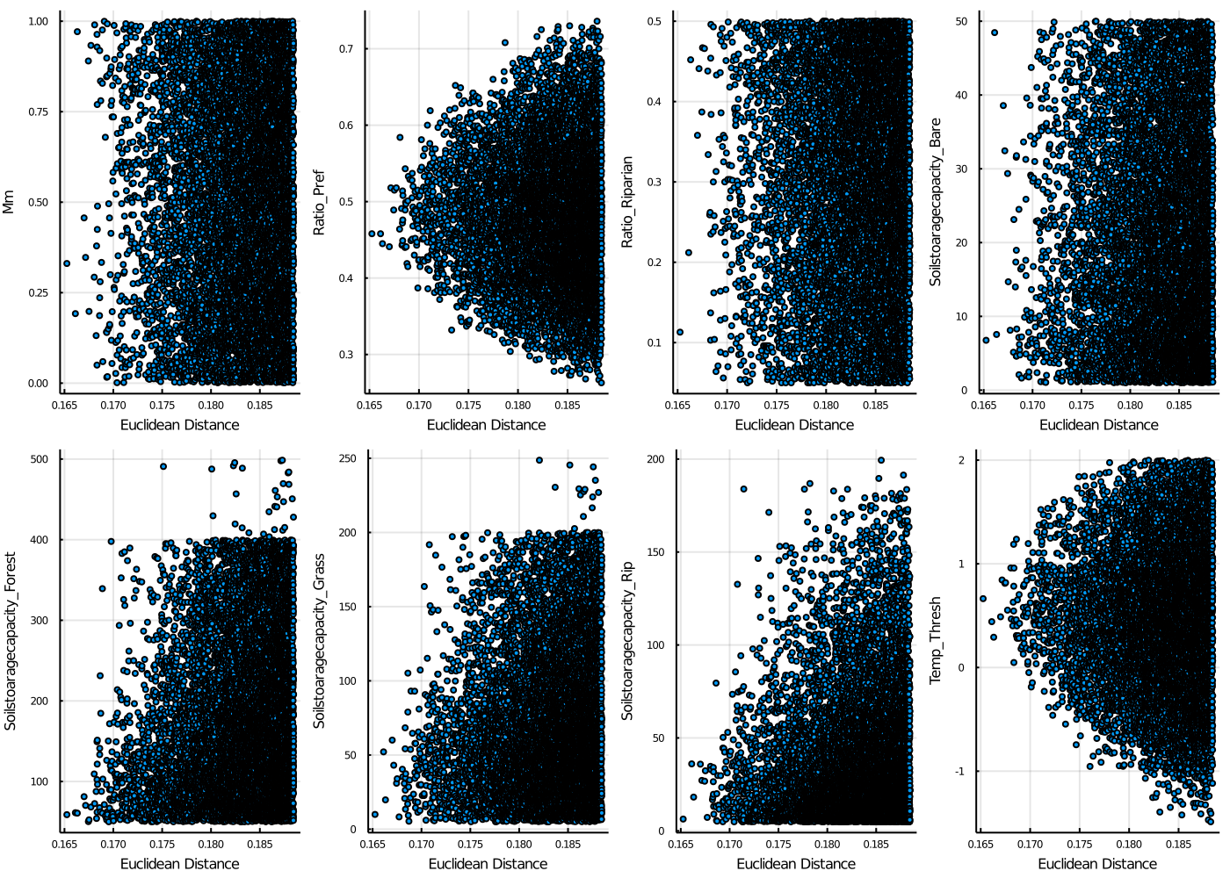
Looking at the parameter fits of the 10000 best fits it can be distinguished that:
- beta values cover the whole range of possible values
- Interceptioncapacities as well, although the riparian interceptioncapacity does not reach upper limit
- Ce and Kf_Rip are also distributed over the whole range
- for Kf and Ks a trend towards 0.2 and 0.002 can be distinguished
- the meltfactor decreases with better fits, being in the lower range of 1-2
- Mm and Ratio Riparian are distirbuted over the whole range
- Ratio of Preferential Flow converges towards 0.5
- the Soilstoragecapacities seem to converge towards lower values
- the threshold temperature lies between 0 and 1

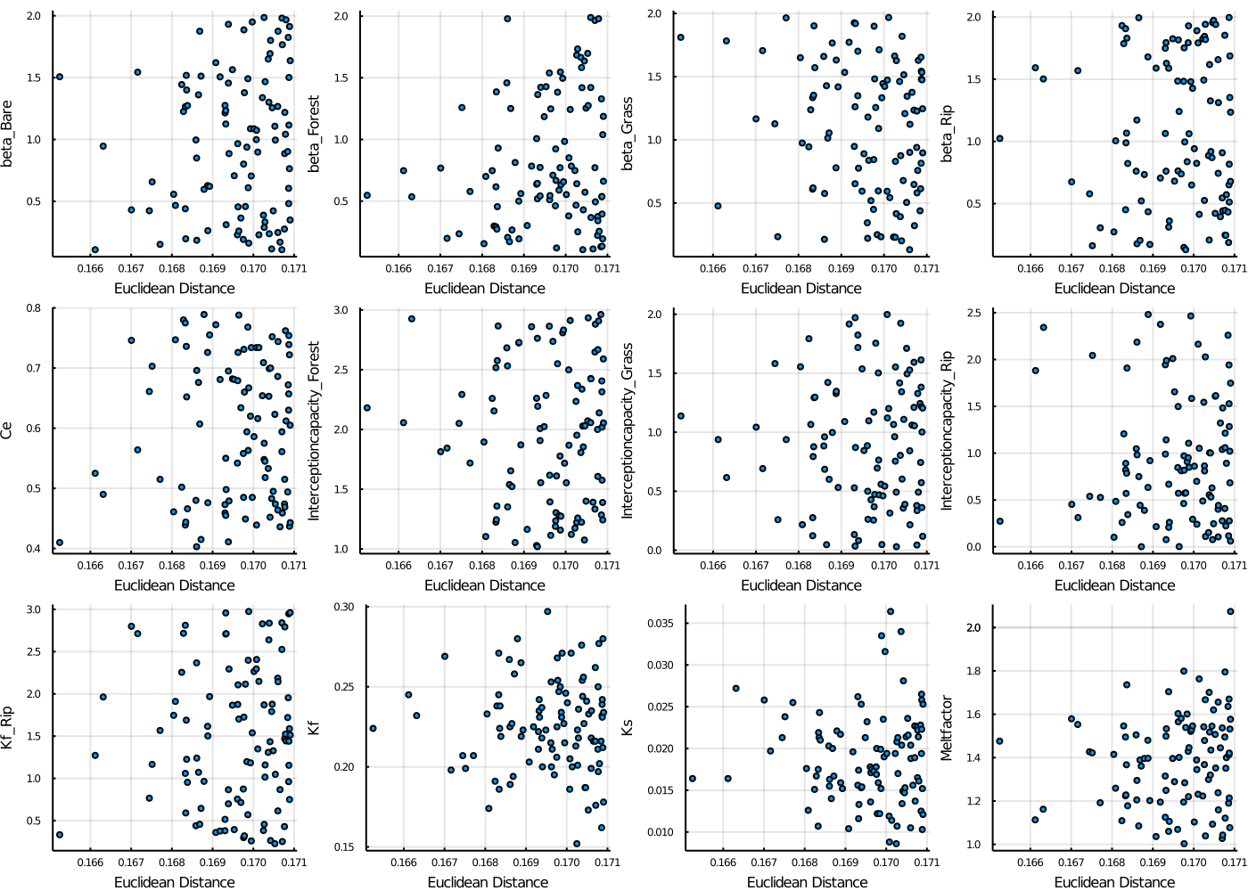
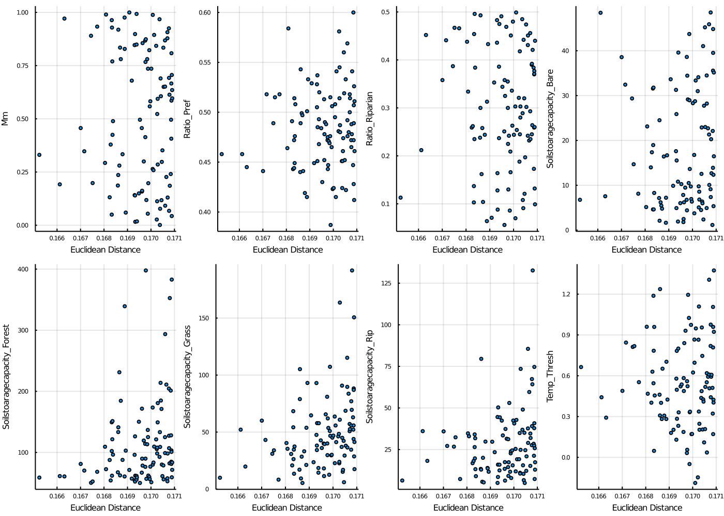

- the soilstoragecapacity of the riparian HRU is below 125
- for the best parameter sets the soilstoragecapacity of the forest lies below 100 mm (is that too low?)

Comments:
- Meltfactor seems quite low, maybe because of a lot of forest within the catchment (57%), I only took one meltfactor… If the forest coverage would change in future my model would probably not run well… (in literature it says it shoulw between 2-4)
- taking 1 or 2 Mio Runs does not make a real difference (0.167 – 0.1725)

Validation
- Validation of 5 years: Eculidean Distance increases by up to 0.05 for best 100 runs
- the overall Euclidean Distance is 0.17-0.22
- AC, FDC, snow cover and Runoff are still very good in validation:
- NSE, VE and NSElog decrease more severly
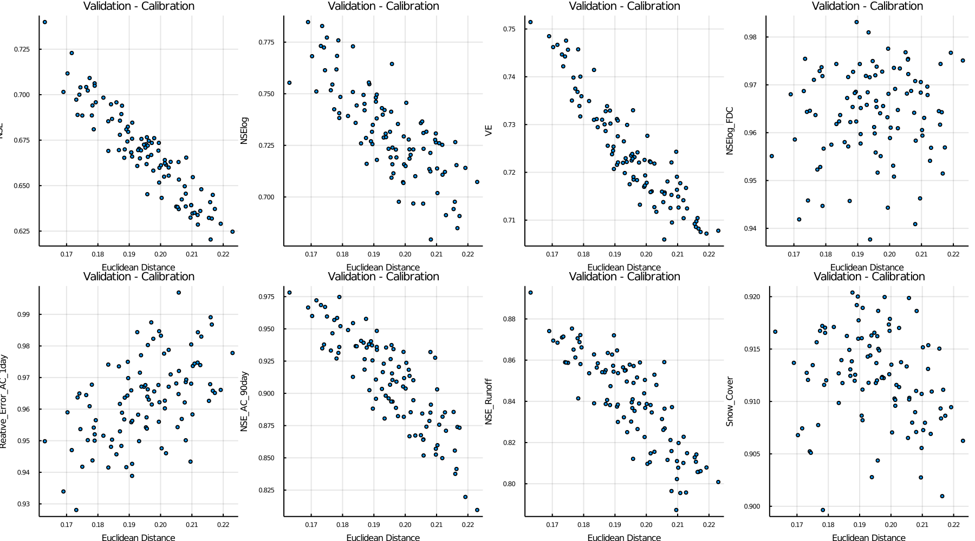

Looking at the relative change of objective functions between the calibration and validation it can be seen, that the performance of the model of NSE, NSElog, VE and runoff decreases, whereas it increases for AC and snow cover

- which parameter sets should I use for running the projections? Just start with the best 10?

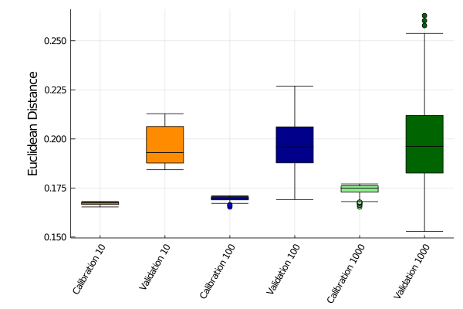
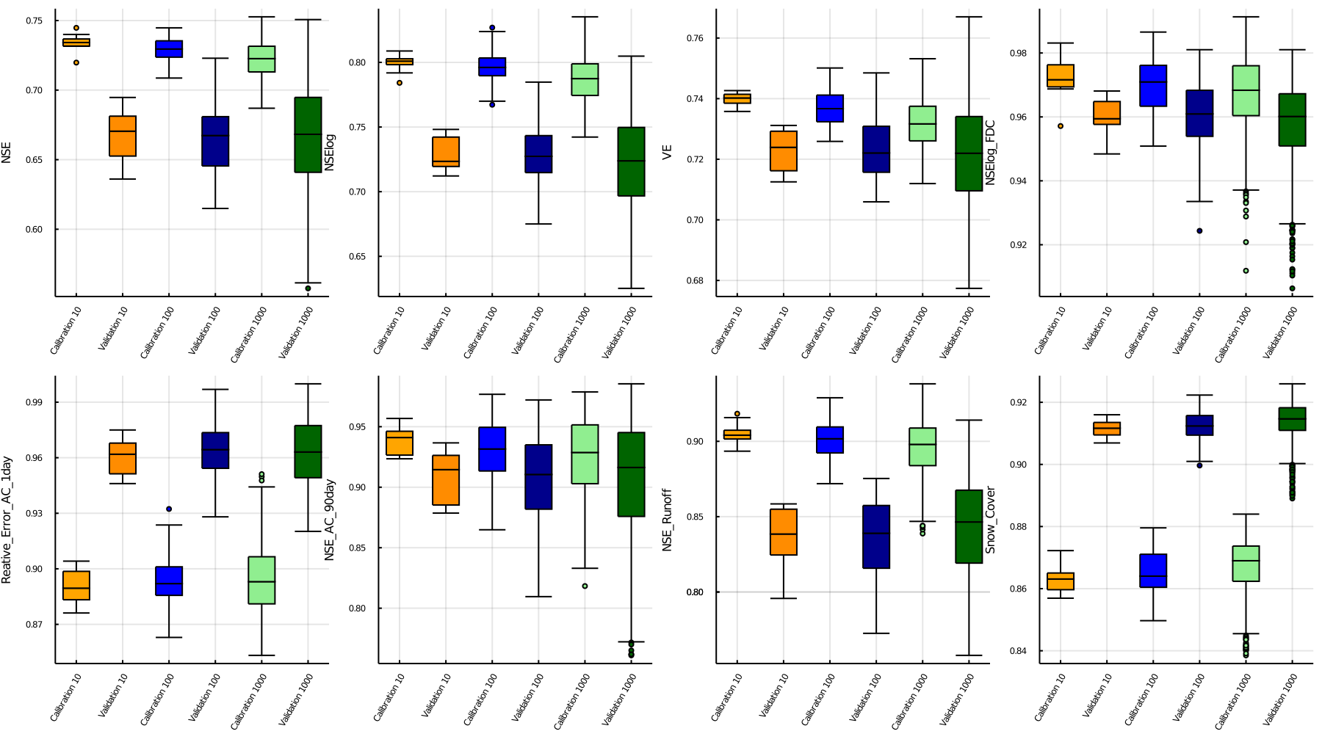

Ground water Storage
- the GW storage shows an annual pattern with a decrease in GW levels until April and an increase in spring until reaching highest levels in July and then decreasing again
- the GW levels decrease in winter because no recharge occurs due to snow

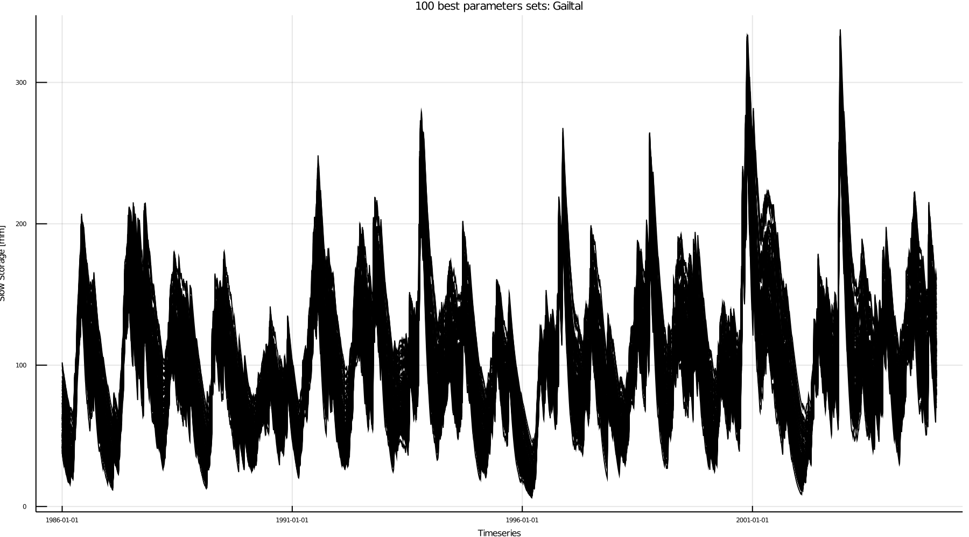
- some years show a different pattern with highest GW levels in October, might be due to higher temperature in autumn which delays the snow accumulation
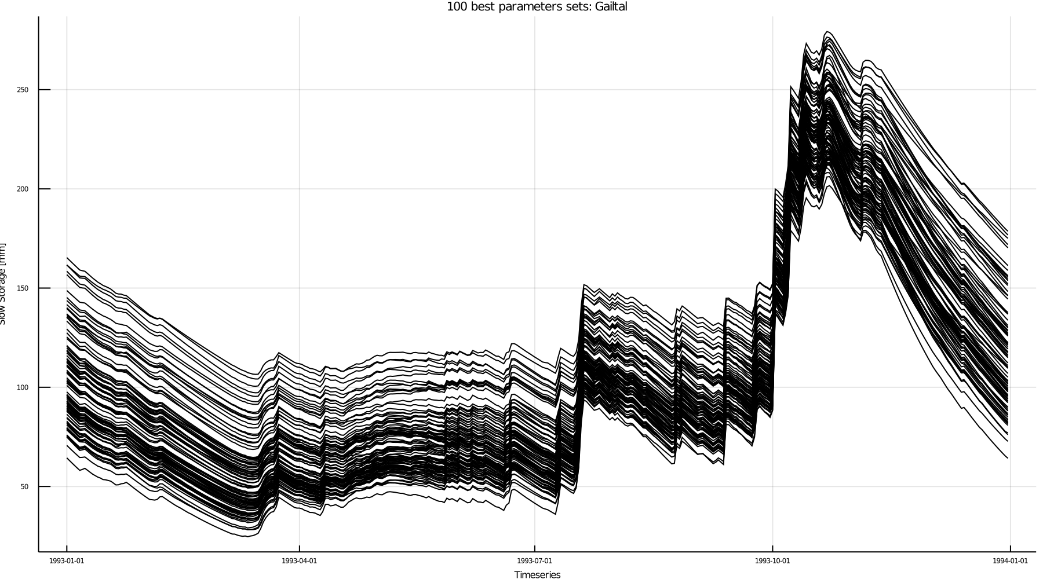
Discharge

- the general patterns are well represented
- not too much changes between the best 100 parameters sets
- peak discharges are often not captured
- modelled discharge a bit too spiky

Snowstorage
- pattern fits
- more snow at higher elevations
- highest elevation (800mm), 1500m around 200mm

Soilstorage
- the soilstorage capacities of the best runs vary highly (e.g. 60 forest – 30 rip) (best2) and 70 forest and everything else very low (best8)
- in 10 best fits forest soilstorage always below 100mm
- in best 20 parameter sets also above 150 mm (13 and 16)
- yearly pattern fits (decrease in summer) steady in winter because decreased temperatures)

Precipitation
- compare the real precipitation to the precipitation of the projections
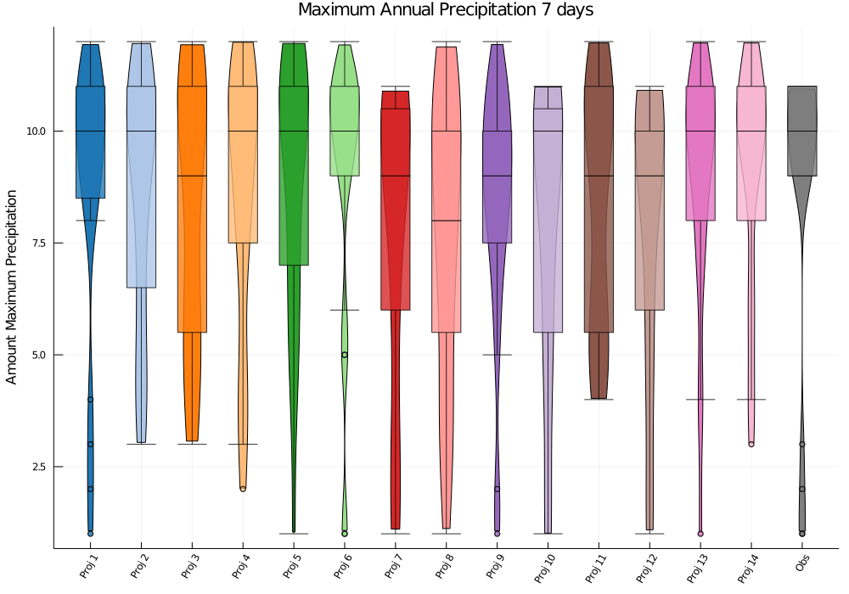
- it can be seen that the timing of the month of the annual maximum precipitation of the projections is comparable to the the real data
Also, the amount of the annual maximum precipitation is comparable
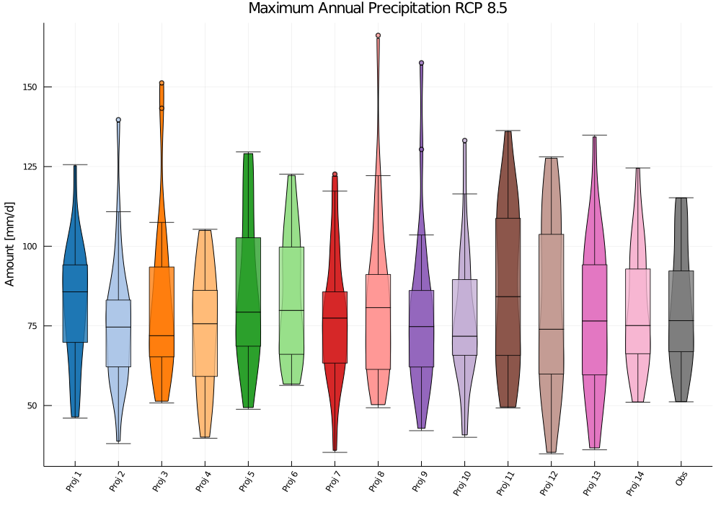
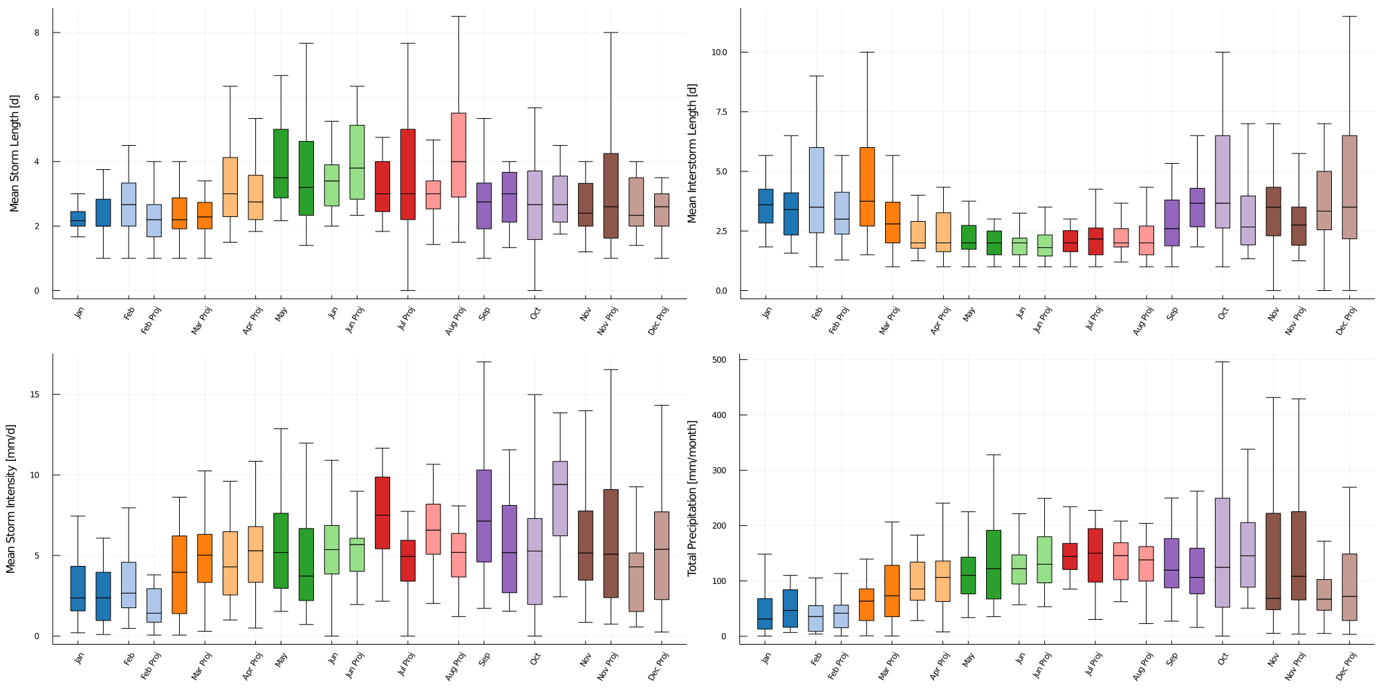
Also, the other seasonalitiy indices of the precipitation are quite well represented by the projections (total monthly precipitation, storm intensity, storm duration and interstorm duration)
Temperature Statistics fit well as well

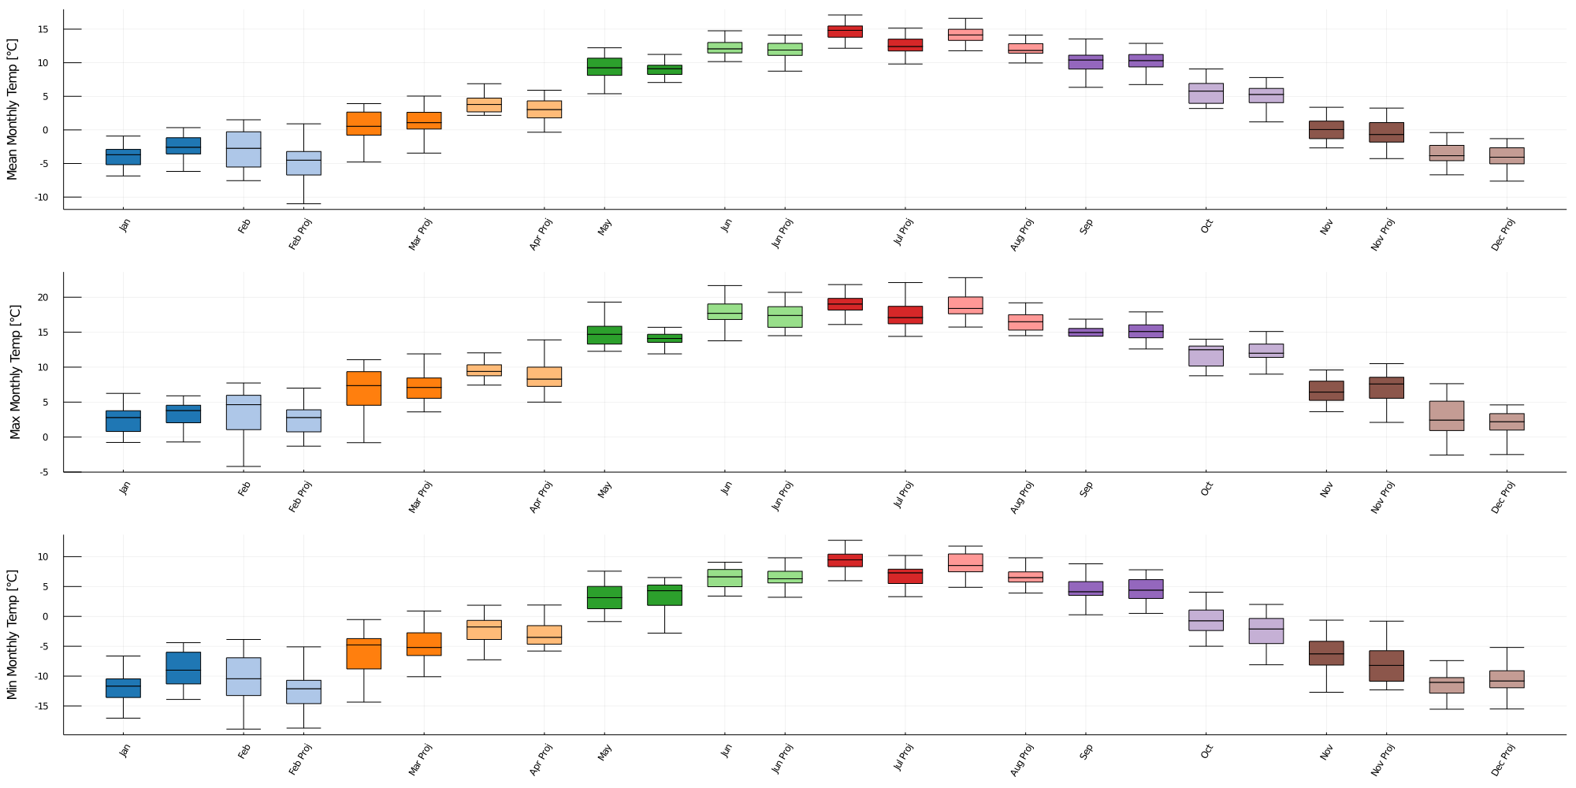
Comparing the Results of the Projections and Calibration

- NSE, NSElog and VE perform very bad as expected because the timing of precipitation in the projections does not fit the timing in real historical data
- NSE Flow Duration Curve fits very well for all projections which means the probabilities of magnitudes of discharges is well represented by the projections
- the NSE of the Autocorrelation Curve of the projections fits well with the measured discharge AC, which means the projections also represent well the “memory” of the catchment, so the catchment characteistics
- the NSE of the monthly runoff coefficient preforms very bad, which can be expected because the timing of the runoff of the projections and real data do not match due different timing of precipitation (although over a longer period of time the runoff coefficients match better which means that the long term probabilites in the projections are right)
- the snow cover extend is captured reasonably well by the projections but not as good as for calibration because the exact timing of precipitation do not match

if precipitation of each month is compared with real data it shows that in a lot of months the projections overestimate the monthly precipitation

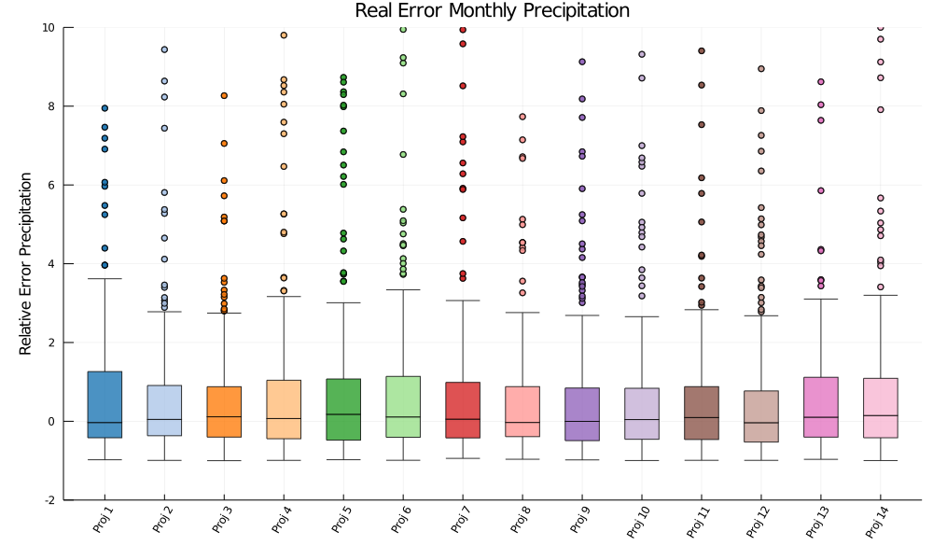
So, projections on average show the right monthly precipitation amounts, but not in the same years

