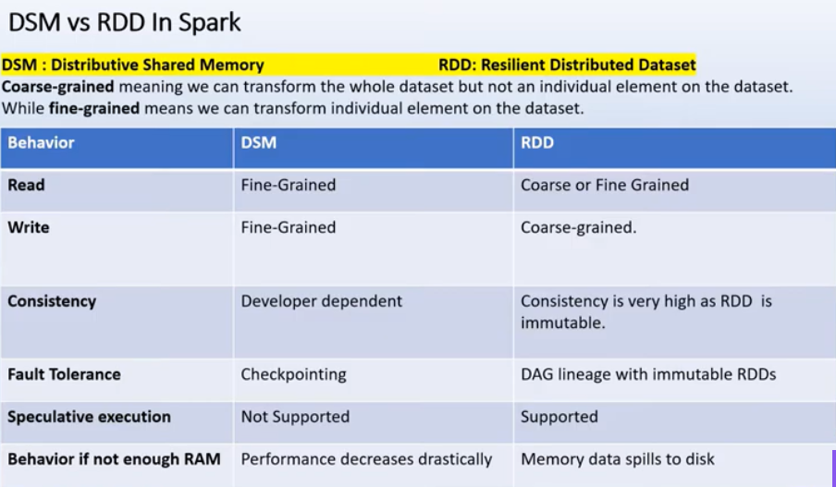

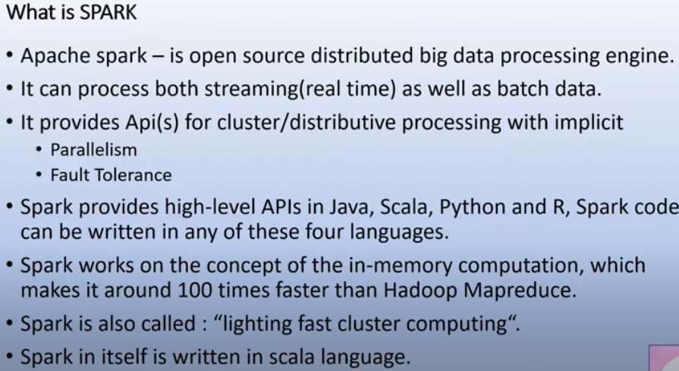

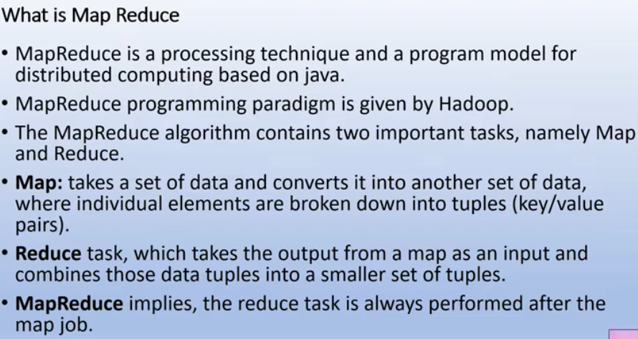

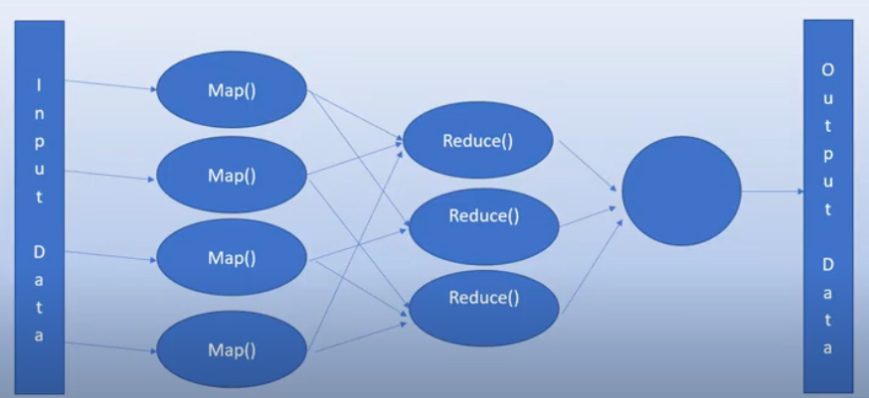

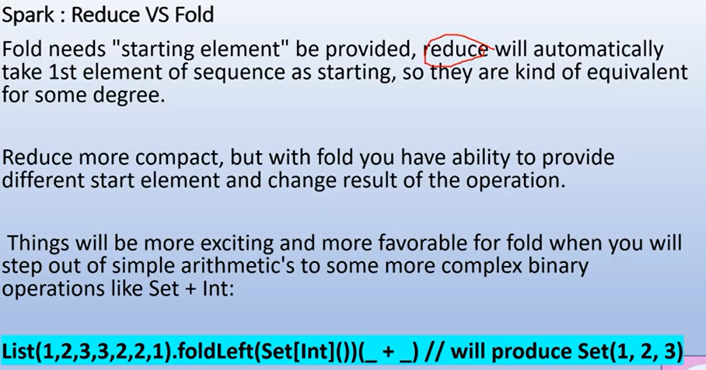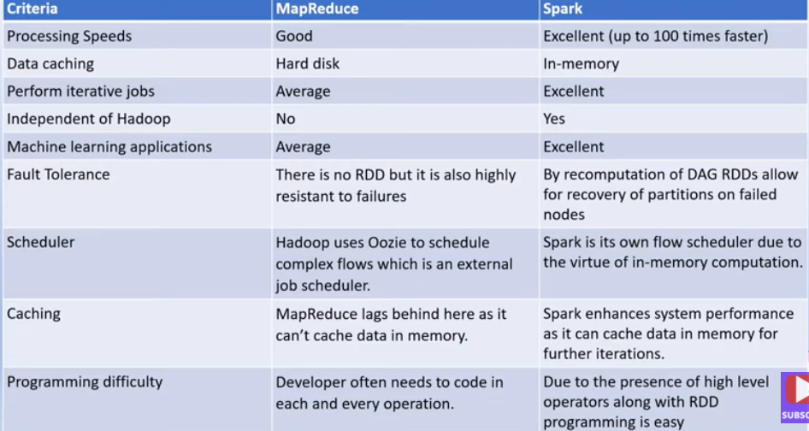

* fold() is an action. It is wide operation (i.e. shuffle data across multiple partitions and output a single value)
* It takes function as an input which has two parameters of the same type and outputs a single value of the input type.
* It is similar to reduce but has one more argument 'ZERO VALUE' (say initial value) which will be used in the initial call on each partition.

***def fold(zeroValue: T)(op: (T, T) ⇒ T): T***

Aggregate the elements of each partition, and then the results for all the partitions, using a given associative function and a neutral "zero value". The function op(t1, t2) is allowed to modify t1 and return it as its result value to avoid object allocation; however, it should not modify t2.

**Example :**  
val rdd1 = sc.parallelize(List(1,2,3,4,5),3)  
rdd1.fold(5)(_+_)

**Output :**  
Int = 35