 | www.ectwebdesign.com  info@ectwebdesign.com  4 Wood St, Bath, BA1 2JQ

Custom Product Detail Page Mod
(C) ECT Web Design
www.ectwebdesign.com
If you are experiencing any difficulties, do not hesitate to email us.

- Copy the ‘mod’ folder into your vsadmin/inc directory and main root directory on your website
- Open the included vsadmin/inc/incproddetail.php in your HTML editing program
- The page will look something like this (NB HTML editing program in this example is Dreamweaver MX)
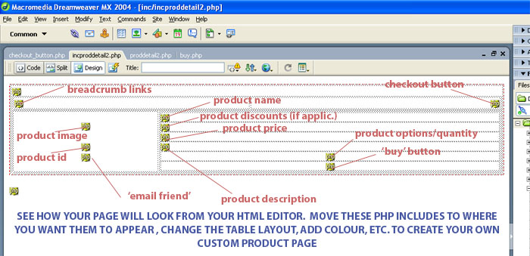
- You will see the different includes files contained within the table. To change the look of the product detail page, simply moves these includes files to where you would like them to appear
- Putting your cursor on the include icons will display the particular page feature, e.g. mod/product_name.php will refer to the products name, mod/image.php will refer to the image. You can make tweaks to the individual items by opening the files and editing them this way, e.g. you could alter the appearance of the product name. If you open the file you will see this code:
<b><?php print $rs["pName"] . $xxDot;?></b>
Just change this accordingly, e.g. adding a CSS style to it,
<span class=”css_style”> <?php print $rs["pName"] . $xxDot;?></span>
But these advanced tweaks may not be necessary on your page. You can recreate the page completely if you wish!
- Overwrite your current vsadmin/inc/incproddetail.php page with the file include
- People using version 5.5.1+ and our SEO module should do below extra change
- Search for following in /vsadmin/inc/mod/reviewbox.php file :
action="proddetail.php?prod=<?php print $prodid . ($thecatid!='' ? '&amp;cat='.$thecatid : '')?>"
and replace with
action="<?php print $prodid .'.htm'?>"

