$$S→I→R$$

S - susceptible individuals

I - individuals suffering from a disease and spreading the infection

R – recovered

Let's make this assumption:  
1. the increase in the group of individuals sought is proportional to  
the number of individuals released and the number of susceptible individuals -   
2. the increase in healed individuals is directly proportional to the number  
online patients - , where .  
3. the incubation period is so short that it can be neglected - the individual  
susceptible who got infected get sick immediately.  
4. the population is thoroughly mixed - each type of individual has the same place and an individual of a different type.  
With these assumptions, let's formulate the equations (Kermack-McKendrick (1972)):

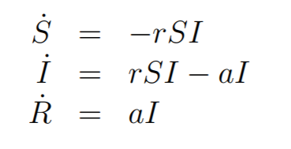

Note that this model has a built-in assumption of constant-count:

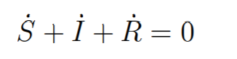  
Meaningful baseline data for the epidemiological model are:



The critical parameter $ρ = a / r$ is called the relative coefficient  
recovery and is the inverse of the contact ratio $σ = r / a$. Associated with it is the so-called base reproduction rate for a given infection:

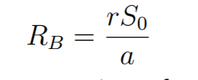

It describes the number of individuals newly infected by one currently infected. If RB> 1, the disease spreads. One of the ways  
the reduction of the RB is the reduction of the S0 or the number of susceptible individuals. The baseline reproductive rate is a key controlled parameter  
e.g. by vaccination.

We have to fit this:

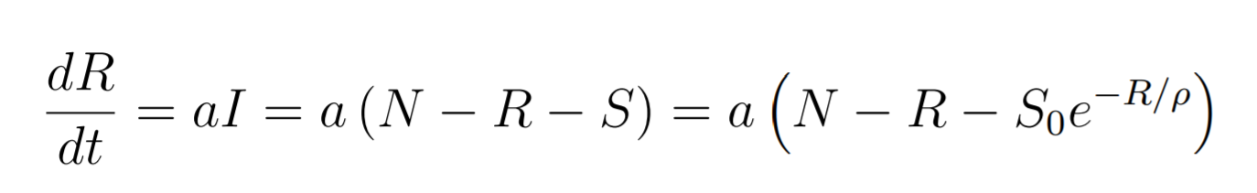

dR/dt are recovered + deaths per day

We have everything except a and $ρ$. We can get this by fitting our data. Then we get Rb and we can compare Rb for different periods of time (for different restrictions).