Boston University Metropolitan College
AD688: Big Data and Cloud Analytics for Business (Fall 2026)

Business Running Case: Evaluating Personal Job Market Prospects
Final Report

Submitted by:
Manan Patel, Richard Park, Michael Phillips
Group 6
October 11, 2026

Executive Summary
This report seeks to provide guidance and recommendations to students utilizing our services for the purposes of navigating through the Computing Infrastructure Providers, Data Processing, Web Hosting, & Related Services (NAICS 5182) career industry. Data on career paths listed under the umbrella of NAICS 5182 were analyzed and evaluated to develop a career evaluation product for job seekers targeting Data Analyst roles, with a growth path toward Data Scientist, Analytics Engineer, and Machine Learning Engineer positions. Our end-user product includes a public website with interactive charts and a salary estimator, built on MET Career Compass job files. After filtering through 815,193 postings to our industry and pathway and removing repeat listings, 765 postings still remained, 303 disclosed a salary, and 570 included the posting text. The following list includes our key findings for the analyzed role:
- The market is defined by mid-level technical specialists. We found that Data/Analytics Engineer roles make up 44% of our remaining postings, Data Scientist roles at 28%, and Data Analyst roles at 15%. The median experience requirement was calculated to ~5 years.
- Specialization can govern compensation. The median disclosed salary rises from $114,750 for Data Analyst postings to $204,875 for Data Scientist and $220,260 for ML Engineer postings. Holding location, seniority, and work arrangement fixed, a Scientist or ML Engineer title is associated with $72,000 to $82,000 more than an analyst title.
- Machine Learning (ML) and Python shape the career path. “Scientist” and “ML” postings name Machine Learning in 68% of cases and Python in 54%, against 11% and 20% for analyst postings, which typically lead with communication, SQL, and visualization.
- The team’s main gaps are Machine Learning and Statistics. Two of three members rate themselves below Advanced in Machine Learning, and Statistics has the lowest team average (3.0 of 5).
- Data Analyst is the best entry point and MLE the best destination. We calculated an Opportunity Scorecard factoring in pay, accessibility, and fit that ranked MLE at the top with 0.822, and Data Analyst last at 0.672, with the caveat being that Data Analyst is the most accessible role.
- AI exposure is associated with higher pay almost everywhere. This is most strongly seen in roles such as software engineering, cybersecurity, and product management, but are least in fields that are already almost entirely AI-related.
The recommendation is that students entering this specific career pathway should begin as an analyst with strong skills in SQL, visualization, and communication. Then, later leverage Machine Learning and Python as the bridge to Scientist/MLE roles, adding cloud skills that the industry highly values.

Product Framing
Target User: Students or early-career job seekers who are qualified, or nearly qualified, for a Data Analyst role and seek to climb the career ladder toward Data Scientist or ML work.
Career Pathway and Industry: The study is focused on four role families along one path: Data Analyst, Data/Analytics Engineering, Data Scientist, and MLE. These are all within the NAICS 5182 industry, Computing Infrastructure Providers, Data Processing, Web Hosting, and Related Services. Its employers sell computing, storage, and data processing services, meaning data roles are established within the core product rather than merely a support function.
Product Question: Within the NAICS 5182 industry, which tools and skills distinguish Data Analyst roles from Data Scientist and MLE roles, and how should job seekers prioritize their learning to successfully move from one role to the other? Table 1 breaks this down into four research questions.
 | Research Question (RQ) | Answered in
RQ1 | What does the market look like: role, mix, pay, location, experience, education, and work arrangement? | Market Baseline
RQ2 | Which skills separate analyst postings from scientist and ML postings, and where are our team’s gaps? | Skill-Gap Analysis
RQ3 | Which factors are associated with higher pay, and which role offers the best mix of pay, accessibility, and fit? | Final Analytics
RQ4 | What should a job seeker learn first, and where should they apply? | Recommendations
Table 1: Research Questions
The Product: Our website helps walk users through an intensive sequential analytical process helping capture Scope, Project Overview, Data Preparation, Exploratory Analysis, Benchmark Analysis, Skill Gap Analysis, Predictive Modeling - which includes an interactive salary estimator with dropdown inputs, and Final Recommendations - where another dropdown will compare the analyst role with each target role. Appendix G maps each website page to the section of this report it supports.

Context and Related Work
The industry currently remains large. For example, roughly 453,800 people were employed in September 2026, according to employment data from the Federal Reserve Bank of St. Louis (2026). Furthermore, the end goal of our pathway, the data scientist role, is growing quickly, with employment projected to grow 35% from 2025 to 2035 and about 24,800 openings per year (U.S. Bureau of Labor Statistics, 2026). We are directly using job postings as our established evidence source to determine what employers are looking for. Research shows that skill requirements in postings vary across firms and are associated with differences in pay (Deming & Kahn, 2018). A 2026 study of 1,355 U.S. data analyst postings found demand for SQL skillsets in about 50% of the listings, Python in 33%, and stakeholder communication in 59%, but it covered analysts across all industries (Magnet, 2026). This particular study does not display what separates analyst from scientist postings within our industry, which is the gap our product fills.
Three findings from recent research shape how we read our data. First, AI skills carry a notable pay premium, but its size depends on what is compared. PwC’s 2026 analysis of more than one billion job ads reports that ads asking for AI skills offer an average of 62% higher pay than ads for similar roles that do not (PwC, 2026). However, an IMF study of U.S. job postings from 2020 to 2024 found that, within the same occupation, industry, and county, AI-developer skills such as machine learning are associated with wages more than 8% higher, and AI-user skills with about 2% (Jaumotte et al., 2026). Second, entry into AI-exposed work has become harder. By June 2026, employment of workers aged 22 to 25 in the most AI-exposed occupations was 19% below where it would have been had it maintained its pace with less-exposed peers, primarily due to fewer young workers being hired (Brynjolfsson et al., 2026). Third, pay disclosure has spread quickly. As of May 2025, 59% of U.S. job postings included salary information (Shrivastava, 2025), with pay ranges required in California since 2023 (Tate et al., 2022) and in New York since September 2023 (New York State Department of Labor, 2023). Altogether, these findings mean we can compare skills within the same role, treat entry-level access as a key constraint, and read posted pay mainly as a picture of the states that require disclosure.

Scope and Data
The source of our data is the course’s MET Career Compass Jobs database, which includes 815,193 postings from all industries dating from January 2 to September 30, 2026. We then used this to build scripts in our repository to filter the folder and save exactly what was needed for our analysis. Table 2 demonstrates our data cleaning process.
Step | Rule | Postings
All postings | Every posting in Jobs_2026 folder | 815,193
Industry | Code 518 (equals NAICS 5182 in folder) | 6,964
Pathway titles | Title contains one of 12 keywords (e.g. data analyst, data scientist, data engineer, ML engineer) | 1,232
Distinct postings | One row per title, company, state, and date (467 repeats removed) | 765
With posting text | Used for skills and degree wording | 570
With a disclosed salary | Used for pay analysis | 303
Table 2: Construction of analytical sample
The titles are then assigned to one of our four role families in order: ML Engineer (103 postings), Data Scientist (211), Data/Analytics Engineer (335), and Data Analyst (116, including Business and BI analysts). We then used the following cleaning decisions:
- Salary: 0 used for not disclosed. Hourly rates converted to annual salary by multiplying 2,080 hours. Internships are excluded. Finally, we analyze the midpoint of the posted range.
- Skills and Degrees: Each posting’s skill field lists up to three skills, and the education field is modeled rather than stated. Therefore, both are read from the posting text. We analyzed 17 skill name patterns, and each degree labeled required, preferred, or named without explicit requirement wording.
- Experience: Minimum-years field is filled for only 77 postings, so we were forced to interpret phrases such as “5+ years” from the text (206 postings).
- Location and Employer: U.S. States are resolved from mixed fields (653 of 765). Job-board listings without a real employer (27) are excluded from employer rankings only.
Our two supporting datasets use the same rules. The salary estimator is trained on 2,252 pathway postings with a salary from all industries (155 in NAICS 5182), because 303 salaries are too few for many inputs. The benchmark summarizes all 733,064 valid postings, of which 69,246 state a usable salary. See Appendix B & C for further details.

Market Baseline
Table 3 summarizes the market that students/job seekers on our pathway face.
Dimension | What the 765 postings show | What it means for job seekers
Role mix | Data/Analytics Engineer - 335 (44%)  Data Scientist - 211 (28%)  Data Analyst - 116 (15%)  ML Engineer - 103 (13%) | Demand in people with ability to build data systems/models. Analyst openings represent small share.
Pay | 303 postings (40%) disclose a salary.  Median salary - $188,100  Middle half - $154,000 to $227,750 | High pay that rises sharply with role (Figure 1)
Location | California/New York (141/113 Postings | Total 39%)  Texas/Virginia/Washington (54/53/36 Postings)  Median pay:  California - $224,500  New York - $190,000  Virginia - $155,900 | California & New York lead volume and pay. Virginia has many postings correlated largely with federal contractors, at lower pay.
Experience | Stated in 206 postings (27%)  Median - 5 years  73% request 3-8 years  17% request 2 years or fewer  Data Analyst postings: Median 4 yrs | Mid-career market.  Few postings describe a new graduate.
Education | Out of 570 postings with text:  68% list no degree  Master’s required in 11  PhD required in 4 | Graduate degree rarely a hard requirement in postings
Work arrangement | 77% do not state one  Remote - 78 postings  Hybrid - 75 postings  Onsite - 26 postings | Remote policy must be confirmed with employers
Table 3: Market baseline for pathway in NAICS 5182
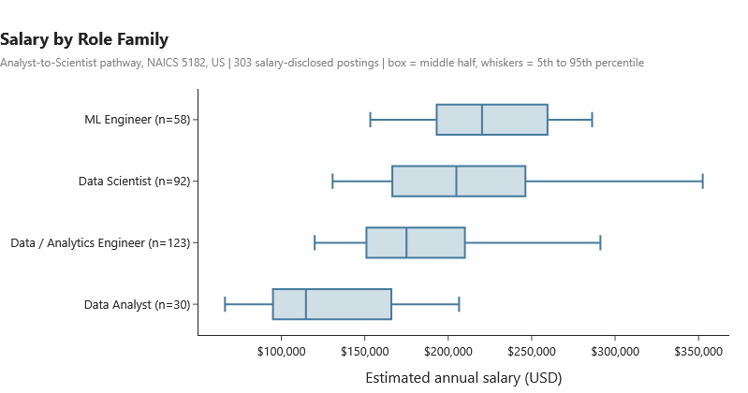
Figure 1: Disclosed salary by role family
Figure 1 displays our researched pay ladder that encourages this particular pathway. Transitioning upward from Data Analyst to Data Scientist can be worth about $90,000 at the median. These posted figures are far above the national median wage for Data Scientists ($120,230) based off the U.S. Bureau of Labor Statistics in 2026, partly because salary disclosure is concentrated in high-pay states.

Skill-Gap Analysis
Method: For our market side, we computed the share of postings whose text contains each of the 17 skills and did so separately for Data Analyst postings (85 with text) and Data Scientist/ML Engineer postings (239 combined). Starting with the team side, each member rated six skills from 1 (Beginner) to 5 (Expert). We will label skills “High demand” if 50% or more of either role’s postings name it, “Moderate” at 25% to 49%, and “Low” below 25%. Advanced (level 4) is set as our target in High and Moderate skills.
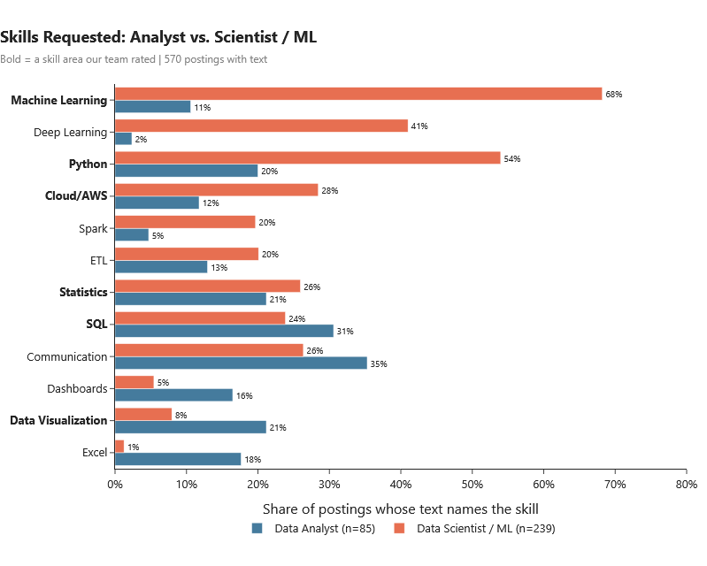
Figure 2: Share of postings whose text names each skill. Data Analyst is set against Data Scientist/ML Engineer postings.
What the market looks for: The two ends of the pathway use different methodologies/skills. Data Scientist & ML Engineer postings name Machine Learning (68%), Python (54%), Deep Learning (41%), and Cloud/AWS (28%) far more often than analyst postings do. Analyst postings lead with communication (35%), SQL (31%), data visualization (21%), Excel (18%), and dashboards (16%). We see that SQL and Statistics are most commonly shared across both our paths. According to a national analyst study, it shows the same order with higher levels (e.g. communication - 59%, SQL - 50%) (Magnet, 2026), suggesting that our text matching undercounts skills but ranks them consistently. With that, we would compare shares across roles rather than reading as exact requirements.
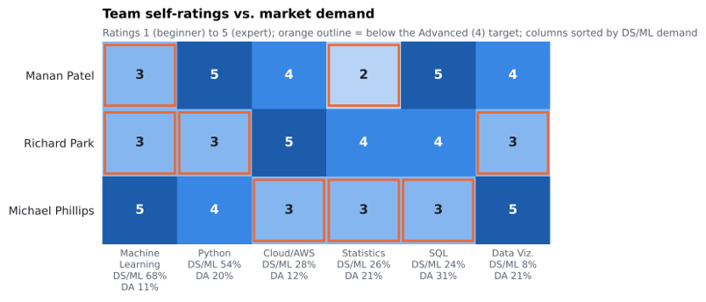
Figure 3: Team self-ratings for the six skill areas including DS/ML & DA postings that also name each skill.
Skill | Analyst Postings | DS/MLE Postings | Demand | Team Average | Below Advanced (4)
Machine Learning | 11% | 68% | High | 3.7 | Manan, Richard
Python | 20% | 54% | High | 4.0 | Richard
Cloud/AWS | 12% | 28% | Moderate | 4.0 | Michael
Statistics | 21% | 26% | Moderate | 3.0 | Manan, Michael
SQL | 31% | 24% | Moderate | 4.0 | Michael
Data Visualization | 21% | 8% | Low | 4.0 | Richard
Table 4: Skill-gap scorecard. Market demand against team self-ratings
Gaps & priorities: None of our group members are strongest in every skill (Figure 3, Table 4). Machine Learning has the clearest gap while being the most-requested skill in the role our pathway ultimately leads to (two of three members rate it at 3). Statistics follows after that with the lowest team average while appearing at both ends of the path. Then there are individual gaps in Python (Richard), Cloud/AWS & SQL (Michael), and Data Visualization (Richard).
Member | Priority | Actions and Resources
Manan Patel | Machine Learning, then Statistics | Supervised learning project w/ Michael. Machine Learning & Statistics Courses.
Richard Park | Machine Learning, Python, Data Visualization | Supervised learning project w/ Michael. Python with Manan. Then Python & Tableau Courses.
Michael Phillips | SQL, then Cloud/AWS and Statistics | SQL Aggregation practice. AWS Cloud Practitioner Course/Certification.
Table 5: Member Improvement Plan
The idea here is to utilize each team member’s strengths as peer coaching. With Michael’s Machine Learning at level 5, he can coach both the other members while Manan at Python level 5 can teach Richard. Richard and Michael can then collaborate and improve upon their SQL/Data Visualization skillset together. The whole team will then complete Statistics courses together as an example.

Final Analytics
For this section, we built three tools that turn market description into decisions. Table 6 reports how two of the predictive models were evaluated. Each score is derived from 5-fold cross-validation repeated several times, so it reflects postings the model did not see during training.
Model | Data | RMSE | MAE | R²
Baseline (Predicts Median) | 303 NAICS 5182 salaries | $61,849 | $48,183 | -0.04
Ridge Regression | 303 NAICS 5182 salaries | $50,254 | $37,888 | 0.31
Random Forest | 303 NAICS 5182 salaries | $49,785 | $37,960 | 0.32
Baseline (Predicts Median) | 2,252 salaries, all industries | $65,656 | $50,630 | -0.01
Ridge Regression (Salary Estimator) | 2,252 salaries, all industries | $43,568 | $31,996 | 0.56
Table 6: Cross-validated performance of the salary models

Salary Regression
The disclosed salary of 303 NAICS 5182 postings was modeled to identify which factors still remained associated with pay when others are held fixed. The variables included the following: role family, senior title (senior, staff, principal, lead, manager, director, head of, or architect), state group, and work arrangement.
What we found was that both the ridge regression and random forest clearly beat the median baseline and perform nearly identically. Therefore, the ridge model is used because its effects can be read directly. 400 bootstrap refits give a 90% range for each effect. See Appendix D for full specifications and effect with its range.
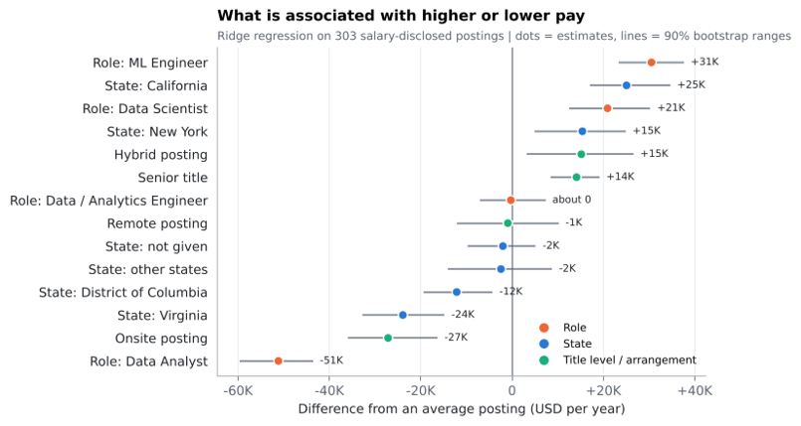
Figure 4: Ridge regression effects on disclosed pay
The results of this mean that role is our strongest factor (Figure 4). ML Engineer titles are associated with approximately $31,000 above an average posting, Data Scientist titles are $21,000 above, and Data Analyst titles with $51,000 below. This displays a gap of about $72,000 to $82,000 between the ends of our pathway. We also see that states such as California (+$25,000) and New York (+$15,000) pay more while Virginia (-$24,000) is paid less. A senior title adds about $28,000 over other titles. We also see that work arrangement effects rest on only 10 onsite & 25 hybrid salaries, so it should not be relied on. The model explains 31% of pay differences with a typical error of around $38,000, comparing factors and does not predict an individual offer.

Role Opportunity Scorecard
An important distinction must be made that pay is only one part of a good opportunity. Here, we scored each role from 0 to 1 on three criteria:
- Pay - role’s median salary divided by highest role median (weight: 40%).
- Accessibility - share of non-senior titles and of postings that do not require or prefer graduate degree (weight: 30%).
- Fit w/ our Team - average self-rating weighted by how often the role’s postings name each skill (weight: 30%).
The evaluation is that a scorecard has no accuracy metric and its weights are our judgement. We then re-ranked the roles under three other weightings:
Weighting | Pay | Accessibility | Fit
Base Weights | 40% | 30% | 30%
Equal | 33% | 33% | 33%
Pay-heavy | 60% | 20% | 20%
Accessibility-and-fit-heavy | 20% | 40% | 40%
Table 7: Scorecard weightings used to test rankings
Role | Postings | With salary | Median salary | Pay | Access | Fit | Score
ML Engineer | 103 | 58 | $220,260 | 1.000 | 0.645 | 0.760 | 0.822
Data Scientist | 211 | 92 | $204,875 | 0.930 | 0.691 | 0.746 | 0.803
Data/Analytics Engineer | 335 | 123 | $175,000 | 0.795 | 0.671 | 0.786 | 0.755
Data Analyst | 116 | 30 | $114,750 | 0.521 | 0.788 | 0.757 | 0.672
Table 8: Role opportunity scorecard
These results tell us that ML Engineer and Data Scientist score highest. Students also face a trade-off based on the scores between ML Engineer paying the most w/ least accessibility, while Data Analyst pays the least but is more accessible. The fit is similar across roles because our rates are fairly even, so pay and accessibility are what is primarily driving the ranking. The roles show steps on one path, which is to start as an analyst, and aim for scientist or ML roles. The ranking is the same under all four weightings (Table 16, Appendix E), so our conclusions do not depend on the weights we chose.

Salary Estimator
The estimator lets a user describe a posting, or their own next step, and see the estimated salary and which single changes are associated with higher pay. Our variables include seven dropdown inputs, years of experience, and checkboxes for the 17 skills.
It is trained on 2,252 salaries from all industries and explains 56% of pay differences with a typical error of about $32,000 (Table 6). It shows a driver only when its 90% range across 150 bootstrap refits excludes zero. It can run in the browser, so nothing a user enters leaves the page. See Appendix G for reference.
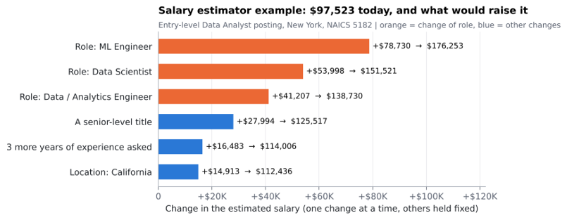
Figure 5: Salary estimator output for an entry-level example
For the entry-level example in Figure 5, the estimate is $97,523. The largest gains come from changing roles (+$54,000 to Data Scientist, +$78,700 to ML Engineer), followed by a senior title (+$28,000), three more years of experience (+$16,500), and a California location (+$14,900). Across the model, each year of experience requested adds about $5,500, and naming Machine Learning adds about $7,800 even after the role is known. Being in NAICS 5182 adds only about $1,700 compared with an otherwise identical posting in another industry, and its range (-$4,200 to +$7,300) includes zero.

Benchmark Against the Whole Market
Across all industries, the median salary is $120,000 for Data Analytics & BI, $160,000 for Data Engineering, and $187,454 for Data Science & ML, the highest of any field and about $50,000 above Software Engineering ($137,500). Within specifically the computer and business fields, AI-related postings have a median of $172,250 against $97,500 for other postings, representing a 77% raw gap that is far larger than the premium of about 8% that research finds for AI-developer skills within the same occupation (Jaumotte et al., 2026), because AI-related postings are typically associated more with senior positions.

Recommendations
- Enter through the analyst toolkit, and show communication. Analyst postings most often name communication (35%), SQL (31%), visualization (21%), and Excel (18%). Build a portfolio project that answers a business question with SQL and presents it in a dashboard with a short written summary.
- Make Machine Learning and Python the bridge. Scientist and ML postings name them in 68% and 54% of cases, and Machine Learning is the skill most clearly associated with higher pay once role is known. On its own, Machine Learning adds about $7,800 once the role is known; the larger gain comes from moving into a role that expects it. Complete a supervised-learning project in Python that explains its evaluation and limitations.
- Add cloud and pipeline skills for this industry. Cloud/AWS appears in 28% of scientist postings and 55% of engineer postings, and ETL in 68% of engineer postings. A cloud certification and one analysis run on a cloud platform signal fit with these employers, and Data / Analytics Engineer roles (median $175,000) are a second route up the pathway.
- Build documented experience early. Only about 17% of postings with a stated requirement ask for two years or fewer, which matches research showing that employment of young workers in AI-exposed jobs has fallen behind their peers (Brynjolfsson et al., 2026). The median posting asks for five years, and each additional year requested is associated with about $5,500 more. Internships, research, and projects count most when they are documented in a portfolio.
- Choose locations deliberately. California and New York offer the most postings and the highest disclosed pay; Virginia, the District of Columbia, and Maryland offer federal-contractor roles at lower pay. Only 10% of postings say they are remote.
- Apply without the listed graduate degree. Only 11 of 570 postings with text state a Master’s as required and 4 a PhD. Lead with skills and project evidence.
For career advisors, the website’s salary estimator and Final Recommendations page can be used directly in advising sessions, and the build scripts can refresh the product with each new release of the job files.

Limitations
- Small samples. There are 303 disclosed salaries, only 30 for Data Analyst postings, so close roles cannot be reliably separated.
- Text-based measures. Posting text exists for 570 of 765 postings, and skills and degrees are matched by name patterns, so the shares are lower bounds.
- Posted pay. Posted ranges are not accepted offers, and disclosure is concentrated in California and New York.
- Labels and coding. Role and seniority come from job titles, and the industry code is assigned by the data provider, so some employers outside traditional hosting appear in NAICS 5182.
- Judgment. Skill ratings are self-reported by three people, and the scorecard weights and the Advanced target are our choices.
- Associations and one period. The models describe patterns in 2026 postings, not causes, and cannot show trends over time.
Future versions should add a quarterly data refresh with trends, a comparison with Bureau of Labor Statistics wages by state, a manual check of the skill patterns on a sample of postings, and an input that lets each user enter their own skill ratings.

Conclusion
 | Research Question (RQ) | Answer
Product Question | Which skills separate the two ends of the pathway, and how should a job seeker prioritize? | Machine Learning, Python, Deep Learning, and cloud skills define the scientist end; communication, SQL, visualization, and Excel define the analyst end. Learn the analyst toolkit first, then Machine Learning and Python, then cloud skills.
RQ1 | What does the market look like: role, mix, pay, location, experience, education, and work arrangement? | Technical & mid-career.  California and New York lead on volume and pay. And most postings do not state a work arrangement.
RQ2 | Which skills separate analyst postings from scientist and ML postings, and where are our team’s gaps? | Machine Learning and Statistics for the team. Python, Cloud/AWS, SQL, and visualization for individual members.
RQ3 | Which factors are associated with higher pay, and which role offers the best mix of pay, accessibility, and fit? | First role, then seniority, location, and experience. Industry adds little. ML Engineer and Data Scientist score highest. Finally, Data Analyst is most accessible.
RQ4 | What should a job seeker learn first, and where should they apply? | Enter as an analyst, bridge with Machine Learning and Python, add cloud skills, document experience early, and target California and New York.
Table 9: Answers to Product Question & Research Questions
Throughout this process we have seen that the path from starting as a Data Analyst to transitioning towards becoming a Data Scientist in this industry is both highly valuable and demanding. The pay difference we saw went up to $90,000 at the median, and it is earned primarily by changing roles. The skills that make the change possible are concrete and attainable, but can be time consuming as the market expects about five years of experience. Any student or jobseeker who plans the path as a sequence can utilize this product to help decide where they want to apply and what their learning focuses should be on.

References
Brynjolfsson, E., Chandar, B., & Chen, R. (2026). Canaries in the coal mine? Six facts about the recent employment effects of artificial intelligence. Stanford Digital Economy Lab. https://digitaleconomy.stanford.edu/publication/canaries-in-the-coal-mine-six-facts-about-the-recent-employment-effects-of-artificial-intelligence/
Deming, D., & Kahn, L. B. (2018). Skill requirements across firms and labor markets: Evidence from job postings for professionals. Journal of Labor Economics, 36(S1), S337–S369. https://doi.org/10.1086/694106
Federal Reserve Bank of St. Louis. (2026). All employees, computing infrastructure providers, data processing, web hosting, and related services. https://fred.stlouisfed.org/series/CES5051800001
Jaumotte, F., Kim, J., Koll, D., Li, E. Z., Li, L., Melina, G., Song, A., & Tavares, M. M. (2026). Bridging skill gaps for the future: New jobs creation in the AI age. International Monetary Fund. https://www.imf.org/-/media/files/publications/sdn/2026/english/sdnea2026001.pdf
Magnet, S. (2026, April 24). Data analyst job outlook 2026 [Research on 1,000 job postings]. 365 Data Science. https://365datascience.com/career-advice/data-analyst-job-outlook-2025/
New York State Department of Labor. (2023). Pay transparency law for employers (P687). https://dol.ny.gov/pay-transparency-law-employers-p687
PwC. (2026, June 15). AI reshapes global labour market into two distinct paths, rewarding human skills: PwC 2026 Global AI Jobs Barometer. https://www.pwc.com/gx/en/news-room/press-releases/2026/pwc-2026-ai-jobs-barometer.html
Shrivastava, A. (2025, July 2). Pay transparency across high-earning sectors. Indeed Newsroom. https://www.indeed.com/news/releases/pay-transparency-across-high-earning-sectors
Tate, D., Okamoto, W. T., & Ebbink, B. M. (2022, September 30). California requires pay range in job postings. SHRM. https://www.shrm.org/topics-tools/employment-law-compliance/california-requires-pay-range-job-postings
U.S. Bureau of Labor Statistics. (2026, August 27). Data scientists Occupational outlook handbook. U.S. Department of Labor. https://www.bls.gov/ooh/math/data-scientists.htm

Appendix A - Team Contributions
Member | Main Contributions
Manan Patel | Repository and website setup; data preparation, exploratory analysis, benchmark analysis, skill gap analysis, predictive modeling
Michael Phillips | Final presentation, edits on skill-gap & benchmark analysis
Richard Park | Final Paper, Final presentation, exploratory analysis
Table 10: Team Contributions

Appendix B - Data Dictionary
The main analytical file is data/processed/met_text_panel.csv, with one row per distinct posting (765 rows). Posting text is not stored. The skill and degree flags were computed from it when the file was built. The repository file data/processed/data_dictionary.md also documents the estimator panel and the benchmark tables.
Variable | Description
job_id | Posting ID from the source files
title | Cleaned job title
role | Role family assigned from the title
company_name,  company_name_clean | Employer as given, and with web domains mapped to the employer. Job-board listings and blank names become Unknown employer (27 rows)
state | U.S. state resolved from the state and location fields. Empty when it cannot be resolved (653 rows have one)
remote_status | Remote, Hybrid, Onsite, or Unknown (empty or Unknown in 586 rows)
employment_type | Employment type as given in the source
salary_min_annual,  salary_max_annual | Annual salary range in USD. Empty when not disclosed or for internships (303 rows have one)
posted_at | Posting date, January 2 to September 30, 2026
has_text | True when the source has posting text (570 rows). Flags below are empty otherwise
experience_min_years,  experience_source | Minimum years of experience, from the structured field when it is above zero (77 rows) or read from the text (129 rows)
skill_<name> | True when the posting text matches the skill’s name pattern (17 skills)
degree_<level> | For Associate, Bachelor, Master, and PhD: required, preferred, mentioned (named without requirement wording), or none
Table 11: Variables in main analytical file

Appendix C - Classification Rules
Pathway title keywords (12): data scientist, data engineer, machine learning engineer, ml engineer, data analyst, business analyst, bi analyst, business intelligence analyst, analytics engineer, applied scientist, data architect, database architect.
Role families, checked in this order (the first match wins): ML Engineer: machine learning engineer or ML engineer. Data Scientist: data scientist or applied scientist. Data / Analytics Engineer: data engineer, analytics engineer, data architect, or database architect. Data Analyst: data analyst, business analyst, BI analyst, or business intelligence analyst.
Senior title words: senior, sr, staff, principal, lead, manager, director, head of, architect.
Repeat listings. A posting is dropped when another posting has the same title, company, state, and date.
Salary. Zero means not disclosed: Values under $1,000 are treated as hourly and multiplied by 2,080 hours. Internship titles are treated as not disclosed. Analyses use the midpoint of the range.
Experience: The structured minimum-years field when it is above zero; otherwise the smallest number of years, from 1 to 20, that the text ties to the word experience (for example, “5+ years of experience”).
Skill | Matched text (case ignored)
Python | python
SQL | sql, structured query
Machine Learning | machine learning, ML
Cloud/AWS | AWS, Amazon Web Services, Azure, Google Cloud, GCP, cloud computing
Data Visualization | data visualization, Tableau, Power BI, Looker, Qlik
Statistics | statistic (statistics, statistical)
Tableau, Power BI, Excel, Snowflake, Java | the tool name
Spark | Spark, PySpark
ETL | ETL, ELT, data pipeline
Communication | communicat (communication, communicate)
Dashboards | dashboard
Data Modeling | data model
Deep Learning | deep learning, neural network, LLM, generative AI
Table 12: Skill name patterns used to read posting text
Degree wording. Each sentence that names a degree level is checked. It counts as preferred if it says prefer, a plus, nice to have, desired, desirable, bonus, or ideal; otherwise as required if it says require, minimum, must, mandatory, or necessary; otherwise as mentioned. A posting keeps the strongest label found.
AI-related posting (benchmark only). The title names AI or artificial intelligence, machine learning or ML, deep learning, NLP or natural language, LLM, generative or gen AI, computer vision, neural, prompt engineer, or MLOps, or the text names machine learning, artificial intelligence, deep learning, neural networks, natural language processing, NLP, LLM, large language models, generative AI, computer vision, PyTorch, or TensorFlow.

Appendix D - Model Specifications and Full Results
 | Salary Regression | Salary Estimator
Data | 303 NAICS 5182 postings with a disclosed salary | 2,252 pathway postings from all industries with a salary and posting text (155 in NAICS 5182). Midpoints from $30,000 to $500,000
Target | Midpoint of the posted annual range | Midpoint of the posted annual range
Inputs | Role family, title level, state group (California, New York, Virginia, District of Columbia, other states, not given), work arrangement | Role family, title level, 10 most common states plus other and not given, work arrangement, employment type, industry, highest degree named, years of experience and whether it is stated, 17 skill flags
Model | Ridge regression (penalty 3.0) on one-hot inputs; random forest (300 trees, at least 3 postings per leaf) for comparison | Ridge regression (penalty 10.0)
Evaluation | 5-fold cross-validation repeated 5 times, against a median baseline | 5-fold cross-validation repeated 3 times, against a median baseline
Uncertainty | 90% range from 400 bootstrap refits | 150 bootstrap refits. A driver is shown only when its 90% range excludes zero
Table 13: Specification of the two salary models
Input | Effect (USD per year) | 90% bootstrap range
Role: ML Engineer | +30,530 | +23,295 to +37,634
Role: Data Scientist | +20,910 | +12,504 to +30,271
Role: Data / Analytics Engineer | -259 | -7,118 to +7,338
Role: Data Analyst | -51,181 | -59,700 to -43,575
Senior title | +14,119 | +8,458 to +19,147
Other title | -14,119 | -19,147 to -8,458
State: California | +25,067 | +17,033 to +34,662
State: New York | +15,398 | +4,960 to +24,890
State: other states | -2,426 | -14,139 to +8,799
State: not given | -2,001 | -9,731 to +5,194
State: District of Columbia | -12,126 | -19,437 to -4,276
State: Virginia | -23,912 | -32,800 to -14,797
Hybrid | +15,176 | +3,220 to +26,589
Arrangement not stated | +12,900 | +5,456 to +20,968
Remote | -922 | -12,048 to +10,204
Onsite | -27,154 | -35,974 to -16,312
Table 14: Salary regression effects relative to an average posting (303 postings)

Appendix E - Scorecard Calculation and Sensitivity
Each criterion is scaled from 0 to 1. Pay is the role’s median disclosed salary divided by the highest role median (ML Engineer, $220,260). Accessibility is the average of two shares: postings whose title has no senior word, and postings with text that do not require or prefer a Master’s or PhD. Fit is the team’s average self-rating in each of the six skill areas, weighted by the share of the role’s postings that name the skill, divided by 5.
Role | Non-senior titles | No graduate degree required or preferred | Accessibility
ML Engineer | 37.9% | 91.2% | 0.645
Data Scientist | 46.9% | 91.2% | 0.691
Data / Analytics Engineer | 37.0% | 97.2% | 0.671
Data Analyst | 64.7% | 92.9% | 0.788
Table 15: Inputs to accessibility score
Role | Base (40/30/30) | Equal | Pay-heavy (60/20/20) | Access-and-fit-heavy (20/40/40)
ML Engineer | 0.822 (1) | 0.802 (1) | 0.881 (1) | 0.762 (1)
Data Scientist | 0.803 (2) | 0.789 (2) | 0.845 (2) | 0.761 (2)
Data / Analytics Engineer | 0.755 (3) | 0.750 (3) | 0.768 (3) | 0.742 (3)
Data Analyst | 0.672 (4) | 0.689 (4) | 0.622 (4) | 0.722 (4)
Table 16: Opportunity score and rank under four weightings of pay, accessibility, and fit
The ranking stays the same under all four weightings, but the gaps change (Table 16, Appendix E). When accessibility and fit carry more weight, ML Engineer and Data Scientist are less than 0.002 apart and Data Analyst comes within about 0.04 of the top. That is why we treat the top two as tied and present Data Analyst as the entry point.

Appendix F - Reproducibility
From the repository root, the commands in Table 17 rebuild every processed file, the website, and this report, in the order shown. The course Jobs_2026 folder is downloaded beside the repository first.
The repository stores only processed files: no raw postings, no posting text, and no API keys. The API key used for course data is kept in a local .env file excluded by .gitignore, and only .env.example, with the key left blank, is committed.
Command | What it builds
python build_met_text_panel.py ../Jobs_2026 | NAICS 5182 panel (765 postings)
python build_met_text_panel.py ../Jobs_2026 --all-industries | Salary estimator panel
python build_benchmark_tables.py ../Jobs_2026 | Benchmark summary tables
quarto render | Website
python build_report_figures.py | Report figures
quarto render final_report.qmd --to docx | This report
python polish_docx.py _site/final_report.docx | Keeps each table and figure on one page
Table 17: Commands that rebuild our product

Appendix G - Product Website
Page | Visual Display | Interactive Features
Home | Product vision, product question, roadmap | None
Project Overview | Problem, rationale, literature review, industry and pathway documentation, data fields | None
Data Preparation | Source data, industry, date, and title filters, repeat removal, cleaning of each variable, supporting datasets | None
Exploratory Analysis | Job volume, salary, location, experience, education, work arrangement, and top employers | 12 charts with hover details and zoom
Benchmark Analysis | AI-related against other postings, data fields against neighboring fields, demand against pay | 3 charts with hover details
Skill Gap Analysis | Team ratings, market demand by role, comparison, improvement plan | 4 charts with hover details
Predictive Modeling | Salary regression, opportunity scorecard, salary estimator | 4 charts & an estimator with 7 dropdowns, an experience field, and 17 skill checkboxes
Final Recommendations | Recommendations, a three-step plan, and the four roles at a glance | Chart with a target-role dropdown that reorders the skills by gap
Table 18: Website pages
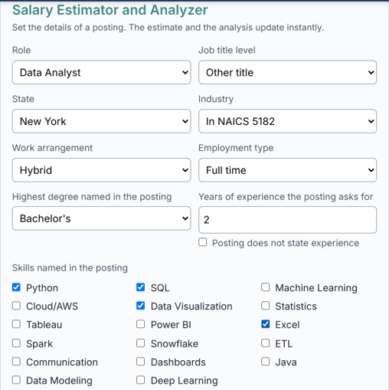
Figure 6: Salary estimator inputs on the Predictive Modeling page, set to the example profile.

