 | GUJARAT TECHNOLOGICAL UNIVERSITY  Chandkheda, Ahmedabad  Affiliated | 

SAL EDUCATION CAMPUS

SAL Engineering and Technical Institute

“Pink Tax: A Data-Driven Analysis of Gender-Based Price Differences in Indian Online Retail”

A Report

Submitted By

Kanishka Shah | 231260131051

Under Subject of

SUMMER INTERNSHIP (3170001)

Of

BACHELOR OF ENGINEERING

In

Computer Science & Engineering

Under the guidance of

Prof. Himani Patel

Academic Year
2026-27

ATTACH THE CERTIFICATE DOWNLOADED FROM PMMS

ATTACH THE CERTIFICATE HERE FROM THE COMPANY/AGENCY (for the
ONLINE/OFFLINE INTERNSHIP only)
SAL ENGINEERING AND TECHNICAL INSTITUTE
COMPUTER SCIENCE & ENGINEERING
2026

CERTIFICATE

Date:

This is to certify that the “Pink Tax: A Data-Driven Analysis of Gender-Based Price Differences in Indian Online Retail” has been carried out by Kanishka Shah (231260131051) under my guidance in completion of Summer Internship in Computer Science & Engineering Branch, 7th Semester of Gujarat Technological University, Ahmedabad during the academic Year 2026-27.

Prof. Himani Patel | Dr. Madhuri Parekh
Internal Guide | Head of Department
Computer Science & Engineering | CE, CSE, IT & ICT Department
SETI | SETI

ABSTRACT

The “Pink Tax” is more than a pricing issue. It raises a simple question: do products marketed to women actually cost more than comparable products marketed to men? This project uses data analysis to investigate gender-based price differences across everyday consumer products sold online in India. It compares similar items across categories, brands and product types, and all prices are in Indian Rupees (₹).
Three public Kaggle datasets were combined: product listings from Myntra (fashion, footwear and accessories), BigBasket (beauty and hygiene) and Amazon.in (personal care). After cleaning, de-duplication, outlier removal and tagging each product by its target gender using product URLs and English and Hindi keywords, the final dataset contained 79,390 products from 2,769 brands in 44 comparable categories. The analysis was done in Python (Pandas, NumPy, SciPy, Statsmodels, scikit-learn, Matplotlib, Seaborn and Plotly) on Google Colab, with an Excel workbook and a Power BI dashboard for reporting.
The prices were examined through four lenses of increasing strictness. The first compared women's and men's prices within each category using non-parametric tests with bootstrap confidence intervals and false-discovery-rate correction. The second compared price per 100 ml for liquids. The third compared 860 brand-matched pairs, where the same brand sells a men's and a women's version in the same category. The fourth was a fixed-effects regression that controls for brand and category.
The results show that there is no blanket Pink Tax in Indian online retail. Women paid significantly more in only 4 of 44 categories, while men paid more in 22. Within the same brand, the women's version was dearer in 27% of pairs and the men's version in 54%, and the typical gap was −5.9%. Personal-care liquids showed no significant difference per 100 ml. The Pink Tax does, however, appear consistently in specific pockets: girls' night suits (+78%), innerwear (+33%), kids' clothing sets (+11%) and women's sports shoes (+5%). Women's deodorants on BigBasket also cost 17% more at the selling price because they are discounted less. Much of the gap comes from brand mix and product differentiation rather than a uniform surcharge. The practical lesson for consumers is to compare unit prices and to look across the gender aisle.
Keywords: Pink Tax, gender-based pricing, price discrimination, e-commerce, hypothesis testing, fixed-effects regression, data analytics, Python, Power BI.

Introduction

The term Pink Tax describes the extra amount women are said to pay for products and services that are marketed to them, when an almost identical version marketed to men costs less. A razor in pink packaging, a “for her” deodorant or a girl's T-shirt may cost more than its male counterpart even when the materials and function are the same. Unlike a real tax, the money does not go to the government. It is a price difference created by marketing and pricing decisions.
The issue became widely known after a 1994 study by the California Assembly, which led to the Gender Tax Repeal Act of 1995 for services. The best-known study of goods is the New York City Department of Consumer Affairs report From Cradle to Cane (2015). It compared nearly 800 products with clear male and female versions and found that women's products cost about 7% more on average, and 13% more for personal-care products. Later work has been more cautious. The U.S. Government Accountability Office (2018) found higher prices for women in 5 of 10 personal-care categories but could not attribute them to gender bias alone. Moshary, Tuchman and Bhatia (2021) found no systematic premium when truly identical products were compared.
In India, public debate has focused mainly on the “tampon tax”, which ended when sanitary napkins were exempted from GST in July 2018. Gender-based pricing of everyday goods has received far less data-driven attention, even though online retail now makes it possible to observe the prices of tens of thousands of products at once.
This project fills that gap with a reproducible data-analysis pipeline. It collects real product listings from three Indian e-commerce platforms, labels each product as targeted at women or men, and uses statistical tests, matched comparisons and regression to measure where the Pink Tax exists, how large it is and what explains it. The work was carried out during a 15-day summer internship. Chapter 1 introduces the internship, its aims and the tools used. Chapter 2 records the day-by-day activities and learning, and Chapter 3 presents the conclusions.

Contents
Abstract I
Introduction II
Contents III
Chapter 1: Introduction 1
1.1 Introduction of Summer Internship 1
1.2 Aim & Objective 1
1.3 Tools & Technology used during Internship 2
1.4 Dataset Description 2
Chapter 2: What I Learned during Internship 3
Day-1: Orientation and Understanding the Pink Tax 3
Day-2: Setting up the Development Environment 4
Day-3: Python Refresher – NumPy and Pandas 5
Day-4: Data Sourcing from Kaggle 6
Day-5: Data Understanding and Profiling 7
Day-6: Data Cleaning 8
Day-7: Feature Engineering – Gender, Category and Unit Price 9
Day-8: Exploratory Data Analysis (EDA) 10
Day-9: Data Visualisation with Matplotlib, Seaborn and Plotly 11
Day-10: Hypothesis Testing Across 44 Categories 13
Day-11: Comparing Like with Like – Unit Price and Brand-Matched Pairs 14
Day-12: Regression with Fixed Effects (Statsmodels) 16
Day-13: Discount Analysis and Machine Learning (scikit-learn) 18
Day-14: Excel Workbook – Formulas, Pivot Summaries and Charts 20
Day-15: Power BI Dashboard, GitHub Publishing and Report 22
Chapter 3: Conclusion 23
3.1 Summary of Findings 23
3.2 What I Learned from the Internship 23
3.3 Limitations and Future Scope 24
References 25

Chapter 1: Introduction

1.1 Introduction of Summer Internship
The summer internship was a 15-day, project-based programme in data analytics. Its purpose was to take a real-world question from idea to evidence: finding and understanding data, cleaning and transforming it, analysing it with statistics, and communicating the results through charts, spreadsheets and dashboards. The work was organised as a single end-to-end project, the Pink Tax in Indian online retail, so that every new skill was applied straight away to the same dataset.
The internship was divided into four phases:
- Foundations (Days 1–3): problem understanding, literature review, setting up Python, Google Colab and GitHub, and revising NumPy and Pandas.
- Data engineering (Days 4–7): sourcing data from Kaggle, profiling it, cleaning it and engineering features such as gender, category and price per 100 ml.
- Analysis (Days 8–13): exploratory analysis, visualisation, hypothesis testing, brand-matched comparison, regression and a machine-learning check.
- Reporting (Days 14–15): an Excel workbook with live formulas, a Power BI dashboard, the GitHub repository and this report.

Each day ended with a short log of what was done, what was learned and what problems came up. Chapter 2 is based on these logs.

1.2 Aim & Objective
Aim: to find out, using real data and sound statistical methods, whether products marketed to women in India cost more than comparable products marketed to men, and where any such Pink Tax appears most consistently.
Objectives
- Build a clean, gender-tagged dataset of Indian consumer products from public sources.
- Compare women's and men's prices within each product category and test whether the differences are statistically significant.
- Compare like with like: price per 100 ml for liquids, and the same brand's men's and women's lines.
- Separate a true gender premium from brand and category effects using regression.
- Check whether discounts change the gap between the list price (MRP) and the price actually paid.
- Present the results in a Colab notebook, an Excel workbook and a Power BI dashboard, and publish the project on GitHub.

Research questions and hypotheses
- RQ1: Within a product category, do women's products have higher prices than men's?
- RQ2: Does the gap survive when unit price, brand and category are held constant?
- RQ3: In which categories does the Pink Tax appear most consistently?
- H₀: the price distributions of women's and men's products are the same. H₁: they differ. The significance level is α = 0.05, with a false-discovery-rate correction.

1.3 Tools & Technology used during Internship
Table 1.1: Tools and technologies used
Tool / Library | Purpose in this project
Python 3.11 with Google Colab / Jupyter | Main language and notebooks for the complete, reproducible data pipeline
NumPy and Pandas | Numerical operations, bootstrap resampling; loading, cleaning, grouping and pivoting data
Regular expressions (re) | Extracting gender, category and pack size from product titles and URLs
Matplotlib, Seaborn and Plotly | Publication-quality static charts and an interactive chart with hover details
SciPy and Statsmodels | Mann-Whitney, Welch, Wilcoxon and chi-square tests; OLS / fixed-effects regression, FDR correction
scikit-learn | Random-forest price model, target encoding, permutation importance
Microsoft Excel and OpenPyXL | Workbook with COUNTIFS / AVERAGEIFS summaries, pivot-style tables, conditional formatting
Power BI | Star-schema data model, DAX measures and an interactive dashboard
Git, GitHub and Kaggle | Version control, publishing (github.com/mppyxx/PinkTax) and the data source

1.4 Dataset Description
All data came from public Kaggle datasets, and every price is in Indian Rupees. The MRP (maximum retail price) is the list price printed by the brand. The selling price is the price after the platform's discount.
Table 1.2: Datasets used
Source | Raw size | Used | Content
Myntra (2023) | 168,029 × 13 | 72,771 | Apparel, footwear, accessories, perfume; men, women, boys, girls
BigBasket (2022) | 27,555 × 10 | 736 | Beauty & hygiene: deodorants and perfumes
Amazon.in (2023) | 1,589,160 × 11 | 5,883 | Personal care: deodorant, perfume, razor, trimmer, washes, shampoo
Total |  | 79,390 | 44 categories, 2,769 brands; adults: 46,022 men's and 28,906 women's items; kids: 4,462 items

Chapter 2: What I Learned during Internship

Day-1: Orientation and Understanding the Pink Tax
Objective: understand the problem, review earlier research and turn a broad idea into questions that can be tested.
Activities performed
- Attended the orientation session and discussed the project scope: an end-to-end data analytics study of gender-based pricing.
- Read the NYC Department of Consumer Affairs study From Cradle to Cane (2015). Women's products cost 7% more on average, and 13% more for personal care.
- Read the U.S. GAO report (2018) and the paper by Moshary et al. (2021), which argue that many gaps disappear when truly identical products are compared.
- Wrote down the research questions (RQ1–RQ3) and the null and alternative hypotheses.
- Planned the workflow shown in Figure 2.1.

Learning outcome
Good analysis starts with a precise question. “Do women pay more?” is too vague. “Within the same category and brand, is the women's version priced higher?” can be tested. I also learned the difference between the Pink Tax (a price gap between gendered versions of a product) and the tampon tax (a sales tax on menstrual products, removed in India in 2018).
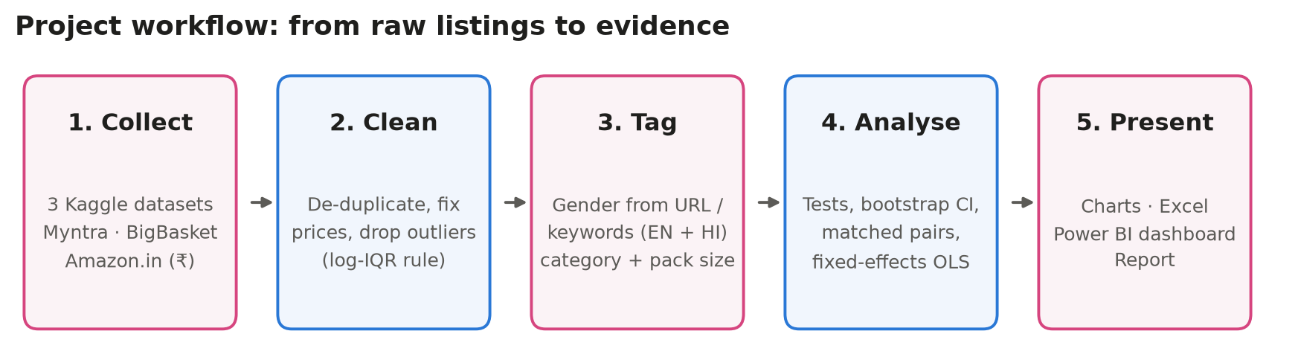
Figure 2.1: Project workflow planned on Day 1

Day-2: Setting up the Development Environment
Objective: prepare a reproducible working environment for the project.
Activities performed
- Set up Google Colab and a local Jupyter environment, and learned the difference between a hosted runtime and a local kernel.
- Installed and imported the main libraries: NumPy, Pandas, Matplotlib, Seaborn, Plotly, SciPy, Statsmodels, scikit-learn and OpenPyXL. Recorded their versions in requirements.txt.
- Created the GitHub repository PinkTax and a clear folder structure: src/, data/, notebooks/, outputs/, excel/, powerbi/ and report/.
- Learned basic Git commands (clone, add, commit, push) and wrote a .gitignore so that large raw files are not uploaded.
- Wrote config.py to keep all paths and chart colours in one place.

Learning outcome
A project is only useful if someone else can run it. Keeping the code in numbered scripts (01_download_data.py … 07_powerbi_export.py) and the settings in one configuration file means the whole analysis can be reproduced with a few commands, locally or in Colab.
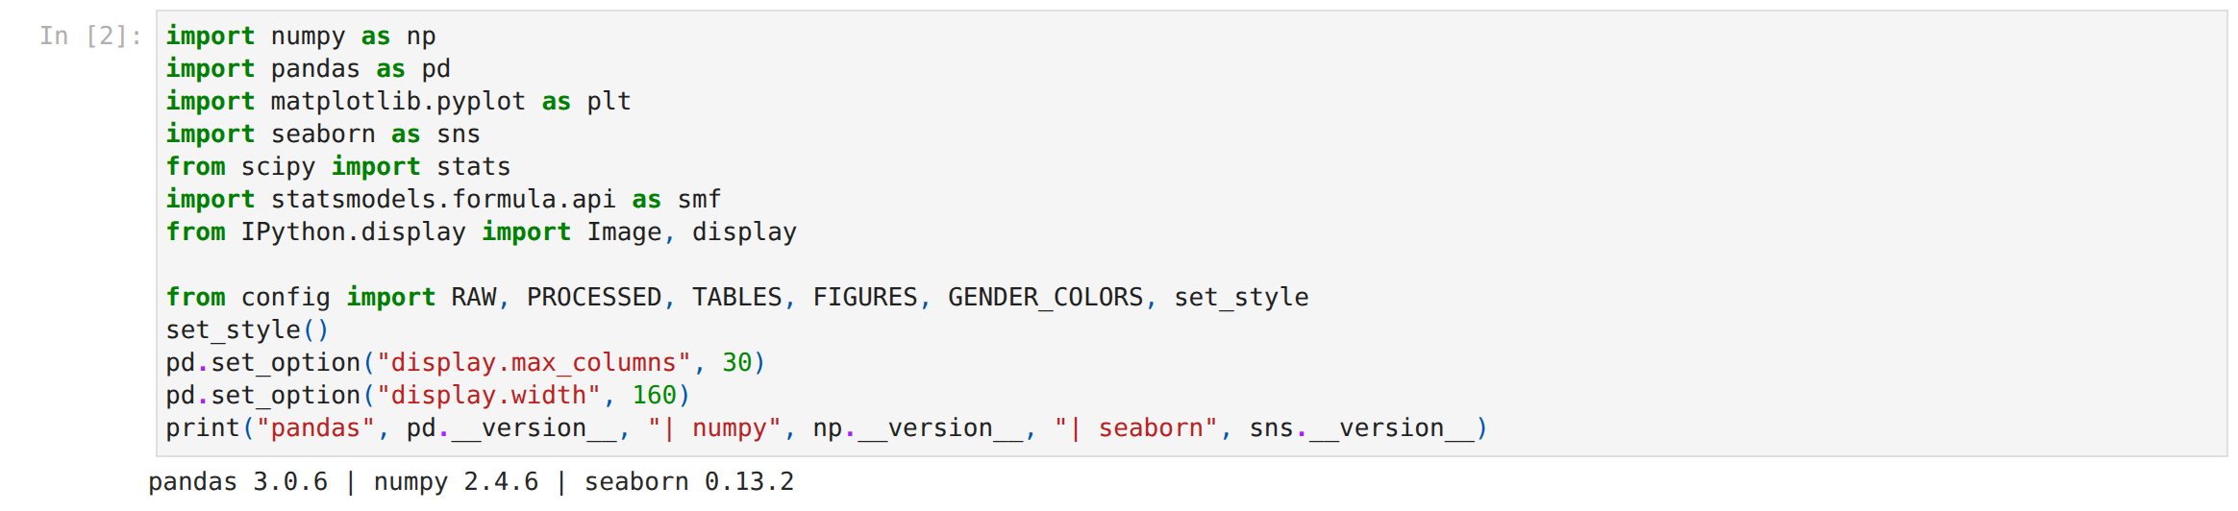
Figure 2.2: Importing the analysis libraries in the Colab notebook
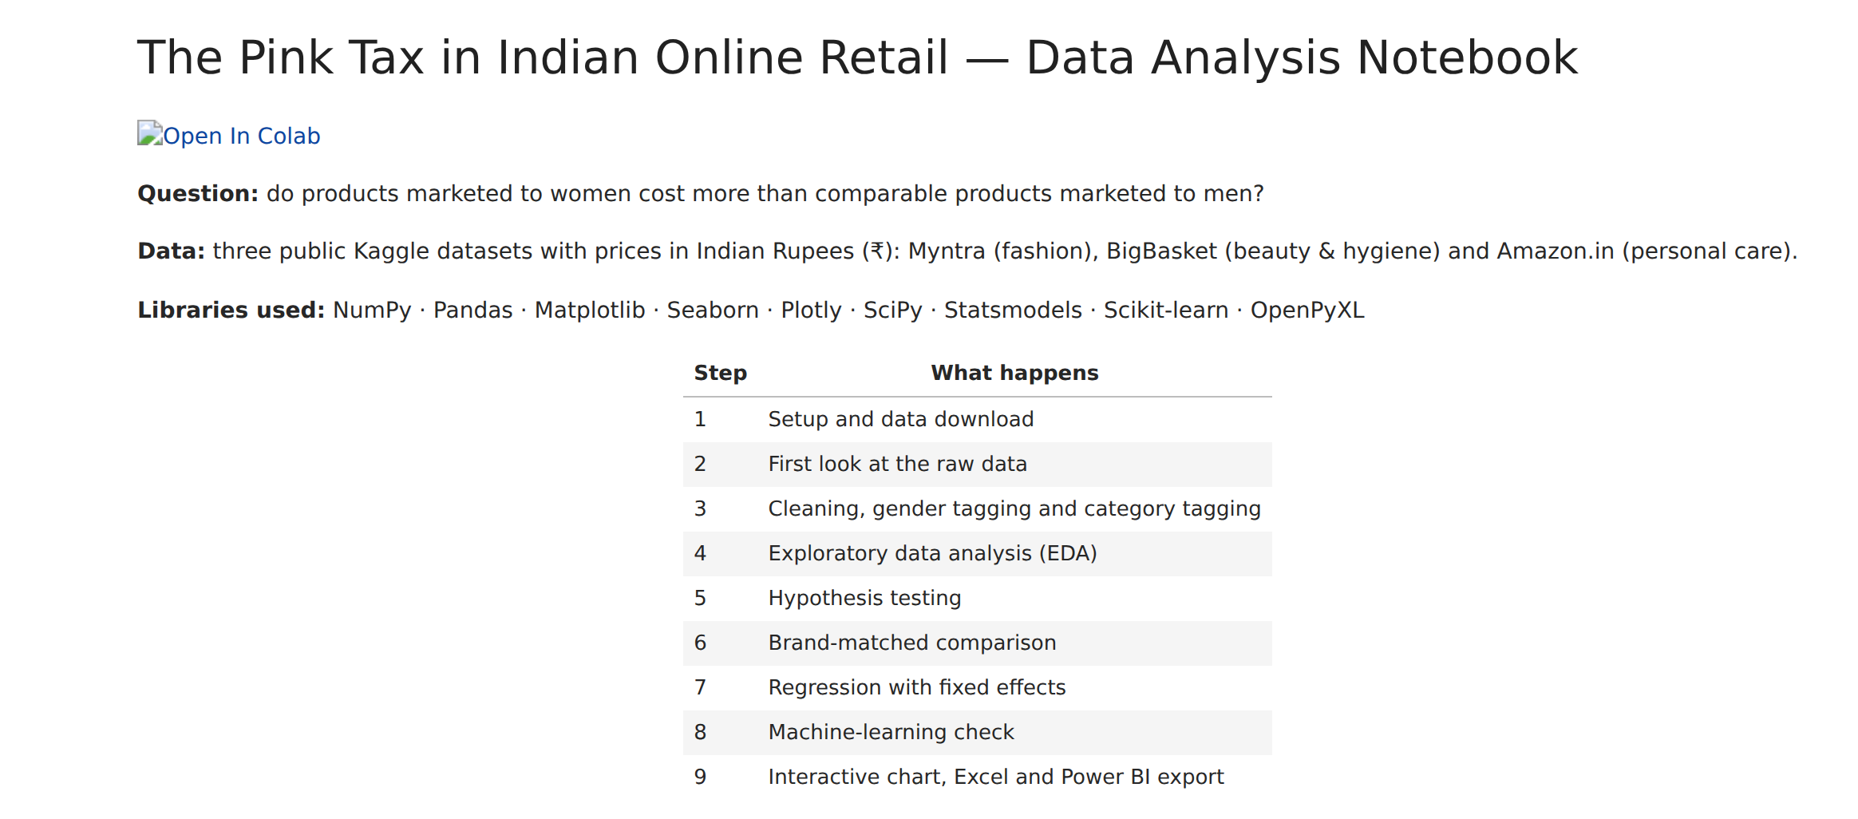
Figure 2.3: Notebook overview with the Open-in-Colab link

Day-3: Python Refresher – NumPy and Pandas
Objective: strengthen the Python data-handling skills needed for the project.
Activities performed
- Revised NumPy arrays, vectorised operations, broadcasting and random number generation, which are used later for bootstrapping.
- Practised Pandas: Series and DataFrame, loc/iloc indexing, boolean filtering, groupby, agg, pivot_table, merge and concat.
- Learned the .str accessor for text columns: contains, extract, replace and split.
- Practised regular expressions such as -(men|women|boys|girls)-, which later pulled the gender out of Myntra product URLs.
- Solved small exercises: average price per brand, the most expensive category, and the share of discounted items.

Learning outcome
Vectorised Pandas code is much faster and clearer than Python loops. Filtering about 1.6 million Amazon rows took seconds with boolean masks. Regular expressions are a powerful tool for turning free text into structured features.
Table 2.1: Pandas operations practised and where they were used
Operation | Used for
read_csv, info, describe | Loading and profiling the raw files
str.extract / str.contains | Gender and category tagging, pack-size extraction
drop_duplicates, dropna | Cleaning
groupby + agg / transform | Category medians, outlier limits, fixed effects
pivot_table, crosstab | Summary tables and brand-matched pairs

Day-4: Data Sourcing from Kaggle
Objective: find public datasets with real Indian prices that can be tagged by gender.
Activities performed
- Searched Kaggle for “pink tax”, “gender price”, Myntra, Nykaa, BigBasket, Flipkart and Amazon India. No ready-made Pink Tax dataset exists, so product catalogues had to be used.
- Evaluated candidates against four criteria: prices in ₹, a way to identify the target gender, enough products per category, and a clear licence and source.
- Selected three datasets: Myntra 168k products, the BigBasket product list and Amazon India products 2023 (1.5 million listings).
- Wrote 01_download_data.py to download and unzip the files automatically through the Kaggle API, so that the download is reproducible.
- Loaded the files and checked their shapes and columns (Figure 2.4).

Learning outcome
In real projects the perfect dataset rarely exists. The skill is to combine sources that each answer part of the question. Myntra covers fashion with gender in the URL, BigBasket labels men's and women's deodorants, and Amazon titles include pack sizes for unit-price comparison.
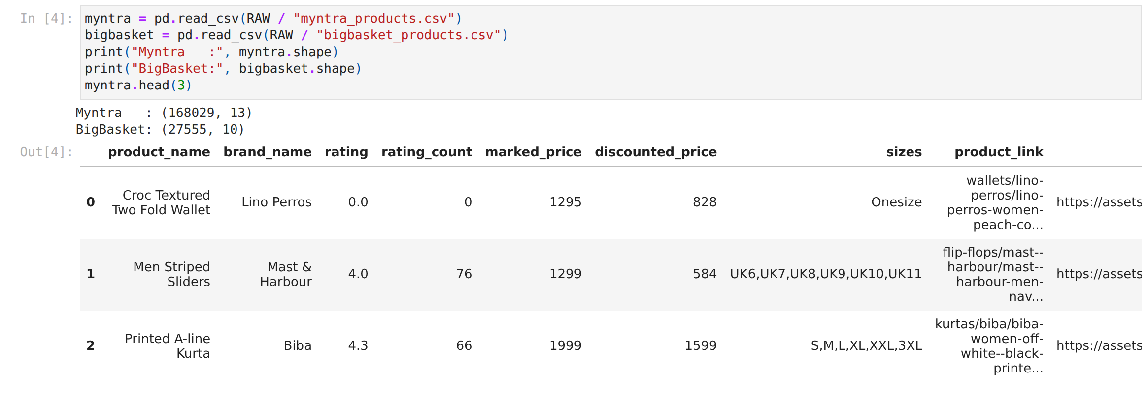
Figure 2.4: Loading the raw Myntra and BigBasket files with Pandas

Day-5: Data Understanding and Profiling
Objective: understand what each column means, how the data is stored and what quality problems exist.
Activities performed
- Used info(), describe() and value_counts() to check data types, missing values and distributions.
- Found where the gender is stored in each source: in the product URL for Myntra, in the product type for BigBasket and only in the title for Amazon.
- Found that most Amazon titles are in Hindi (for example “पुरुषों के लिए” means “for men”), so English-only keywords would miss most products.
- Noted quality issues: zero list prices, duplicate listings, unisex and combo packs, and extreme prices.
- Decided to use MRP as the main price and the selling price as a second measure.

Learning outcome
Profiling before cleaning saves time. Checking gender labels on Myntra showed 58,436 women's, 53,615 men's, 4,671 girls' and 4,209 boys' products, plus 43,823 without a gender tag. That told me how much usable data there was before writing any cleaning code.
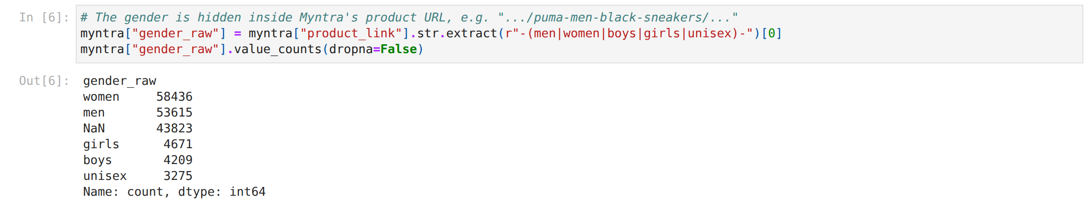
Figure 2.5: Extracting the target gender from Myntra product URLs using a regular expression

Day-6: Data Cleaning
Objective: turn the raw files into a reliable, analysis-ready table.
Activities performed
- Removed duplicate listings using product links, ASINs, or name + brand + price.
- Dropped products with zero or missing prices, and capped the selling price at the MRP.
- Removed unisex, “men and women”, couple and multipack products, because they have no single target gender.
- Kept only categories with at least 15 products for each gender, so that every comparison is between genuine alternatives.
- Removed outliers beyond 3 × IQR on the log price within each category, a rule that suits right-skewed prices.
- Recorded every step in a cleaning log (Table 2.2).

Table 2.2: Cleaning log
Step | Rows remaining
Products in scope (Myntra 72,914 + BigBasket 7,273 + Amazon 62,078) | 142,265
After gender and category tagging | 80,008
After removing zero or missing prices | 79,817
After keeping comparable categories (≥ 15 per gender) | 79,553
After log-IQR outlier removal and final de-duplication | 79,390

Learning outcome
Every cleaning rule is a decision that can change the result, so each rule must be justified and documented. Using the log scale for outliers was important. A normal IQR rule on raw prices would have removed many genuine premium products.
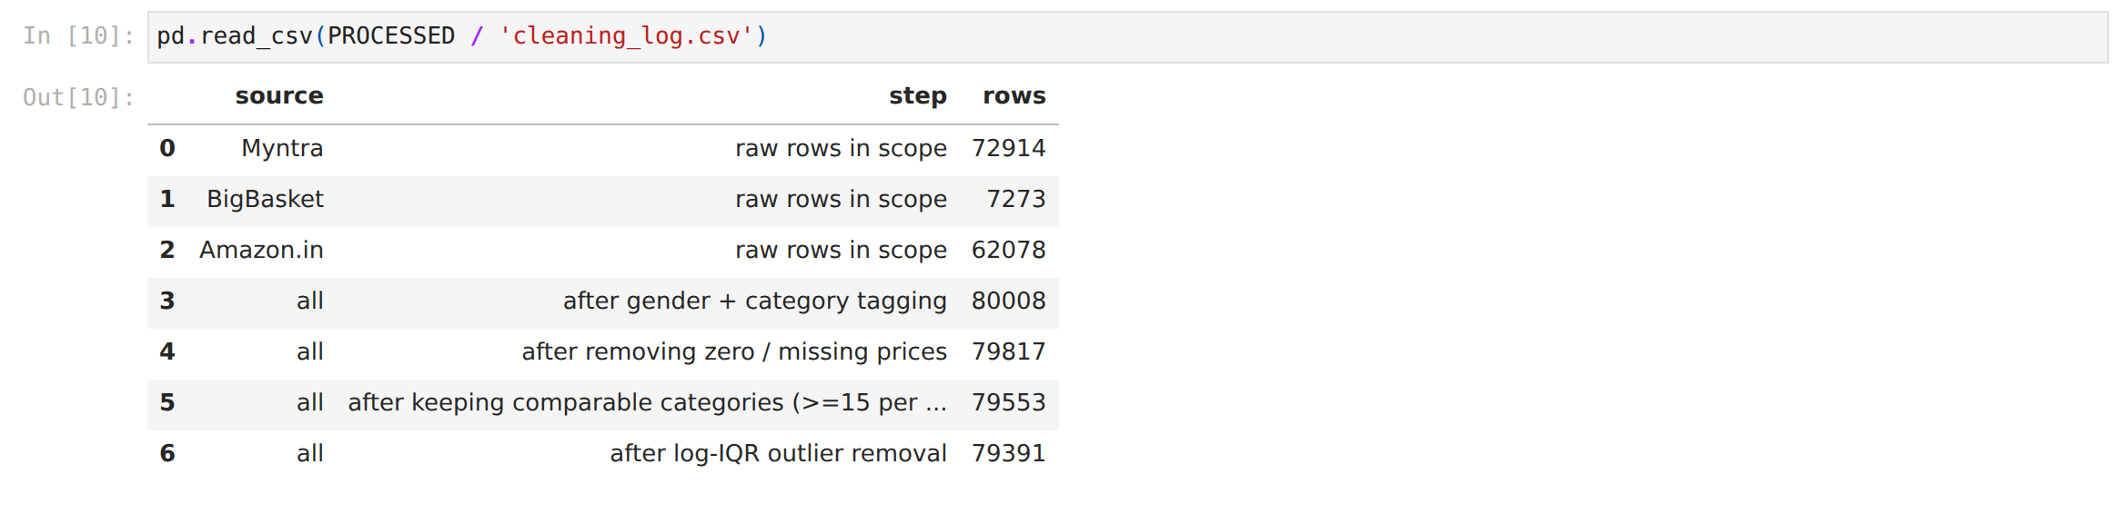
Figure 2.6: Cleaning log produced by the pipeline

Day-7: Feature Engineering – Gender, Category and Unit Price
Objective: create the variables needed for a fair comparison.
Activities performed
- Gender: built keyword rules in English (men, man's, him, gents, women, her, ladies, femme …) and Hindi (पुरुष, महिला). Titles that match both genders are excluded.
- Category: wrote ordered regular-expression rules. For example, attar is tested before razor because the Hindi word for “treasure” (ट्रेजर) contains the letters of “razor” (रेजर). I found and fixed this bug during spot checks.
- Pack size and unit price: extracted ml and g values from titles and calculated ₹ per 100 ml for liquids.
- Discount % = (1 − selling price / MRP) × 100.
- Segment: grouped categories into Apparel, Footwear, Accessories and Personal Care, and added an age group (Adult or Kids).
- Saved the tidy master table (79,390 rows × 16 columns) as pinktax_master.csv.

Learning outcome
Automatic tagging must always be checked by reading real examples. Printing random samples for each category and gender showed mistakes that summary statistics would never reveal, such as hair-removal creams being counted as razors.
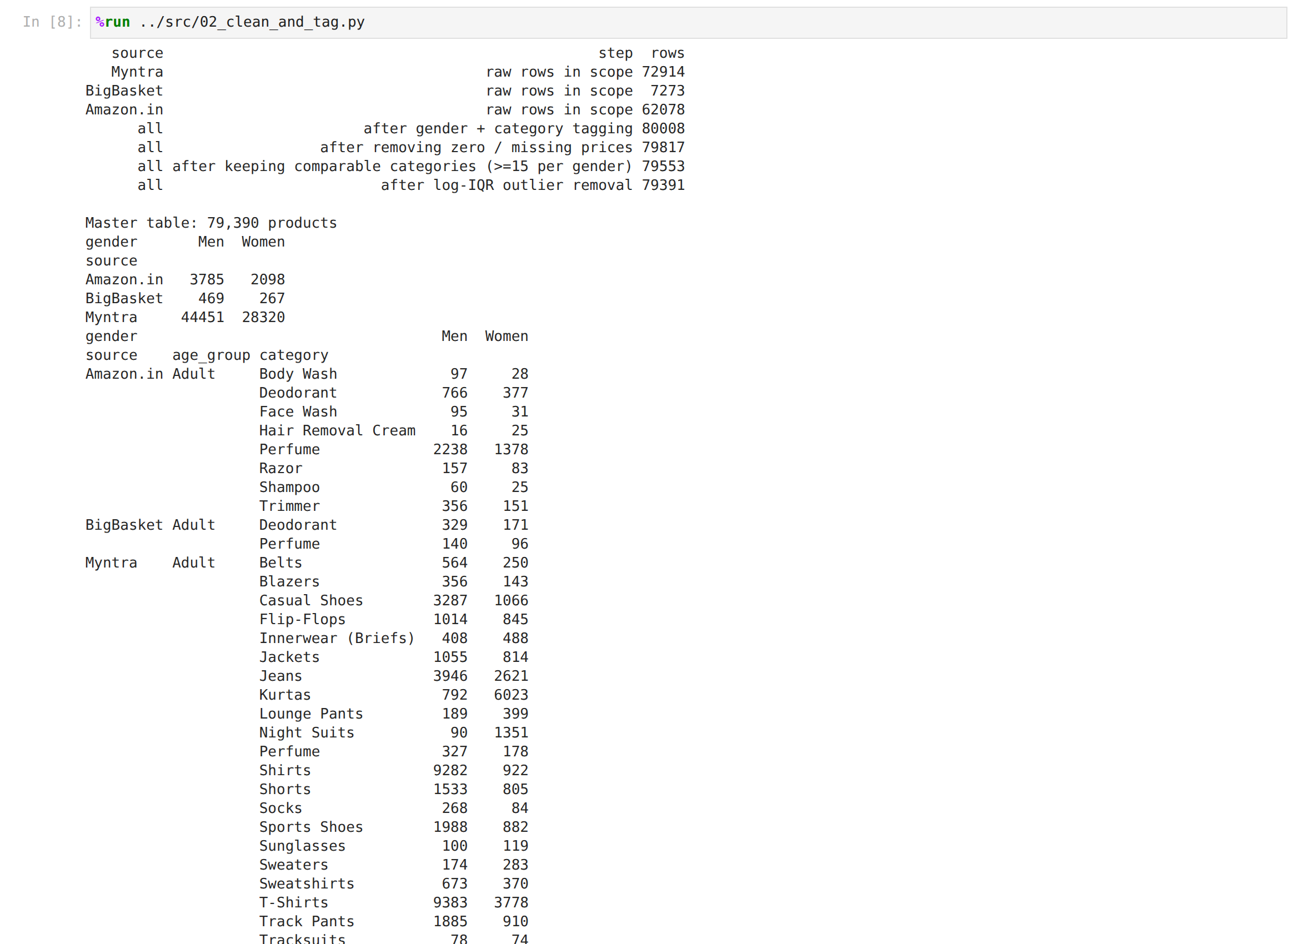
Figure 2.7: Output of the cleaning and tagging script: products per source, category and gender

Day-8: Exploratory Data Analysis (EDA)
Objective: understand the shape of the data before testing anything.
Activities performed
- Built pivot tables of product counts and median prices by source, segment and gender.
- Checked the distributions. Prices are strongly right-skewed, so medians and log prices are better summaries than means.
- Compared means with medians. In personal care the mean women's price is 21% higher, but the median is 7% lower, because a few expensive women's perfumes pull the mean up.
- Found that the sample is unbalanced: Myntra lists far more men's shirts and T-shirts, and far more women's kurtas and night suits.

Learning outcome
EDA stops the analysis from reaching the wrong conclusions. Comparing overall averages would be misleading because men's and women's catalogues contain different mixes of products. Every later comparison was therefore made within a category.
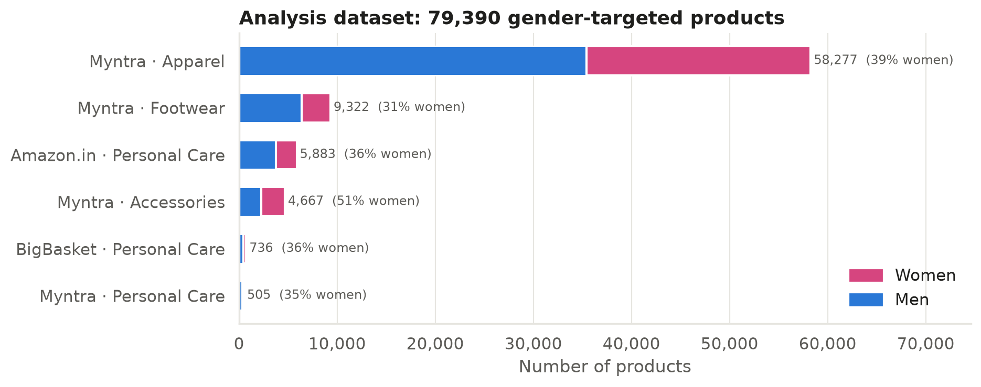
Figure 2.8: Composition of the final dataset by source, segment and gender
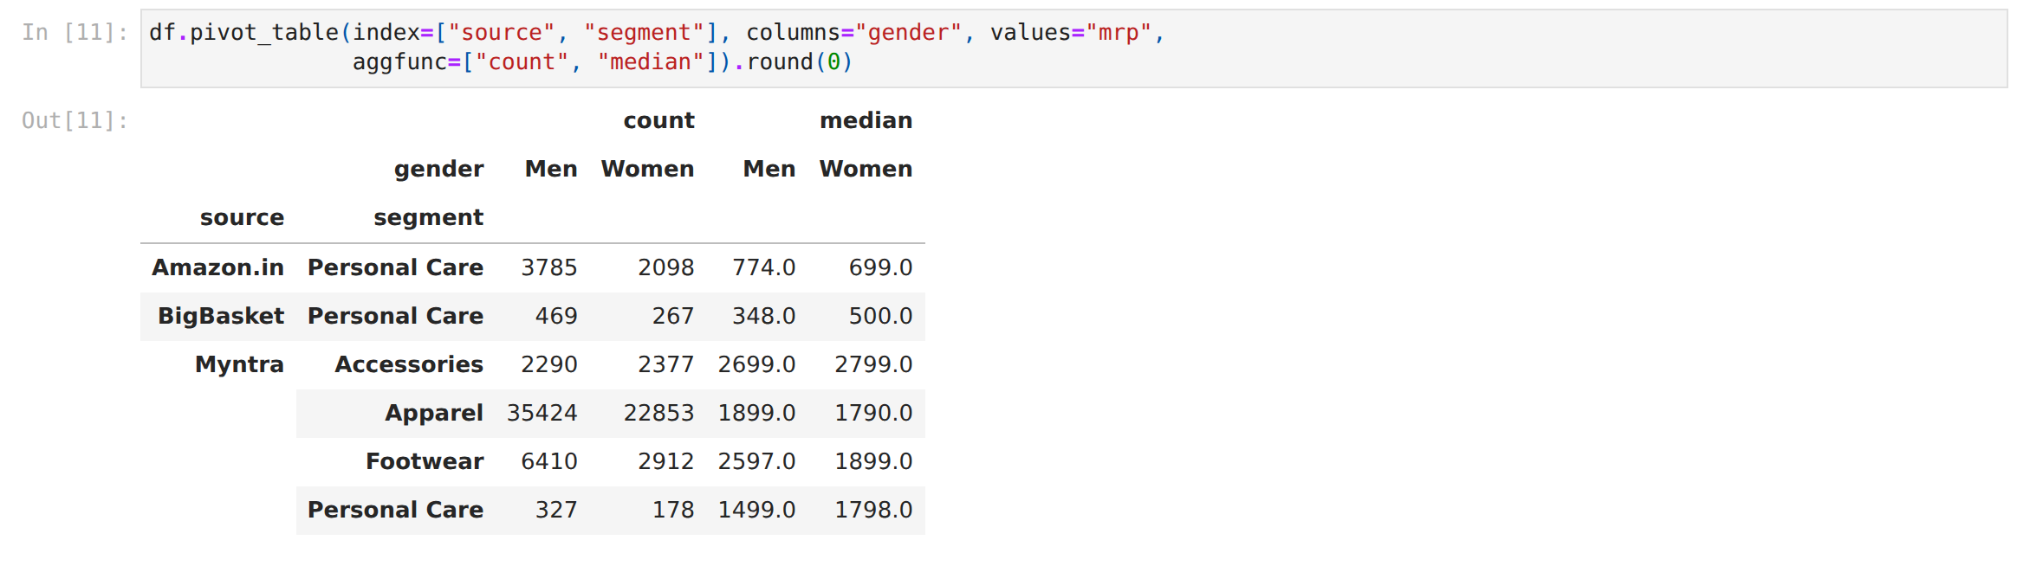
Figure 2.9: Pivot table of product counts and median MRP

Day-9: Data Visualisation with Matplotlib, Seaborn and Plotly
Objective: design clear and honest charts that explain the data.
Activities performed
- Chose one colour for women (pink) and one for men (blue) and checked that the pair can be told apart by colour-blind readers. The same colours are used in Python, Excel and Power BI.
- Drew box plots on a log scale (Figure 2.10), grouped bar charts, dot plots with confidence intervals, histograms and a correlation heatmap.
- Followed chart design rules: direct labels, a single axis, light grid lines, and titles that state what the chart shows.
- Built an interactive Plotly chart where hovering over a category shows the sample sizes, medians and p-value.

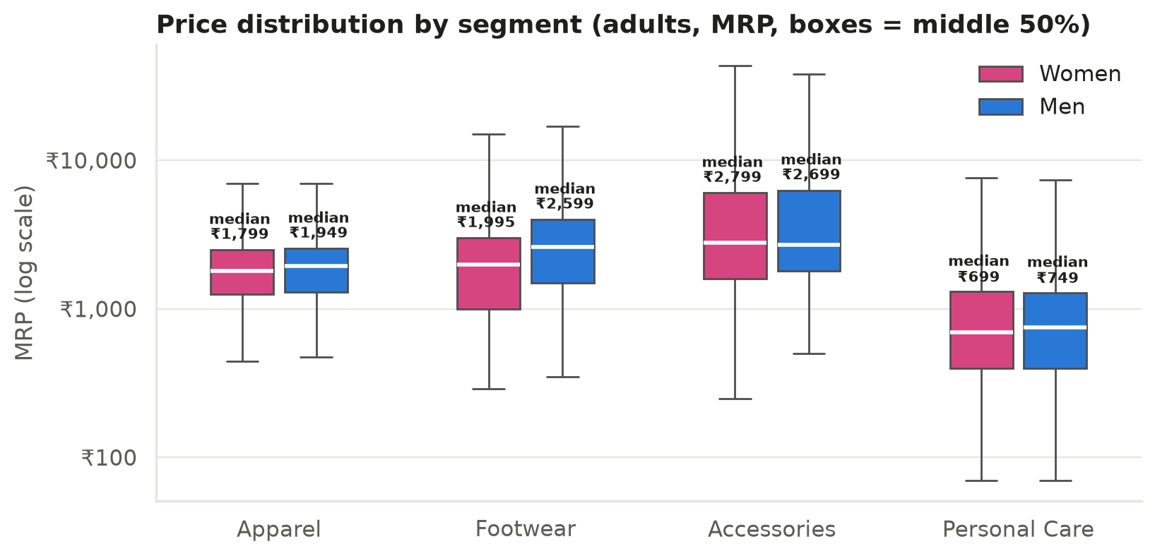
Figure 2.10: MRP distribution by segment and gender (adults)
Learning outcome
A chart is an argument. The log scale made both cheap socks and expensive watches readable on one axis. The box plots already hint that adult women's median prices are not higher than men's in apparel and footwear.
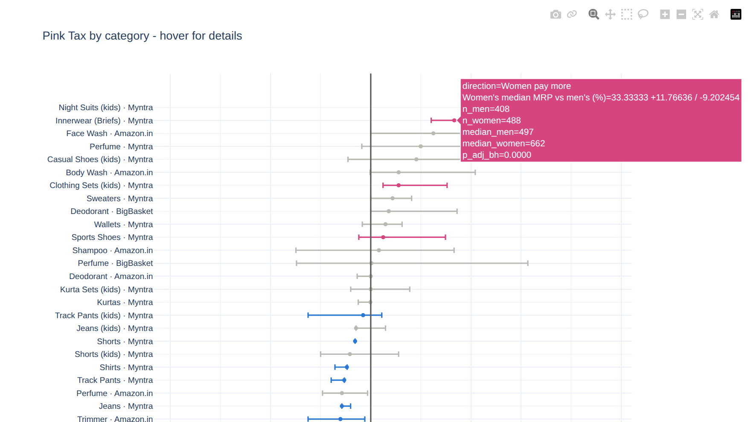
Figure 2.11: Interactive Plotly chart with hover details

Day-10: Hypothesis Testing Across 44 Categories
Objective: test, category by category, whether women's and men's prices differ.
Activities performed
- Used the Mann-Whitney U test, which does not assume a normal distribution, and Welch's t-test on log price, which allows unequal variances.
- Measured the effect size with Cohen's d and computed bootstrap 95% confidence intervals (2,000 resamples) for the median premium.
- Corrected for testing 44 categories at once with the Benjamini-Hochberg false-discovery-rate method.
- Worked example: adult T-shirts on Myntra had a median of ₹999 for women vs ₹1,299 for men (−23%, p < 10⁻¹⁰⁰).

Result
Women pay significantly more in 4 of 44 categories: girls' night suits (+78%), innerwear (+33%), kids' clothing sets (+11%) and sports shoes (+5%). Men pay more in 22 categories, including belts (−43%), blazers (−36%), sunglasses (−32%) and jackets (−25%). The other 18 categories show no significant gap.
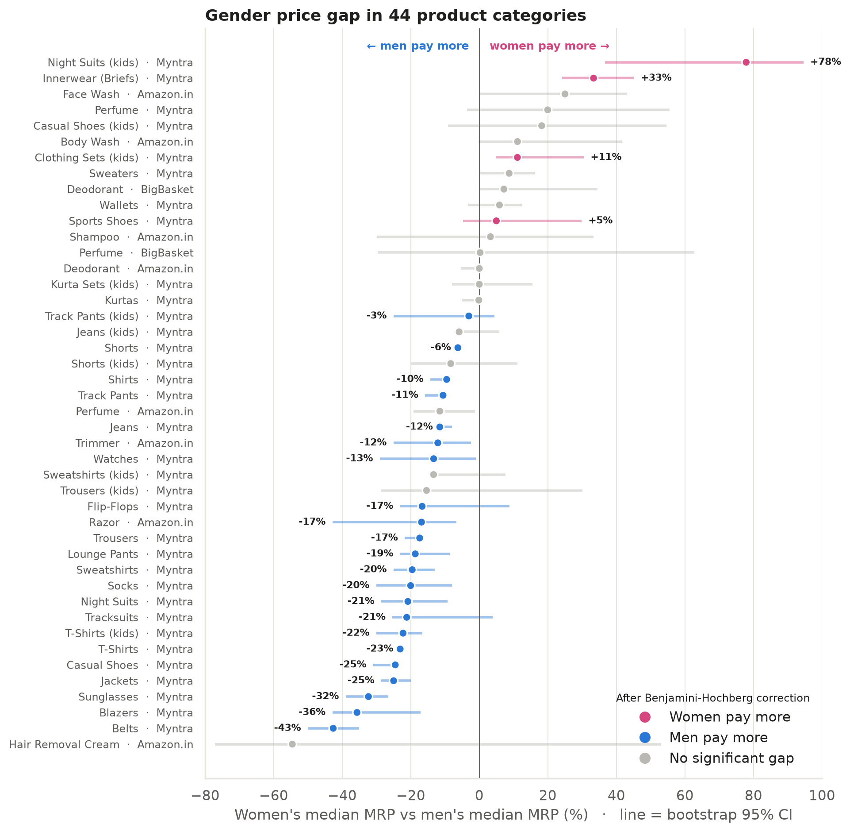
Figure 2.12: Median price gap for 44 categories with 95% confidence intervals

Day-11: Comparing Like with Like – Unit Price and Brand-Matched Pairs
Objective: remove the effect of pack size and brand from the comparison.
Activities performed
- Compared ₹ per 100 ml for deodorants, perfumes, body wash, face wash and shampoo. No category showed a significant gap. Deodorant, for example, was ₹210 vs ₹201 per 100 ml (+4.6%, p = 0.80).
- Built 860 brand-matched pairs, each one brand selling both a men's and a women's line in the same category, and compared the two median prices.
- Tested the pairs with the Wilcoxon signed-rank test and a sign test, and used a chi-square test to check whether the outcomes differ by segment.

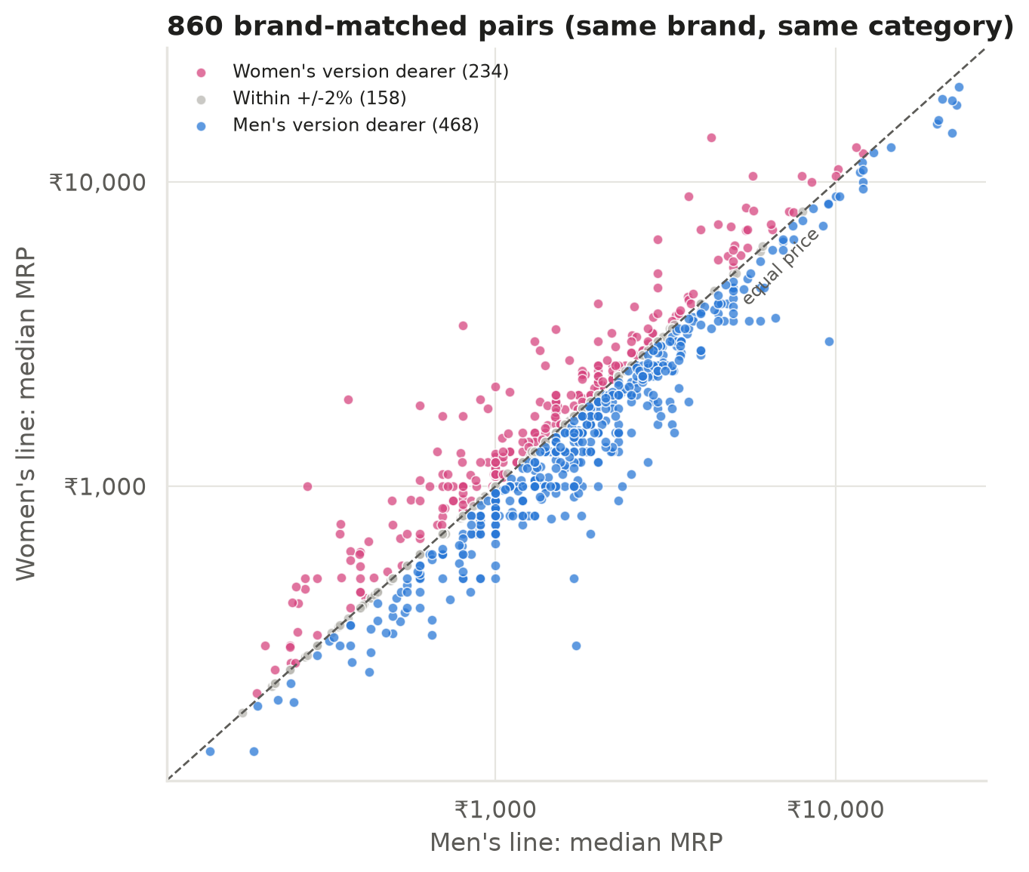
Figure 2.13: Brand-matched pairs. Points above the line mean the women's line is dearer
Result
The women's version was dearer in 27% of pairs, the men's in 54%, and 18% were within ±2%. The typical gap was −5.9% (95% CI −7.7% to −4.0%, p < 0.001). Personal care was the only balanced segment (35% vs 37%, p = 0.93), and the outcome depends on the segment (χ² = 37.0, p < 0.001).
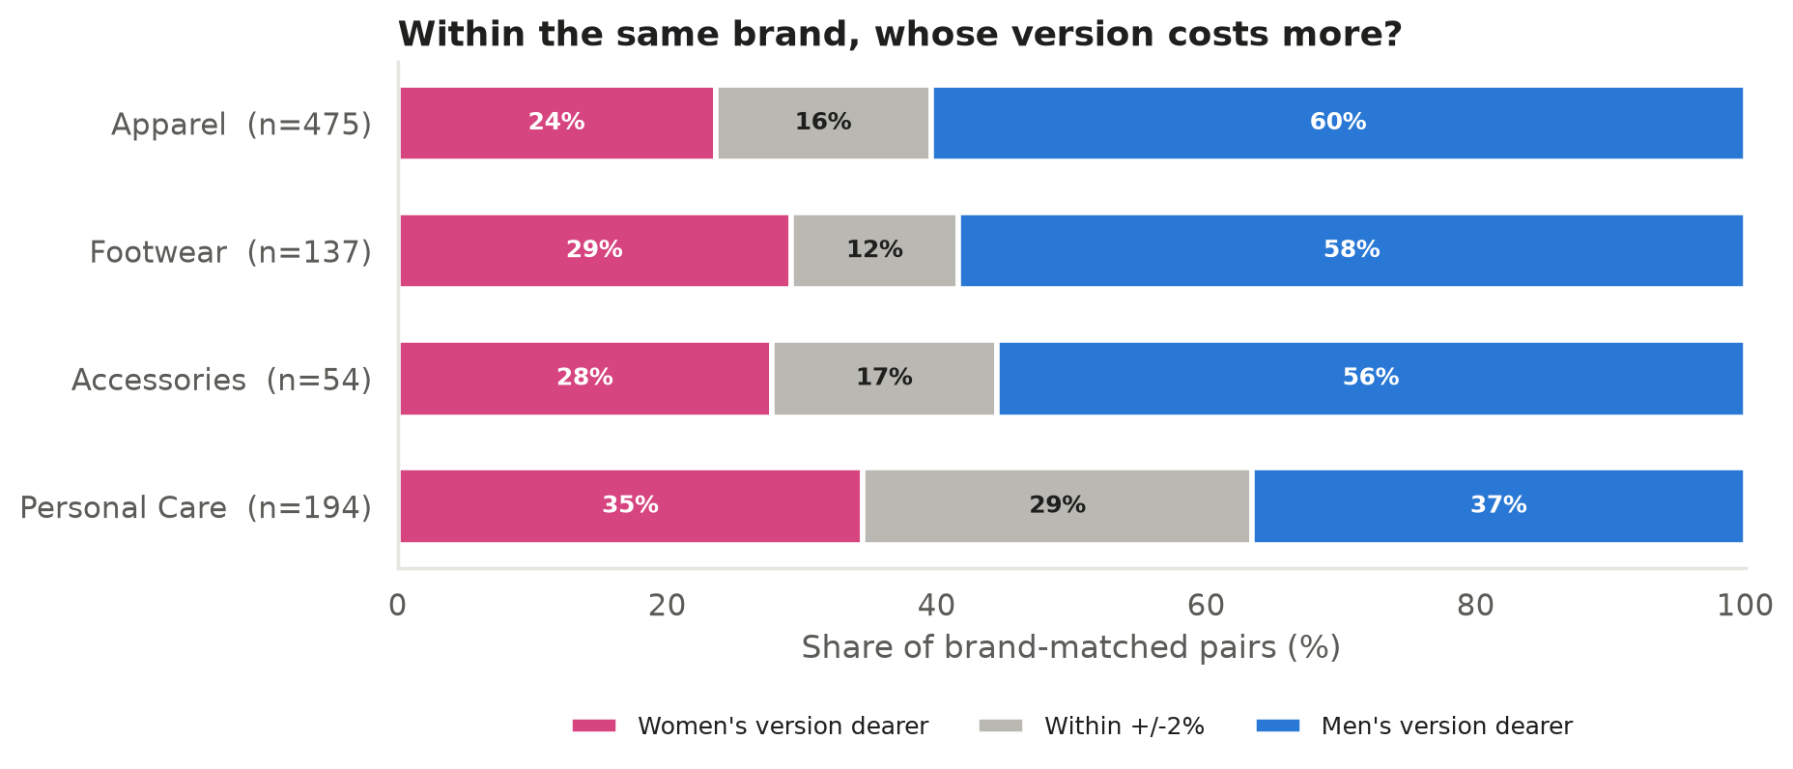
Figure 2.14: Share of pairs where each version is dearer, by segment

Day-12: Regression with Fixed Effects (Statsmodels)
Objective: estimate the gender premium while controlling for brand and category.
Activities performed
- Fitted OLS models of the form log(MRP) = β·Female + group effects, where eᵝ − 1 is the percentage premium.
- Used the within (demeaning) estimator for brand × category fixed effects and clustered standard errors by brand.
- Estimated separate models for each segment, for kids, and for price per 100 ml.
- Checked for a composition effect: kids' products look 18% dearer for girls overall, but the gap disappears within categories because girls' categories (kurta sets, clothing sets) are pricier in general.

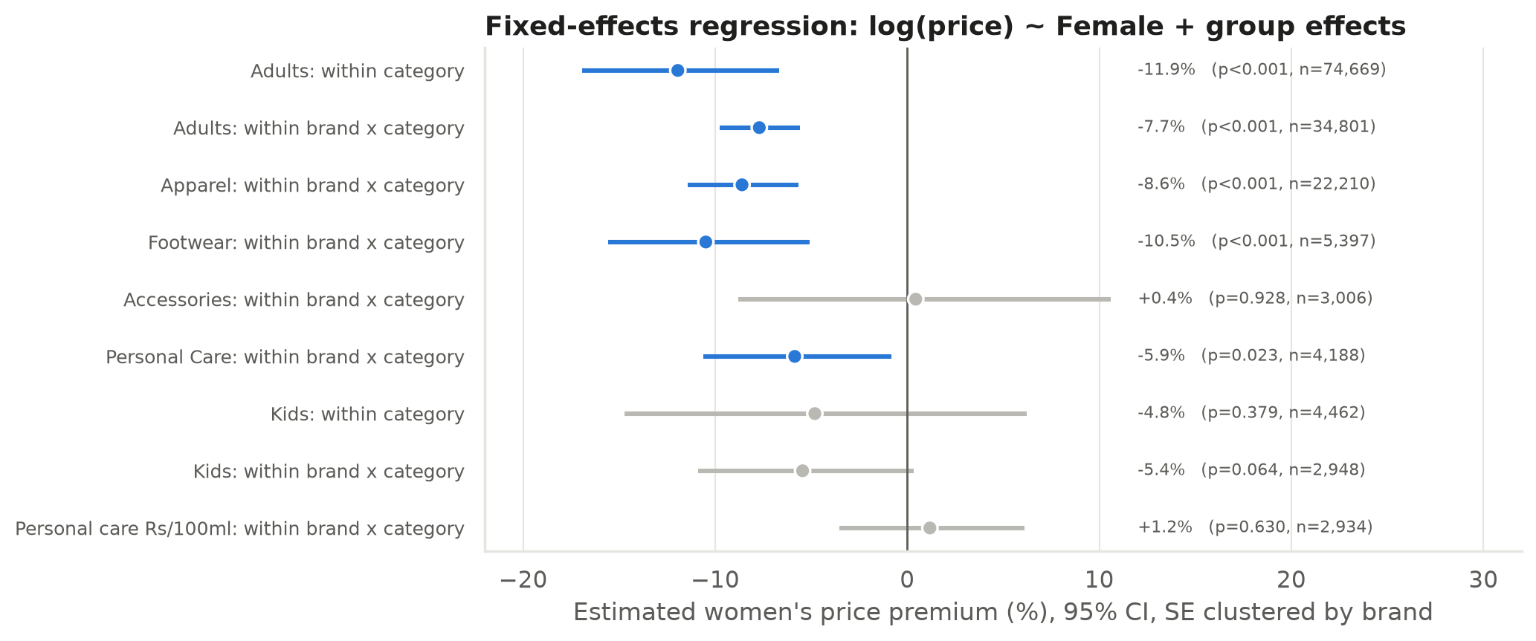
Figure 2.15: Fixed-effects estimates of the women's price premium
Result
Within the same brand and category, adult women's products are 7.7% cheaper (95% CI −9.8% to −5.6%). Accessories show no gap (+0.4%, p = 0.93), and personal care per 100 ml shows no gap (+1.2%, p = 0.63). The kids' premium is not significant (−4.8%, p = 0.38).
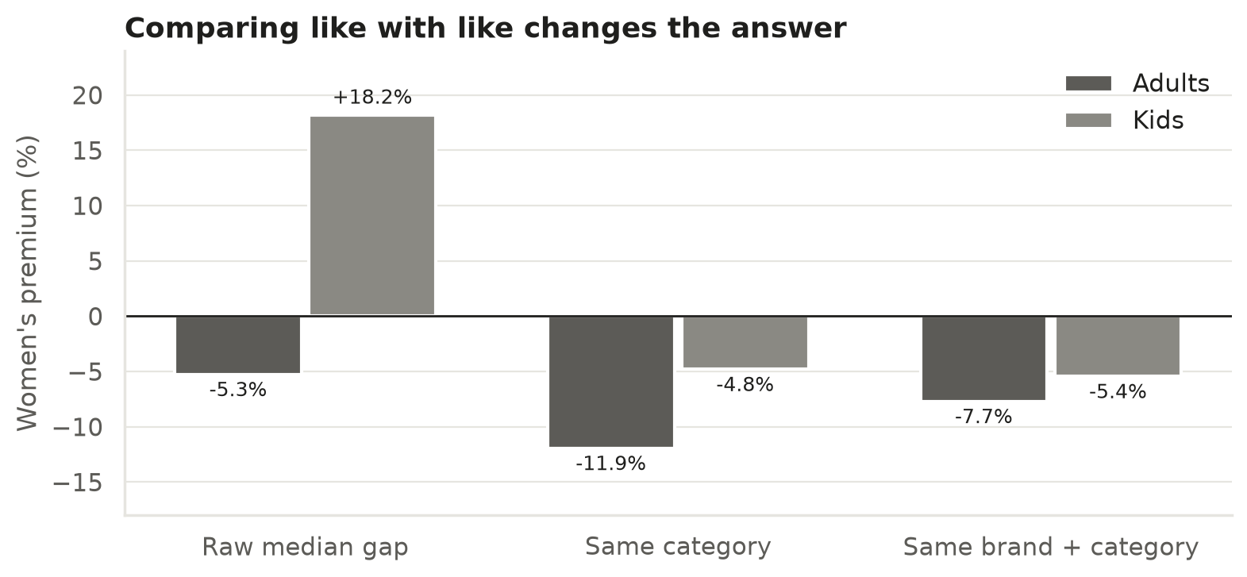
Figure 2.16: How the answer changes when like is compared with like

Day-13: Discount Analysis and Machine Learning (scikit-learn)
Objective: check whether discounts change the picture, and measure how much gender really explains price.
Activities performed
- Compared discounts. Women's items carry deeper discounts (36.7% vs 32.9%, p < 0.001), especially in apparel and accessories.
- Repeated the category tests on the selling price. The innerwear premium flips from +33% on MRP to −11% after discounts. BigBasket women's deodorants go from no gap to +17%, because they are discounted less. This is a Pink Tax at the point of sale.
- Trained a random-forest model (scikit-learn) to predict log price from category, segment, retailer, brand (target-encoded) and gender. It reached a test R² of 0.78.
- Used permutation importance to rank the features.

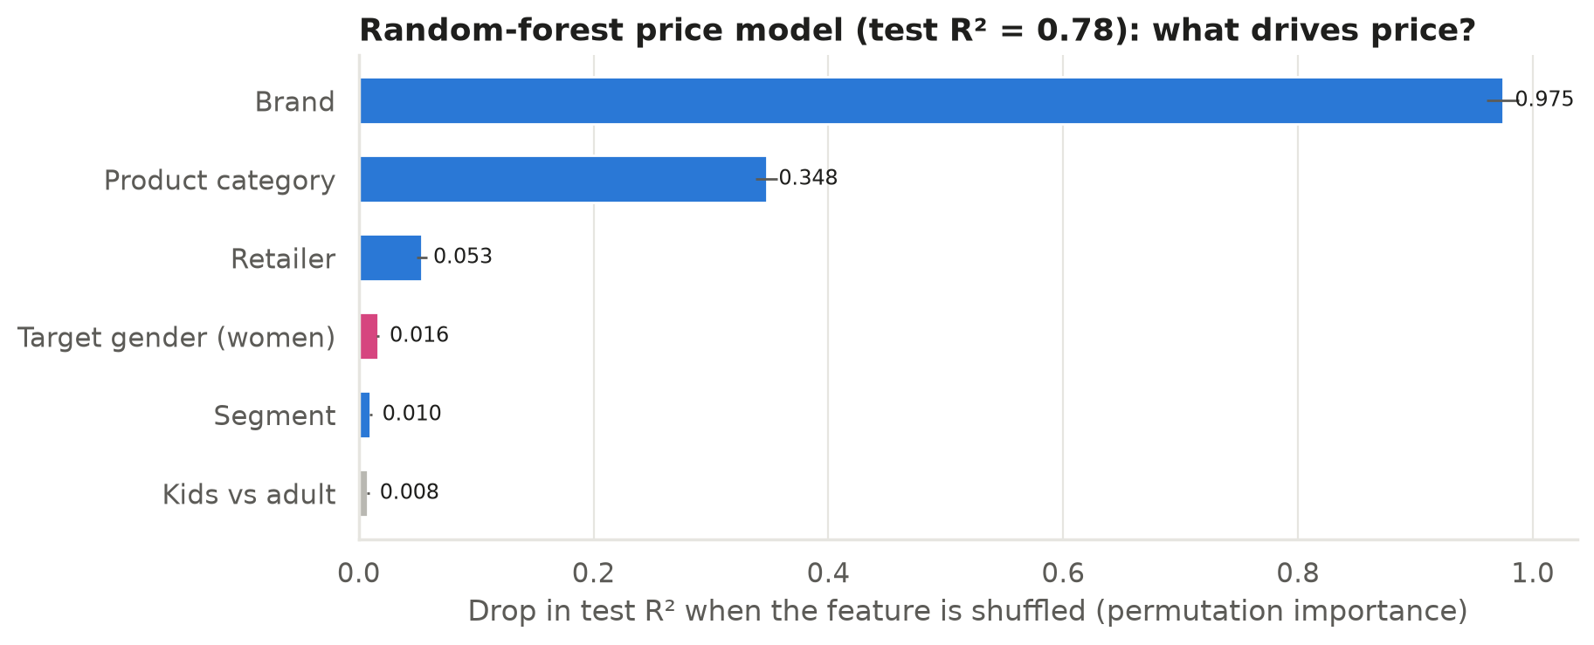
Figure 2.17: Permutation importance of each feature in the random-forest model
Result
Brand (importance 0.97) and category (0.35) explain most of the price. Target gender adds only 0.02. Price is driven by what the product is and who makes it, not by who it is marketed to.
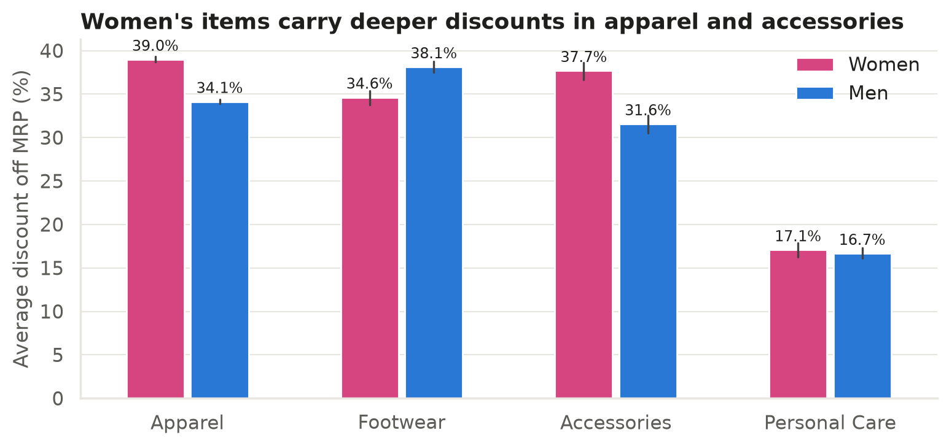
Figure 2.18: Average discount by segment and gender

Day-14: Excel Workbook – Formulas, Pivot Summaries and Charts
Objective: make the analysis available to Excel users without Python.
Activities performed
- Loaded all 79,390 products into an Excel Table (tbl_Products) so that it can be filtered, sorted and pivoted.
- Built a Category_Summary sheet with live COUNTIFS and AVERAGEIFS formulas, for example =AVERAGEIFS(MRP, Source, A5, Category, D5, Gender, "Women"), next to the medians, confidence intervals and p-values from Python.
- Built a pivot-style segment × gender summary, a Matched_Pairs sheet with data bars, and a Stats_Tests sheet.
- Applied conditional formatting: a blue-to-pink colour scale on the premium and coloured result labels.
- Added native Excel bar charts and checked that the formulas give the same numbers as Python.

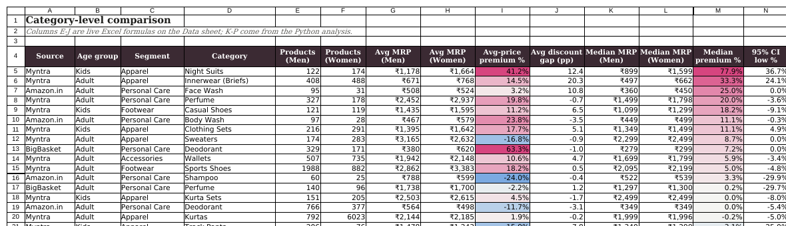
Figure 2.19: Category_Summary sheet with formulas and conditional formatting
Learning outcome
Excel is still the most widely used analysis tool. Formulas that update when the data changes make a workbook reusable. Checking that the Excel formulas give the same numbers as Python is a quick way to validate both.
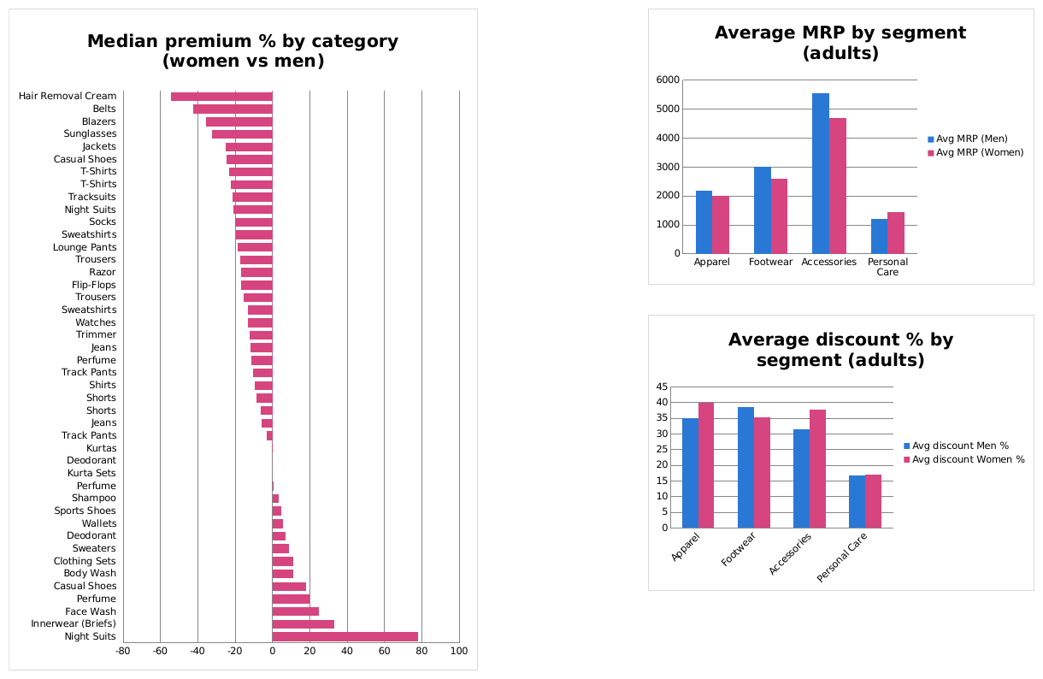
Figure 2.20: Native Excel charts

Day-15: Power BI Dashboard, GitHub Publishing and Report
Objective: build an interactive dashboard and publish the complete project.
Activities performed
- Exported Power BI-ready tables and designed a star schema: fact_products linked to dim_category, with category_premium and brand_pairs as result tables.
- Loaded them through Power Query, set the data types and created DAX measures such as Median MRP (Women), Pink Tax % = DIVIDE([Median MRP (Women)], [Median MRP (Men)]) − 1, Pairs Women Dearer % and a conditional-colour measure.
- Built the dashboard: six KPI cards, a category gap chart, segment medians, a brand-pair outcome chart, a table of the Pink Tax pockets, and slicers for source, segment, age group and category. Applied a custom JSON theme.
- Wrote the README, pushed everything to GitHub and completed this report.

Learning outcome
A dashboard lets a non-technical user explore the result: selecting “Kids” or “Personal Care” in a slicer immediately updates every visual. Publishing the code and data on GitHub makes the whole study transparent and reproducible.
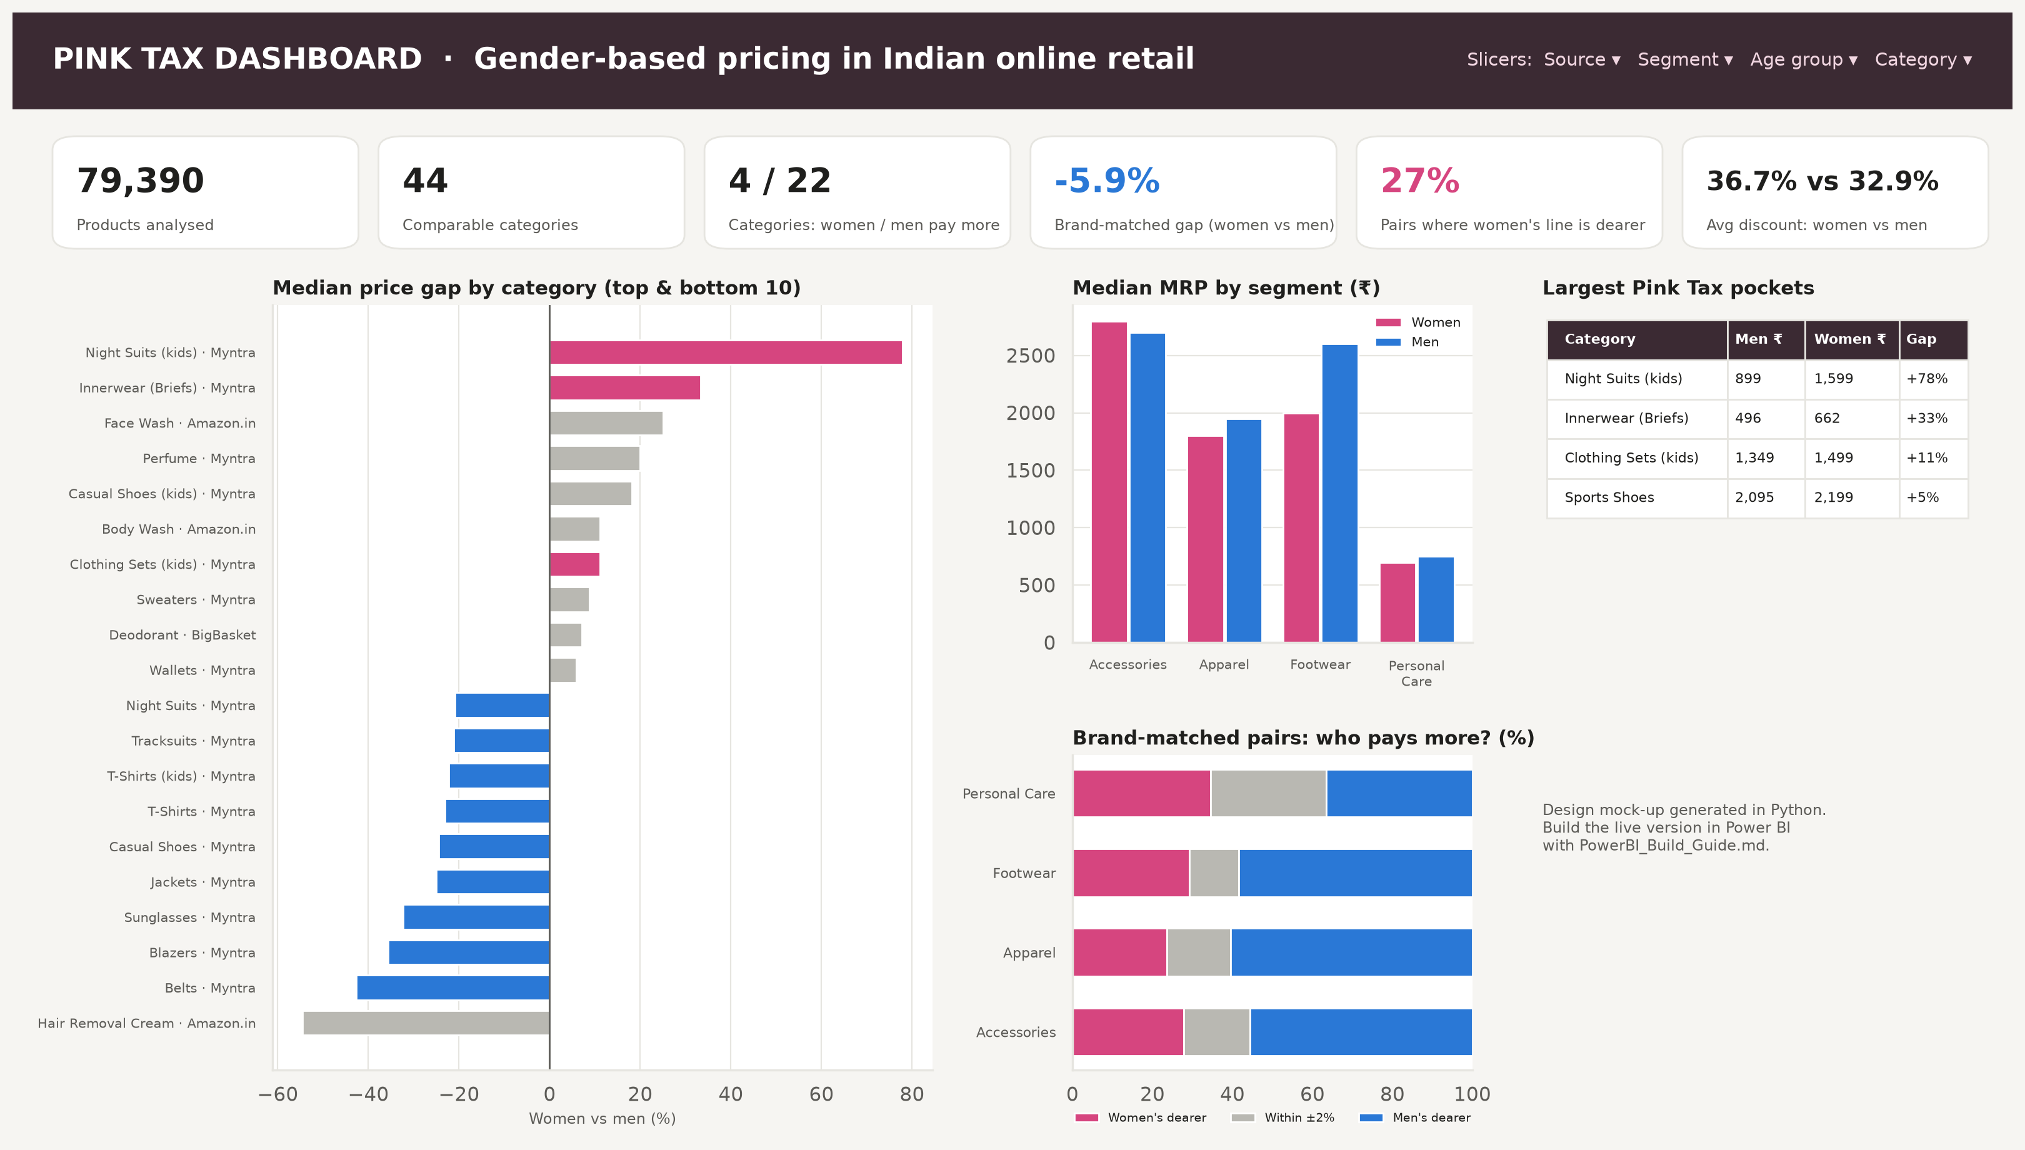
Figure 2.21: Pink Tax dashboard design (Power BI)

Chapter 3: Conclusion

3.1 Summary of Findings
This project set out to answer a simple question with real data: do products marketed to women in India cost more than comparable products marketed to men? After analysing 79,390 products from Myntra, BigBasket and Amazon.in, the answer is “not in general, but yes in specific places.”
- No blanket Pink Tax. Women pay significantly more in 4 of 44 categories and men pay more in 22. Within the same brand and category, adult women's products are about 7.7% cheaper.
- The Pink Tax is concentrated in girls' night suits (+78%), innerwear (+33%), kids' clothing sets (+11%) and sports shoes (+5%) at MRP, and in women's deodorants at the selling price (+17%).
- Like-for-like comparisons remove most gaps. Personal care per 100 ml shows no significant difference, and the raw kids' premium disappears within categories.
- Brand and category drive price; gender barely does. In the machine-learning model gender adds about 0.02 to R², compared with 0.97 for brand.
- Discounts matter. Women's items are discounted more deeply on average, so the MRP and the price actually paid can tell different stories.

These results agree with recent research that finds no systematic premium for identical products. The gaps reported in earlier studies mostly come from comparing differentiated products and different brand mixes. For consumers the practical advice is to compare unit prices and to look at the other gender's version of simple products such as razors, deodorants and basic clothing.

3.2 What I Learned from the Internship
- Technical: writing a complete, reproducible data pipeline in Python; advanced Pandas and regular expressions (including Hindi text); visualisation with Matplotlib, Seaborn and Plotly; Excel formulas and conditional formatting; Power Query, data modelling and DAX in Power BI; Git and GitHub.
- Statistical: choosing non-parametric tests for skewed data, bootstrap confidence intervals, multiple-testing correction, effect sizes, fixed-effects regression with clustered errors, composition effects (Simpson's paradox) and model interpretation with permutation importance.
- Analytical thinking: a headline number such as “women pay X% more” depends on what is compared with what. Checking assumptions and reading real examples matters as much as writing code.
- Professional: planning work in daily milestones, documenting decisions, and presenting findings honestly even when they differ from the popular expectation.

3.3 Limitations and Future Scope
- Gender and category tags are based on keywords, so a small share of products may be mislabelled.
- “Comparable” is approximated by same category and same brand. Differences in fabric, fit and design remain.
- The data are one-time snapshots (2022–2023) of listed prices and do not include sales volumes.
- Future work: track prices over time with web scraping, match exact twin products (same SKU except gender), add offline stores and services such as salons and dry-cleaning, and use text similarity models to find near-identical products automatically.

References
New York City Department of Consumer Affairs (2015). From Cradle to Cane: The Cost of Being a Female Consumer – A Study of Gender Pricing in New York City.
U.S. Government Accountability Office (2018). Consumer Protection: Gender-Related Price Differences for Goods and Services (GAO-18-500).
Moshary, S., Tuchman, A., & Bhatia, N. (2021). Investigating the Pink Tax: Evidence against a Systematic Price Premium for Women in CPG. SSRN Working Paper.
Duesterhaus, M., Grauerholz, L., Weichsel, R., & Guittar, N. A. (2011). The cost of doing femininity: Gendered disparities in pricing of personal care products and services. Gender Issues, 28(4), 175–191.
State of California. Gender Tax Repeal Act of 1995 (Civil Code §51.6) and Assembly Bill AB-1287 (2022), Price discrimination: gender.
Government of India, GST Council (2018). Exemption of sanitary napkins from GST, effective 27 July 2018.
Kaggle datasets: Myntra 168k Products (ashishjangra27); BigBasket Entire Product List (surajjha101); Amazon India Products 2023 (asaniczka).
McKinney, W. (2022). Python for Data Analysis (3rd ed.). O'Reilly Media.
Benjamini, Y., & Hochberg, Y. (1995). Controlling the false discovery rate. Journal of the Royal Statistical Society: Series B, 57(1), 289–300.
Project repository: https://github.com/mppyxx/PinkTax

