

IOT COURSE PROJECT (AR App)

Report



# **DONE BY:**

# MADDI PRANAV REDDY – SE20UARI090

# SAI ANISH SREERAMAGIRI – SE20UARI130

**Introduction:**  
  
Sangeet AR is a music app that uses Augmented Reality technology to offer a new and exciting musical experience. With this app, we can interact with virtual musical instruments like the flute, drums, and harmonium. By scanning special AR cards related to each instrument, we can see these virtual instruments in their own surroundings using the Android mobile devices.  
  
  
**Use Case:**  
  
Sangeet AR aims to bring creativity and entertainment together by combining augmented reality with music. We can get to play virtual instruments in our own space, making the musical experience personal and enjoyable.

**Functionalities:**

**a. Instrument Visualization:**

We can scan AR cards for the flute, drums, and harmonium, making these virtual instruments appear in their real-world surroundings.

**b. Interactive Touch Controls:**

Simply tapping on a virtual instrument triggers the playback of authentic instrument sounds, creating an interactive and immersive experience.

**c. Real-time Augmented Reality:**

Sangeet AR uses real-time AR technology, allowing users to move around and interact with virtual instruments from different angles for a dynamic and responsive experience.

**TIPS While Scanning: (Works only On Android Devices)**  
Make sure you place the “**Show the AR Card**” tagline we get on the device on the **small white Speaker** in the AR Card to get the instrument to interact with.  
  
After instrument appears on the screen, we get the tagline **“Tap to Play,”** Now tap on the instrument and turn on the volume to listen the sound associated with that instrument.

**Limitations:**

**a. Device Compatibility:**

The AR experience relies on the capabilities of the user’s device. Older or less powerful devices might not provide the best experience.

**b. Card Dependency:**

The app needs specific cards for each instrument to work. If these cards are lost or damaged, users may have trouble accessing certain instruments.

**c. Limited Instruments:**

Currently, the app features three instruments due to time constraint.

**d. Only Android Devices:**

App is designed to work only on Android Devices; therefore, we cannot use other OS to use the App.

**AR Cards to scan to interact with respective instrument:(PS: Give Camera Permission while using the App to interact with instruments)**

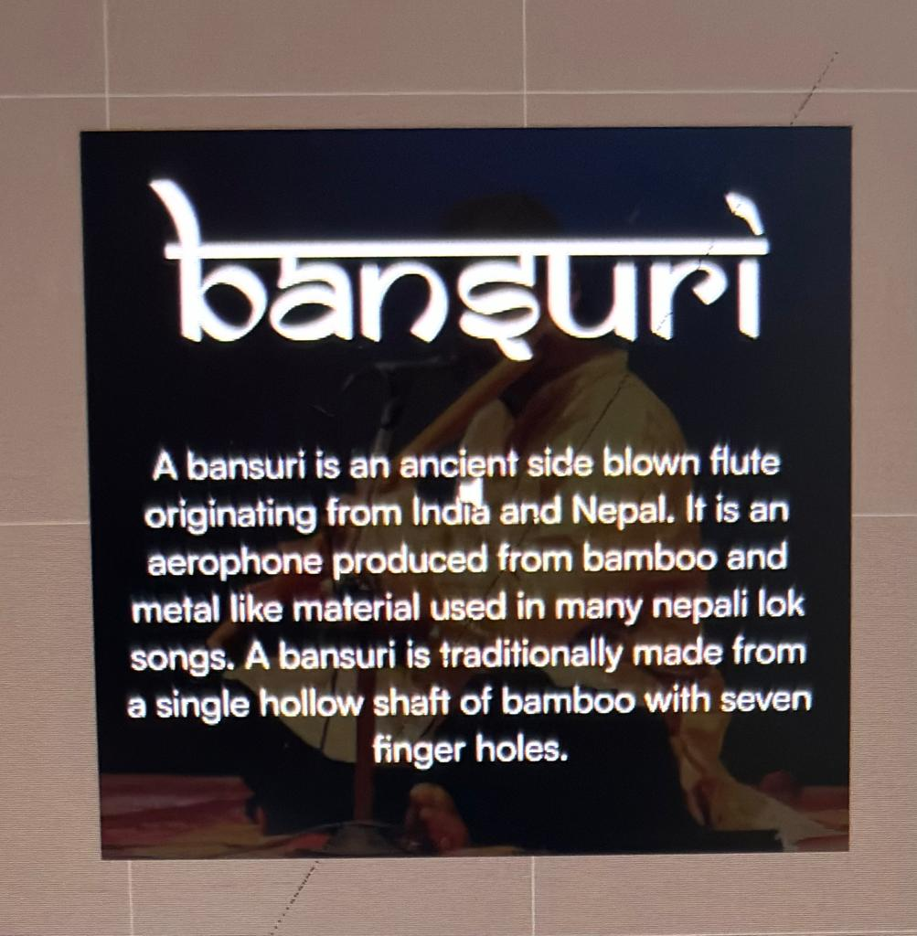

Flute AR Card

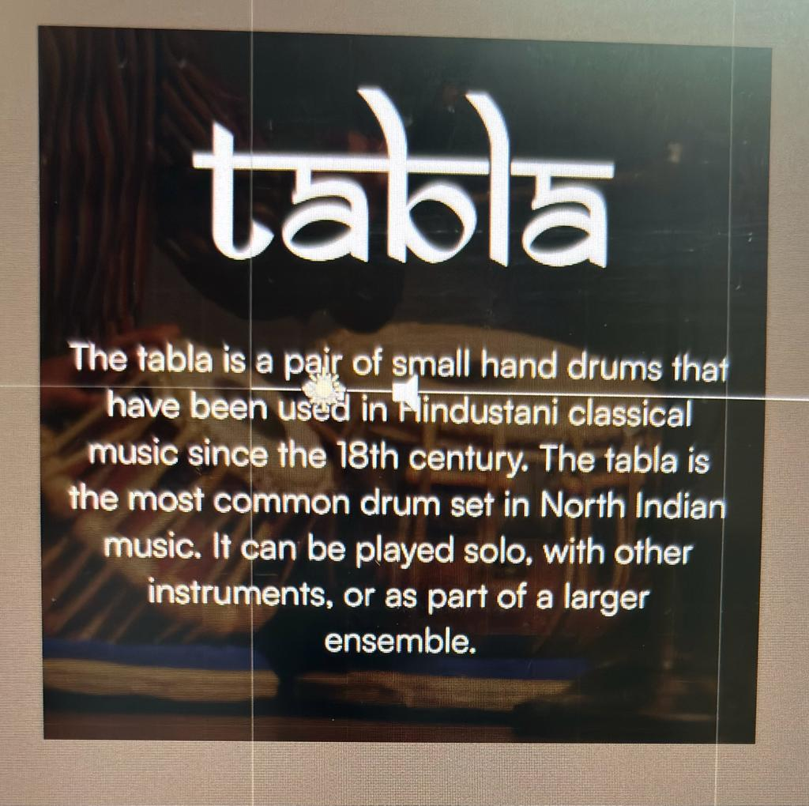

Tabla AR Card

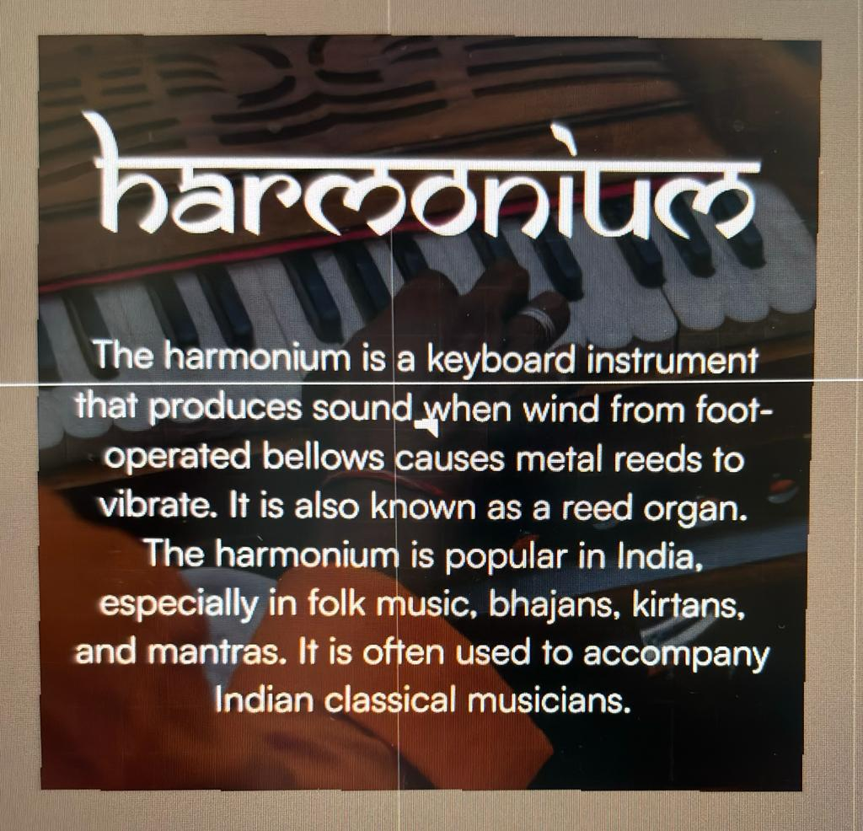

Harmonium AR Card

**App Download link:**

https://mahindraecolecentrale-my.sharepoint.com/:u:/g/personal/pranav20uari090_mahindrauniversity_edu_in/EcnpDA80puBGte4GS4eXFHkBgwzxX5_6S5c2czQ7O-39vw