Start server

LHS

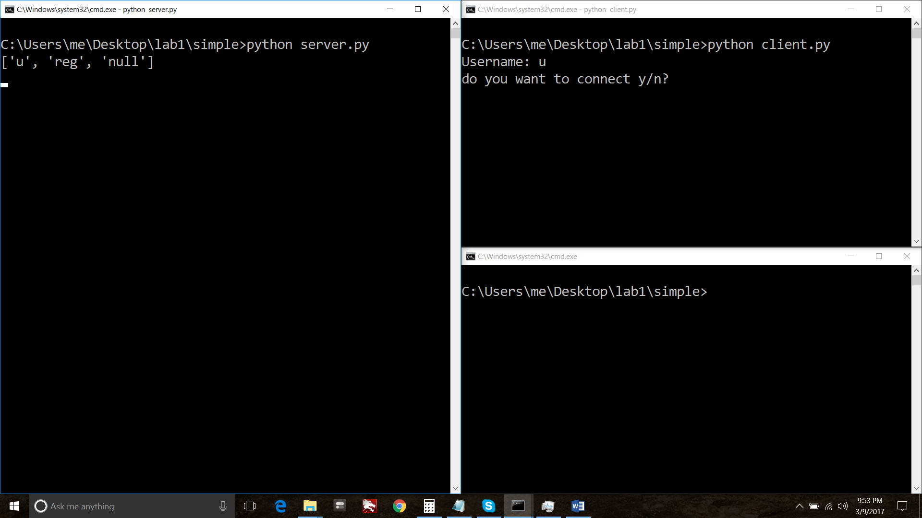

Start 2 clients RHS

Enter user “u” enter  
select “n”, to register as first user

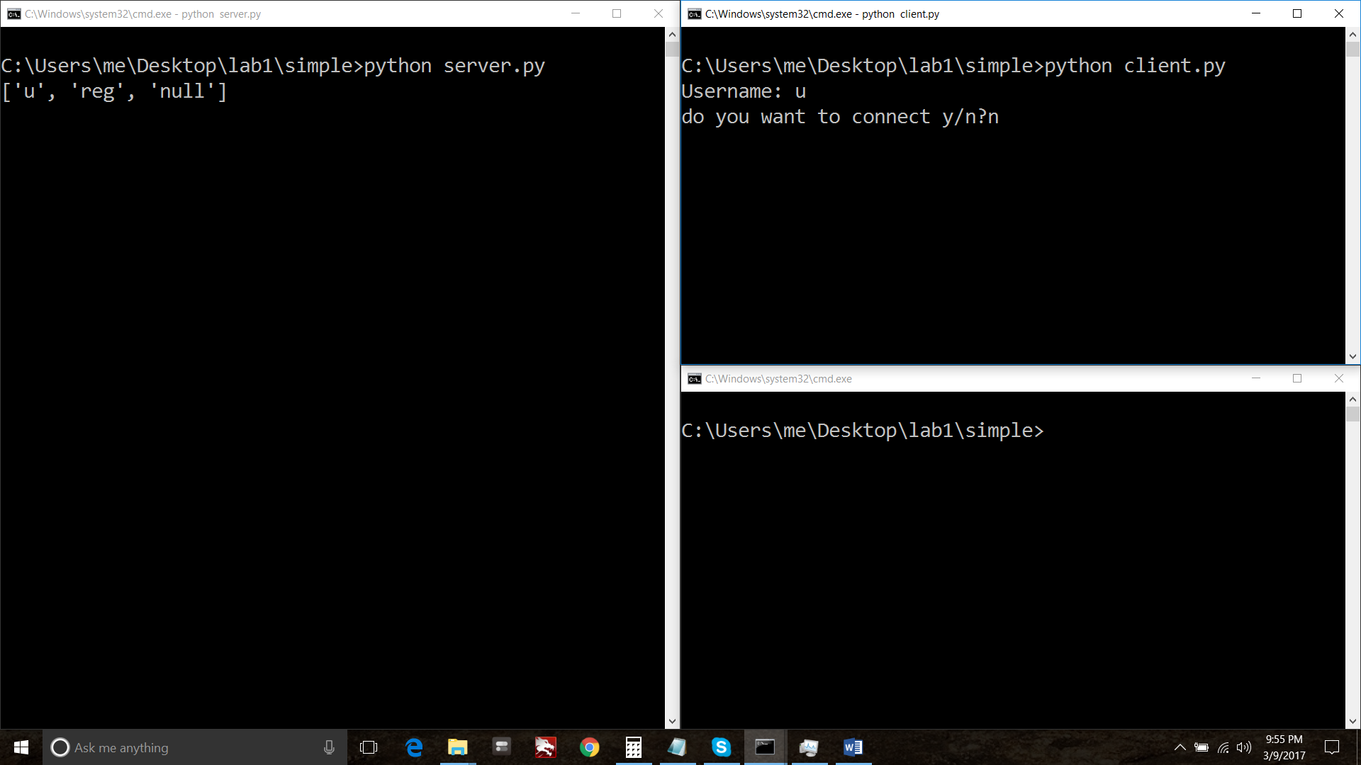

Start 2 user : “v”  
select “y” enter  
select user “u” to connect with.

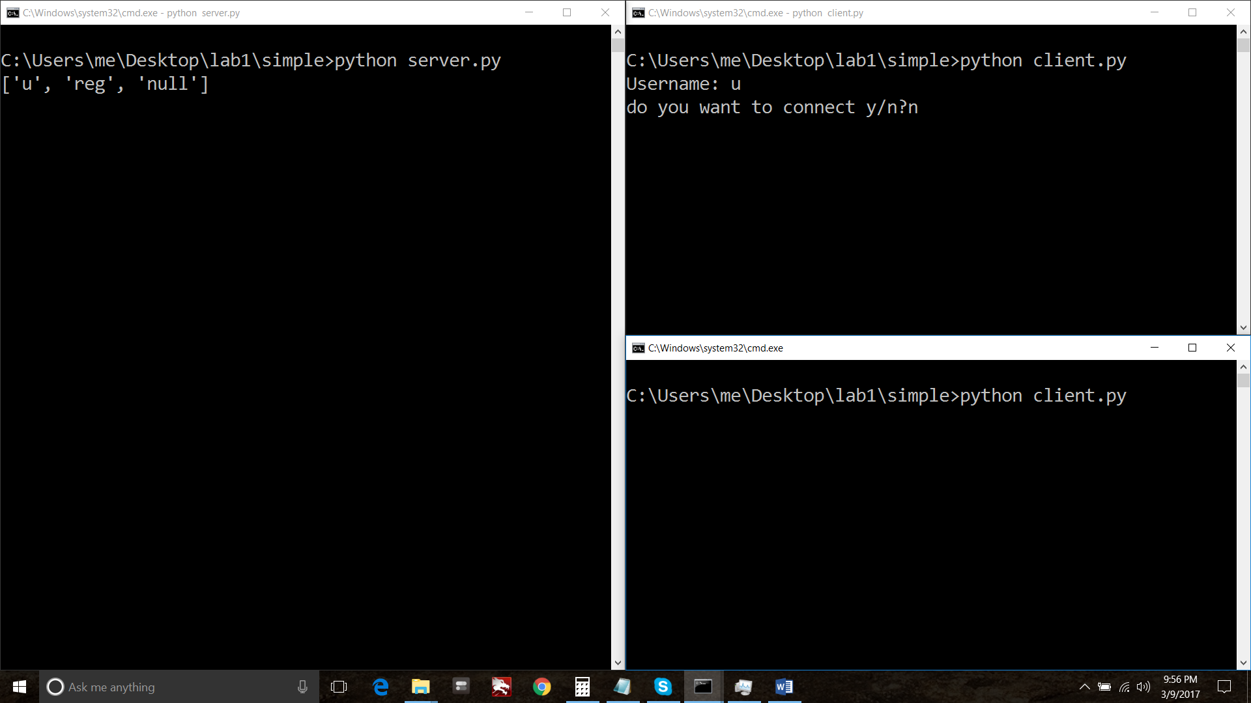

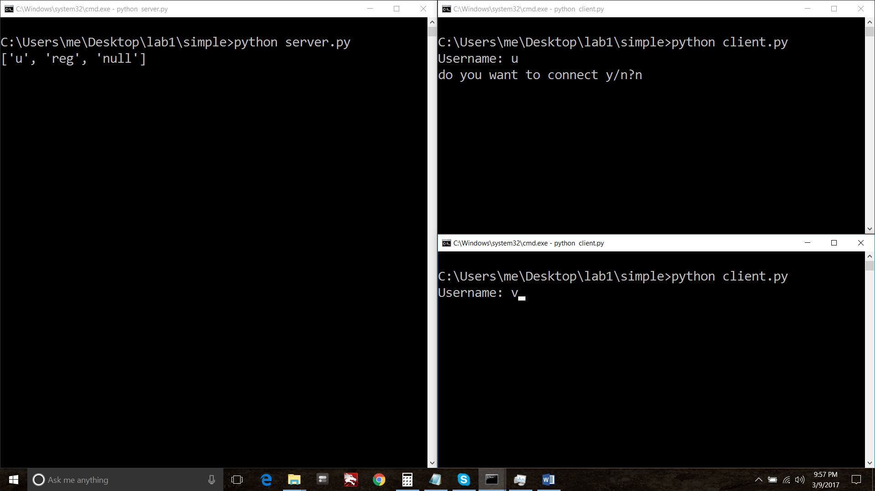

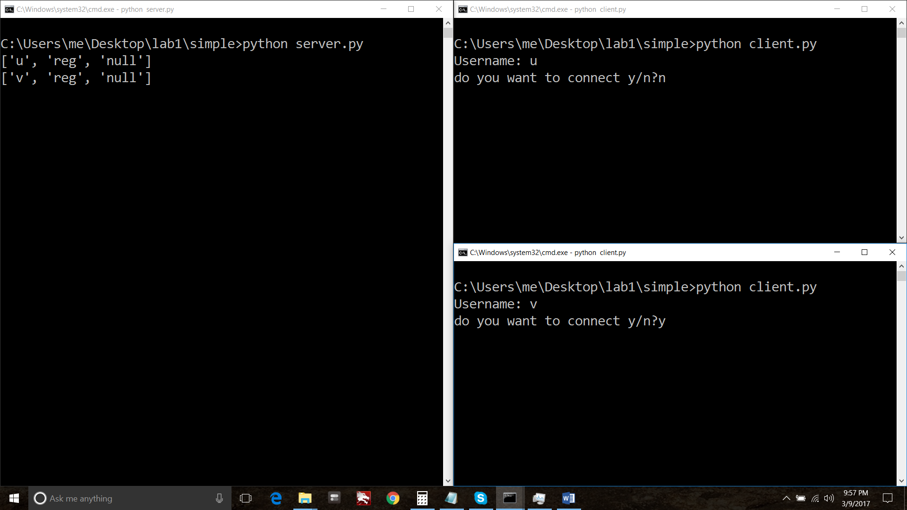

Connect to “u”

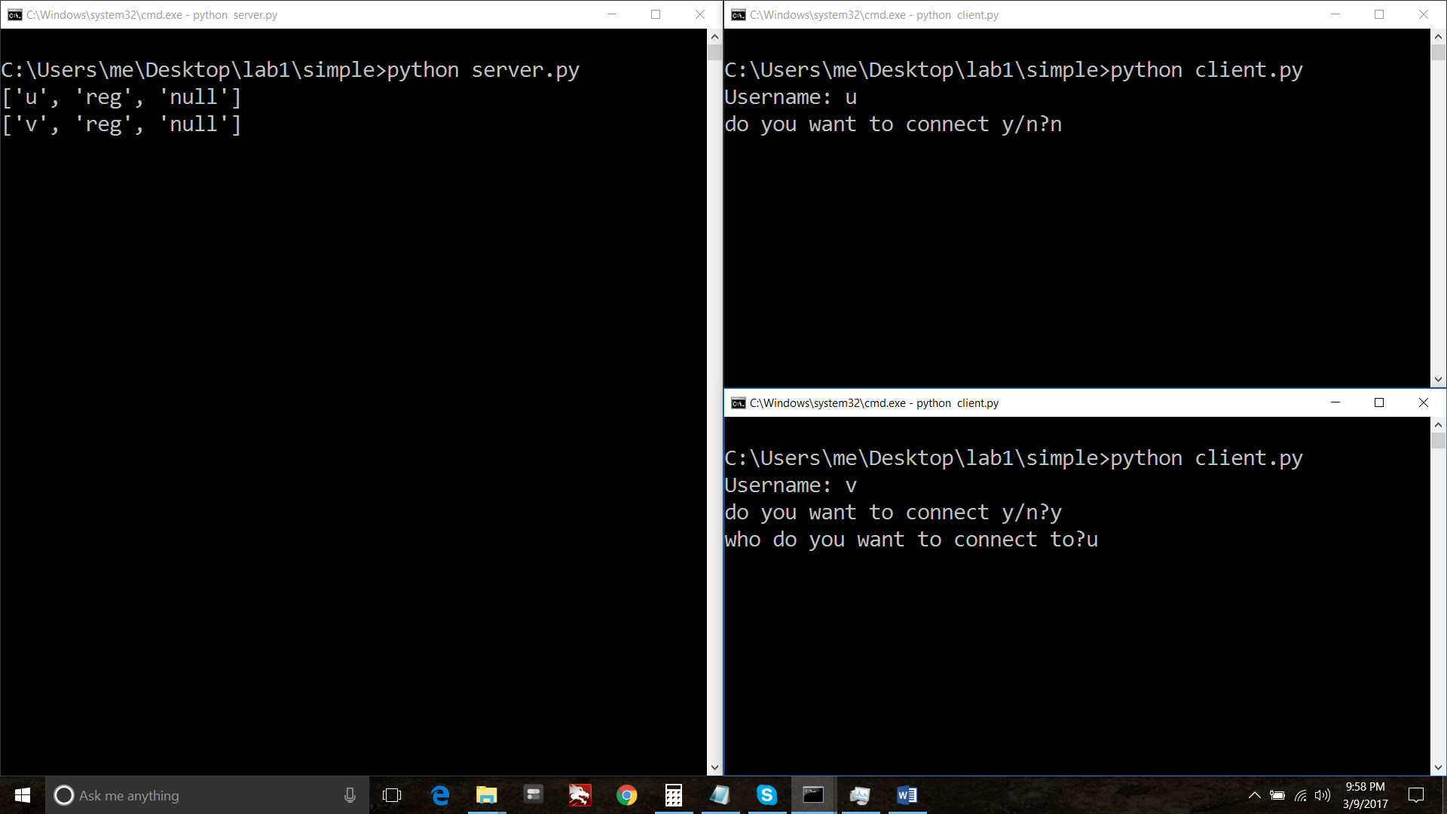

User v is connected to u. check server side screen shot below “v, conn, u”

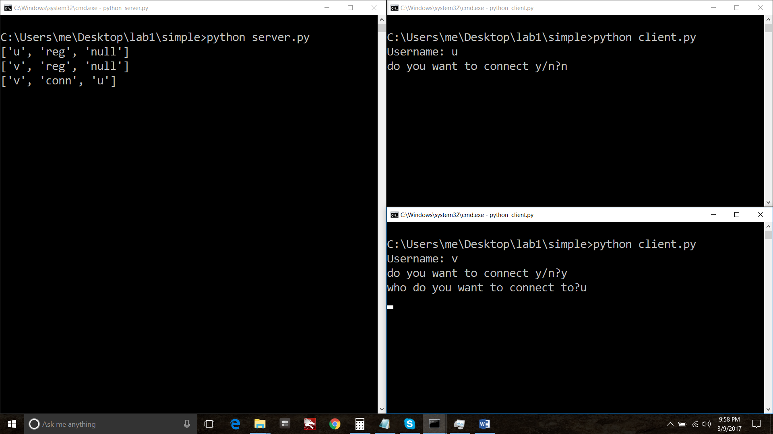

Start typing messages from v to u.  
server will show all message between u and v..

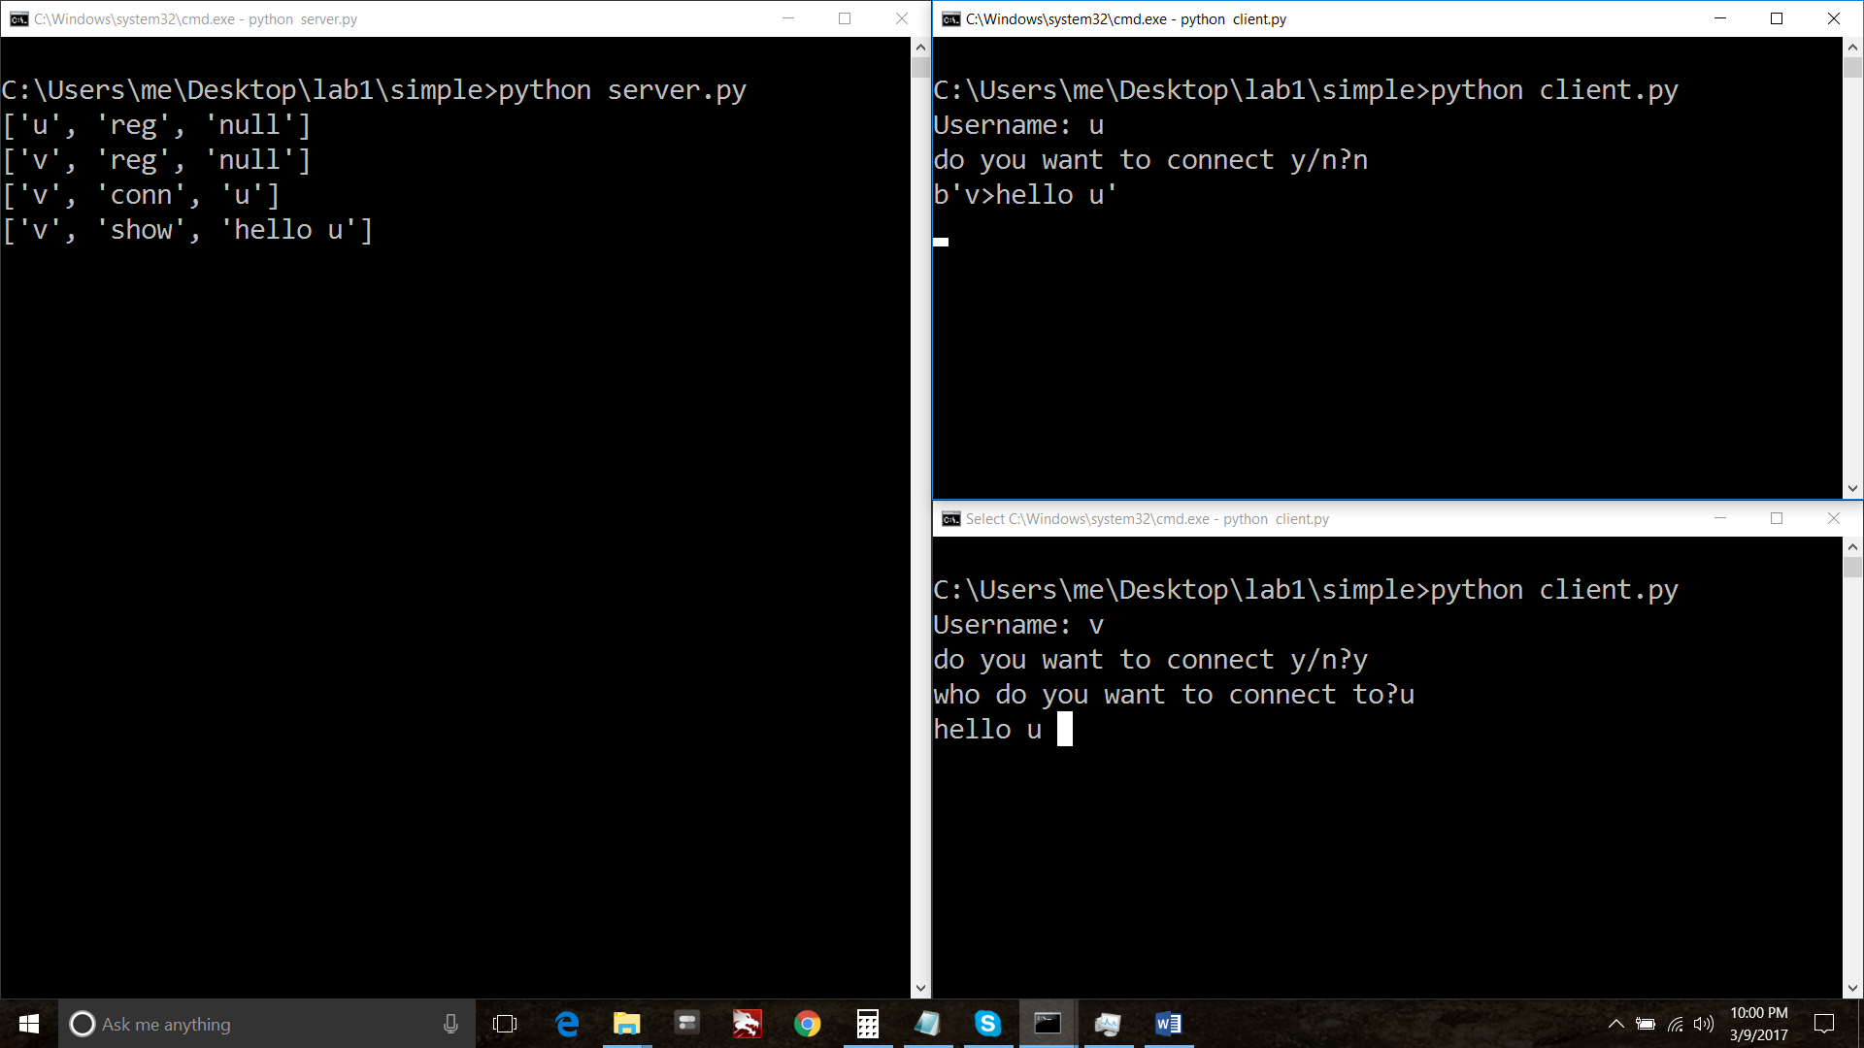

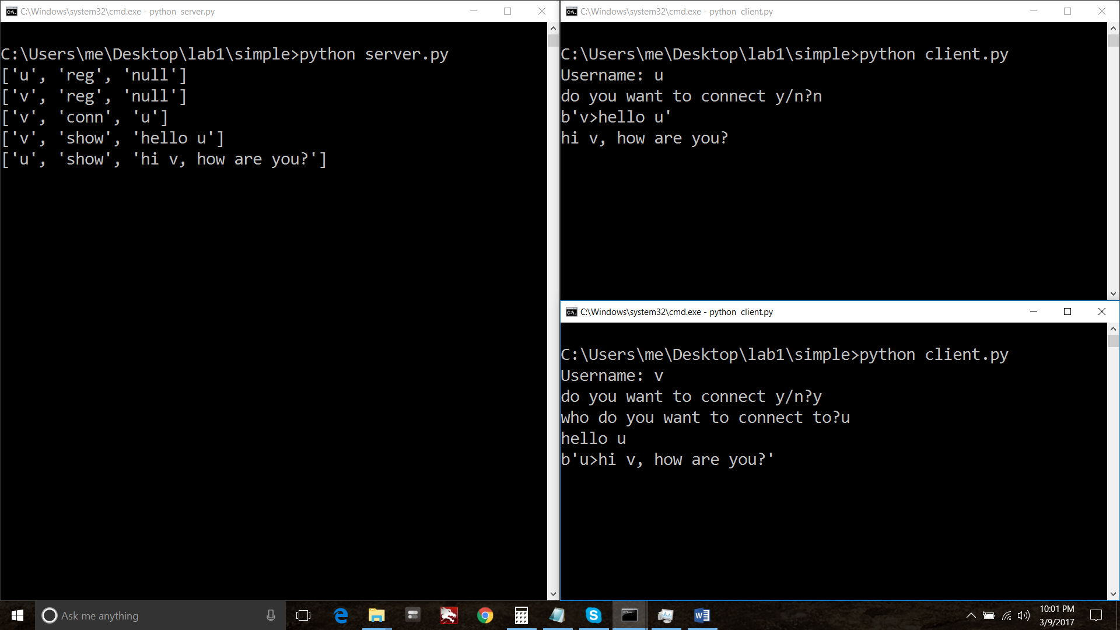

Create two more users “x” and “y” as same as above process and communicate  
their communications will not affect communication of u and v These will be separate threads.

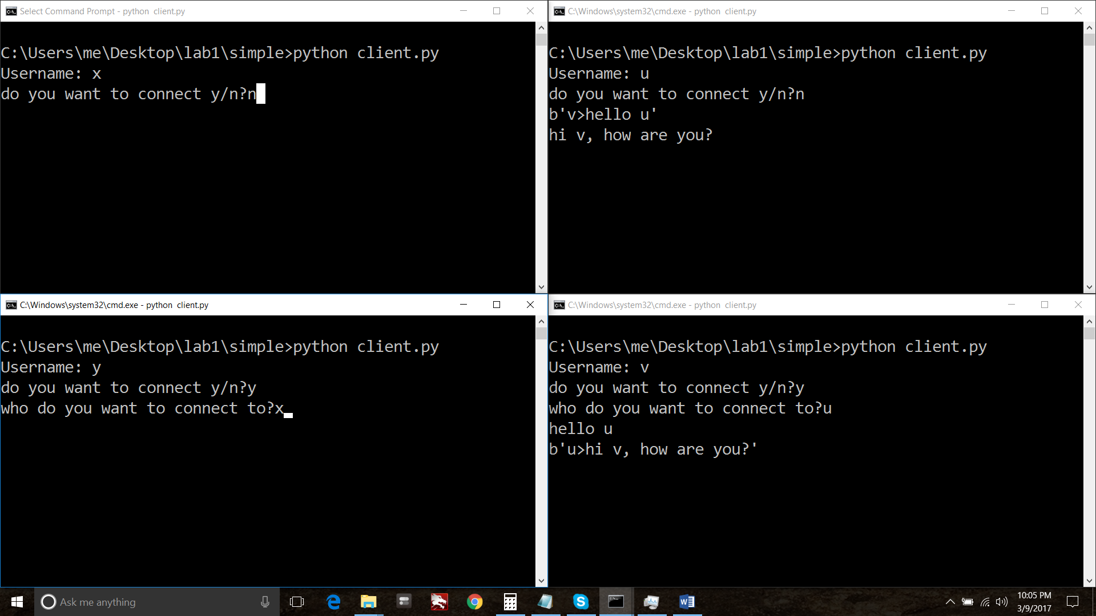

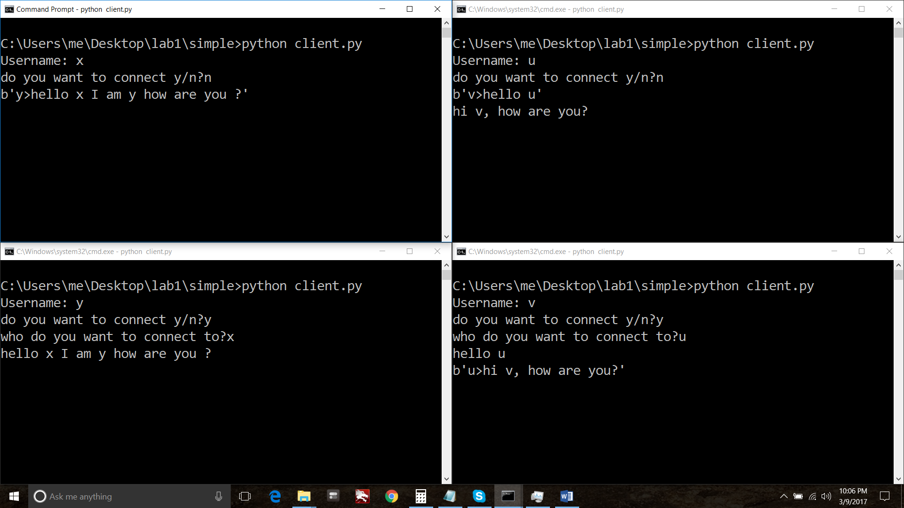

All communications on server:

