**COP5612 Fall 2018**

**Project 2 Gossip Simulator**

**October 1, 2018**

**Group members**

**Prahlad Misra [UFID: 00489999]**

**Saranya Vatti [UFID: 29842706]**

# Implementation for Gossip and Push-Sum

In order to simulate the Gossip spread, we used multiple GenServers and a Supervisor. A Supervisor process is first created and it parses the inputs given through the command line which include the number of nodes. According to the inputs, the supervisor created the number of nodes specified. The kind of node again depends on the algorithm that is taken as input.

In case of topologies like 3D and Sphere, the number of nodes are rounded up to the closest cube and square respectively. The Supervisor picks a random process and propagates the message (in case of Gossip) or starts the push sum algorithm for sum computation. Each node then transmits the message to other node (picked by topology), and also calls itself to ensure continuous propagation.

The state of the GenServer worker holds the information it requires. In Gossip, it holds the number of times it has heard the message, while in Push-Sum, it holds the sum, weight and the ratio. Once it crosses a threshold of max_count, it stops transmitting and sends a message to the Supervisor to increment the count of nodes completely heard. The Supervisor keeps listening for the nodes who have heard the message.

We assume convergence once 90% or more coverage is done. The Supervisor dies and the time taken is measure from the creation of nodes to the ending of the Supervisor. We ran the process for for 90% and 100% convergence in case of Gossip. Once all the nodes have heard the message some max number of times, the process is ended. For Push-Sum algorithm, the convergence is achieved when the ratio of (s/w) does not change by more than 10^-9 in three rounds of calling the same process. Once that happens for all processes, we print the ratio achieved and exit.

# Observations

We plotted the number of nodes run with both the algorithms and all the topologies. With Gossip, we see the high variance when directly plotted verses the time taken by the process. Time is calculated by the System.monotonic_time provided by Erlang. The linear graph is in Figure 1. The logarithmic graph is in Figure 2.

1. We notice that the **line** takes the maximum time. It takes a little lesser time in 90% convergence but a lot higher in 100% convergence. This is perhaps because the end nodes have lesser probability of some node reaching them to deliver the message.
2. In a similar observation**, fully connected takes the least time**. If a small network, this can be preferred. However, the overhead is maintaining a network of all nodes that is accessible from any node.
3. 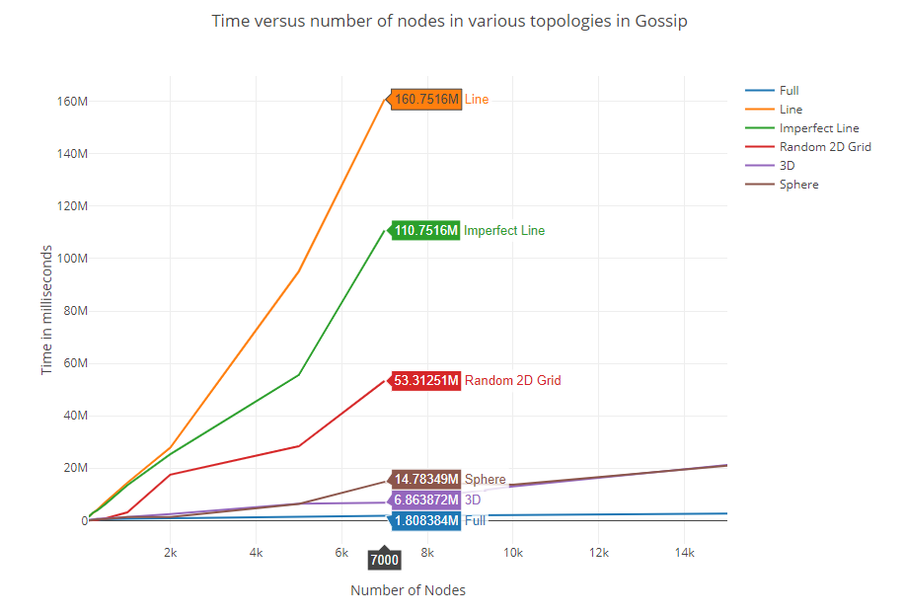Interesting observation is that the performance can be improved significantly just by adding an additional node in the **imperfect line**. This perhaps can be preferred with a balance between overhead and time taken.

Figure 1 Nodes versus Time for Gossip

1. Since the Sphere and 3D Grids are almost fully connected for a small number of nodes, we can see that the times taken by them is similar as well, as expected.
2. The plotted graphs show the times each topology has taken for the Gossip algorithm to reach 100% convergence with max count as 50. That means, each process has to hear the message 50 times for it to stop propagating.
3. While it is true that maximum connection will intuitively suggest minimum time, taking into consideration the amount of extra work done by the processes which are not receiving anymore, we can see that using either Random 2D or an extra random node in Imperfect Line are most profitable.

**Figure 2: Nodes versus log(time) with Gossip on all topologies**

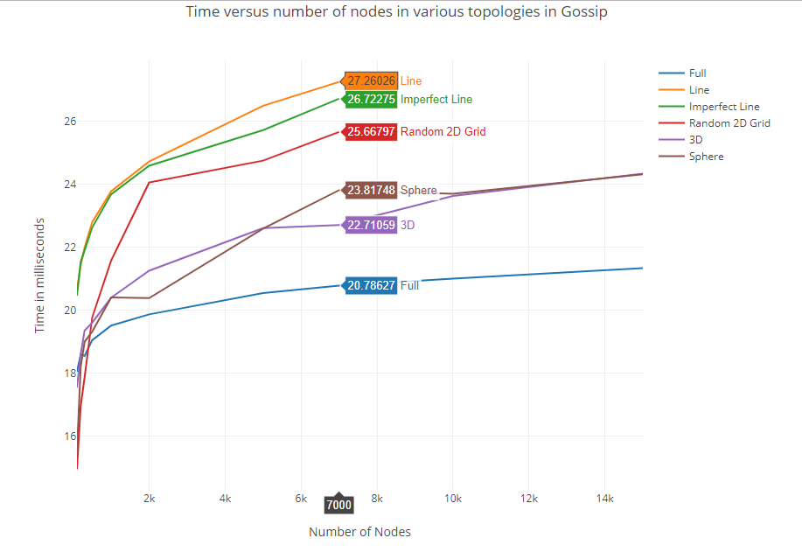Similar observations can be made in convergence of Push Sum as well.

# Table showing the logarithmic times of different topologies with Gossip

|  |  |  |  |  |  |  |
| --- | --- | --- | --- | --- | --- | --- |
| Time in microseconds -> / Number of nodes | Full | Line | 3D | Imperfect 2D | Sphere | Random 2D Grid |
| 100 | 18.05528 | 20.666224 | 20.46999151 | 17.54689446 | 15.52356 | 14.95419631 |
| 200 | 18.61102 | 21.425216 | 21.54898743 | 18.6110248 | 18.20945 | 16.96578428 |
| 300 | 18.55075 | 21.993646 | 21.9099048 | 19.357552 | 19.00843 | 17.87651695 |
| 500 | 19.05257 | 22.80191 | 22.63300939 | 19.60917874 | 19.32193 | 19.77313921 |
| 1000 | 19.51964 | 23.785963 | 23.68905955 | 20.40832974 | 20.40939 | 21.58824615 |
| 2000 | 19.87344 | 24.728133 | 24.59608782 | 21.26033152 | 20.39124 | 24.06507949 |
| 5000 | 20.55075 | 26.502521 | 25.72858487 | 22.61332905 | 22.59502 | 24.75853554 |
| 7000 | 20.78627 | 27.260258 | 26.72275251 | 22.71059122 | 23.81748 | 25.66797083 |
| 10000 | 21.01053 |  |  | 23.63469763 | 23.70563 |  |
| 15000 | 21.34096 |  |  | 24.34186625 | 24.32115 |  |

# Graph showing the nodes versus topologies for Push Sum

Additional technical details are in the ReadMe.

